

2003

SUBJECT REFERENCE: ENGLISH 1.8

Internal assessment resource reference number: Eng/1/8 – A version 3

“Web Designer”

Supports internal assessment for:

Achievement Standard 90059
Produce a media or dramatic presentation
Credits: 3

Date version published: January 2003

Ministry of Education For use in internal assessment
quality assurance status

Teacher Guidelines:
The following guidelines are supplied to enable teachers to carry out valid and consistent assessment using this internal assessment resource.

Context/setting:
This resource may be used in the context of Internet research work or as part of a text study. Students will design their own websites to promote a text they have been studying in class. Sample web pages are provided for teachers to discuss and identify key techniques before students begin their own designs, however it is desirable that students have access to websites on-line, so that they can be viewed in colour. Students can design their web-sites on-line or complete this activity by producing their designs on paper.

Conditions:
This activity should be worked on in the classroom or computer room under teacher supervision to ensure authenticity. Teachers may guide students actively through the web page samples provided, helping them to identify techniques used and comment on their effectiveness. It would be appropriate for students to go on-line to find web page samples of their own and to view the samples and exemplars provided. Teachers may show how the techniques used in the samples could be applied to students’ own designs.

Between drafts, teachers can advise students that their web pages may need further work on ideas, language, organisation, layout or design but not offer specific directions on improvement.

Resource requirements:
Access to the Internet.
Two web page samples are provided. These can be located on-line:
Birnam Wood on the Net: www.geocities.com/Athens/Styx/5025/index.htm
Tolkien Online The One Ring: www.tolkienonline.com/index.cfm
Four student exemplars are provided. They can be viewed at www.ncea.govt.nz. under NCEA English resources (activity: Eng/1/8 – A version 3)

Additional information:
Students should be familiar with the Internet before beginning this activity.

2003
SUBJECT REFERENCE: ENGLISH 1.8

Internal assessment resource reference number: Eng/1/8 – A version 3

“Web Designer”

Achievement Standard 90059
Produce a media or dramatic presentation
Credits: 3

Student Instructions Sheet

In this activity you will develop a web page of your own to promote a text. Before you begin your design you will look at sample web pages. You will examine the components of a web page and the techniques designers have used to make them appealing. Your own web page should use the design principles you have observed in these samples. On completion of your design, you will write an explanation or talk to your teacher, explaining the techniques you have used and the effect you set out to achieve in your design.

You will be assessed on
- how well you communicate ideas to your audience
- the appropriateness and effectiveness of your verbal and visual techniques
- how clearly you identify and explain the techniques you have used in your web page.
- Task 1: What makes a good web page?

- Read the Elements Chart below. A web page is likely to have most but not all of these features. Discuss which techniques are visual or verbal, or a combination of the two.

Elements: | Description:
Page title | This should be brief (up to approximately 40 characters) and should clearly explain the page's contents.
Top-of-page graphics; images | These can be banner headings, logos or simple design elements which give the page its identity. Images should highlight important elements of the site.
Banner advertisements | These are usually long, narrow graphics, featuring a simple catch phrase or text designed to make the user click on the advertisement.
Page backgrounds | These can range from full page images, art works or simple paper texture or colour. Images and colours should relate to the subject matter. It is important not to obscure the writing with a background that is too 'busy' or dark.
Headline text | Each different part of a page normally has a headline. They should be brief, interesting and enticing. Headlines should give an explanation of the content which follows.
Body text | This is used to communicate the bulk of any written information. Text type should not be too small.
Menu bars | These come in two forms: the illustrated form which usually consists of a series of buttons, each of which takes the user to different locations OR a permanent column down one side which splits the screen into a number of areas (frames).
Links | Hypertext links to related information, either within the same site or on another Internet site.
URL address/ author information | Contact information is an essential part of the website. This can include its URL (uniform resource locator) address, the identity of the page's creator and their e-mail address. It may also feature a guest book and a last update figure.

- Look at the sample web page Welcome to Birnam Wood on the Net on page 6 where several of these elements have been labelled and identified.

- Label and identify the elements on the sample web page. Use the sample provided for you on page 7 or go to the Internet to see them on screen. See page 2 for their URLs.

- Read the following description of a good website by Jennifer Story from Next Online. Use this grid to comment on how effectively the web pages you looked at have been designed. Use Jennifer Story's comments as a guide to help you.

It must:

be made with a specific purpose in mind

be attractive and innovative in design

function in terms of its purpose

be easy to navigate

- Surf the Internet for ideas for your own web page. A good place to start is English On-Line www.english.unitecnology.ac.nz. Take particular notice of the design of web pages, looking at the way design relates to content. Roughly sketch or take notes on ideas that you think are effective.
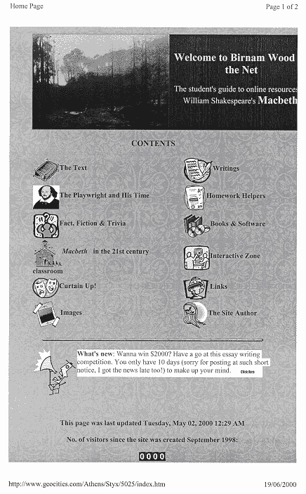
Top of Page Graphics - Presented as a banner headline.
Image of forest matches title. Birnam wood is part of the setting for Macbeth.
Page background - This web page has a pale green leafy background in keeping with the forest image of the title and graphics at the top of the page.
Menu buttons - Introduces the contents. The links to related web pages are indicated by cartoon graphics, e.g. the link to information on Shakespeare is identified by a bust of Shakespeare.
Several symbols are also used.

Body text - there is very little on this page, but the website author does use a short section under the menu bars to tell browsers about relevant up dates. It's done here in a chatty style to make the website appealing to young people (eg 'Wanna win...')

URL address

Web page: Welcome to Birnam Wood on the Net

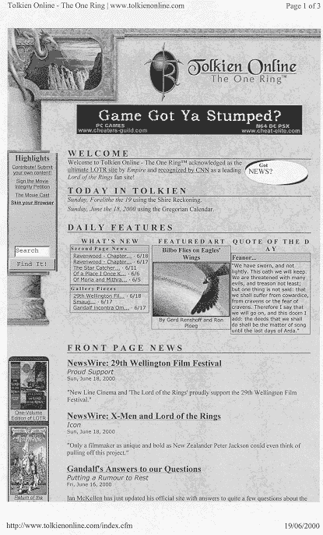
Web page: Tolkien Online
Task 2: Plan your web page

Your task is to design a web page to promote key ideas about the text you have studied in class. Your audience is your class and teacher. Use the Elements Chart on page 4 as a basis for your design. Keep Jennifer Story's comments on page 5 in mind as you plan your page. You may not use any of the material from the sample pages or the exemplars in your web design.

- Look at the web page exemplars from page 10. Identify several features from the Elements Chart. Discuss their strengths and areas they could be improved.

- Brainstorm some possible techniques. You might like to consider the following:
- images, colours, graphics and font style that are appropriate to setting, theme, characters
- links that might be appropriate: eg author/director; theme (eg historical issues or related current events); setting (geographical)
- extracts from the text
- games that might been developed involving characters.

From your brainstorm select the techniques that you think will work best together.

- Sketch the rough layout of your page. It should fit on to one or more A4 sheets. Aim for a balance between graphics and text.

Task 3: Assemble your page

You may choose to produce your web page on-line, however you may cut and paste onto your A4 sheet(s). You must combine visual and verbal techniques in your design to communicate ideas about your text.
It will be easier for you to fit the required material onto your page(s) if you word process it and keep your images and graphics small. If you produce your web page(s) on paper you will need to make it clear which areas of your page(s) can be clicked on as links.

- Do NOT paste any material until you have been through the Elements Chart on page 4 and Jennifer Story's comments as a checklist.

- Be prepared to remove and alter elements that are not contributing to the effectiveness of your web page.

- When all the elements are completed and arranged effectively, paste up your web page.
Task 4: How effective is your web page?

- Choose TWO or more of the elements listed in the Elements Chart on page 5. Include at least ONE visual technique and ONE verbal technique. For each of these elements, describe in specific detail the techniques you used and explain
- the effect you set out to achieve
- how effective your web site is in promoting your book.

- What comments do you think Jennifer Story would make about your design, using her principles of an effective web page?

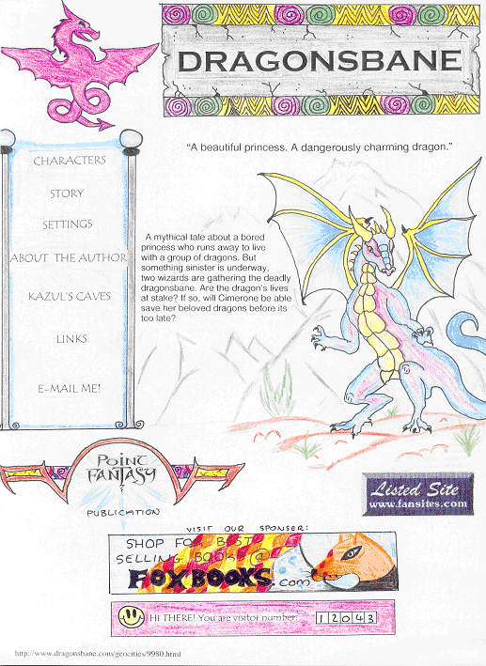

Web page: Exemplar A Dragonsbane :
XCELLENCE

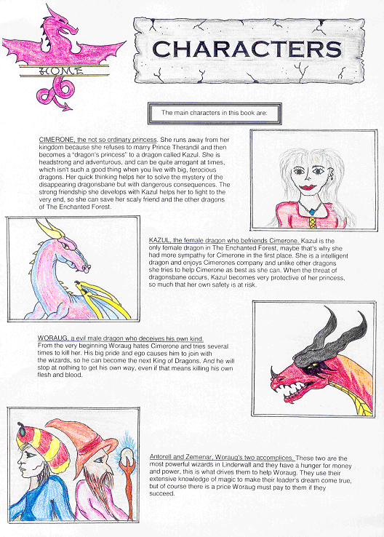

EXEMPLAR A: EXCELLENCE

Student comments on techniques used in web page:

- Symbols and headings- (visual technique) To give the web pages a mediaeval feel I used the dragon symbol together with the cracked background for the ‘characters’ banner. I wanted the title of the home page to stand out even more, so I used some intricate designs around the same style of banner on the ‘characters’ page.

- Descriptions - (verbal technique) The characters in Dragonsbane are fascinating and I wanted the descriptions along with my sketches to ‘sell’ them. With the character descriptions, I used the same structure so that a reader could get a ‘thumb nail’ portrait of the character in the first line which I also underlined. I then included some short interesting details on each character. To also highlight characters, the top of the home page features the caption “A beautiful princess. A dangerously charming dragon” and the first listing on my menu bar takes the reader to the characters’ page.

I think Jennifer Story would like the way I’ve tried to integrate all the components and match them to the mediaeval fantasy theme.

JUDGEMENT OF EXEMPLAR A
EXEMPLAR A | EXCELLENCE | Fully developed ideas are communicated for a specific audience and purpose.  The student presents fully developed ideas about Dragonsbane.  Appropriate verbal and visual techniques are used with striking and/or original effect.  The student has effectively integrated a number of elements to present a unified and original design. The student’s sketches and text work together well. The student has integrated succinct appealing descriptions of the storyline (first page) and characters (second page) with the sketches. Several components match the fantasy theme of the text, including the lettering, the dragon icon, the ‘point fantasy’ logo and the heading banners.  The student has accurately identified some visual and verbal elements used and the effects created.

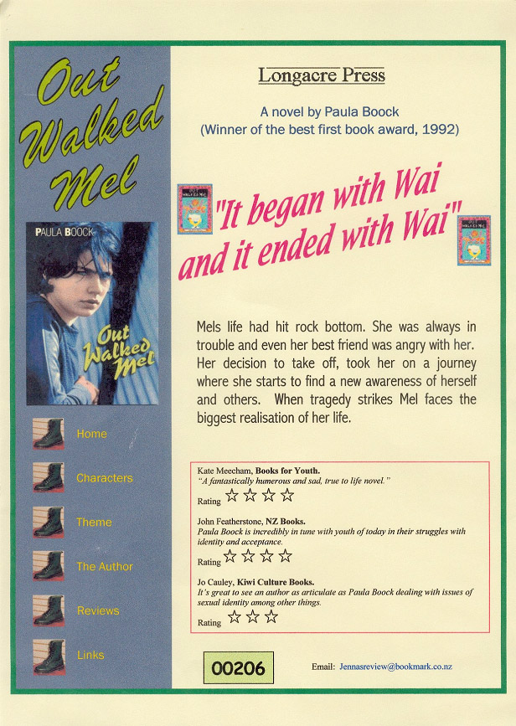
Web page: Exemplar B Out Walked Mel : MERIT

EXEMPLAR A: CREDIT

Student comments on techniques used in web page:

The BODY TEXT (verbal technique) in my web page gives a blurb about the book. It makes the book sound quite exciting so I think it might make people want to read it. There is also a side bar of body text about Salinas Valley. This is effective because it goes with the pictures of Salinas Valley.

I used IMAGES (visual technique) to make my web page attractive. I placed the book cover in the middle and two photos of Salinas Valley underneath. They both show the land. The images back up what is said in the writing.

The MENU BAR (visual/verbal technique) is separate information so I used red type to draw attention to it and to show that it was different. Browsers need to notice it because this is where they go to link to other sites. I think it is effective because of this.

Jennifer Story would think my web page was clearly laid out. It is easy to see its purpose is to inform people about Of Mice and Men. The menu bar is easy to navigate although I think that maybe it isn't clear what the two quotes 'A guy needs somebody' and 'The fatta the lan' ' link to.

JUDGEMENT OF EXEMPLAR A

EXEMPLAR A | CREDIT | The web page communicates straightforward ideas about the text and in particular about the setting.  The page uses appropriate verbal and visual techniques .The photos of the Salinas Valley are appropriately reinforced by the comment regarding the people of Salinas Valley. The use of verbal and visual techniques is adequate but they are not used with effect as required for merit.  Verbal and visual techniques and intended effects are specifically identified.

EXEMPLAR B: MERIT

Student comments on techniques used in web page:

- Border- (visual technique) I used the book cover on the left with the menu buttons underneath so that someone could easily go to another page.

- Menu buttons - (visual technique) I used Mel’s Doc Marten’s boots because they represent that Mel was rebellious and anti authority.

- Quotations from the novel and reviewers - (verbal technique) I placed the quotation at the top is to highlight how important Wai was in Mel’s life. I chose the other quotations at the bottom to suggest aspects of the novel which might hook different readers with different interests and tastes.

I think Jennifer Story would appreciate that my web page is simple and easy to read. Someone looking at the page without knowing the novel would get a reasonably clear idea if they were interested in reading it.

JUDGEMENT OF EXEMPLAR B
EXEMPLAR B | MERIT | Developed ideas are communicated for a specific audience and purpose.  Using a range of techniques, the student successfully presents developed ideas on Mel’s strong link to Wai and other key aspects to Mel’s ‘journey.’  Appropriate verbal and visual techniques are used with effect. Layout is simple and effective. The border on the left uses the colour of the book cover and gives the page a unified look. Menu buttons featuring Mel’s boots are used successfully. The central text together with the quotation and references work together with the images to attract young readers.  However some elements, while competently presented, are not used in a striking or original way needed for excellence: eg  - the book covers for both editions have simply been reused. Overall there is a limited amount of original material incorporated into the design.  The student has accurately identified some visual and verbal elements used and the effects created.

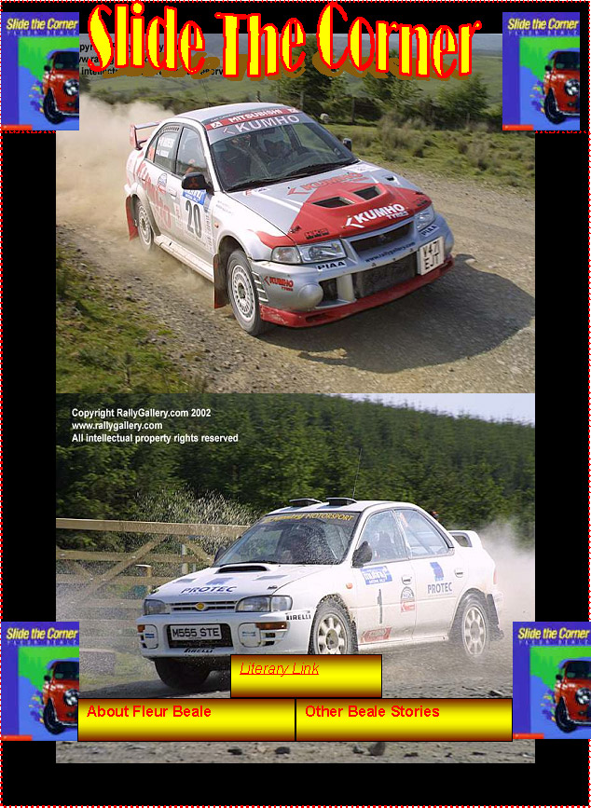
Web page: Exemplar C Slide The Corner : ACHIEVEMENT

Test yourself on the story

More about Greg

Rally pictures

Fan mail

Is your computer safe think is time to update your virus scanner get it free at www.windows.com
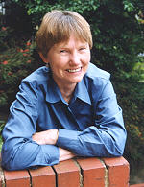
Want to drive like a pro, just like Brad? Get rally driving lessons now just phone 0800 drive
Slide the Corner is an excellent book about a troublesome teenager Greg Mannering who finds his parents just don’t connect with him. Life revolves around a rally car – not school or home.

EXEMPLAR C: ACHIEVEMENT

Student comments on techniques used in web page:

- Page title- (verbal /visual technique) The title I choose was Slide the Corner and I choose this because it relates to the book because his life is taking a turn for the good. He’s changing his ways to better himself. I used this font because it’s easy to read and the lettering is at the right size for easy reading. The colour was quite basic with a red outline and yellow on the inside the red catches your attention to focus on the title and what it’s telling you.

- Page background- (visual technique) The page back ground I choose was black it makes the pictures and font etc stand out from the page so that your eyes focus on the pictures and the text box (about the story). With the background being black the pictures jump out at you and the words lift off the page, which makes it good as a background.

- Body text- (verbal technique) The information I used in my body text was about the author Fleur Beale the text box contained information about the book which was slide the corner its says how life as Greg is hard for him and how his parents just don’t connect with he like different hobbies than the rest of the family eg Greg like rally cars but his sister is interested music and is very intelligent much like her parents and brother but Greg is the odd one out.

Jennifer Story would think my web page was clearly laid out. It is easy to see its purpose is to inform people about Slide the Corner.

JUDGEMENT OF EXEMPLAR C
EXEMPLAR C | ACHIEVEMENT | Straightforward ideas are communicated for a specific audience and purpose.  The student communicates an idea about the main character and how important rallying is to him.  Appropriate verbal and visual techniques are used.  Visual elements are used in a clear way with the photos of rally cars and the author. Good use is made of contrasting colours. The menu buttons make relevant links to the visual elements.  The use of verbal and visual techniques is adequate but they are not combined with effect as required for merit. Layout is cluttered.  Verbal and visual techniques and intended effects are specifically identified.

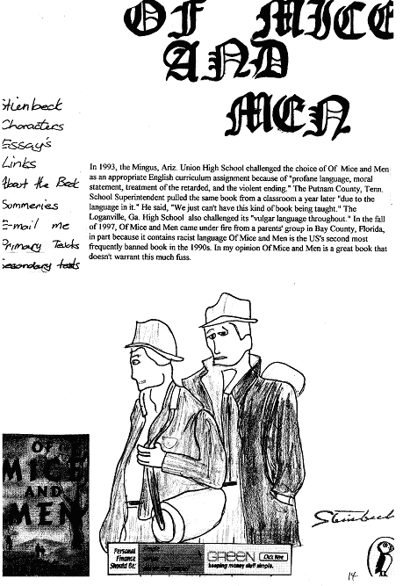
Web page: Exemplar D Of Mice and Men : NOT ACHIEVED

EXEMPLAR D: NOT ACHIEVED

Student comments on techniques used in web page:

Headline Text (verbal technique)
I have written the title of the book in old fashioned writing to make it stand out.

Body Text (verbal technique)
There is some interesting information to show the book was banned. People will want to know why and it will make them read it.

Images (visual technique)
I have a picture of Lennie and George in the middle. I have a picture of the book cover so people will know what the book looks like and the symbol of the penguin shows it is a penguin book.

My web page is effective because it has interesting information and shows you what the book is about.

JUDGEMENT ON EXEMPLAR D:
EXEMPLAR D | NOT ACHIEVED | Does not communicate straightforward ideas about the text. The main point the page makes about the story is not appropriate or relevant information for a home page.  Appropriate verbal and visual techniques are not used. Verbal and visual techniques are inappropriate and poorly arranged and presented, eg  - gothic script has no noticeable relevance to the subject  - lengthy body text  - menu buttons presented as a hurried handwritten list.  Identification of visual and language techniques is imprecise. The intended effect is not clear.

Assessment Schedule: 1.8 Produce a media or dramatic presentation

 | Descriptor | Example
Achievement | Communicates straightforward ideas for a specific audience and purpose.  Uses appropriate verbal and visual techniques.  Identifies verbal and visual techniques used and their intended effect. | Refer achievement exemplar C.
Merit | Communicates developed ideas for a specific audience and purpose.  Uses appropriate verbal and visual techniques with effect.  Identifies verbal and visual techniques used and their intended effect. | Refer merit exemplar B.
Excellence | Communicates fully developed ideas for a specific audience and purpose.  Uses appropriate verbal and visual techniques with striking and or original effect.  Identifies verbal and visual techniques used and their intended effect. | Refer excellence exemplar A.

