CONNECTED, LEVEL 3 2014, Why Is That?  Counting Kākahi  by Hannah Rainforth  Overview  This is a report about research that’s been done by a scientist. Hannah investigated kākahi in the Whanganui River to find whether the evidence supports claims by local kaumātua that they are disappearing.  A Google Slides version of this article is available at www.connected.tki.org.nz. |  |  | 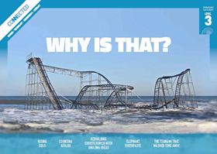  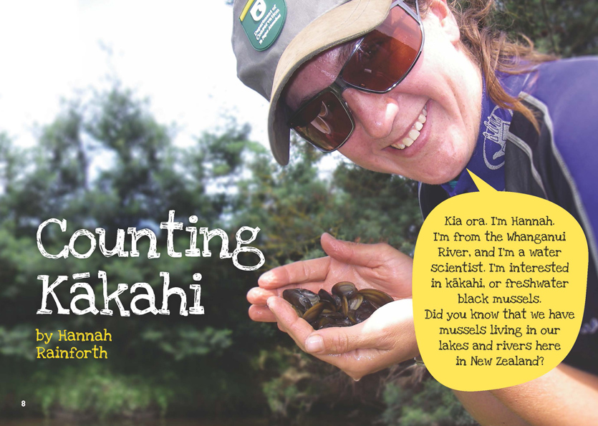
Science capability: Use evidence |  | Text characteristics

Science is a way of explaining the world. Science is empirical and measurable. This means that in science, explanations need to be supported by evidence that is based on, or derived from, observations of the natural world. Students should be encouraged to support their ideas with evidence and look for evidence that supports or contradicts other explanations.  At the core of science is theory building – making better explanations. What sets scientific explanations apart from other ways of explaining the world is their reliance on evidence and their ability to evolve as new evidence comes to light.  For more information about the “Use evidence” science capability, go to http://scienceonline.tki.org.nz/Introducing-five-science-capabilities/Use-evidence |  | - An informal, conversational voice that includes questions to the reader and rhetorical questions.  - Photographs with captions, diagrams, illustrations, subheadings, and a glossary.  - Complex sentences containing explanations.  - Scientific and technological vocabulary and words in te reo Māori that may be unfamiliar to some students.

Curriculum context

SCIENCE
NATURE OF SCIENCE: Understanding about science  Achievement objective(s)  L3: Students will identify ways in which scientists work together and provide evidence to support their ideas. |  | LIVING WORLD: Ecology  Achievement objective(s)  L3: Students will explain how living things are suited to their particular habitat and how they respond to environmental changes, both natural and human-induced. |  | Key Nature of Science ideas  - Evidence is based on, or derived from, observations of the natural world.  - Scientific ideas and explanations are supported by evidence.  - Scientists make use of relevant evidence to support or revise their predictions and explanations.  Key science ideas  - Reproduction is essential for a species' survival.  - Environmental changes in an ecosystem affect the survival of living organisms.

ENGLISH

READING  Ideas  Students will show a developing understanding of ideas within, across, and beyond texts. |  | INDICATORS  - Uses their personal experience and world and literacy knowledge confidently to make meaning from texts.  - Makes meaning of increasingly complex texts by identifying main and subsidiary ideas in them.  - Starts to make connections by thinking about underlying ideas in and between texts.  - Makes and supports inferences from texts with increasing independence. |  | THE LITERACY LEARNING PROGRESSIONS  The literacy knowledge and skills that students need to draw on by the end of year 6 are described in The Literacy Learning Progressions.

Using evidence

- Scientists use empirical evidence to develop theories about how the world works.
- Empirical evidence is data gathered from observations and experiments.
The science capability, Use evidence, is about students developing and considering theories and explanations in the light of evidence (http://scienceonline.tki.org.nz/Introducing-five-science-capabilities/Use-evidence).
Students should be:
- using evidence they have gathered to develop their own explanations about the way the world works
- critiquing explanations offered by others, including scientifically accepted explanations, by considering the evidence that supports them.
Scientific explanations, including those found in museums, in television programmes, on the Internet, and in non-fiction books and texts, often fail to discuss the evidence and testing that led to the development of these explanations.
Teachers can:
- help students to be more critical consumers of science information by being explicitly critical themselves
- model a sceptical stance
- ask questions such as:
  - How do you think people found that out about that?
  - What kind of evidence would support that idea?
  - How could a scientist test that idea?
- use concept cartoons to propose possible explanations. (See http://conceptcartoons.com/what-is-a-concept-cartoon-.html)
When doing practical investigations, teachers can support students to:
- consider a range of possible explanations for their findings
- think about how these explanations fit with the evidence they have gathered
- avoid suggesting that scientific investigations prove anything – rather, investigations provide evidence that supports or refutes a hypothesis or idea.
Establish a science classroom culture by:
- welcoming a range of possible explanations
- encouraging students to consider possible explanations in the light of evidence
- having students draw evidence from their experience
- using questions such as:
  - What have we seen today that supports X’s idea?
  - Has anyone seen anything somewhere else that might be evidence for X’s idea?
- encouraging investigation:
  - What could we do to test X’s idea?
  - What would we expect to happen? Why?
A range of questions and activities designed to get students to use evidence is available on the Science Online website: http://scienceonline.tki.org.nz/Introducing-five-science-capabilities/Use-evidence

Meeting the literacy challenges

The following instructional strategies will support students to understand, respond to, and think critically about the information and ideas in the text. After reading the text, support students to explore the key science ideas outlined in the following pages.

TEACHER SUPPORT

Want to know more about instructional strategies? Go to:
- http://literacyonline.tki.org.nz/Literacy-Online/Teacher-needs/Reviewed-resources/Reading/Comprehension/ELP-years-5-8
- “Engaging Learners with Texts” (Chapter 5) from Effective Literacy Practice in Years 1 to 4 (Ministry of Education, 2003).
Want to know more about what literacy skills and knowledge your students need? Go to:
- http://literacyonline.tki.org.nz/Literacy-Online/Student-needs/National-Standards-Reading-and-Writing
- www.literacyprogressions.tki.org.nz/
“Working with Comprehension Strategies” (Chapter 5) from Teaching Reading Comprehension (Davis, 2007) gives comprehensive guidance for explicit strategy instruction in years 4–8.
Teaching Reading Comprehension Strategies: A Practical Classroom Guide (Cameron, 2009) provides information, resources, and tools for comprehension strategy instruction.

INSTRUCTIONAL STRATEGIES

FINDING INFORMATION IN THE TEXT
Tell the students the title and EXPLAIN that this is a report by a scientist working at the Whanganui River. Use a map to show the students where the Whanganui River is. ASK QUESTIONS to help them make connections to what they already know about kākahi and about the river.
What do you know about the Whanganui River?
What do you think kākahi might look like?
Where do you think they live?
What might they eat?
Why do you think this report is called “Counting Kākahi”?
MODEL how to SKIM and SCAN to find key information on pages 8 and 9. You could show the text on an interactive whiteboard or use the Google Slides version. Give the students removable sticky notes so they can identify the key information as they read.
- I can gather information about the freshwater mussel by skimming and scanning the text in the hook and first paragraph. I can use the title of the article and the heading of the first paragraph to identify important ideas and information. I can use a sticky to highlight key words and phrases that tell me about the kākahi so I can begin to learn more about them. (Highlight words like “freshwater”, “black”, and “living in our lakes and rivers”.)
PROMPT the students to use what they have read so far to predict why there are lower numbers of kākahi.
Show the students how to SCAN the subheadings to get an overview of the text. PROMPT them to notice that they include a series of questions. DISCUSS the fact that scientists work by asking questions and collecting evidence to suggest explanations. As they read, have each student write a list of questions for another class member, focusing on the main idea in each section of the text.
MODEL how the reader needs to follow the sequence of ideas, make inferences, and ask questions to find the information in complex sentences.
- “And what's more” tells me that there is a third reason for the reduction in mussel numbers. “... they need certain fish to reproduce” is interesting – why would a mussel need a fish to reproduce? “... and some of these fish are now rare and threatened” – so what are these fish and why are they threatened? “.... but more on that later”. Okay, so I need to remember this and look for the answers to my questions later in my reading.
MODEL the use of inference to find information that is not made explicit.
I've been wondering how Hannah was able to collect all the data by herself. It says, “I recorded how many people were helping me search …” That tells me she had a team of people to help. She also says she started her investigation by talking to “our kaumātua” and in fact, when she talks about the kākahi, she talks about “our kākahi”. Although she doesn’t exactly say so, I can infer from all of these pieces of information that a lot of people in Whanganui must care about them.
The students may wonder why Hannah refers to “our kaumātua”. EXPLAIN that she belongs to Ngāti Hauiti and Te Atihaunui-a-Pāpārangi, both of which live by and are strongly connected to the Whanganui River.
Have the students SUMMARISE the process Hannah used, using a graphic organiser like this.
What Hannah did | Why she did this

After the students have finished reading, have them use the key words they have identified to write a list summarising what they have learned about the kākahi.

INTERPRETING ADDITIONAL INFORMATION TO CLARIFY THE TEXT
EXPLAIN that the author has included the diagram on page 9 to help readers understand how kākahi feed. The diagram is labelled and supports the information in the text. PROMPT the students to look closely at the accompanying photo to link where the siphons are shown in the diagram to where they are in the photo.
Do the photograph and diagram show kākahi from the same angle?
PROMPT the students to read the information and then use the diagram to explain to a partner how filter feeders feed. To help clarify the importance of using both sets of information (the diagram and the text), ask the students to explain how the diagram and the text work together.
PROMPT the students to look closely at the diagram of the kākahi life cycle on page 10 and explain the cycle to their partners, using some of the subject-specific vocabulary. Then have them construct a simple flow diagram demonstrating the relationships, using the sentence beginning, “So for kākahi to thrive …”

DEALING WITH UNFAMILIAR VOCABULARY
Check that the students understand who Hannah is referring to as “kaumātua”.
DISCUSS the meanings of the words and phrases that the students have listed on their sticky notes. PROMPT them to refer to the glossary, where they will find the meanings of some of those words and phrases. Have them write their own definitions of the words that are not explained in the glossary, using the text as a source (for example, glochidia – “The female kākahi releases tiny larvae, called glochidia ...”

Key science ideas
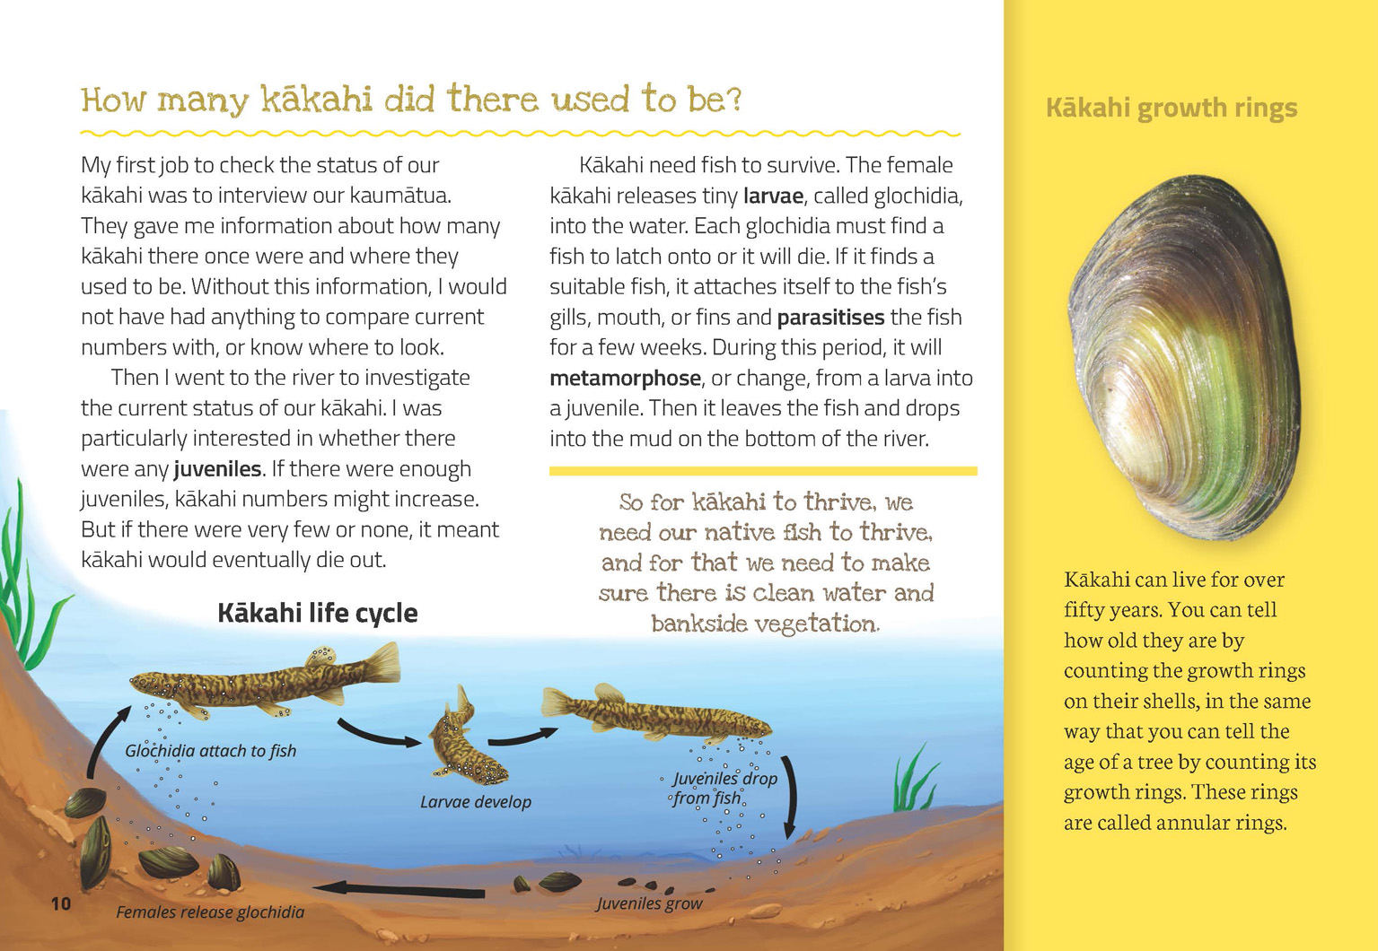 | Reproduction is essential for a species’ survival.  Environmental changes in an ecosystem affect the survival of living organisms.  Scientists and kaumātua work together to investigate an issue.
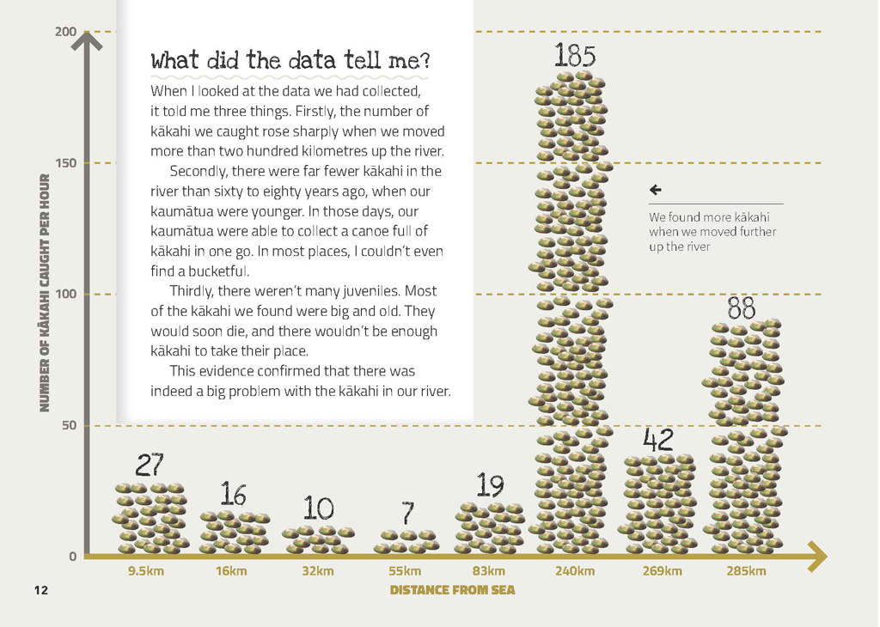 | Scientists use evidence to support or revise their predictions and explanations.  Evidence is based on observations of the natural world.  Scientists’ ideas and explanations are supported by evidence.

Exploring the science
Some activities focus directly on the science capability of “using evidence to support ideas” and the Nature of Science strand. Other activities extend student content knowledge. You are encouraged to adapt these activities to make the focus on Nature of Science explicit and to support students to develop the capability of using evidence to support ideas.

LEARNING FOCUS
Scientists make observations and gather data to provide evidence to support ideas.

LEARNING ACTIVITIES

Activity 1: Getting the full picture
Read the article “The Mysterious Freshwater Mussel” from www.stuff.co.nz/dominion-post/news/local-papers/wairarapa-news/2488390/The-mysterious-freshwater-mussel for further information about Hannah's study. Have the students use this reading to refine the information in their graphic organiser. Ask questions to draw their attention to how she used both western and iwi methods to gain the evidence she needed to “get the full picture”.
What evidence did Hannah find that means she thinks the kākahi are in trouble?
Why was it so important to interview the kaumātua first?
Look carefully at the data on page 12. What do you notice? Why do you think there are more kākahi further up the river in some places but not others? How could you check your ideas?
How do you think scientists worked out that counting the rings on a kākahi shell tells you how old it is?
Read the article “The Fish Highway” in Connected 3, 2013, which is about monitoring native fish. Compare the different methods Frances and Hannah use to make measurements.
Why is the ability to make accurate measurements so important to scientists?
What are some other methods scientists use to make measurements?
Activity 1 in the teacher support materials (TSM) for “The Fish Highway” suggests how the students could further explore the importance of measurement.
Extension
Select other activities from the TSM for “The Fish Highway” as part of an integrated unit on the impact of environmental change on native aquatic species.

Activity 2: The life cycle of kākahi
Investigate the life cycle of kākahi and the environmental factors that affect it.
What needs to be done to ensure kākahi do not become extinct?
Compare the life cycle of kākahi with those of whitebait and longfin eels, as described in the Science Learning Hub materials on “Tōku Awa Koiora” www.sciencelearn.org.nz/Contexts/Toku-Awa-Koiora/NZ-Research/Toku-Awa-Koiora
What are the similarities and differences in the life cycles of these animals?
Use Animal Life Histories: Reproduction, Growth, and Change, Building Science Concepts book 4, to develop the students' understanding about how living organisms survive and to reinforce the idea that, in science, the word “animal” applies to all multicellular organisms that are heterotrophic, or cannot produce their own food.

Activity 3: Tōku Awa Koiora
The concerns about changes to the Whanganui River are mirrored in “Tōku Awa Koiora” www.sciencelearn.org.nz/Contexts/Toku-Awa-Koiora/NZ-Research/Toku-Awa-Koiora. This Science Learning Hub context investigates how kaitiaki are working to restore the health of the lower half of the Waikato River. It has numerous videos in which iwi discuss the importance of the river. It includes “River Connections”, an activity that encourages students to make connections between the river environment, species in and around it, and the connectedness of the people.

Activity 4: Become a citizen scientist
Hannah Rainforth could not have collected enough data without the help of a team of volunteers or “citizen scientists”. Use the Science Learning Hub link on citizen scientists (www.sciencelearn.org.nz/Science-Stories/Butterflies/Citizen-scientists) to explore this concept and to find out about citizen science in action.
The students could carry out a survey of their local waterways for habitat that would support kākahi and, if appropriate, carry out a search as suggested in the article. They could present their data in a size distribution graph and share their findings with the class. (An alternative, if you live by the sea, is to conduct a similar activity by collecting, counting, and measuring sea shells.) If their investigation raises concerns, they could write a letter to their regional council or the Department of Conservation.
Many local and regional councils offer opportunities for students to be citizen scientists through activities such as helping to monitor the health of their local stream, surveying the presence of native species in the waterway, or taking part in riparian planting schemes. Activity 5 of the TSM for “The Fish Highway” suggests some ideas. You could also consider these:
The Whitebait Connection (www.whitebaitconnection.co.nz) is a non-profit action-based community conservation education programme. Its coordinators will come to your school to help you plan and integrate the programme into your curriculum. Students take part in hands-on exploration of their local freshwater environment and then take action to preserve it.
Marine Metre Squared (www.mm2.net.nz) is a University of Otago research project that uses citizen scientists. Students can add survey data to show others what is living on their local coastline, then use a simple mapping and analysis tool to compare their findings with the rest of New Zealand.

Google Slides version of “Counting Kākahi” www.connected.tki.org.nz

RESOURCE LINKS

Building Science Concepts, Book 4 – Animal Life Histories: Reproduction, Growth, and Change
“Estuary Health Check” by Leeanne Arnold. School Journal Part 4 Number 3, 2008, pp. 28–32.
“The Fish Highway” Food for Thought. Connected 3, 2013 (article and TSM available from www.connected.tki.org.nz)

Science Learning Hub
“Farming and Environmental Pollution” www.sciencelearn.org.nz/Contexts/Soil-Farming-and-Science/Science-Ideas-and-Concepts/Farming-and-environmental-pollution
“Tōku Awa Koiora” www.sciencelearn.org.nz/Contexts/Toku-Awa-Koiora/NZ-Research/Toku-Awa-Koiora
“Student Activity – River Connections” www.sciencelearn.org.nz/Contexts/Toku-Awa-Koiora/Teaching-and-Learning-Approaches/River-connections

Other resources
Virtual field trips, available from LEARNZ, www2.learnz.org.nz/core-fieldtrips.php
- Freshwater Ecology – investigating water quality and biodiversity around Lake Taupō
- Harbours and Estuaries – investigating Ohiwa Harbour, a regional taonga
“The Mysterious Freshwater Mussel”
www.stuff.co.nz/dominion-post/news/local-papers/wairarapa-news/2488390/The-mysterious-freshwater-mussel
“A Life Less Ordinary for Native Mussels” http://blog.forestandbird.org.nz/a-life-less-ordinary-for-native-mussels
“Kākahi” www.niwa.co.nz/our-science/freshwater/tools/kaitiaki_tools/species/kakahi
“Marine Metre Squared” www.mm2.net.nz
“Take Action for Water” www.gw.govt.nz/take-action-for-water
“The Whitebait Connection” www.whitebaitconnection.co.nz
Videos of filter feeders available from:
www.biotechlearn.org.nz/focus_stories/farming_green_lipped_mussels/video_clips/mussels_are_filter_feeders
www.youtube.com/watch?v=vNqEQjGaDVk

