CONNECTED, LEVEL 2 2015, Have You Checked?  Heat It Up  by Kate Potter  Overview  This article tells the story of Paige and Sabitra, two friends who want to make a solar-powered oven. When their first attempt fails, they decide to conduct an investigation to find out whether they could use colour to improve the effectiveness of their oven. The experience teaches them a lesson about the importance of controlling the variables when conducting a scientific test.  A Google Slides version of this article is available at www.connected.tki.org.nz. |  |  | 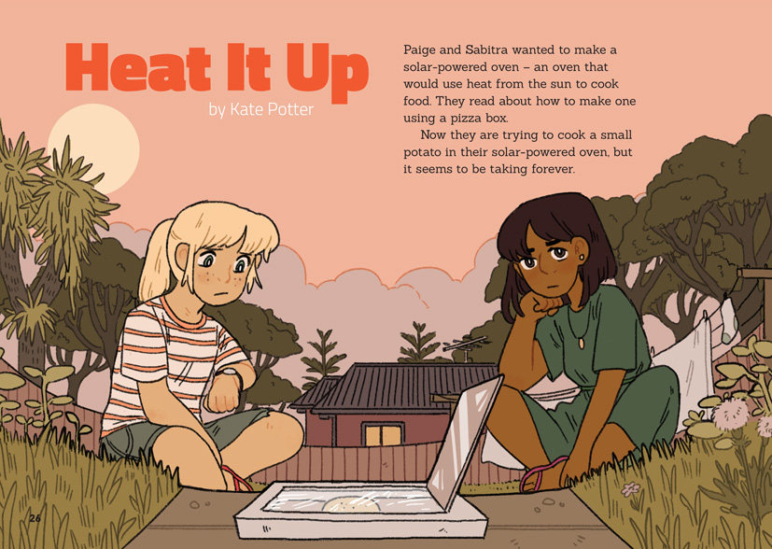
Science capability: Critique evidence |  | Text characteristics

Science knowledge is based on data derived from direct or indirect observations of the natural physical world. An inference is a conclusion drawn from those observations; it is the meaning you make from the observations. Understanding the difference between an observation and an inference is an important step towards being scientifically literate.  Being ready, willing, and able to critique evidence is also an important step towards being scientifically literate. Students must be able to assess the quality and reliability of both the observations (data) and the inferences made from those observations. In order to know what sort of questions to ask to evaluate the trustworthiness of data, students need both methodological knowledge (how data is generated and collected) and statistical knowledge (how data is collated and analysed).  For more information about the “Critique evidence” science capability, go to http://scienceonline.tki.org.nz/Introducing-five-science-capabilities/Critique-evidence |  | - The form of the text as a narrative with a considerable amount of direct speech in quotes.  - A conversational tone that helps the reader visualise information and includes the use of idiom.  - A clearly structured article with descriptive headings that signal the information in each section and help the reader to navigate the texts.  - Pictures and a diagram that clarify the text and require some interpretation.

Curriculum context

SCIENCE
NATURE OF SCIENCE: Understanding about science  Achievement objective  L2: Students will appreciate that scientists ask questions about our world that lead to investigations and that open-mindedness is important because there may be more than one explanation. |  | NATURE OF SCIENCE: Investigating in science  Achievement objective  L2: Students will extend their experiences and personal explanations of the natural world through exploration, play, asking questions, and discussing simple models.  PHYSICAL WORLD: Physical inquiry and physics concepts  Achievement objectives  L2: Students will explore everyday examples of physical phenomena, such as movement, forces, electricity and magnetism, light, sound, waves, and heat.  Students will seek and describe simple patterns in physical phenomena. |  | Key Nature of Science ideas  Scientists:  - evaluate the trustworthiness of data by asking questions about investigations carried out by others  - undertake more than one trial to provide sufficient evidence to support a theory  - check that there are enough samples to reliably establish a conclusion or theory  - replicate investigations to critique the evidence or data provided by other scientists  - look carefully at the way data has been collected when they consider investigations done by others.  Key science ideas  - The Sun is our most important producer of heat energy.  - Dark surfaces absorb radiant heat more readily than light ones.

ENGLISH

READING  Ideas  Students will show some understanding of ideas within, across, and beyond texts. |  | INDICATORS  - Uses their personal experience and world and literacy knowledge to make meaning from texts.  - Makes meaning of increasingly complex texts by identifying main ideas.  - Makes and supports inferences from texts with some independence. |  |  |  | THE LITERACY LEARNING PROGRESSIONS  The literacy knowledge and skills that students need to draw on by the end of year 4 are described in The Literacy Learning Progressions.

TECHNOLOGY
TECHNOLOGICAL PRACTICE: Outcome development and evaluation  Achievement objective  L2: Students will investigate a context to develop ideas for potential outcomes; evaluate these against the identified attributes; select and develop an outcome in terms of the need or opportunity. |  |  |  | Key technology ideas  - Technological modelling is an essential part of the process when developing a new technological outcome.  - The technologist considers the performance properties of each material when selecting them for a technological outcome.

MATHEMATICS AND STATISTICS
GEOMETRY AND MEASUREMENT: Measurement  Achievement objective  L2: Create and use appropriate units and devices to measure length, area, volume and capacity, weight (mass), turn (angle), temperature, and time. |  |  |  | Key measurement idea  - Making accurate measurements is required for successful outcomes.

Critiquing evidence

The science capability “Critique evidence” is about students evaluating the quality of the data supporting a scientific claim or idea (http://scienceonline.tki.org.nz/Introducing-five-science-capabilities/Critique-evidence).
Scientists use empirical evidence to develop theories about how the world works.
- Empirical evidence is data gathered from observations, experiments, and investigations.
- Scientific claims are only as dependable as the evidence on which they are based.
- Scientists design their investigations carefully to ensure that the data they gather is both reliable and valid. Valid data is data that measures what it is supposed to measure - it answers the research question. Reliable data is dependable and consistent. Replicating the experiment and getting the same results makes us more confident the data is reliable.
- To gather high-quality evidence that is reliable and valid, scientists measure accurately, keep conditions the same or control variables that might influence measurements or observations, repeat tests or investigations many times, investigate multiple examples, and/or use statistical sampling techniques to make their observations or data as representative and accurate as they can.
Students should be critiquing and evaluating the quality of data gathered from their own investigations by:
- engaging in a range of investigation types, exploring, comparing, classifying, identifying, seeking patterns, using models, making things to test ideas, and investigating systems so that they learn different ways to gather different types of data
- identifying ways to make the data they collect in their own investigations as accurate and reliable as possible
- suggesting and developing ways to control conditions or variables or keep things fair, repeating observations or measurements or tests, and developing appropriate sampling methods
- applying their developing understanding of statistics and probability when making decisions about sample size and repetitions and when working with their data.
Students should also be encouraged to look for, consider, and critique methods and data underpinning scientific claims made by others. This includes critically examining the appropriateness of methods and the quality of evidence used to develop scientific claims in the media and other sources.
Teachers can:
- help students to be more critical consumers of science information by being explicitly critical themselves
- support students to identify correlations as evidence of a potential relationship, but not necessarily cause and effect
- ask questions such as:
  - Would this always happen?
  - How sure are you of your measurements?
  - How many times should you repeat these tests/measurements?
  - Is this a fair result?
  - What may have influenced the data?
  - Was there a big enough sample?
  - Does the data match the claim?
  - How much variation is there in your results? Why might that be?
- support students to evaluate how data is presented; for example, if data is presented graphically, is this done appropriately or is it misleading? (This draws on another science capability, Interpret representations.)
- support students to apply their understanding of statistics and probability when considering claims, evidence, and data.
- establish a science classroom culture by:
  - modelling and encouraging a critical stance
  - encouraging students to consider the quality and interpretation of data underpinning scientific claims
  - using media headlines to introduce learning conversations and demonstrate the relevance of critiquing evidence to everyday life.
A range of questions and activities designed to get students to critique evidence is available on the Science Online website: http://scienceonline.tki.org.nz/Introducing-five-science-capabilities/Critique-evidence

Meeting the literacy challenges

The literacy demand of this text lies in the use of a narrative format to locate and evaluate the processes involved in making and critiquing a solar oven. The present tense and a sequenced order of events supports the reader to follow the process used by the two girls.
The following strategies will support students to understand, respond to, and think critically about the information and ideas in the text. You may wish to use shared or guided reading, or a mixture of both approaches, depending on the reading expertise of your students and the background knowledge they bring to the text.
After reading the text, support students to explore the activities outlined in the following pages.

TEACHER resources

Want to know more about instructional strategies? Go to:
- http://literacyonline.tki.org.nz/Literacy-Online/Teacher-needs/Reviewed-resources/Reading/Comprehension/ELP-Years-1-4
- “Engaging Learners with Texts” (Chapter 5) from Effective Literacy Practice in Years 1 to 4 (Ministry of Education, 2003).
Want to know more about what literacy skills and knowledge your students need? Go to:
- http://literacyonline.tki.org.nz/Literacy-Online/Student-needs/National-Standards-Reading-and-Writing
- http://www.literacyprogressions.tki.org.nz/
“Working with Comprehension Strategies” (Chapter 5) from Teaching Reading Comprehension (Davis, 2007) gives comprehensive guidance for explicit strategy instruction in years 4–8.
Teaching Reading Comprehension Strategies: A Practical Classroom Guide (Cameron, 2009) provides information, resources, and tools for comprehension strategy instruction.

INSTRUCTIONAL STRATEGIES

FINDING THE MAIN IDEAS
Introduce the text to the students and provide a brief overview. Tell them that the text contains information about how to critique evidence as two girls attempt to make a solar oven. This information is included in a sequenced description of their actions, and also in the dialogue. The story is mainly told in the present tense, although the author uses the future tense to explain what actions the girls will take.
It may be useful for students to share their knowledge of solar energy and how it can be used to power technology. Provide background information as necessary.
Prior to reading, ASK the students to SCAN the text, using the title, headings, and pictures to get a sense of what it will be about and what the author's purpose might be. PROMPT the students to notice that the two girls are acting like scientists and that the headings signal some of the ways they will do that (for example, solving problems, asking questions, conducting experiments, repeating experiments, and thinking about differences).
- The author uses interesting headings like “A Very Slow Cooker”, “Back to Square one”, “Cutting the Differences”. How do these headings help the reader and link to the information that follows?
- What do the headings suggest about the things people do when they are acting like scientists?
Read the title and the introduction on page 26. PROMPT the students to notice that the definition for a “solar-powered oven” is embedded in the first sentence.
ASK QUESTIONS to focus the students’ attention on the importance of critiquing evidence.
- Why does Miss Rata ask about the girls’ method? Why does she want to know whether everything was the same, apart from the colour of the paper?
- How would you answer the question on page 30?
- What is different about the second experiment the girls conduct? Which results would you trust more – those from the first or second experiment? Why?
Remind the students of their initial ideas about the author's purpose. DISCUSS whether they think the author succeeded in her purpose. Draw their attention to the narrative style of the text and the large amount of direct speech.
- Why do you think the author chose to write this as a story?
- Do you think this is a good way of conveying scientific information?
- What made it hard or easy? What do you need to know and do when you read science texts that are written as a story?

USING PICTURES AND DIAGRAMS TO CLARIFY THE TEXT
As the students read, have them use the visual cues on each page to make predictions and pose possibilities. Encourage them to check their predictions as they read on.
- From what you can see of the pizza box oven on page 28, what do you think Paige and Sabitra have done to convert their pizza box into an oven? How does this compare to what you can see on pages 26 and 27?
- Before you read the words on page 29, look closely at the pictures. What can you see about the methods Paige and Sabitra used to conduct their experiment? Is there anything you can see that might cause a problem?
When you have finished the reading, DISCUSS the role of the pictures in helping the reader understand the text.
- Could you have understood the text if you did not have the pictures?
- Which pictures were especially helpful? Why?
- How does the illustration on page 30 help to reinforce the differences between the two experiments? What is another way that this information could have been conveyed?

DEALING WITH UNFAMILIAR VOCABULARY
Have the students investigate the word “solar”, exploring its origins and how it is used in the English language. They could illustrate this with pictures (“solar energy”, “solar eclipse”, “solar panel”).
If the students do not already know this, EXPLAIN that the word “variable” is used in both science and mathematics. Have them use the text, a dictionary, and the Internet to write a definition of this word and to find examples from both disciplines. They could do this in groups and then share their findings.

Key science ideas
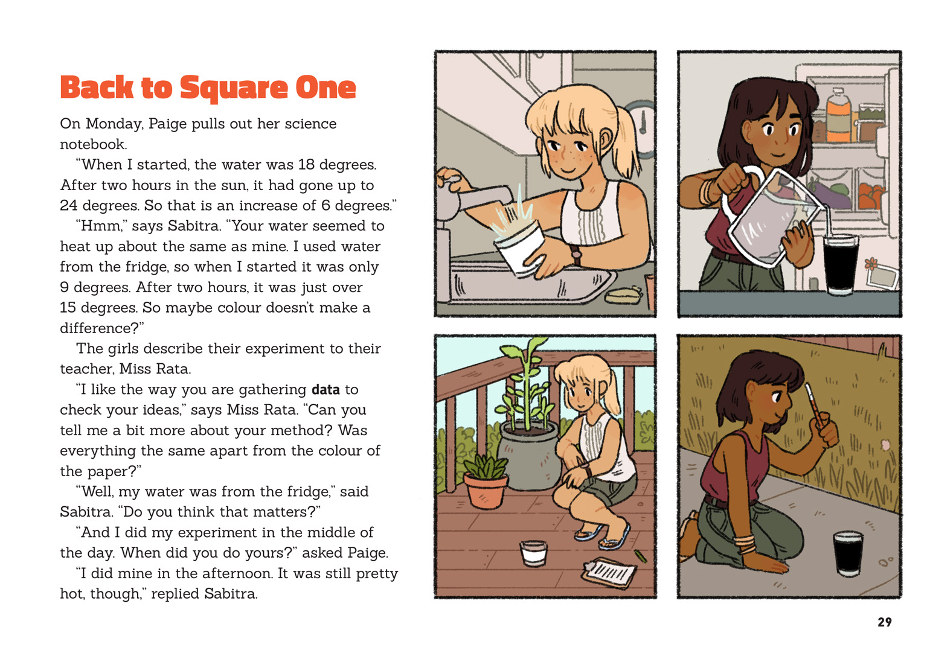 | Scientists design their investigations to ensure the data they gather is reliable.  Scientists ask questions to evaluate the trustworthiness of data.  Students make observations and discuss their investigation.
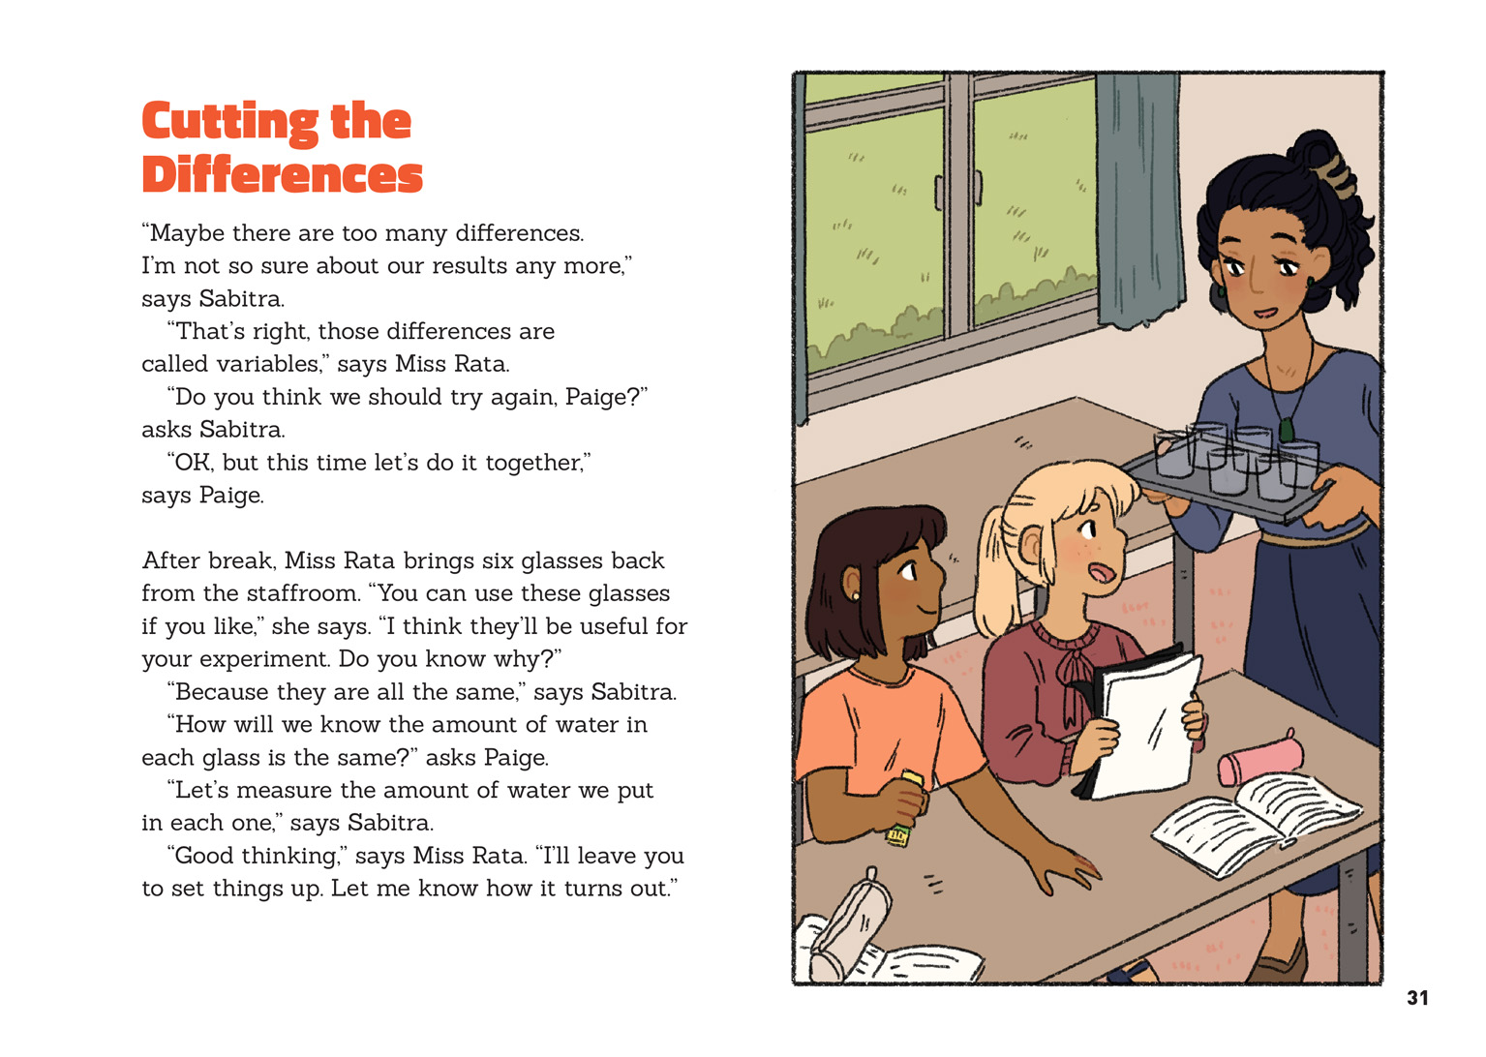 | Replicating the experiment makes us more confident the data is reliable.  Scientists evaluate the trustworthiness of data.  Scientists replicate an investigation keeping all variables the same.  Scientists carry our more than one investigation to gather data.

Learning activities
The following activities and suggestions are designed as a guide for supporting students to explore and develop understandings about the science capability “Critique evidence”. Some activities focus directly on the science capability. Other activities extend student content knowledge across the learning areas. You are encouraged to adapt these activities to support your students’ learning needs.

EXPLORING THE SCIENCE

Activity 1: Working with water
The article finishes with a suggestion that the reader carries out the water experiment. Have the students do so, but first have them write a procedure for the investigation, including their hypothesis, the equipment they will use, and their method. Before they conduct their investigations, have a partner critique their procedures and think about how they will make sure that they keep all the variables but one the same.
Are you sure that all your measurements are going to be accurate?
How many times do you think you would need to repeat the procedure to be sure of your results?
Afterwards, the students should write an explanation of their results. EXPLAIN that when writing a procedure, we use imperative verbs and that in an explanation, we need to use the language of cause and effect. MODEL how to do this.
Instead of "They wrap three glasses", we start the sentences in a procedure with a verb: "Wrap three glasses".
In an explanation, we need to say what happened, why we think it happened, and the evidence that supports our claim.
Following their investigations, have the students share their results and critique their evidence.
Were you surprised by any of your results?
Did you include all your results in your presentation?
Prompt them to think about any questions they have and encourage them to design their own further investigations. The students might explore:
what happens if they do not wrap the glasses
what happens if they just place the glasses on the paper rather than wrapping them
what happens if they place the glasses on different-coloured papers
what happens if they vary the amounts of water
the rate of temperature change.
Students could work in groups to write up their procedures, conduct their investigations, and record their explanations, following the same process they did before. As they do so, provide opportunities for the students to check each other’s designs, focusing on the control of variables.
Extension
The students could write up their investigations as if they were reports being presented for a scientific journal. Explain to the students that they should write as if their article will be reviewed by experts who are used to asking critical questions about their own and other people's experiments. The students will need to show that they have considered all the factors that might have affected their results and have drawn valid conclusions. They will need to set their reports out correctly, with headings for the hypothesis, method, results, and conclusion.

Activity 2: Exploring heat and insulation
Use "Heat It Up" as a catalyst for inquiring into temperature, heat, and insulation. Connected 1, 2010, Staying Warm Keeping Cool focuses on these concepts, with the teacher support materials suggesting a wide variety of potential follow-up activities. You can also explore these concepts using the following Building Science Concepts books: 14 – Making Porridge: Conducting Heat and Cooking Food, 36 – Heat on the Move: Transferring Heat through Temperature Difference, 46 – Keeping Warm: Getting Heat Energy and Keeping It, and 47 – Insulation: Keeping Heat Energy In. The section on heat in Making Better Sense of the Physical World has subsections on the movement of heat (through radiation, conduction, and convection) and insulation.
"Science Fair Project Ideas" (www.real-world-physics-problems.com/science-fair-project-ideas.html) sets out a variety of experiments, with supporting photographs. They are quite advanced so would be best carried out as a class. The procedures are already outlined; you would need to discuss with the students the best methods for collecting, organising, presenting, and interpreting the data.
Extension
Re-read "Heat It Up" and have the students consider the different ways the author communicated scientific information. Use this to generate a list of possible presentation techniques that could be used to communicate scientific information, such as:
narrative style with direct speech
a comic strip with captions
labelled and captioned diagrams
a graphic organiser showing the steps of the investigation
a formal scientific report
a written procedure.
Have the students select one of the experiments they carried out for this inquiry and focus their attention on how they can effectively communicate what they learned to an audience. Together with the students, decide upon a method for communication and construct a rubric for evaluating its effectiveness. The students should work independently on this task and then use their rubrics to self- and peer-evaluate their work.

RESOURCE LINKS

Building Science Concepts
Book 14 – Making Porridge: Conducting Heat and Cooking Food
Book 36 – Heat on the Move: Transferring Heat through Temperature Difference
Book 46 – Keeping Warm: Getting Heat Energy and Keeping It

Other Resources
Staying Warm Keeping Cool. Connected 1, 2010 and TSM
“Heat” Making Better Sense of the Physical World, pp. 55–64
“Science Fair Project Ideas” www.real-world-physics-problems.com/science-fair-project-ideas.html
“Why [Does] Black Color Paper Get Warm and White Color Paper Get Cool When Expose[d] to Sun?” http://scienceline.ucsb.edu/getkey.php?key=3790

link to technology
The following activities and suggestions are designed as a guide for supporting students to explore and develop understandings about technological modelling and technological products.

Activity 1: Solar ovens
Have the students design solar ovens after looking at potential designs on the Internet. They could build their ovens in teams of three or four, who could then compete to test the efficiency of their ovens.
The students could examine possible materials for their ovens and investigate and record the properties of these materials. For example, they could consider:
whether or not to use the plastic wrap
whether the shiny side of the tin foil should face in or out
whether to use newspaper or another material to insulate the box.
The students could also investigate other attributes of a solar oven, for example:
the size of the hole cut in the lid
the angle of the lid.
The Science Learning Hub has a full unit plan called “Harnessing the Sun” (http://sciencelearn.org.nz/Science-Stories/Harnessing-the-Sun), which includes a student activity for making a solar oven and a case study that describes how a teacher adapted the original resource for use with her students. The case study provides insights into the usefulness of the solar oven as an object that the students can use to contextualise their learning about scientific and technological concepts. It describes how the teacher and students brought the learning together in a final “performance” for an audience of peers. The production itself was an opportunity for the students to extend and apply their technological skills.
The Resource Links section includes other descriptions of how to create a solar oven, some of which have video demonstrations.
“Cooking Cookies with Solar Power” (www.pbslearningmedia.org/resource/phy03.sci.phys.mfe.zsolar/cooking-cookies-with-solar-power/) would be the easiest for students to follow. However, the best approach may be to scaffold the students through a first attempt before they experiment with materials and the attributes of the ovens to develop and produce their own designs for the competition.
Extension
The students could complete this work with a dramatic performance for another class.
What have we learned that we want to tell the other class about?
What are some ways we could communicate this information?
What are some ways technology is used in a dramatic production?
How could we use digital technology in our performance?

Activity 2: Get cooking
The students could explore traditional methods of cooking from different cultures. Link this to Activity 2 in the Exploring the Science section so they extend their understandings about heat and insulation.
Include community experts in the planning for this activity and in its implementation. The suggestions below focus on the construction of a hāngī or umu, but you could draw on the range of community resources to help the students understand the different kinds of technology used to cook food in different cultures.
What are some features these different cooking methods have in common?
What are the differences, and what are the reasons for those differences?
What are some cultural beliefs about food preparation? What are the reasons for them?
“Wicked – Hangi” (http://wicked.org.nz/Interactives/Maori-themed-interactives-in-English/Hangi) is an interactive bilingual resource that you could use to show students how to make a hāngī and introduce them to the science of the hāngī process.
Follow this with an opportunity for students to make an actual hāngī or an umu. If you do this, you could adapt the NZ Maths unit “Hanging out for Hāngi” (http://nzmaths.co.nz/resource/hanging-out-h-ngi) to learn how they can collect and analyse data to make an informed decision about the food to provide. In that case, the data is collected for the school, but you may prefer to make this an activity for your class or syndicate and the students' whānau. Give this an authentic purpose, for example, as part of a celebration and sharing of the students' learning.
“Guidelines for a Successful Hangi or Umu” (http://resources.ccc.govt.nz/files/GuidelinesForASuccessfulHangiOrUmu-healthsafety.pdf) sets out basic safety rules. Create a chart with the guidelines listed on the left-hand side. Discuss and record the reasons for each guideline down the right-hand side.

Guidelines for a Successful Hāngī or Umu
Guideline | Reason

The students will need to predict how long it will take their food to cook and use this to plan a timetable for the day.
As the students work, have them take photos or video recordings of each step. Afterwards, have them write an explanation of what they did and why. This should be accompanied by an evaluation of how well they carried out the technological and cultural processes required to cook their food. Alternatively, they could create a narrative to accompany their video recordings and edit this to create a short film. This could then be placed in the library or on the School Intranet to become a resource for others in the school.

RESOURCE LINKS

Science Learning Hub
“Making a solar oven” http://sciencelearn.org.nz/Science-Stories/Harnessing-the-Sun/Making-a-solar-oven
“Making and using an artefact” http://sciencelearn.org.nz/Teacher-Ideas/Education-Research/Making-and-using-an-artefact
“Performing science” http://sciencelearn.org.nz/Teacher-Ideas/Education-Research/Performing-science
“Students reflect on learning science” http://sciencelearn.org.nz/Teacher-Ideas/Education-Research/Students-reflect-on-learning-science

Other resources: Solar oven
“Build a Solar Oven” www.hometrainingtools.com/a/build-a-solar-oven-project
“Cooking Cookies with Solar Power” www.pbslearningmedia.org/resource/phy03.sci.phys.mfe.zsolar/cooking-cookies-with-solar-power/
“How to Turn a Pizza Box into a Solar Oven” www.howcast.com/videos/155609-how-to-turn-a-pizza-box-into-a-solar-oven/%20
“The Joy of Cooking with a Solar Oven” hwww.permaculturecairns.com/solaroven.html%20
“Mission to Jupiter”. Connected 3, 2009 (the TSM includes an activity on how to build a solar power oven)
"Schoolgen – Warming It up Using Solar Energy" www.schoolgen.co.nz/pdf/SE_L1-2_TA_Warming.it.up.pdf
"Schoolgen – What's Cooking with Solar?" www.schoolgen.co.nz/pdf/SE_L3-4_TA_Whats.cooking.with.solar.pdf

Other resources: Hāngī
“Guidelines for a Successful Hangi or Umu” http://resources.ccc.govt.nz/files/GuidelinesForASuccessfulHangiOrUmu-healthsafety.pdf
“Hanging out for Hāngi” http://nzmaths.co.nz/resource/hanging-out-h-ngi
“How to Put Down a Hangi” http://www.wikihow.com/Put-Down-a-Hangi
“Wicked – Hāngī” http://wicked.org.nz/Interactives/Maori-themed-interactives-in-English/Hangi

EXPLORING THE mathematics and statistics
The following activities and suggestions are designed as a guide for supporting students to develop capabilities relating to gathering and interpreting data, statistical thinking, and problem solving. You are encouraged to adapt the activities to suit the specific needs of your students.

Activity 1: Using measurement within science and technology
Whether the students are exploring the use of solar energy to heat water or make a solar oven or they are constructing a hāngī or umu, there are opportunities for them to develop their measurement skills. Depending upon their activity, students may need to measure, for example:
the size of the hole cut in the pizza box
the amount of water
the temperature of the water
the time it takes for the water or the oven to heat
the depth of the hole.
Students will also use mathematics to compare their results as they make variations to features of their designs. This will be particularly fun if they are engaging in a competition. Draw out the importance of making accurate measurements and ordering and recording the data in such a way that they can make comparisons and draw valid conclusions.
What are the measurements we need to make?
What devices (for example, rulers, thermometers) will we use to make our measurements?
What do the marks on the device we choose represent?
How can we record our data? (A table? A graph?) What is the information we want to be able to show?
How will we sort the data? What types of tables or graphs will clearly display the information we collect?
How can we show the patterns in our data?
How can we present the results of our investigation to the class?

Activity 2: Measuring temperature
Discuss the role of accurate measurement in ensuring the reliability of Paige and Sabitra's experiment. If the students have conducted their own experiments involving the measurement of temperature, they can also connect to that experience.
Staying Warm Keeping Cool, Connected 1, 2010, focuses on temperature and insulation. The teacher support materials for that issue include a set of activities to help students explore the mathematics of measurement and statistics in relation to these concepts.
You might begin with a reading of “Heat Thieves”, which shows the students how to interpret a wind-chill table to calculate wind-chill temperature. The table could be used to look at the pattern in temperature change with increases and decreases in temperature and speed.
There are various wind-chill tables and calculators available on the Internet. Students might enjoy an activity where they use a speedometer on a bike to measure speed and a barometer to measure air temperature. They can then use one of the calculators to find out the wind chill they experience when riding at different speeds and temperatures. This would also provide a good opportunity for exploring the difference between Celsius and Fahrenheit and miles and kilometres.
The article demonstrates the practical application of this information for motorbike riders.
What are some other situations where it would be useful to know the wind-chill factor?
How might knowing this information help people designing products for different activities?

RESOURCE LINKS

“Hanging out for Hāngi” http://nzmaths.co.nz/resource/hanging-out-h-ngi
“Online Conversion – Wind Chill” www.onlineconversion.com/windchill.htm
Staying Warm Keeping Cool. Connected 1, 2010
“Windchill Tables” https://www.eol.ucar.edu/homes/rilling/wc_table.html
Google Slides version of “Heat It Up” www.connected.tki.org.nz

