CONNECTED, LEVEL 2 2015, Have You Checked?  Learning from the Tangata Whenua:  An Interview with James Ataria  by Susan Paris  Overview  This article introduces students to the work of James Ataria, an environmental scientist who investigates the impact of toxic chemicals on the natural world. Through a series of interview questions, the article reveals how aspects of James’s identity as Māori and as a scientist contribute to the way he does research. The article provides an opportunity for students to understand how scientific, cultural, and local knowledge can all contribute to addressing pollution, one of the significant problems confronting the world today.  A Google Slides version of this article is available at www.connected.tki.org.nz. |  |  | 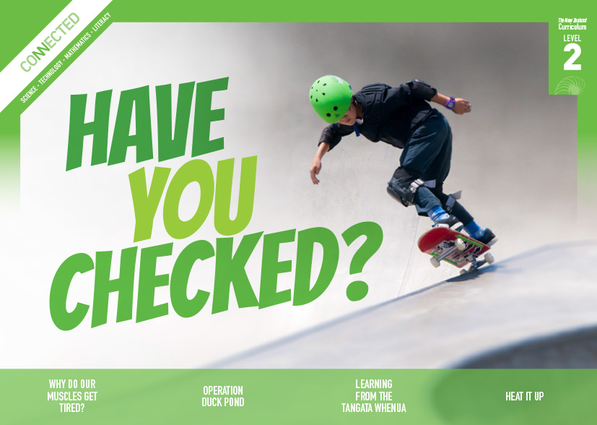  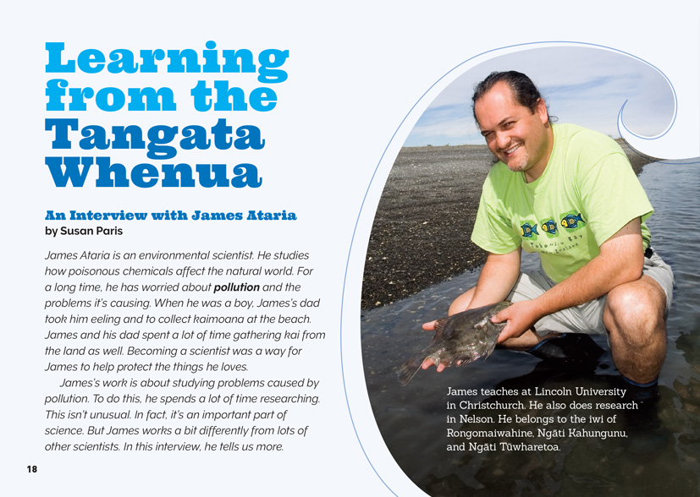
Science capability: Critique evidence |  | Text characteristics

Science knowledge is based on data derived from direct or indirect observations of the natural physical world. An inference is a conclusion drawn from those observations; it is the meaning you make from the observations. Understanding the difference between an observation and an inference is an important step towards being scientifically literate.  Being ready, willing, and able to critique evidence is also an important step towards being scientifically literate. Students must be able to assess the quality and reliability of both the observations (data) and the inferences made from those observations. In order to know what sorts of questions to ask to evaluate the trustworthiness of data, students need both methodological knowledge (how data is generated and collected) and statistical knowledge (how data is collated and analysed).  For more information about the “Critique evidence” science capability, go to http://scienceonline.tki.org.nz/Introducing-five-science-capabilities/Critique-evidence |  | - Abstract ideas accompanied by concrete examples in the text that help support students' understanding.  - The form of the text as an interview with brief questions and extended answers.  - An introduction, photographs, captions, and a glossary that clarify the text and require some interpretation.  - Scientific and technological vocabulary and words in te reo Māori that may be unfamiliar to some students.

Curriculum context

SCIENCE
NATURE OF SCIENCE: Understanding about science  Achievement objective  L2: Students will appreciate that scientists ask questions about our world that lead to investigations and that open-mindedness is important because there may be more than one explanation. |  | PLANET EARTH AND BEYOND: Interacting systems  Achievement objective  L2: Students will describe how natural features are changed and resources affected by natural events and human actions. |  | Key Nature of Science ideas  Scientists:  - evaluate the trustworthiness of data by asking questions about investigations carried out by others  - undertake more than one trial to provide sufficient evidence to support a theory  - replicate investigations to critique the evidence or data provided by other scientists  - check that there are enough samples to reliably establish a conclusion or theory  - look carefully at the way data has been collected when they consider investigations done by others.  Key science ideas  - The quality of water affects all animal and plant life.  - Water quality can be investigated by analysing the chemicals in it.

ENGLISH

READING  Ideas  Students will show some understanding of ideas within, across, and beyond texts. |  | INDICATORS  - Uses their personal experience and world and literacy knowledge to make meaning from texts.  - Makes meaning of increasingly complex texts by identifying main ideas.  - Makes and supports inferences from texts with some independence. |  | THE LITERACY LEARNING PROGRESSIONS  The literacy knowledge and skills that students need to draw on by the end of year 4 are described in The Literacy Learning Progressions.

Critiquing evidence

The science capability “Critique evidence” is about students evaluating the quality of the data supporting a scientific claim or idea (http://scienceonline.tki.org.nz/Introducing-five-science-capabilities/Critique-evidence).
Scientists use empirical evidence to develop theories about how the world works.
- Empirical evidence is data gathered from observations, experiments, and investigations.
- Scientific claims are only as dependable as the evidence on which they are based.
- Scientists design their investigations carefully to ensure that the data they gather is both reliable and valid. Valid data is data that measures what it is supposed to measure – it answers the research question. Reliable data is dependable and consistent. Replicating the experiment and getting the same results makes us more confident the data is reliable.
- To gather high-quality evidence that is reliable and valid, scientists measure accurately, keep conditions the same or control variables that might influence measurements or observations, repeat tests or investigations many times, investigate multiple examples, and/or use statistical sampling techniques to make their observations or data as representative and accurate as they can.
Students should be critiquing and evaluating the quality of data gathered from their own investigations. They should be:
- engaging in a range of investigation types, exploring, comparing, classifying, identifying, seeking patterns, using models, making things to test ideas, and investigating systems so that they learn different ways to gather different types of data
- identifying ways to make the data they collect in their own investigations as accurate and reliable as possible
- suggesting and developing ways to control conditions or variables or keep things fair, repeating observations or measurements or tests, and developing appropriate sampling methods
- applying their developing understanding of statistics and probability when making decisions about sample size and repetitions and when working with their data.
Students should also be encouraged to look for, consider, and critique methods and data underpinning scientific claims made by others. This includes critically examining the appropriateness of methods and the quality of evidence used to develop scientific claims in the media and other sources.
Teachers can:
- help students to be more critical consumers of science information by being explicitly critical themselves
- support students to identify correlations as evidence of a potential relationship, but not necessarily cause and effect
- ask questions such as:
  - Would this always happen?
  - How sure are you of your measurements?
  - How many times should you repeat these tests/measurements?
  - Is this a fair result?
  - What may have influenced the data?
  - Was there a big enough sample?
  - Does the data match the claim?
  - How much variation is there in your results? Why might that be?
- support students to evaluate how data is presented; for example, if data is presented graphically, is this done appropriately or is it misleading? (This draws on another science capability, Interpret representations.)
- support students to apply their understanding of statistics and probability when considering claims, evidence, and data.
- establish a science classroom culture by:
  - modelling and encouraging a critical stance
  - encouraging students to consider the quality and interpretation of data underpinning scientific claims
  - using media headlines to introduce learning conversations and demonstrate the relevance of critiquing evidence to everyday life.
A range of questions and activities designed to get students to critique evidence is available on the Science Online website: http://scienceonline.tki.org.nz/Introducing-five-science-capabilities/Critique-evidence

Meeting the literacy challenges

The literacy demand in this text lies in following the interview question–answer format to find specific information. The tone is conversational and the elaborated answers also include additional supporting information. Students may need support to locate and evaluate information. The use of subject-specific vocabulary and te reo may be challenging for some students.
The following strategies will support students to understand, respond to, and think critically about the information and ideas in the text. You may wish to use shared or guided reading, or a mixture of both approaches, depending on the reading expertise of your students and the background knowledge they bring to the text.
After reading the text, support students to explore the activities outlined in the following pages.

TEACHER resources

Want to know more about instructional strategies? Go to:
- http://literacyonline.tki.org.nz/Literacy-Online/Teacher-needs/Reviewed-resources/Reading/Comprehension/ELP-Years-1-4
- “Engaging Learners with Texts” (Chapter 5) from Effective Literacy Practice in Years 1 to 4 (Ministry of Education, 2003).
Want to know more about what literacy skills and knowledge your students need? Go to:
- http://literacyonline.tki.org.nz/Literacy-Online/Student-needs/National-Standards-Reading-and-Writing
- http://www.literacyprogressions.tki.org.nz/
“Working with Comprehension Strategies” (Chapter 5) from Teaching Reading Comprehension (Davis, 2007) gives comprehensive guidance for explicit strategy instruction in years 4–8.
Teaching Reading Comprehension Strategies: A Practical Classroom Guide (Cameron, 2009) provides information, resources, and tools for comprehension strategy instruction.

INSTRUCTIONAL STRATEGIES

FINDING THE MAIN IDEAS
EXPLAIN that this is quite a challenging text that includes abstract ideas about how James’s identity as Māori affects his work as a scientist and about how different kinds of knowledge can be brought together to address environmental issues. Tell the students that this text is an interview and that most of the information is found in James’s answers to the interviewer’s questions.
DISCUSS the heading. Make sure that the students understand what the term “tangata whenua” means.
- Who are the tangata whenua in our area?
- What sorts of things might a scientist want to learn from the tangata whenua?
Share-read the text on page 18. Ideally you could project this onto a Smartboard so that the text is enlarged.
Direct the students to look closely at the photograph. ASK QUESTIONS to help the students make links to their prior knowledge and predict what the text will be about:
- What might an “environmental scientist” do?
- How did James’s early life affect his decision to become a scientist?
- Why do you suppose the caption tells us the iwi James belongs to?
- What is James doing in the photo?
- How do you think James might work differently to other scientists?
Have the students SKIM the text to understand its form as an interview. PROMPT the students to notice that the information on each page answers the interviewer’s question. ASK the students to find further clues about what the text is about and what is special about the ways James works. MODEL how to navigate the text using the questions to locate key words and ideas in each section.
Construct a concept map with two columns. Have the students RECORD the things that James does as a scientist in one column. In the other column, have the students RECORD the things James does that are influenced by his Māori heritage. After the students have read James’s response to each question, have them add further detail, including the benefits of each way of working, examples of it in practice, and key differences.
As the students read, ASK QUESTIONS to help them IDENTIFY the information they need to complete the concept map.
- What is James saying about the differences between scientific knowledge and cultural or local knowledge?
- How does James expect scientists on his team to work with local Māori hapū and iwi? How does this benefit the research?
- What do the photos show about what James and his colleagues do to get more information?
- What does it mean to be “open-minded”? Why do scientists need to be open-minded?
- James says that “scientists think carefully about how to collect and critique evidence”. He also says that he doesn’t question local or cultural knowledge. If he doesn't ask questions about “cultural and local knowledge”, how does he know that it can be trusted?
After the reading, have the students REVIEW their concept maps and then write an explanation about why it is important for scientists to embrace and respect Māori culture and experiences relating to the area/s they are working in.

DEALING WITH UNFAMILIAR VOCABULARY
The use of te reo Māori may be a challenge to some students. If so, have them scan the text prior to the reading and IDENTIFY any words in te reo Māori that are unfamiliar to them. Point out that some of these words are defined in the Māori glossary. Encourage them to infer the meaning of any other words from the context and the photographs. You may have experts in the class who can teach their peers these words. (Be sensitive about asking students to share their expertise.) There are also many online dictionaries they could use to construct definitions that they can record and keep. RECORD these words and their meanings on the class word wall, along with any other new words. As the students engage in further activities, encourage them to use these words in their conversations and writing.
If the students are interested in the difference between hapū and iwi, they could learn about those in their local area by using Te Kāhui Māngai (Te Puni Kōkiri's Directory of Iwi and Māori Organisations, http://www.tkm.govt.nz/).
James refers to both “cultural knowledge” and “local knowledge”. These have similarities and differences but they are not stated clearly in the text. MODEL how the students can use the glossary and draw inferences to understand what “local knowledge” might mean. Then PROMPT the students make connections to their own locality. Prepare for this with some examples of your own.
- James talks about “cultural knowledge” and “local knowledge”. These seem to be very similar but not quite the same. The glossary tells me that “cultural knowledge” means “things that people understand or know from their background”. I think that “local knowledge” must mean “things that people understand or know from living in their locality or place”. James gives examples of cultural knowledge. He talks about knowing when it is best to catch certain kinds of fish and the best ways to catch them. I know that Māori people have lived in New Zealand for a long time. I think that Māori have so much knowledge of this place that it is part of their cultural knowledge. Non-Māori who have lived in the same place for a long time also have local knowledge but it hasn't had so long to develop.
- Can you think of examples of the local knowledge people who live here have about our environment? Do you know of any examples of the cultural knowledge held by local Māori?
PROMPT discussion on the meaning of the term “open mind”.
- What does it mean to have an “open mind”?
- James says that “it is always good to have an open mind, especially when you’re a scientist”. Why is this especially important for a scientist?
- What are some other situations where it is good to have an open mind? Can you share some examples?

RESPONDING TO THE TEXT
If the students invite kaumātua and other community experts to speak about a local environmental issue (as in Science Activity 2), they could use their prepared questions and their notes to write up the interview, using the same format as this text does. They could illustrate the interview with photographs and sketches from their investigations, and they could publish it for others to read. They might follow this up with a letter to the editor of the local paper, expressing their own opinions and sharing findings from their own investigations.

Key science ideas
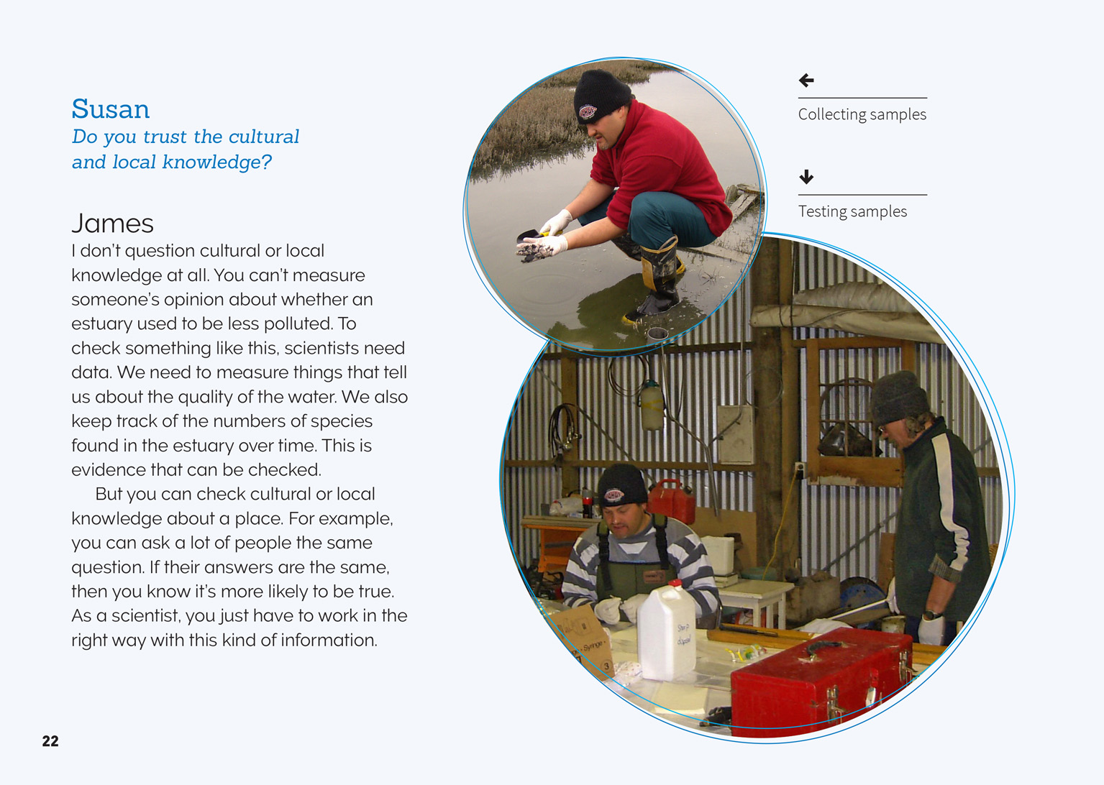 | Scientists look carefully at the way data is being collected.  Scientists evaluate the trustworthiness of data from investigations carried out by others.  Scientists ask questions and identify ways to make the data they collect as accurate and reliable as possible.  Scientists look carefully at the way data is being collected.

Learning activities
The following activities and suggestions are designed as a guide for supporting students to explore and develop understandings about the science capability “Critique evidence”. Some activities focus directly on the science capability. Other activities extend student content knowledge across the learning areas. You are encouraged to adapt these activities to support your students’ learning needs.

exploring the science

Activity 1: Working together to solve problems
This activity focuses on the idea that the world today faces some complex and significant problems that cannot be solved without the collaborative expertise of a range of stakeholders. Examples include climate change and the obesity epidemic. Many people call these "wicked problems". You may or may not want to use this term with your students but, if the term is new to you, you may like to read Rachel Bolstad's (May 2011) article "Taking a 'future focus' in education-what does it mean?" (http://www.nzcer.org.nz/research/publications/taking-future-focus-education-what-does-it-mean).
Explain to the students that this activity focuses on the idea that in the world today, we face some very complex problems that have no obvious solutions. Many of these problems are national and even international problems, but we can see the effects - and help find solutions - in our local community. This means that the process of finding a solution needs to include the knowledge and perspectives of a range of people - like scientists, engineers, and policy makers but also members of the community like us. The environmental problems James Ataria tries to address are examples of problems like these. He brings his scientific knowledge to the problem, but he also gets local people involved and brings in their local and cultural knowledge.
Encourage the students to suggest other examples of big problems that we need lots of people to help solve.
What sorts of problems can you think of that the world is facing?
How do those problems affect us here where we live?
What other effects do these problems have?
Who do you think should be involved in solving them?
Many of the items in Connected and in the School Journal address wicked problems (refer to the resource list below). Ask the students if they can recall any examples. Select three items and have the students read them to elicit the information they need to complete the following table. You could take a jigsaw approach, supporting different groups to read and find the information they need. Each group could then present their responses to the class as a whole.
 | Learning from the Tangata Whenua (L2, 2015) | [Text title] | [Text title]
What was the problem?
How was it addressed?
Whose knowledge was used? Was this local, cultural, or scientific knowledge? How did it help?
Could the findings be trusted? Why or why not?
How successfully was the problem addressed? How do we know? (Students may have to do further research on the Internet.)
Following the presentations, discuss what the students have learned about the environmental problems confronting the world and the way different people can contribute different kinds of knowledge to addressing them. Have them write a summary statement in their science notebooks.

Activity 2: Learning from ‘Mātauranga Māori’
Discuss the fact that James Ataria’s work involves studying how toxins, introduced by human beings, affect the natural world. Consider using activities from the Building Science Concepts book 52 – The Land Changes: Keeping Earth’s Systems in Balance to Sustain Life to further explore the idea that human activity can have an impact on the land in ways we may not expect.
The students could inquire into an example of human activity having a negative impact on their local environment. The focus might be on erosion, water quality, or the loss of flora and fauna. The students should examine how different kinds of knowledge – scientific, local, and cultural – can help address the problem.
The students could invite kaumātua from local iwi to share their local and cultural knowledge about natural features in their locality and the changes they have observed. (The school may already have a relationship with local kaumātua that could be built on with this activity.) The students should find out (from the school or local hapū/iwi) the most appropriate way to welcome their guests. They should have already done some background research and be prepared with questions to generate discussion. Encourage them to prepare questions that will prompt discussion on how to address the problem and not just on the problem’s causes and effects. The students could also invite others with local knowledge of the issue to add to their understanding and they could search relevant historical records, such as photographs or sketches. Have them use a graphic organiser to collate their information as they go. This might be located on a shared platform, such as Google Docs.
The problem [statement]
Information source | Cause | Effect | Potential solutions
The students could visit the affected site to make their own observations. Have them sketch or photograph what they see. They could then use what they have learned to create a map or diagram that is labelled to show the impact of human activity over time.
Revisit the graphic organiser and review the information that the students have collated, adding anything that they can from their site visit. Prompt the students to evaluate the potential solutions. Have each student make a brief oral presentation, explaining what they think would be the best course of action.
Have the students consider how they could integrate their map and diagram into a resource that will raise community awareness of the need to take action to combat the problem and of potential ways of doing so. They might communicate their message through a Wiki or blog. Students may also want to take more direct action by working with local iwi or other community organisations on conservation and restoration projects.
Provide an opportunity for the students to reflect on how cultural, scientific, and local knowledge have combined to give them a better understanding of the causes of a local environmental issue and how to address it. Give them time for group discussion, followed by time to record their personal thoughts in their science notebooks.
Extension
“Mātauranga Māori” is not simply “Māori knowledge”; it is the knowledge base from te Ao Māori. Defining it simply as Māori knowledge implies that it is knowledge that any Māori person has – it is not. It is knowledge that has been formulated, researched, analysed, and debated over centuries. The resource links below provide opportunities for students to learn more about the use and value of mātauranga in scientific investigations:
The links to Ngā Pae o te Māramatanga provide an opportunity to learn more about James' work.
In “Close Encounters”, marine mammal expert Ramari Stewart describes how she blends Western scientific and traditional Māori perspectives and practices as she studies Campbell Island’s sea lions and southern right whales.
"Rongoā Māori" looks at the use of traditional medical knowledge.
“The Harakeke Project at Industrial Research” examines the use of harakeke.
“He Maramataka Māori / Māori lunar calendar” provides an opportunity to see the Māori Fishing Calendar.
“Iwi and Kaimoana” looks at the impact of the Rena grounding from the perspective of local iwi.
“Toku-Awa-Koiora” describes how Māori are working together with scientists to protect the health of the Waikato river.
“Navigating without Instruments” looks at how Māori used the stars to investigate.
“Māori Soil Science” describes how Māori used soil science to improve kumara crops.
“Mātaitai – Shellfish Gathering” could be explored for what it says about traditional shellfish gathering and the reasons for cultural rules.

RESOURCE LINKS

Building Science Concepts
Book 1 – Waterways: How Rivers and Streams Work
Book 21 – Life between the Tides: Sandy Shores, Mudflats, and Rocky Shores
Book 52 – The Land Changes: Keeping Earth’s Systems in Balance to Sustain Life

Connected
“After the Spill”. Connected 4, 2013, pp. 2–9.
“Close Encounters”. Connected 3, 2004, pp.2–9.
“Counting Kākahi”. Connected 3, 2014, pp.8–13.
“Giving the Ocean a Voice”. Connected 3, 2013, pp.14–19.

Ngā Pae o te Māramatanga
“Dr James Ataria” www.maramatanga.ac.nz/person/dr-james-ataria
“Dr James Ataria: Producing a better environment by matching science and tangata whenua knowledge” www.maramatanga.co.nz/project/dr-james-ataria-producing-better-environment-matching-science-and-tangata-whenua-knowledge

School Journal
“Estuary Health Check”. School Journal, 2008, Part 4 No. 3, pp. 28–32.
“Tiakina a Tangaroa – Protect Our Seas”. School Journal, Level 2 Oct, 2011, pp. 2–11 (with TSM and audio).
“Up the Pipe”. School Journal, Level 3 Nov, 2014, pp. 24–33.

Science Learning Hub
“Iwi and Kaimoana” http://sciencelearn.org.nz/Science-Stories/Where-Land-Meets-Sea/Iwi-and-kaimoana
“Māori Soil Science” http://sciencelearn.org.nz/Science-Stories/Soil-Dig-It/Maori-soil-science
“Navigating without Instruments” http://sciencelearn.org.nz/Science-Stories/Navigating-Without-Instruments
“Rongoā Māori” http://sciencelearn.org.nz/Contexts/Fighting-Infection/Looking-Closer/Rongoa-Maori
“Tōku Awa Koiora” http://sciencelearn.org.nz/Contexts/Toku-Awa-Koiora (Protecting the health of the Waikato river)

Other resources
Bolstad, R. (May 2011). “Taking a ‘future focus’ in education—what does it mean?” An NZCER working paper from the Future-Focused Issues in Education (FFI) project. Wellington: NZCER. http://www.nzcer.org.nz/research/publications/taking-future-focus-education-what-does-it-mean
“He Maramataka Māori / Māori lunar calendar” from Te Taura Whiri i te Reo Māori/The Māori Language Commission. http://www.tetaurawhiri.govt.nz/assets/LanguageResources/MatarikiBooklet.pdf
“Mātaitai – Shellfish Gathering” from Te Ara. http://www.teara.govt.nz/en/mataitai-shellfish-gathering (more about traditional shellfish gathering)
“Te Kāhui Māngai (Directory of Iwi and Māori Organisations)” from Te Puni Kōkiri. www.tkm.govt.nz/
“The Harakeke Project at Industrial Research” from the Biotechnology Learning Hub. http://biotechlearn.org.nz/themes/biotech_and_taonga/the_harakeke_project_at_industrial_research

Google Slides version of “Learning from the Tangata Whenua: An interview with James Ataria” www.connected.tki.org.nz

