Predicting content (B) - Set 2

Waterfalls

Key words: landform, Victoria Falls, Niagara Falls, Angel Falls, Iguazu
Waterfall, eroding, erode

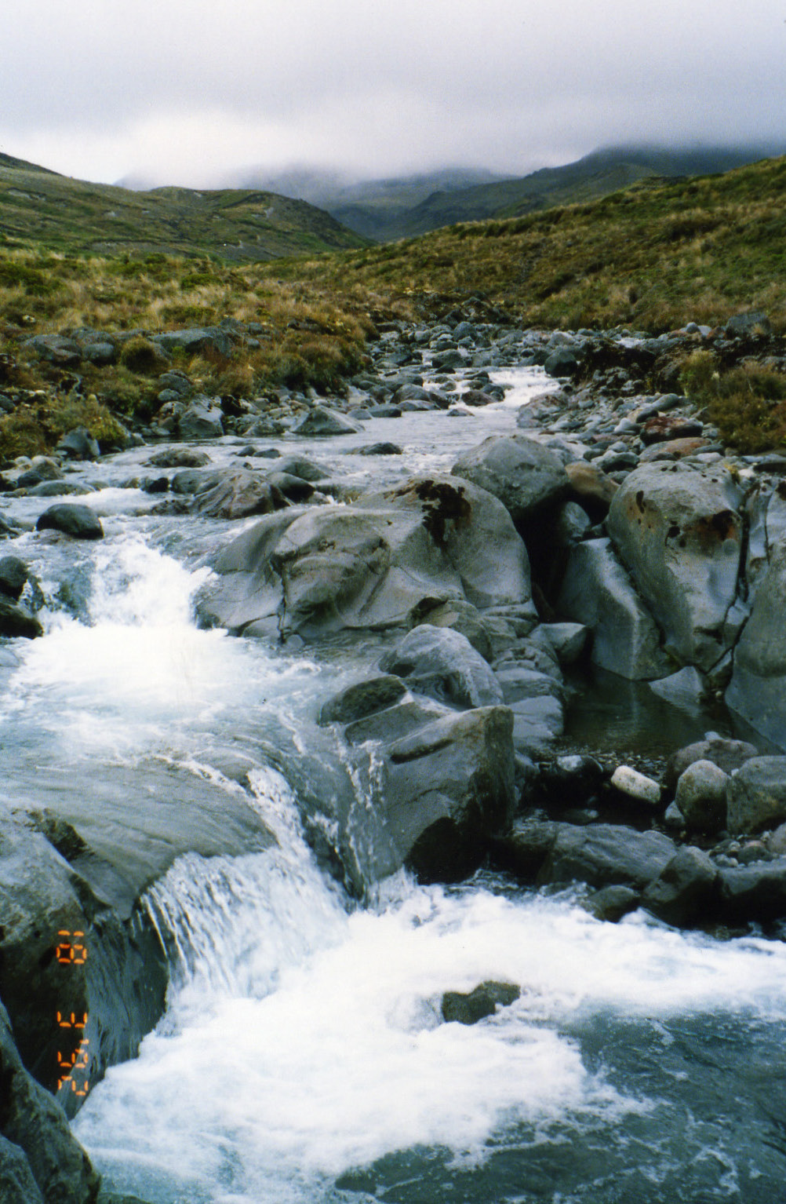
A waterfall in the Tongariro National Park showing a change in the height of the land.
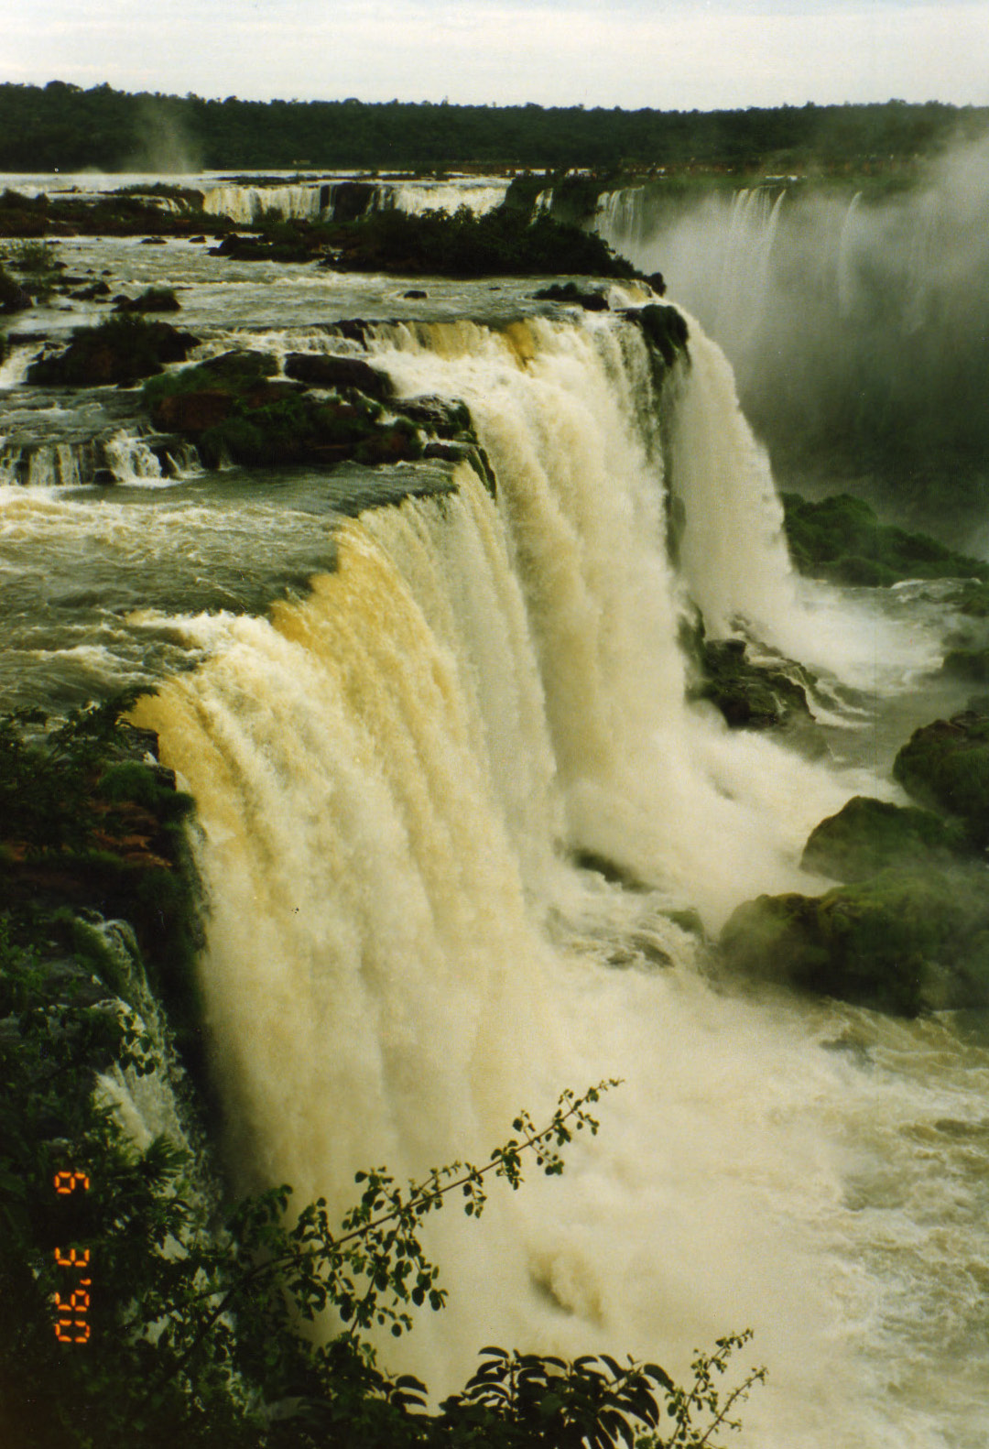
The Iguasu Waterfall on the border of Brazil, Paraguay and Argentina is one of the world’s largest waterfalls.

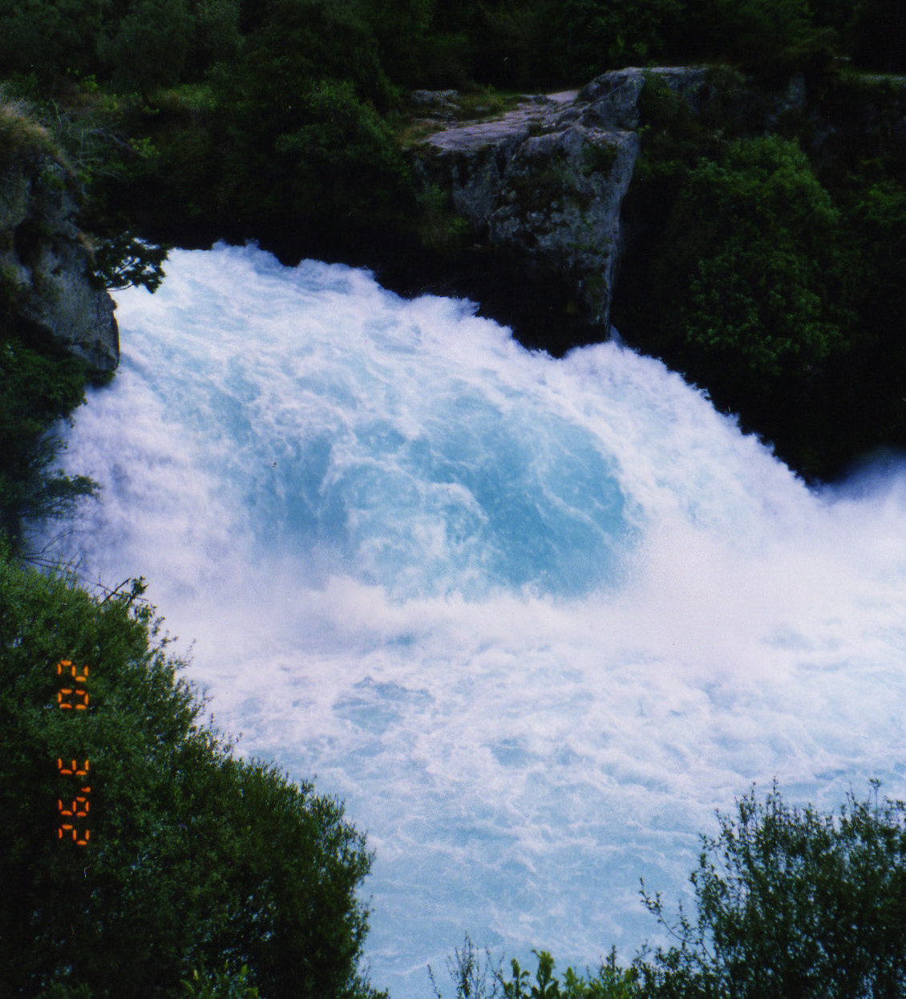
A cataract waterfall in New Zealand, Aratia Falls.

