Teacher Sheet: Formative assessment

Glaciers

Formative assessment

Unit standard 2986, Level 2, version 6
Begin to read independently texts to gain knowledge (ESOL)
This task relates to unit standard 2986 which has one element. This is a formative task and should not be used for summative assessment.
Conditions
- Student responses may be oral or written.
- Written responses need not be grammatically correct, but errors must not interfere with meaning.
- Assistance may be given to understand the requirements of the task.
- A bilingual and/or an English dictionary may be used.

Learning contexts
The English Language Intensive Programme (ELIP) Stage 2, has suggested teaching components, strategies, language features and sample texts on information report genre: ‘Kangaroos’ (11c) and ‘Antarctica’ (11d).

Notes for teachers

A teaching and learning sequence is available for this assessment at http://esolonline.tki.org.nz/ESOL-Online/What-do-I-need-to-know-and-do/Teaching-and-learning-sequences/Written-language-Reading-an-information-report-US2986. This sequence ensures that learners have become familiar with:
- the topic through a range of listening, speaking, reading and writing activities;
- the context and vocabulary;
- the question types used in the assessment.

The same assessment conditions for the summative assessment should be used for the formative assessment in order to familiarise students with the summative assessment process. For this reason:
- it is important to be aware of the special notes in the standard;
- students should not have seen the text before the assessment activity;
- it must be remembered that Question 1 is a prediction exercise that must be completed before the students see the text.

In order to maximize the learning potential of this activity the self-check at the end of the activity should be completed and used to inform further teaching and learning prior to summative assessment.

Student Sheet: Formative task

Formative task
Assessment for unit standard 2986, Level 2, version 6
Begin to read independently texts to gain knowledge (ESOL)
Element 1: Formative task: Glaciers

Name: ___________________________________________

Date: ____________________________________________

- Do this activity in class.
- You may ask the teacher to explain the instructions.
- You may use a bilingual or English dictionary but not an electronic translator.
- Your spelling and grammar do not need to be perfect but your teacher needs to be able to understand what you mean.

Student checklist

In this assessment task you will need to show that you can do the following.

Identify the topic of the text and predict the content of the text from key words, layout, illustrations and diagrams. | 1.1
Identify the main point(s) and supporting detail in the text and show that you understand these. | 1.2
Understand important vocabulary in the text – you must show that you understand both the meaning and the grammar of the words. | 1.3

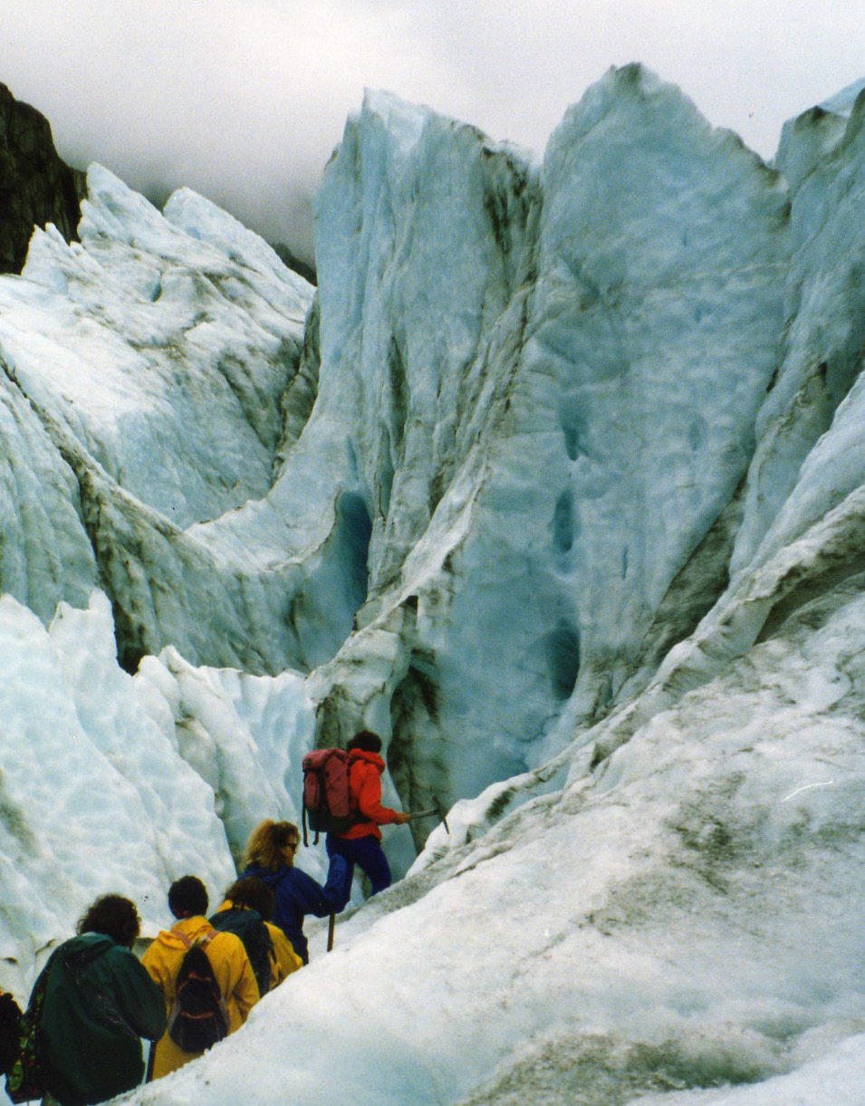
Glacier ice at the Fox Glacier
.
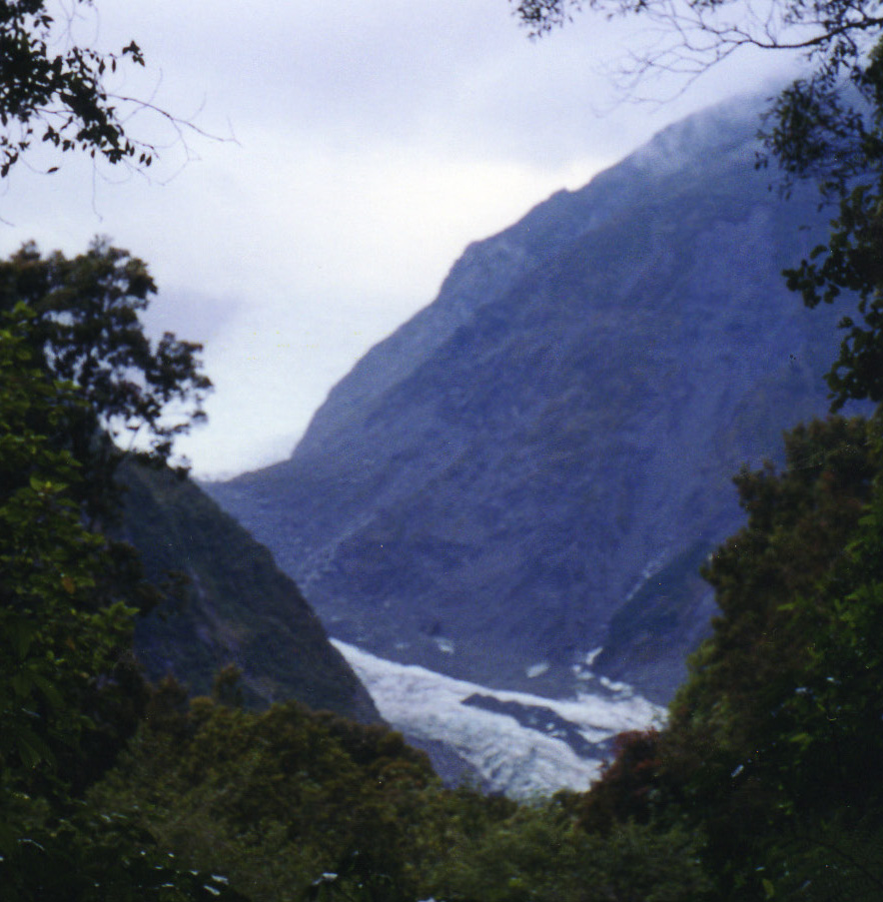

Key words
rivers of ice
granular snow, firn, glacier ice
glacier, move, erode
A u-shaped valley carved out by the Franz Joseph Glacier.
accumulation, ablation
melt, evaporate

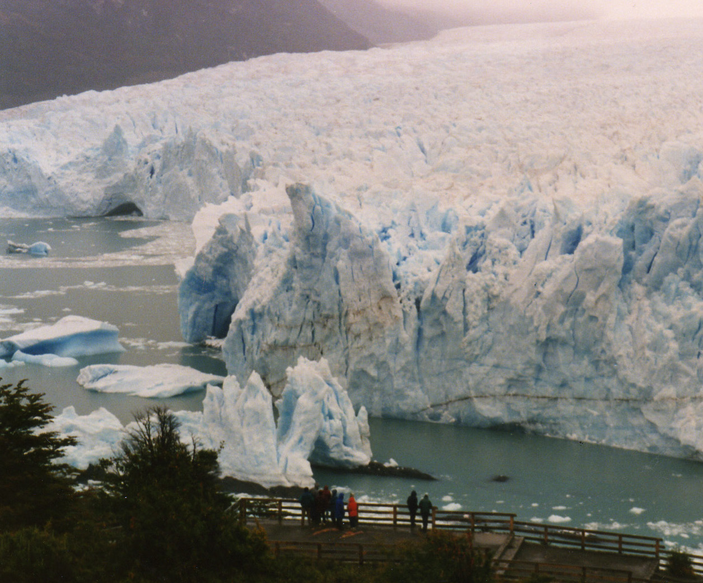
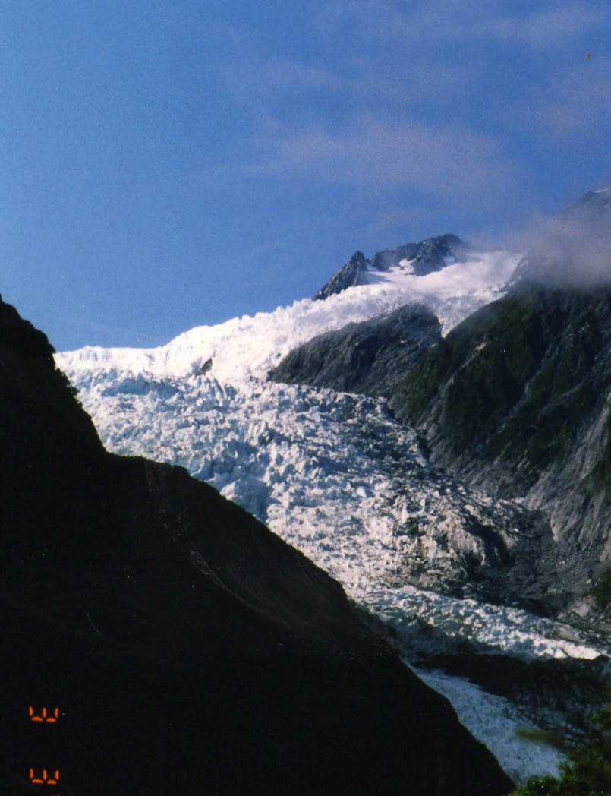
Zone of accumulation
Zone of ablation
Firn line
Perito Moreno Glacier, southern Chile, showing large pieces of ice that have fallen off the main glacier.
Franz Joseph Glacier, New Zealand.

Glossary
Granular ice – The first stage in becoming glacier ice. Snowflakes are pressed together to make smaller crystals called granular ice.
Firn – The second stage in becoming glacier ice. Granular ice is pressed into very hard small pieces of ice. Firn looks like wet sugar and is very hard.

Student sheet: Formative assessment

Assessment for unit standard 2986, Level 2, version 6
Begin to read independently texts to gain information (ESOL)

Name ……………………………………………………... Date …………………

1. Identifying the topic of the text and predicting the content (1.1).

Look at the headings, key words and illustrations in the text for questions 1a. and 1b.

1. Complete the diagram below to show what you think the article will be about.

I think this text will be about

a. _____________________________________________

and might have information about

b.

i)
ii)
iii)

When you have finished give this first page to your teacher so that you can receive the rest of the assessment.

1  2  3  4  5 | Glaciers  Glaciers are large, slow moving rivers of ice. They are made from layers of snow. Most of the world’s glaciers are found near the North and South Poles but there are glaciers on every continent in the world. Approximately 10% of the land on earth is covered by glaciers.  Glaciers begin in mountain valleys where there is lots of snow in the winter. In the mountains it is also cool in summer so the snow does not melt. When new snow arrives the next winter it presses down on the old snow. The old snow turns into granular snow, then into firn and finally into glacier ice.  Glacier ice at the Fox Glacier  Glaciers change the land around them when they move. The weight of the ice and gravity makes the glacier move, or flow. Valley glaciers flow down valleys. When they move, glaciers erode the rock underneath them. A glacier can "carve" a valley, by wearing away rock and soil. They also move debris (large pieces of rock and earth) downhill. The glacier  pushes this debris to the side of the  glacier or to the end of the glacier.  A u-shaped valley carved out by the Franz Joseph Glacier  Glaciers are always changing. At the top edge of a glacier, new ice is added. This is called accumulation. Ice is lost at the bottom edge. This is called ablation. If more ice is added than is lost the glacier grows.  Franz Joseph Glacier, New Zealand.  Zone of accumulation  Zone of ablation  Firn line  Glaciers often lose ice and get smaller. This is called retreating. Most of the world’s glaciers are retreating. Retreating glaciers lose their ice because of heat. Heat can cause to ice to melt or to evaporate. Sometimes large pieces of ice fall off into the water.  Perito Moreno Glacier, southern Chile, showing large slabs of ice that have fallen off the main glacier.  Glossary  Granular ice – The snowflakes are pressed together to make smaller crystals called granular ice.  Firn - Granular ice is pressed into very hard small pieces of ice. Firn looks like wet sugar and is very hard.  n becoming glacier ice. The snowflakes are pressed together into smaller crystals.  Firn- the second stage in becoming glacier ice. Granular ice is pressed into very hard small pieces of ice. Firn looks like wet sugar and is very hard.

Student sheet: Formative assessment

Assessment for unit standard 2986, level 2, version 6
Begin to read independently texts to gain information (ESOL)

Name ……………………………………………………... Date ………………

Formative assessment: Now read the text and answer the questions below.

2. Identify main points and supporting detail (1.2).

2a. Complete the chart on the next page. Choose from these main ideas and
supporting details. There are two extra sentences.

Choose from these main ideas and supporting details
a) Evaporation
b) How glaciers start
c) Glaciers are very important
d) There are glaciers on every continent
e) Melting
f) Finally it becomes glacier ice
g) It is cool and the snow does not melt in summer
h) Glaciers also move large pieces of rock downhill
i) Old ice is lost
j) Glaciers change

Write the main ideas and supporting details from the list on the previous page in the spaces below. Think carefully about where each one goes.

Main idea | Supporting detail
What they are and where they are found. | - They are made from snow.  - i)…………………………………………………………  ………………………………………………………….  - 10% of the world’s land is covered by glaciers.
ii) …………………………  ……………………………  ……………………………. | - New snow presses down on last year’s snow.  - First it becomes granular snow.  - Then it beomes firn.  - iii)…………………………………………………….
Glaciers change the land. | - As glaciers move they erode the rocks and make valleys.  - iv) ……………………………………………………  ……………………………………………………
v) …………………………  …………………………… | - New ice is added.  - vi) ……………………………………………………
Reasons why glacier ice is lost. | - vii)………………………………………………….  - viii)…………………………………………………

3. Understanding is demonstrated of essential vocabulary in the text (1.3).

3a. Meaning - Match the words with their meaning in this text. Choose from the list of words in the box. Be careful that you choose the meaning in this text as some words have more than one meaning.

Words

retreating  a mountain  a continent | accumulation  the surface  to flow | a valley  to melt  to erode | snow  to evaporate  a layer

Word | Meanings
i | to change from a solid to a liquid because of heat
ii | moving backwards, in the opposite direction
iii | a very large area of land, for example, Africa or Asia
iv | when there is a lot of something in a place
v | a very high piece of land with steep sides
vi | to change from a liquid to a gas
vii | a long piece of land between hills or mountains
viii | to move steadily and smoothly
ix | to very slowly change something so it becomes smaller
x | soft, white flakes of ice that fall from the sky in cold weather
xi | a single thickness of something above or below something else
xii | the top or outside area of something

3b. Grammatical form

Choose the correct grammatical form of the word from the choices given in brackets to fit the sentence.

All of the world’s i) ……………………………. (continent, continents, continental) have glaciers.

Glaciers often begin in a ii) …………………………………… (valley, valleys)
at the top of a iii) ……………………………. (mountains, mountain).

Glaciers start high up because this is where it is cold and the iv)……………………… (snow, snows, snowing) doesn’t melt.

New snow falls on the v) ……………………… (surface, surfaces, surfacing) of the old snow from the last year.

The vi)………………………………. (layer, layers, laying) of new snow presses down on the old snow.

The area where snow builds up and turns into glacier ice is called the zone of vii) ……………………….. (accumulate, accumulation, accumulating).

Glaciers move or viii)…………………………….. (flow, flows, flowing) downhill.

As the glacier moves downhill it ix) ………………………………. (erode, erodes, eroding) the land in the valley.

At the bottom of the glacier the ice disappears. One reason this happens is because the sun x) ………………………. (melt, melts, melting) the ice.

Another reason the ice disappears is because it xi) …………………………….. (evaporate, evaporates, evaporating).

Sometimes so much ice is lost that the glacier gets smaller and xii)…………………………. (retreat, retreats, retreating).

Formative assessment schedule: Glaciers

Formative assessment, unit standard 2896, Level 2, version 6
Begin to read independently texts to gain knowledge (ESOL)
Element 1: This formative assessment assesses one text only.
PC | Question | Evidence | Judgement
1.1 | 1 | Answers show that key words, layout, illustrations and diagrams have been used to predict the topic and possible content.  Answers similar to:  1a) glaciers, types of glaciers  1b) snow, ice, mountains, valleys,  types of glaciers, how glaciers  grow, different glaciers, places  with glaciers | Topic is identified and content predicted from key words, layout, illustrations and diagrams.  1a) Any reasonable prediction.  1b) 2 out of 3 must be reasonable predictions.
1.2 | 2 | - d – There are glaciers on every continent  - b – How glaciers start  iii. f – Finally it becomes glacier  ice  iv. h – Glaciers also move large  pieces of rock downhill  - j - Glaciers change  - i - Old ice is lost  - e or a – melting or evaporation  - a or e – evaporation or melting | Main points and supporting details are identified.  Understanding is demonstrated by linking main points and supporting details correctly.  6 out of 8 correct

1.3 | 3a | Correct answers are  - to melt  - retreating  - continent  - accumulation  - a mountain  - to evaporate  - a valley  - to flow  - to erode  - snow  - a layer  - the surface | Understanding of the meaning of ten items of essential vocabulary is demonstrated.  10 out of 12 correct
1.3 | 3b | Correct answers are  - continents  - valley  - mountain  - snow  - surface  - layer  - accumulation  - flow  - erodes  - melts  - evaporates  - retreats | Understanding of the grammatical form of ten items of essential vocabulary is demonstrated.  10 out of 12 correct

Student self-evaluation checklist

Use after formative assessment: ESOL unit standard 2986: Begin to read independently texts to gain knowledge (level 2, version 6)

Performance criteria | Question / Skills | I can do this | I got this wrong but know what I should have done | I need more help to do this
1.1. Topic is identified and content predicted from key words, layout, illustrations and diagrams. | I can predict the topic by using the key words, pictures and diagrams.
1.2. Main points and supporting details are identified. | I can find the main idea and the supporting details in a paragraph.
1.2. Main points and supporting details are identified. | I can match main ideas with the correct supporting detail.
1.3. Understanding of the meaning of ten items of essential vocabulary is demonstrated. | I can use clues in the text and my dictionary to work out the meaning of words.
1.3. Understanding of the grammatical form of ten items of essential vocabulary is demonstrated. | I understand the grammatical forms of words.

