We are learning to...  - identify symbols that represent objects. | We will know we can do this when we can...  - match the correct symbol with the object (photo).

Symbols
Cut out and glue the symbol to match each photo.
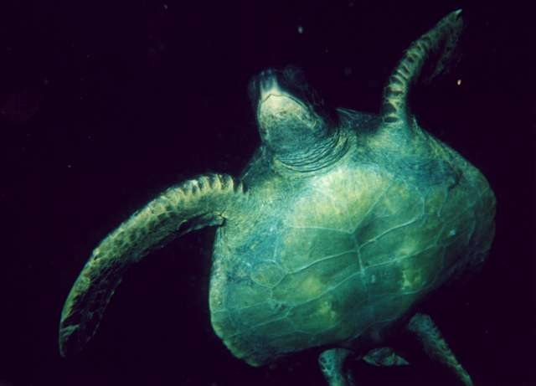 |  |  | 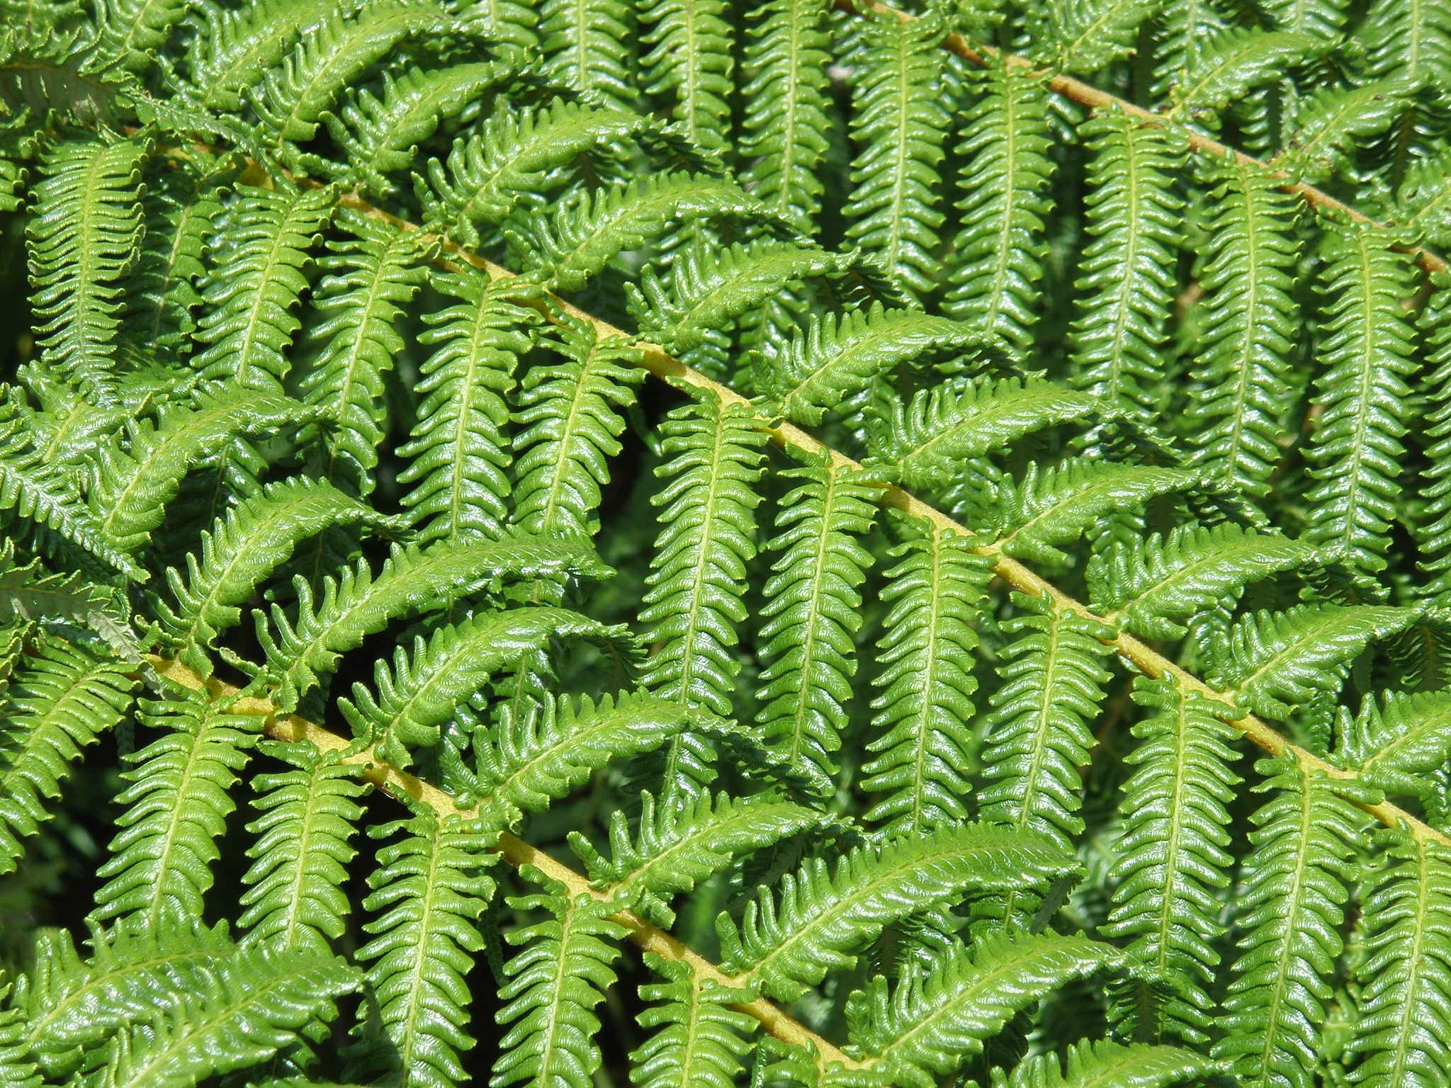
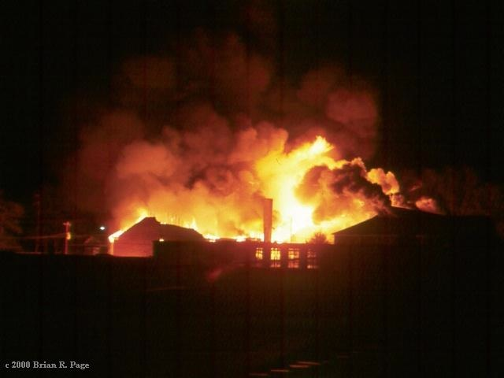 |  |  | 
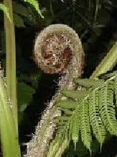 |  |  | 
 |  |  | 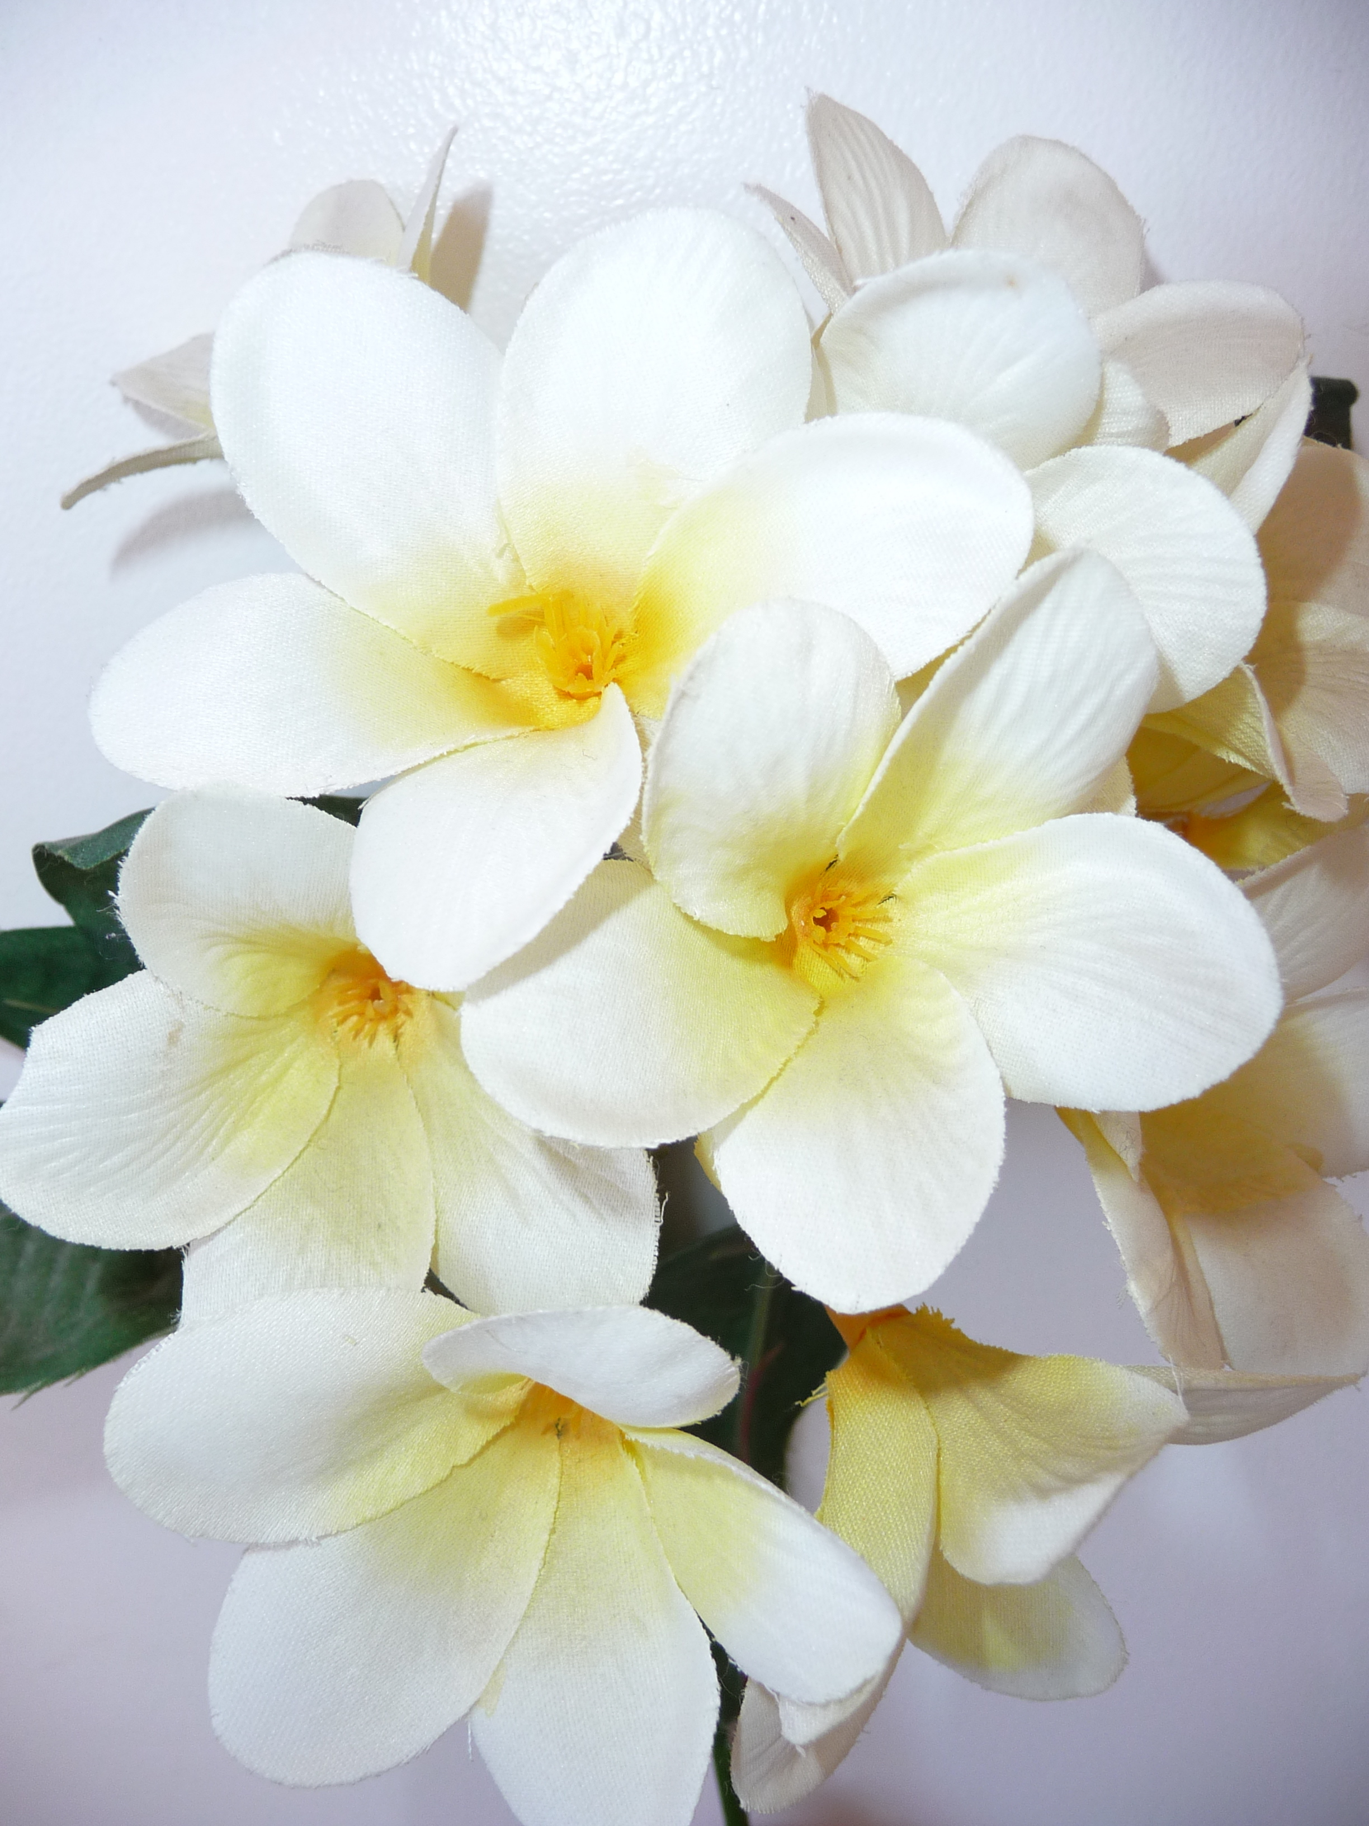

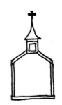 |  | 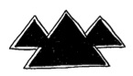 | 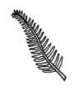
 |  |  | 

Image Use Policy – Photos Used On Previous Page
The Pics4Learning collection is intended to provide copyright friendly images for use by students and teachers in an educational setting. The original photographers of each image retain the copyright to these images and have graciously allowed their use in this collection. The images may not be sold as an image collection or partial image collection. Images in the Pics4Learning collection may be used by teachers and students in print, multimedia, and video productions. These could include, but are not limited to, school projects, contests, web pages, and fund raising activities for the express purpose of improving student educational opportunities.

Turtle: Westerfield, Mike. turtle4.jpg. June 2003. Pics4Learning. 12 Jul 2011 http://pics.tech4learning.com

Ferns: Shipley, Adrienne. p1300130.jpg. 2009. Pics4Learning. 12 Jul 2011 http://pics.tech4learning.com

Church: Isenberg, Nedra. xdsc_0002church.jpg. August 2010. Pics4Learning. 12 Jul 2011 http://pics.tech4learning.com

Fire: Page, Brian. fire02.jpg. 30-Nov-76. Pics4Learning. 12 Jul 2011 http://pics.tech4learning.com

Mountain: O'Dell, Jennifer. img_0379.jpg. July 2009. Pics4Learning. 12 Jul 2011 http://pics.tech4learning.com

Beach: Canipe, Steve. coastalwaves.jpg. 10/09/2003. Pics4Learning. 12 Jul 2011 http://pics.tech4learning.com

Koru: Canipe, Steve. treeferncrozier.jpg. 04/10/2003. Pics4Learning. 12 Jul 2011 http://pics.tech4learning.com

