Read and Achieve
with the All Blacks

David Riley

Contents

Introduction

Section 1: Before the Game
- Use your prior knowledge
- Preview and predict with Richie McCaw
- Know your purpose for reading with Dan Carter

Section 2: During the Game
- Find the main idea with Owen Franks
- Find details with Ma’a Nonu
- Make inferences with Mils Muliaina
- Use context clues with Jerome Kaino
- Visualise with Keven Mealamu
- Sequence with Brad Thorn
- Cause and effect with Hosea Gear
- Compare and contrast with Josevata and Sitiveni
- Fact and opinion with Tony Woodcock
- Understand figurative language with Kieran Reid
- Questioning with Sonny Bill Williams
- Check your understanding

Section 3: After the Game
- Summarising with Sam Whitelock
- Identify author’s purpose with Conrad Smith
- Connecting with Isaia Toeava
- Evaluating with Jimmy Cowan
- Creating with Cory Jane

Conclusion

Sources

Acknowledgements

Introduction

The All Blacks are one of the best rugby teams in the world! Some reasons for that are– they believe in themselves, they study their sport and they practise.

Reading is a lot like rugby. If you believe in yourself, learn some good reading techniques and practise, practise, practise, then you can become a good reader too.

Before a game good rugby players train hard and study their opposition. During the game they play with a plan. After the game they think about what they can learn from it.

You can become a great reader by doing the same.

To get ready for reading set a purpose, preview and make predictions. While you read use different strategies to help you understand. When you finish reading think about what you have read and what you can do with the information.

This workbook will help you become a better reader by teaching you reading skills and strategies you can use whenever you read.

It is set out in three sections:

- Section 1: Before the game
In this section you will learn skills you can use before you read a text. Using these skills will help you understand and enjoy what you are going to read.

- Section 2: During the game
In this section you will learn some strategies to help you understand what you are reading, while you are reading.

- Section 3: After the game
In this section you will learn ways of remembering and using the information you have read.

Section 1: Before the game

Before you read a text there are things you can do to help you understand what you are about to read. Here are some of the strategies you could use before you read.

- Use your prior knowledge
- Preview and predict
- Know your purpose for reading

Use your prior knowledge

Why do rugby players wear long sprigs on their boots on rainy days? They’ve learned that when it’s raining the field becomes slippery. If their sprigs are too short they will slip and slide all over the place! They use their prior knowledge to help them stay on their feet.

You can use your prior knowledge to help you with reading. Before you read a text ask yourself, “What do I know about this topic?” As you read, ask yourself, “How does this connect with what I already know?”

WARM UP

A ‘Brainstorm’ is one way of using your prior knowledge to help you read. Before you read a text, write down anything you already know about its topic. Just let the ideas flow. You can write in any language you want. You can draw pictures too

This is a book about rugby and reading skills. Write and draw anything you already know about rugby. Share ideas with friends. See if you can come up with 15 items together. That’s a rugby team!

RUGBY BRAINSTORM

STRETCH

Next take the items in your brainstorm and see if you can fill in an ‘ABC Brainstorm’. Under each letter write or draw something about rugby beginning with that letter. E.g. in the ‘M’ box you might write ‘maul’, or draw a picture of Richie McCaw. Remember, you can use any language.

A | B | C | D | E
F | G | H | I | J
K | L | M | N | O
P | Q | R | S | T
U | V | W | XY | Z

TRAINING

Read the titles below. Use your prior knowledge to think about what you already know about each topic.

Props: Rugby’s Tough Guys
What do you know about props?

All Blacks’ Haka Inspires Players
What do you know about the haka?

Sonny Bill Williams: The Most Feared Man in World Rugby
What do you know about the way Sonny Bill Williams plays rugby?

GAME TIME

The following article is about the Rugby World Cup. Ask yourself, “What do I already know about this topic?” Read the questions, then circle the letter next to your choice. Your prior knowledge about the Rugby World Cup can help you better understand this article.

1. A trophy is
a. an award given to a winner
b. a honey brown sweet

2. A final is
a. a type of floor covering
b. a championship game

3. A drop kick is
a. a dance move
b. a way of scoring in rugby

4. Extra time happens when
a. players want to keep playing
b. there is a draw in normal time

The Rugby World Cup is named the ‘William Webb Ellis Trophy.’ William was a young man who went to Rugby School in England. A legend says that William was the first person to pick up a football and run forward with it.
In 1987, New Zealand became the first Rugby World Cup Champions. They beat France 29-9 in the final at Eden Park in Auckland. The most successful Rugby World Cup teams are Australia and South Africa. They have each won two times.

The Rugby World Cup has twice been won by a drop kick – in extra time! In 1995 Joel Stansky did it for South Africa against New Zealand. In 2003 Jonny Wilkinson did the same for England against Australia.

EXTRA TIME

You can use a KWL table as another way of activating your prior knowledge about a topic.

K = Know  What do I already know? | W=Want to know  What do I want to find out? | L = Learned  What have I learned?

- Preview the reading
- Fill in the K column
- Fill in the W column e.g. ‘I want to know why’ or ‘I’ve always wondered why . . .’
- What did you learn from the reading? Put this in the L column.

Try it with this article about the beginnings of rugby in New Zealand:

Rugby is sometimes called New Zealand’s national sport. Here’s how rugby came to New Zealand.
Charles Monro was a young New Zealander studying at Christ’s College in England in the 1860s. He learned the game of rugby from some friends who had gone to Rugby School.
When Charles returned to New Zealand he taught the game of rugby to his friends. They liked it and formed the Nelson Football Club. They encouraged Nelson College students to try the game as well so they could have someone to play against.
And so, the first rugby game in New Zealand was played on 14th May 1870. Nelson Football Club beat Nelson College, two goals to none.

Try using a KWL table the next time you have to read a text. It will help to you be a better reader.
WARM DOWN: WRITING

What have you learned about reading from this section?

Preview and predict

All Black captain Richie McCaw is one of the best rugby players in the world. He knows how to prepare for a big game. He watches films to see how his opponents play. He previews the stadium the game will be played in. He meets with the other loose forwards to talk about how they will play the game. This preparation helps Richie know what to expect when he gets on the field.

Previewing is another way of preparing yourself to read. Previewing a text helps you know what to expect when you read a text. It will help you become a better reader. One way to preview is to look closely at text features:

- Front and back cover
- Title
- Photos, illustrations and captions [tip: if there are no images, search for some on the internet so you can see what the topic might look like]
- Headings [hint: sometimes they are bold or in italics or LARGER or underlined or in a different font ]
- First and last paragraphs/sentences

WARM UP

Scavenger Hunt
Find an example of the following text features inside this workbook:

Text  features | Page  number | How does it help you  understand the text?
Table of Contents

A photograph

A diagram or chart

Print variations
e.g. bold, italics, underline, size
Format [how the chapters are set out]

STRETCH

- The title of this book makes me think it will be about

- The Contents page makes me think I will learn about

- By looking at the photos, I think I will read about these players:

TRAINING

Preview the article about Richie which is on the next page. Don’t read the whole article, just preview it. Then answer the questions below.

- Look carefully at the title. Based on the title what do you think the article might be about?

- Look at the sub-headings [hint: they are in bold type]. What do you think you might read about in those sections?

- Look at the photo of Richie carefully. What else might the article be about?

Now read the whole article. Think about your predictions as you go.

Richie Fulfils His Destiny

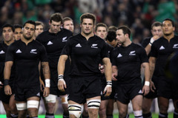
A fine young man!

Otago Boys High School rugby master Neil Baker was one of the first people to predict Richie would become a great player. How did he know? He saw the clues! Richie was a hard worker, intelligent, had leadership skills and was reliable. Maybe that’s why he was also head boy! ‘He was a fine young man,’ Neil said. ‘No question he was destined for greatness.’

A dream comes true!

In 2001 Richie achieved his childhood dream - he was chosen for the All Blacks! He was just 21 years old and only in his first year of top rugby. Why did the All Blacks select Richie so young? They saw the clues! He was very quick, a strong defender and a good support player. Just the kind of player the All Blacks needed in the number seven jersey!

On 17th November 2001, Richie played his first test for the All Blacks, against Ireland. The Irish tackled Richie hard and ran big forwards at him. They wanted to test him out. But they hadn’t read the clues. The All Blacks won 40 -29. Man of the match? Richie McCaw!

Captain Fantastic!

In 2006 Richie was made captain of the All Blacks. Why did coach Graham Henry ask Richie to lead the team? You guessed it – he saw the clues! Richie had become one of the best players in the world. He was aggressive, strong, good in lineouts, deadly in rucks and a great tackler. ‘Richie is an outstanding leader,’ Graham says. ‘He also is an exemplary ambassador off the field, so we are very fortunate to have him out in front of this team.’

How close were your predictions?

on the money! pretty close not close at all!

GAME TIME

Preview the article about Richie on the next page. Don’t read the whole article. Just preview it by looking at the text features. Then answer the questions below.

Title
- What is the title of the article?
- What do you already know about this topic?
- What do you think it will be about?

Headings
- What are the paragraph headings?
- Turn each heading into a question that might be answered in the article

Photo and caption
- Describe the picture.
- What does the caption say?
- What do the picture and caption make you think this will be about?

First and last sentences
- What do you think this article will be about based on the opening sentence?
- What do you think this article will be about based on the last sentence?

Predictions
Use the information above to make predictions. What do you think this article will be about?

Now read the whole article. Think about your predictions as you go.
Richie’s Time Out – In the Sky!
Glide time!

What do All Black players do when they’re not training or playing? Some study at university. Others spend time with their families. Richie McCaw flies glider planes!

Richie has a pilot’s license and is a member of the Canterbury Gliding Club. ‘It’s an unreal feeling. I absolutely love it,’ he says. ‘Gliding is the closest you could get to putting a set of wings on your back.’

Flying in the family

Richie’s love of flying comes from his grandfather Jim McCaw. Jim was a pilot in World War Two. His job was to destroy missiles and bomb enemy targets. Jim was a great pilot. He was awarded a Distinguished Flying Cross medal.

Richie grew up listening to the stories of his grandfather’s flying adventures. And by the age of 9 he and Jim were flying gliders together!

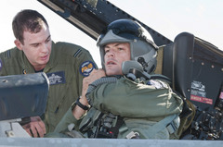

Thrilling but dangerous!

There’s nothing Richie enjoys more than surfing the wind over some of the most beautiful mountains in New Zealand. But Richie knows he can’t get too relaxed. Thunderstorms, turbulence, mountains, other gliders and even sunburn help keep him on full alert!

‘There are risks,’ Richie says. ‘But I certainly don’t go putting myself in danger. It’s no worse than driving a car.’

Similar skills

Richie says being a good glider pilot is a lot like being a good openside flanker! Like a number seven, a pilot has to make good decisions, has to think ahead and has to know what’s going on around him – at all times!

Before flying Richie previews the weather and atmosphere conditions. He doesn’t want any surprises when he’s 20,000 feet above the ground! Richie believes good preparation is the key to a good performance on the field, and in the sky.

How close were your predictions?

on the money! pretty close not close at all!
EXTRA TIME

Sometimes you can predict what an article is about just by reading the first sentence of each paragraph. In the following article you can only see the first sentence of each paragraph. Preview these sentences. Then make predictions about the missing parts.

2010 - What a Year for Richie and the ABs!

The amazing season began with the Tri Nations tournament……………………………………………………………………………………………………………………………………………………………………………………………………………………………………………………………………………………………………………………………………………………………

In November, the All Blacks toured Europe…………………………………………….. ………………………………………………………………………………………………………………………………………………………………………………………………………………………………………………………………………………………………………………………………………………………………………………

Richie ended the year being named IRB Player of the Year! ………………………………………………………………………………………………………………………………………………………………………………………………………………………………………………………………………………………………………………………………………………………………………………

Could 2011 be any better? Well, if the All Blacks win one more trophy it would!

Write your predictions

- What do you think the first paragraph is about?

- What is the second paragraph about?

- What is the third paragraph about?

Here is the whole article. Read it and see how close your predictions were.

2010 - What a Year for Richie and the ABs!

The amazing season began with the Tri Nations tournament. The All Blacks kicked off in style hammering the world champs South Africa, 32-12. The All Blacks won all six of their Tri Nations games. Final points table: New Zealand 27, Australia 11, South Africa 7.

In November, the All Blacks toured Europe. They were unbeaten again! They won their fourth Grand Slam and broke countless records along the way. Richie became the most capped All Black captain in history on the tour.

Richie ended the year being named IRB Player of the Year! He is the only player to have won the award three times. ‘It's been a good year and a lot of fun to work with quality players,’ Richie says. ‘I just love playing rugby, especially international rugby.’

Could 2011 be any better? Well, if the All Blacks win one more trophy it would!

How close were your predictions?

on the money! pretty close not close at all!

Try this predicting strategy the next time you are reading. See how close you and your friends can get!

WARM DOWN: WRITING

You can also use previewing as a way to learn new words:
- write down the bold words you don’t know
- look for the word when you’re reading
- draw a picture that goes with the word
- write your own definition of the word
- write your own sentence with the word in it
Try it with one of the bold words in this section

Know your purpose for reading

When All Black first five Dan Carter wanted to find out more information about his teammate Mils Muliaina, he read Mils’ autobiography, Living the Dream. By reading the book Dan found out where Mils was born, who his parents were and when he played his first game of rugby. Dan found it easy to read Mils’ book because he had a purpose for reading.

Before you read any text you should know the purpose for reading. Knowing why you are reading the text helps you understand and enjoy it more. Here are some different purposes for reading:

- For enjoyment
- To find information
- To improve vocabulary
- To learn something new

Can you think of any more? Write them here:

WARM UP

1. What could be your purpose for reading an All Black test match report?
  - To find out what school Dan went to
  - To find out Dan’s training techniques
  - To find out how well Dan played

- Which of these texts would you read if your purpose was to find out when rugby began?
  - An All Blacks match program
  - A Wikipedia article on the history of rugby
  - A magazine article about Dan Carter

STRETCH

Reading is easier when you have a purpose for reading. This lesson will prove that to you!

This is a team sheet of the All Black team that won the 1987 Rugby World Cup. Study the information for 30 seconds and then cover it. Your time starts … now!

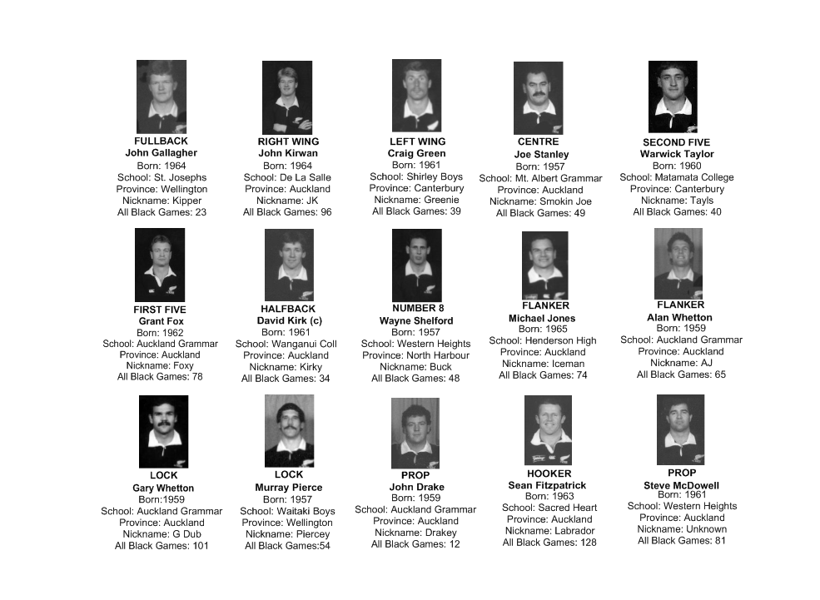

Cover the team sheet. Write down as much as you can remember from your reading:

That was pretty hard right? That’s because you didn’t have a purpose. It’s much easier to read when we know why we’re reading and what we’re looking for.

Read the information again. Answer this question: How many of the players come from Auckland? You have 30 seconds … Go!

Write your answer here:

Did you find it easier the second time? That’s because it’s easier to read when we have a purpose.

What you have learned about reading from this lesson?

TRAINING

Below is an article about Dan Carter’s childhood. Before you read the article ask yourself a question: What do I want to find out? Write your question here:

Tip: if you are having trouble thinking of a question, try the 5W1H method. Think of a question beginning with What, Who, Where, When, Why or How.

Writing down what you want to learn sets a purpose for reading. When you are reading look carefully for any information that answers your question.

In his father’s footsteps

Dan Carter says his father Neville, is a big reason for why he has become a famous All Black.

Neville Carter was a fine player in the Canterbury area. He loved rugby and played for the Southbridge club. From the moment Dan could walk, Neville put a rugby ball in his hands and encouraged him to run with it.

When Dan was five Neville signed him up with Southbridge, the same club he had played for. And who was Dan’s first coach? His father Neville of course!

Neville could see Dan loved rugby as much as he did. So he cleared a section of land at the back of their house and made a field for Dan to practise on! He even built Dan a set of goal posts!

Dan’s father is still his number one supporter. ‘He rings me before every game,’ Dan laughs. ‘No matter where I am in the world, he’ll call me. The main thing he tells me is to make sure I enjoy the game.’

With support like that, it’s no wonder Dan has become such a great player.

Did you find the answer to the question you wanted to find out from this article? Write it here

GAME TIME

Below is an article about Dan’s high school years. Before you read the article think about two things you want to find out? Write your questions here:

1.
2.

Finding the answers to these questions is your purpose for reading. Look carefully for any information that answers your questions.

Seeking Higher Things

When Dan was young, he played mostly at halfback. But by the time he reached Ellesmere College, he was getting taller and a little bigger. His coach decided to make him a first five eighth.

Dan didn’t mind. He was still going to touch the ball more than most other players! And of course, he was the goal kicker. All those hours practising on his own goalposts paid off.

In year 10, Dan was chosen for the First Fifteen! Now he was playing against bigger, more experienced boys. Did it worry him? Not a bit. It just meant he would get better faster.

Dan enjoyed playing for his local school, Ellesmere College. But by the time he reached Year 13, he wanted to experience a harder level of rugby. So he left home and enrolled at Christchurch Boys High School, one of the best rugby schools in New Zealand.

Christchurch Boys’ motto is ‘Altiero Peto: I Seek Higher Things.’ They have twice been World Champions of High School rugby! Twenty three of their students have become All Blacks!

Dan didn’t know if he would even get selected in the Christchurch Boys High School First Fifteen. But he was willing to take that risk. His dream of one day becoming an All Black was on the line. He had to do it.

Dan admits he was very nervous when he first walked into his new school. He looked at the photos of past players hanging on the walls. They seemed to say, ‘You better not let us down country boy!’

Dan played in the trials and made the First Fifteen. From day one he was determined to show everyone, that the country boy from Southbridge could play!

Did you find the answer to the question you wanted to find out from this article? If no, try reading it again. If yes, write it here:

EXTRA TIME

Purposes for reading this workbook

Why does your teacher want you to read this workbook? | Why do you want to read this workbook? | Why does the author want you to read this workbook?

What other purposes for reading this workbook could you have?

As you go through the activities in this workbook think about the different purposes for reading it that you have talked about.

WARM DOWN

Dan went to Christchurch Boys High School because he had a purpose – he wanted to become an All Black. What have you learned about reading in this section?

Section 2: During the game

In this section you will learn some strategies to help you understand what you are reading, while you are reading. You will enjoy and remember your reading more when you understand it.

Here are some of the strategies you could use while you read.

- Find the main idea
- Find details
- Make inferences
- Use context clues
- Visualise
- Sequence
- Cause and effect
- Compare and contrast
- Facts and opinions
- Understand figurative language
- Questioning
- Check your understanding

Find the Main Idea

Owen Franks is the All Blacks’ tighthead prop and one of the strongest players in the team. Owen can lift 240kg from a squatting position! He needs to be strong, because he helps hold the scrum up. If the tighthead prop is stable and has good technique, the scrum will be stable.

Just as props have a main role, paragraphs have a main idea. In the previous lesson you learned that what or who the text is about is the ‘Topic’. The ‘main idea’ is the most important thing the writer wants to say about the Topic.

Often you can find the main idea of a paragraph by looking at the first or last sentence.

EXAMPLE

Read the following paragraph. The main idea is underlined.

Owen first played for the All Blacks in 2009. The date was 27th June. Owen came on as a reserve against Italy. The game was played in Christchurch. The All Blacks won the game 27-6.

The topic of the paragraph is Owen Franks. The main idea of the paragraph is: Owen played his first All Black game in 2009. The other sentences are ‘supporting details’. They give more information about Owen’s first game for the All Blacks.

Here is another way of looking at it. The main idea ‘drives’ the paragraph. The details support the main idea.

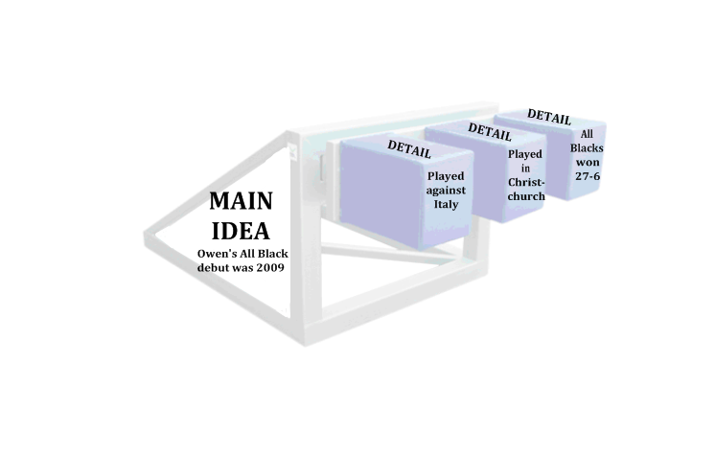
WARM UP

Read the paragraphs below. The main idea is underlined. Find the supporting details, the information that supports the main idea. Put three of these details on to each scrum machine.

Owen always knew he would be a prop. He was chubbier than other kids and not very fast. But he enjoyed scrums. He loved the feeling of banging and smashing into people. Still does!

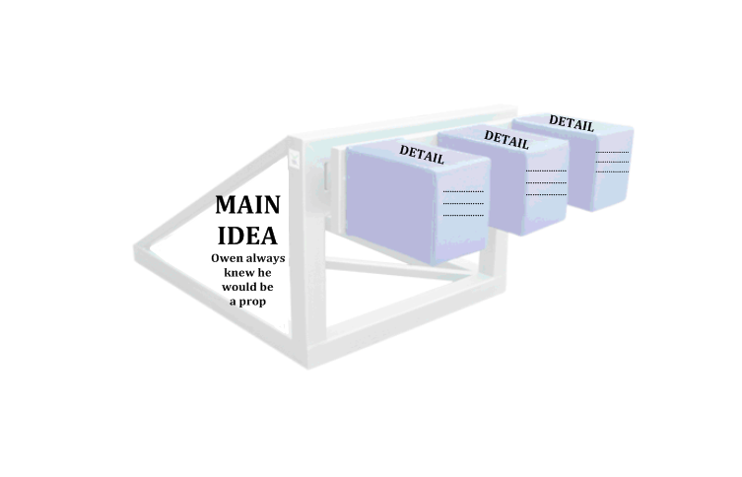

There’s a lot more to props than ‘touch- pause- engage!’ Yes they must be strong in the scrum. But they also have to be able to tackle well. They need to be solid ball carriers. Props must know their role in the lineout. And they must know when to join rucks and when to stay out. Props have as many skills as any other player on the field.

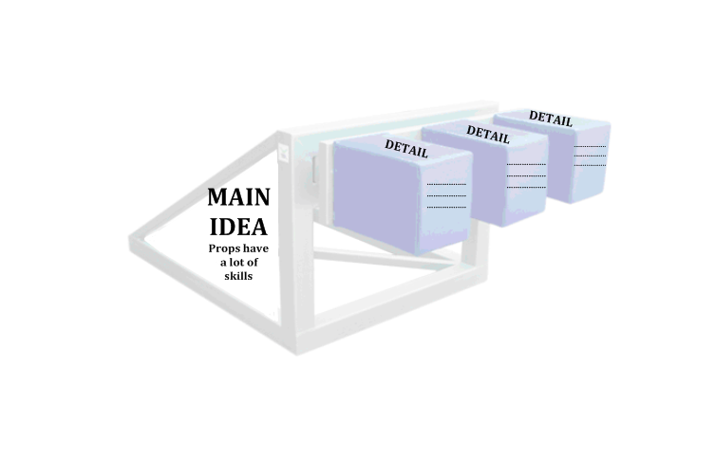

STRETCH

Every paragraph has a main idea, the most important thing the writer wants to say in the paragraph. Read the paragraphs below and answer the questions that follow.

From an early age Owen believed he would one day be an All Black. But when he told his friends they laughed. ‘You’re too fat!’ one giggled. ‘You haven’t made it into any good teams,’ said another. Owen looked at them and said firmly, ‘That just means I’m going to have to work harder than everyone else.’

1. The main idea of this paragraph is
a. Owen was chubby when young
b. Owen believed he would become an All Black

- A detail that supports the main idea is
a. Owen’s friends laughed at him
  - Owen promised to work harder than everyone else

Owen’s father is Ken Franks. Ken did everything he could to help his son become fit and strong. When he was 13, he bought him a set of weights. He taught him how to lift correctly. To keep it fun, he designed new programs for him every year.

3. The main idea of this paragraph is
a. Owen had fun doing weights
b. Owens’ dad helped him to become fit and strong

- A detail that supports the main idea is
a. Owen’s father taught him how to lift weights
  - Owen was a good player

TRAINING

Articles also have main ideas. In an article you will find the main idea in the first and last paragraphs. The body paragraphs will develop –talk more about - the main idea.

Here is an example. First preview the article using skills you learned earlier in this workbook. Then read it and see if you can figure out the main idea.
I’m Not A Hothead!

Owen Franks is an aggressive and fiery player. He’s even got two axes tattooed on his back. Owen says they represent his ‘barbarian ancestors’!

Owen loves the physical contact in rugby. ‘It’s exciting when someone challenges you and runs straight at you,’ he says. ‘It’s cool. I like someone challenging me. I have got to dominate them. I don’t like being dominated.’

In a game against South Africa Owen was teased by Springbok hitman Bakkies Botha. ‘Too bad fatty!’ Bakkies laughed when Owen dropped a ball. ‘Oh yeah, it’s on, it’s on!’ Owen thought to himself. The next time Bakkies got the ball Owen smashed him!

But sometimes Owen’s aggression gets him in trouble. In June 2009? The All Blacks were playing against Australia. Owen had lunch with his dad Ken before the game. ‘Don’t do anything stupid today son because you know you’re going to be hyped,’ Dad said. ‘Yeah yeah, sweet Dad,’ Owen replied. But within 30 seconds of the game starting Owen had joined a scuffle and given away a penalty!

Later that year in a game against France, Owen made his biggest mistake yet. He saw a ruck form. French bodies lay on the All Blacks side. Owen zeroed in on one player and charged in, shoulder first. He was sin binned.

Owen has learned his lesson. He’s not going to stop being aggressive, just smarter. ‘I just have to choose when the best time is to be destructive,’ he says.

MAIN IDEA:
Owen is an aggressive
player

DETAIL:
He loves when
people run straight at him

DETAIL:
He smashed a player who teased him

DETAIL:
He got into a scuffle and gave away a penalty
DETAIL:
He gave away a penalty during a scuffle
DETAIL:
He gave away a penalty during a scuffle

DETAIL:
He gave away a penalty during a scuffle

DETAIL:
He was sin binned for a shoulder charge
DETAIL:
He was sin binned for a shoulder charge

MAIN IDEA:
Owen is an
aggressive
player
DETAIL:
He loves when
people run straight at him
DETAIL:
He smashed a player who teased him
DETAIL:
He gave away a penalty during a scuffle
DETAIL:
He was sin binned for a shoulder charge
MAIN IDEA:
Owen is an
aggressive
player

MAIN IDEA:
Owen is an aggressive
player

Another way of recording this information is by using a spider map. Fill in the boxes using information from the article you just read. One of the boxes has been filled in for you.

MAIN IDEA:
Owen is an
aggressive
player
DETAIL:
He loves when people run straight at him
2. DETAIL:
3. DETAIL:
4. DETAIL:

GAME TIME

Now it’s your turn! Here is another article about Owen Franks. First preview the article. Then read the article. Think about the main idea as you read. When you have finished reading, fill in the spider map that follows.

Owen’s Secret to Success

All Black Owen Franks plays one of the toughest positions in rugby – tighthead prop. How does he do it? It comes down to one word: preparation. ‘If I’ve prepared properly, I’m pretty confident I can do the job,’ he says. ‘That’s why I like to put a lot of time into my preparation.’ Owen prepares himself by taking care of three things: training, eating and attitude.

Train Hard

A prop needs to be physically strong. He’s got to toughen up his shoulders, his thighs and his arms. ‘For guys playing in the front row, it is really important to lift weights,’ Owen says. ‘Lifts like the squat, dead lift and power lift are very important.’

Eat Well

Owen is careful about what he eats. He knows that eating the wrong kinds of foods can stop him playing his best. ‘Anything that comes out of the ground is good, so eat your vegetables,’ he says. ‘Fish, chicken and meat are all good for you to build strength.’

Believe in yourself

Having the right attitude is just as important as training and eating right. ‘Never give up,’ Owen says. ‘Some guys may not make the top teams at school .But even if you miss the First XV you can still be a top player. A good attitude is the way ahead.’

What’s the secret to being a successful All Black? Preparation. Owen trains hard, eats well and believes in himself. That’s how he prepares to battle the strongest men in world rugby!

DETAIL:

2. DETAIL:
3. DETAIL:
4. DETAIL:

MAIN IDEA:

EXTRA TIME
Read the following story.
It’s the early hours of a morning in 1999. Everyone in the Franks family is fast asleep. Suddenly a fire ignites. Smoke and flames soon fill the kitchen. ‘PEEEOOOO! PEEEOOOO!’

The smoke alarm wakes Ben. He wakes his mum and sister. He sprints into Owen’s room.

‘Zzzzz!’
‘Bro, wake up!’
‘Huh?’
‘The house is on fire! Move it!’
‘Zzzzz!’

Talk about a heavy sleeper! Ben shakes Owen awake, drags him out just as his room is swallowed by fire.

‘Thanks bro. You saved my life.’

The house is completely burned. Two items that survive: the brothers’ school uniforms, and their rugby gear!

Draw a picture that shows the main idea of this story. Underneath the picture explain why it shows the main idea.

Explanation

WARM DOWN

Read this paragraph then answer the questions that follow.

Ben and Owen Franks enjoy doing things together. Since they were young they loved to train and encourage each other. They have even opened a gym together in Christchurch. On 12th June 2010 the brothers achieved something amazing – they played in a test match together for the All Blacks! The game was against Ireland, in New Plymouth. The All Blacks won 66-28. ‘We both wanted to make the All Blacks and that’s the way it turned out,’ Owen said. The last brothers to play for the All Blacks in a test match were Robin and Zinzan Brooke back in 1997.

1. The main idea of this paragraph is

a. Ben and Owen enjoy doing things together
b. Ben and Owen opened a gym

2. Which of the following details does not support the main idea?

- Ben and Owen train together
- Robin and Zinzan Brooke played in 1997
- Ben and Owen opened a gym together
- Ben and Owen played in a test together for the All Blacks
- The All Blacks played Ireland in New Plymouth

WRITING

Choose three of the articles you have read so far in this workbook. Read each one again. Then write a summary of the main idea of each, in your own words.

Find the Details

As well as being one of the best rugby players in the world, Ma’a Nonu is one of the most supportive. When Sonny Bill Williams came into the All Blacks, Ma’a said, ‘We’ve got to look after him. He’s one of us now.’

In the last lesson you learned that details are pieces of information that support the main idea. Being able to find details helps you understand and remember what you read.

WARM UP

Read the following paragraph.
What does Ma’a love to do when he’s away from rugby? Answer: Surfing! Ma’a began surfing after watching his brother do it. Most of the time he surfs at his home beach, Lyall Bay in Wellington. He has also surfed in Australia and South Africa. Ma’a attended Rongotai College when he was young. ‘Just getting out in the water makes you free,’ he says.

Choose the sentence that does not support the main idea.
  - ‘Just getting out in the water makes you free’
  - He has also surfed in Australia and South Africa.
  - Ma’a began surfing after watching his brother do it.
  - Ma’a attended Rongotai College when he was young

STRETCH

Read the following article then answer the questions that follow.
Did you know that ‘Rock’ plays for the All Blacks? No, not the WWE wrestler! Ma’a Nonu’s nickname is ‘Rock’. It could be because ‘ma’a’ is a Samoan word meaning ‘rock’. It might also be because of the way he plays rugby.
Ma’a was born in Wellington and attended Rongotai College. He was 18 when Wellington’s Westpac Stadium, ‘The Caketin’, opened. And that was the ground he made his All Black debut at in June 2003. He’s now played over 50 test matches! He’s one of the most experienced players in the team.
At 1.8 meters tall and weighing 104kg, Ma’a is big for an inside back. And he knows how to use his size to overpower the world’s best rugby players. He’s scored almost 20 tries in his test career. And who knows how many tries he’s stopped opponents scoring with his rock solid defence!

One way to find the details in a text is to use the 5W1H method. Ask questions using the starters what, when, where, who, why and how.

Try it with the article you just read
Questions | Details
What ground did he make his All Black debut at?
When did he make his All Black debut?
Where did he grow up and go to school?
Who is this article about?

Why is he nicknamed ‘Rock’?

How heavy and how tall is he?
How many tests has he played?

TRAINING

Read the following article about Ma’a’s tattoos. Think about the main idea. Remember you can often find it in the first paragraph. Then, look for the supporting details as you read.

Ma’a loves tattoos and is one of the most tattooed All Blacks ever! But his tattoos are more than just pretty designs. They have important meanings.
He has his surname “NONU’ etched along his back. It’s not in case he gets lost! It’s a symbol of how proud Ma’a is of his family.
Maa’ also shows pride in his upbringing in the tattoos on his left arm. They were designed by fellow All Black Neemia Tialata. The designs represent Ma’a’s life growing up in Wellington, facing challenges and overcoming them.
Ma’a also has a tattoo that represents humbleness. It’s a picture of Jesus on the cross and it runs right down his back. Ma’a says the tattoo reminds him to be humble. Just because you’re an All Black doesn’t mean you should have a big head.

Fill in the diagram using information from the article to help you.

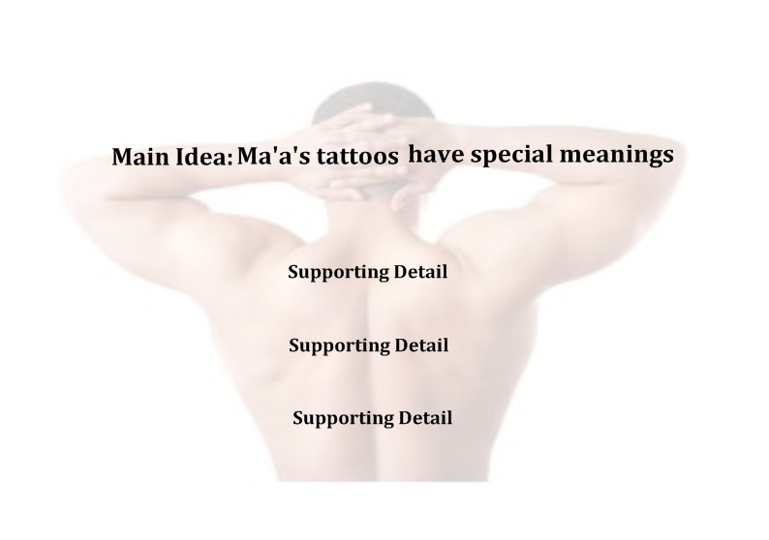

GAME TIME

‘Ma’a is a highly skilled player,’ says All Black assistant coach Wayne Smith. Just how skilled is Ma’a? Read the following article and decide for yourself!
Ma’a Nonu is one of the most complete players in the All Blacks. He is a powerful attacker, excellent defender and has become an important leader in the team.
Whenever the All Blacks have the ball opponents have to be on guard for Ma’a. He is one of the best line breakers in the world. He has a strong fend, can sidestep off both feet and has the speed to finish tries! And if you do manage to grab him he can offload or throw a pinpoint spiral pass to supporting players.
Ma’a’ is also a great defender. He knows how to read the game and where he’s needed on defence. He’s a strong tackler. You will know when the Rock hits you.
Ma’a has become a leader in the All Blacks. He’s mature and respected. He doesn’t do it by words but with action. When Sonny Bill Williams dropped the ball in his first test, Ma’a ran over to him. “Don’t worry about it,” he told him. “Pick yourself up. Focus on the next play.”

What is the main idea of this article?
  - Ma’a is a great line breaker
  - Ma’a is a strong defender
  - Ma’a is a highly skilled player

Can you find 10 details that support the main idea?

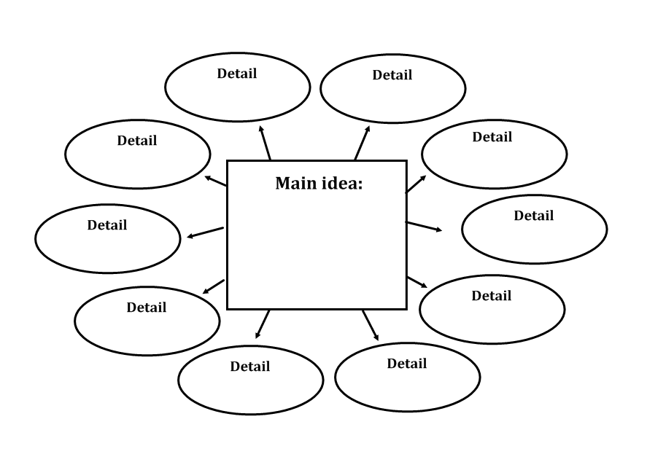

EXTRA TIME

Read the article about Ma’a and Stylin’. As you read think about the main idea and the supporting details. Try to visualise as you read.
Ma’a likes to express his personality on the field. He shows it in the way he plays. He also shows it in the way he looks!
When Ma’a first came into the All Blacks he wanted a hair style that would be different to everyone else and unique. The style he chose? Dreadlocks.
After a while dreadlocks became popular amongst rugby players. In one test match Ma’a played in, four of the players wore their hair in dreads! “This is getting too common,” Ma’a thought to himself.
Ma’a wondered what he could do next to be different. That’s when he decided to colour his dreadlocks. One of his favourite colours was yellow – the colour of the Hurricanes! When other players coloured their hair too, Ma’a put coloured ribbons in his.
But it was time to take things to a new level. There was one thing Ma’a didn’t see any other player doing: wearing eye liner. “I just wanted to make a fashion statement,” Ma’a said. To date no other player has copied Ma’a’s eye make-up style. He might have found a way to be unique!

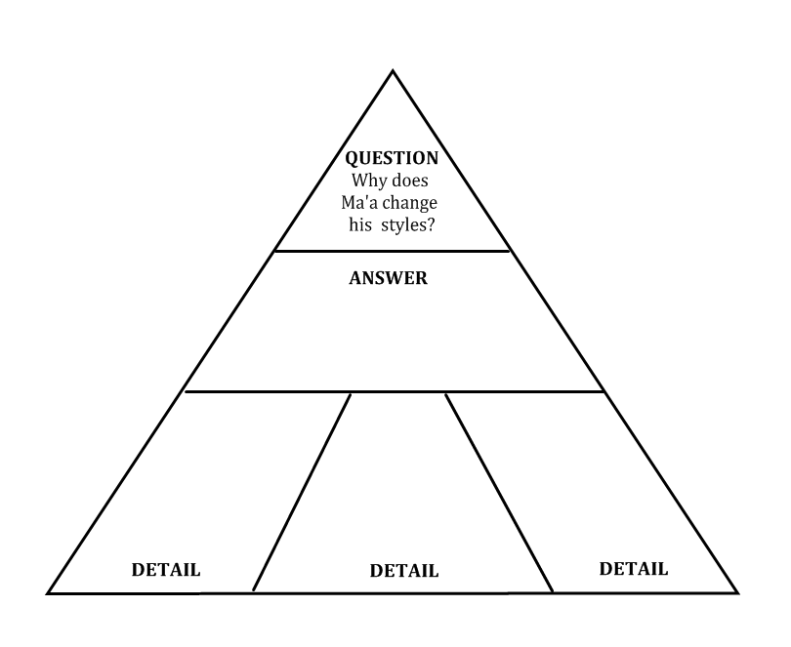
WARM DOWN

On 21st August 2010 Ma’a set up one of the most famous tries in All Black history. Ma’a used all his skills to set Israel Dagg up and win the 2010 Tri-Nations for New Zealand. Here’s how it went down:
It’s the 79th minute of the All Blacks last test match against South Africa in 2010. The scores are tied 22 -22. South Africa are on attack, in the All Blacks’ half. First five Morne Steyn sets himself to take a drop goal. He’s the man who regularly kicks 50 meter drop goals. A South African player takes the ball into a ruck, makes a few more meters for Morne. Morne sets himself. If the kick goes over South Africa will win the game.
But the All Blacks have other ideas. The ball is stolen in the ruck. Keven Mealamu picks it up and drives forward. The ball is spun out to Ma’a. He looks up and can’t believe who is in front of him –Springbok hooker John Smit and prop C.J. van der Linde, two of the slowest men on the field! They have no chance.
Ma’a dummies twice then steps between the two Springbok front rowers. John Smit lunges desperately at Ma’a’s legs. He grabs Ma’a’s foot, tries to hold on. But Ma’a is too strong. He pulls out of John Smit’s tackle, leaving his right boot behind!
South Africa’s fullback rushes forward to pressure Ma’a. Ma’a dummies inside then throws a perfect pass to Israel Dagg who careens downfield, one finger waving in the air and scores the match winning try. All Blacks jump on Ma’a in celebration. The South African coaches hold their heads in their arms. The All Black coaches high five. The Tri-Nations is theirs.

Make inferences

Who Am I?

I was born in Samoa
Grew up in Southland
Play for Waikato
But went to school in Auckland

I’m the last line of defence
Catch kicks, man they’re high!
I’m a very fast runner
I love scoring tries

Who am I?

Answer: I’m All Black fullback Mils Muliaina!

The writer never told you the name. How did you work it out? By reading the clues and using your background knowledge about Mils and the position he plays.

There’s a name for what you just did. It’s called ‘Inferring’.

When you infer, you use clues and your own knowledge to figure out what a text means. Mils is a very active player. You have to be an active reader to be able to infer.

Inferring is challenging and fun, it’s like cracking a secret code! Inferring takes you deeper into the reading and helps you understand more. Inferring exercises your brain muscles!

WARM UP

1. The All Blacks are playing the Springboks at Eden Park. Mils comes out to check conditions. It has been raining for days. He trudges through mud puddles on the sideline. He is wearing a thick track suit. Shivering, he rubs his hands together. His breath is like steam.

Can you infer what season it most likely is?

  - Winter
  - Summer

2. Just before halftime, Mils receives a long pass. He side steps past two defenders. He sprints away from a third man. He dives. The crowd cheers.

Can you infer what happened here?

- Mils got injured
- Mils scored a try
- Mils went out

3. The Springboks are attacking the All Blacks’ tryline. The Springbok first five eighth kicks the ball as high as he can. Mils calls, ‘My ball!’ He jumps . . . Mils’ teammates high five him.

Can you infer what happened here?

- Mils dropped the ball
- Mils scored a try
- Mils caught the ball

4. The game is over. Mils skips into the All Blacks changing room. He high fives his teammates. Coach Graham Henry comes in. He shakes Mils’ hand and says, “Well done!”

Can you infer who won the game?

    - All Blacks
    - South Africa
    - It was a draw

STRETCH

You can also make inferences based on images. Study these pictures carefully. Then answer the questions beside them.

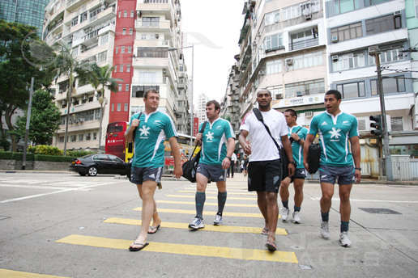
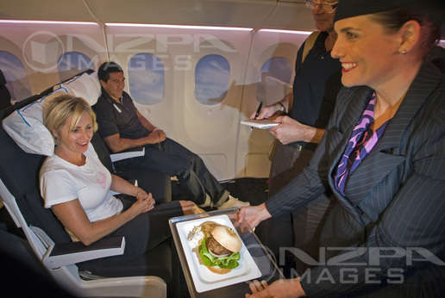
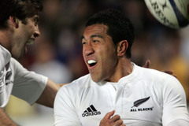
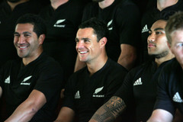
1. What do you infer happened?

…………………………………………………..

2. Evidence

…………………………………………………..
1. Where do you infer Mils is?

…………………………………………………..

2. Evidence

…………………………………………………..
1. What do you infer is happening?

…………………………………………………..

2. Evidence

…………………………………………………..
1. What do you infer is happening?

…………………………………………………..

2. Evidence

…………………………………………………..

TRAINING

In this section you will read about Mils’ time in the New Zealand Sevens team. This time the inferences are made for you. Your challenge is to give the evidence that proves the inference. Are you up for it? Let’s go!
Mils’ coach in the New Zealand Sevens team was Gordon Tietjens. “If you eat well, you will play well”, Gordon told the team. Gordon would sometimes drive to MacDonalds and Burger King to check if any of the players were there. Any player caught with the wrong food was given a growling . . . and extra training!

Inference: Gordon is very strict when it comes to food

Evidence:

Some players hid biscuits, chips and lollies under their mattresses. Sometimes they said they were going to the toilet but went and bought ice creams. On the night before the 2000 Wellington Sevens Final, Jonah Lomu, Amasio Valence and Mils sneaked off to KFC. ‘I hadn’t had it for so long’, Mils said. ‘I thought it would be alright.’

Inference: the players were sometimes not as serious as their coach about food

Evidence:

Mils scored an important try in the 2000 Wellington Sevens Final against Fiji. But he felt exhausted after scoring it. Mils had never felt as tired as that during a game. Jonah had a quiet game and was replaced. Fiji won the game 24-14. ‘I should have really sacrificed that trip to KFC,’ Mils later said.

Inference: the KFC affected the way Mils and Jonah played

Evidence:

‘I thought I had let the team down,’ Mils says. ‘That was where I learnt that it wasn’t just about yourself. You’ve got to sacrifice things like KFC to get the best out of yourself, and for the team.’

What do you infer Mils will do the next time he is tempted to eat KFC before a big game? Draw your prediction here:

GAME TIME

An important part of inferring is using your own background knowledge and experiences to help you make guesses. This activity will show you how to do that.

Mils grew up in Invercargill. He attended Cargill High School and later Southland Boys High School. When he was 17, Mils began to drink alcohol with his friends after games. Sometimes they would get into trouble with other groups of young people.

Clues in the text | Your own knowledge | Inference
Mils and his teammates are celebrating another victory. They have been drinking beer in a park. They go to MacDonalds to get some food. Another young person teases Mils in front of some girls. | How do young people who have been drinking sometimes react when they are teased or mocked? | How will Mils react?
Mils and the other young man are fighting. The police arrive. | What usually happens when the police arrive at a fight? | What will the police do to Mils?
Mils’ mother is worried about his behaviour. She feels like she is losing control of him. Mils’ older brother is living in Auckland. He is doing well. | What do parents sometimes do when they feel they can’t control their teenaged children? | What will Mils’ mum decide to do?
Mils is told he is going to stay in Auckland. He will have to leave his family and friends. | How would I feel if I was sent away from home? | How does Mils feel about moving to Auckland?
What do you think will happen next in the story?

EXTRA TIME

Another way to practise inferring is to use the KIS Technique

K – underline Key words
I – make an Inference
S - Support your inference

Example

The All Blacks are playing the Springboks at Eden Park. Mils comes out to check conditions. It has been raining for days. He trudges through mud puddles on the sideline. He is wearing a thick track suit. Shivering, he rubs his hands together. His breath is like steam.

Question: What season is it?

- underline Key words that help answer the question
- make an Inference – the season is most likely Winter
- Support your inference
  - It’s been raining for days
  - There are mud puddles
  - He’s wearing a thick track suit
  - He’s shivering
  - He rubs his hands together
  - His breath is like steam

Your turn.

The game is over. Mils skips into the All Blacks changing room. He high fives his teammates. Coach Graham Henry comes in. He shakes Mils’ hand and says, “Well done!”

Question: Who won the game?

- Underline key words that help answer the question.
- make an Inference - ………………………………… won the game
- Support your Inference
  - ……………………………………………….
  - ……………………………………………….
  - ……………………………………………….

WARM DOWN: WRITING

Remember the Who Am I challenge this section began with? Now it’s time for you to try. Choose an All Black or a player from another team. Think of clues you can write to describe the player. Then test a friend!

PLAYER

…………………………………………

CLUES

…………………………………………

…………………………………………

…………………………………………

…………………………………………

…………………………………………

For an extra challenge write in a poetic style like the one at the beginning of this section. You could use rhyme.

If you really feel brave, try writing in similes. Here’s an example:

His tackles feels like thunder pounding your ribs.
When he gets the ball his eyes flash like lightning
He runs around you like a ferocious wind
Or over the top of you like a cyclone

Who do you infer the player is? ………………………………………………………..

Use context clues

When Jerome Kaino breaks from the scrum he’s not sure what the opposition are going to do. Will they run the ball, pass it or kick? He doesn’t have time to ask his coach what to do. He has to make a guess right then. How does he do it? He looks for clues.

You can do the same thing when you’re reading and you come across a word you aren’t sure of. It breaks the flow of your reading if you keep stopping to ask a teacher or look in a dictionary to find the meaning of a word you don’t know. Like Jerome, you can use clues to help you.

Here are two strategies you can use to help you figure out the meaning of a word you don’t know.

  - Say the word out loud. You might be able to guess what it means by the way it sounds.

  - Break the word down. Many long words have different parts.
    - A prefix at the beginning of the word such as im-, dis-, re-
    - A suffix at the end of the word such as –tion, -ible, -ate
    - A base word, a word you might know in the middle
These parts have meanings too. By looking at each part you might be able to figure out the meaning of the whole word. Try it with this word: ‘unbelievable’

Prefix:un = not
Base word: believe = think it is true
Suffix: able = can

Meaning: cannot think it is true

If you still don’t know what the word means you could try looking for words that help. This is called using context clues. This is the strategy we will practise in these activities. Here’s how to do it.

Jerome once said: ‘To get …………….. from the All Blacks is not a good feeling.’ We can figure out the missing word by looking at the words around it.

If you were in the All Blacks, what would not be a good feeling? Losing wouldn’t be a good feeling. ‘To get losing from the All Blacks is not a good feeling.’ That word doesn’t sound right.

What else would not be a good feeling? Getting dropped! ‘To get dropped from the All Blacks is not a good feeling.’ Right. That’s the missing word. We figured it out by thinking about the meaning of the sentence, looking at the words around the missing word, and trying some possibilities.

WARM UP

Read the sentences and use context clues to help you figure out the meanings of the bold words.

1. Jerome’s debut for the All Blacks was against the Barbarians in 2004. He was the only new player in the team.

debut in this sentence means

a. last game c. first game
b. penalty d. injury

Which words helped you:

2. Jerome used speed and stepping to elude defenders and score his first try for the All Blacks.

elude in this sentence means

a. tackle c. ruck
b. yell at d. get away from

Which words helped you:

3. Jerome was dropped from the All Blacks in 2005. Coaches said his fitness was deficient and not All Black standard.

deficient in this sentence means

a. poor c. skills
b. outstanding d. injury

Which words helped you:

4. Did Jerome get disheartened and feel like giving up? No way! He listened to the coaches and worked his way back into the All Blacks.

disheartened in this sentence means

a. scared c. excited
b. depressed d. happy

Which words helped you:

STRETCH

- To be a great All Black Jerome had to get fitter. He decided to do less weights and more ……………..

Write one word that could fit in the gap:
a……………………..

- Jerome is one of the ……………. tacklers in world rugby. When he hits, it hurts!

Write two words that could fit in the gap:
a………………. b…………………

- It’s important that all three loose forwards ……………. well together. A united group is hard to stop.

Write three words that could fit in the gap:
a……………… b………………. c……………….

4. Jerome loves the physical side of rugby, especially …………..
Write four words that could fit in the gap:
a………… b………… c………… d…………

TRAINING

Read the following paragraph. Fill in the missing words from the box below it. Remember to use context clues to help you figure out the right word to use.

Jerome grew up in ¹………… He remembers living near the beach and playing rugby with his cousins. Jerome’s ²………… were hard workers. They helped an uncle who ran a ³…………. company. But they had ⁴………….. of their own too. When Jerome was four years old, his parents decided to move the family to⁵………………. On the day they left it seemed like the whole ⁶…………… came to the airport to say ⁷…………….. Jerome’s father wasn’t sure if it was the right thing to do. It was a big ⁸………………… of life, a little scary. Jerome is ⁹………………. his parents came to New Zealand. So are the ¹⁰ …………….!

Word Bank
goodbye change All Blacks thankful

dreams New Zealand parents

bus village Samoa

Write your answers here

1. 6.
2. 7.
3. 8.
4. 9.
5. 10.

GAME TIME

Read the following paragraph. Fill in the missing words with words of your own. Remember to use context clues to help you figure out the right word to use.

Jerome showed¹ ………….. for rugby from an early age. Amazingly, he made the first fifteen in year² ………… That’s young! In year eleven he was³ ……….. by Saint Kentigern’s College. They had a ⁴……….. team that included future All Blacks Joe Rokocoko and John Afoa. Jerome ⁵…………. center and fullback. As Jerome got ⁶………….. he became more suited to the forwards. His Coach decided to shift him to the ⁷……………. of flanker. The change turned out ⁸…………. for Jerome. In 2001 he was ⁹……………. for his first ¹⁰……………. team – New Zealand Secondary Schools.

Write your answers here

1. 6.
2. 7.
3. 8.
4. 9.
5. 10.

EXTRA TIME
Practise looking for context clues again.
Jerome may be a famous All Black. But he’s also a ¹………… person like you and me. Like² ……. he has had many challenges in his life. ³……… experienced rejection. Like ⁴……… he was dropped from the All Blacks, twice. He’s gone ⁵…………. physical pain. Like the major shoulder injury he ⁶………… in 2005. And like us, he has sometimes made ⁷…………. decisions off the field. Like the time he was charged with drink driving. But Jerome has come back⁸ ………….. all these challenges. He has⁹ ………. the lessons he needed to and has become one of the ¹⁰………. players in the world!

Write your answers here

1. 6.
2. 7.
3. 8.
4. 9.
5. 10.
WARM DOWN

Here is an activity you can use to learn new words. It’s called a word map. Try it with one of the new words you have learned so far.

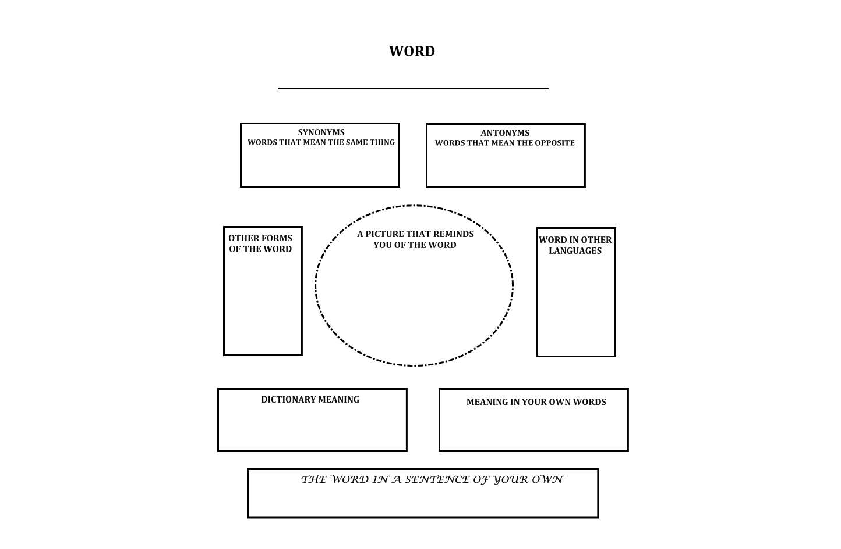
Visualising

Keven Mealamu was eight years old when New Zealand last hosted the Rugby World Cup in 1987. Keven watched the games with his family. He was thrilled by way the All Blacks played. ‘I wonder if I could do that,’ he thought. In his mind he saw a picture of himself putting on the black jersey, singing the anthem, performing the haka.

Keven was visualising. The pictures Keven saw in his mind came true. Today he is one of the All Blacks’ most important players.

Visualising can help you become a better reader. When you read a text try to imagine what you are reading about. Change the words into pictures in your mind. Doing this will help you better understand and remember what you are reading.

WARM UP

Keven’s position in the All Blacks is hooker. A hooker has many important skills to learn. One of them is throwing the ball into lineouts. A good lineout throw helps jumpers catch the ball and wins possession for your team.

Keven uses visualisation to help with his throwing. He runs quickly to the spot where the ball is. He stands tall and steady. He makes sure his grip is firm, elbows in. He pictures the ball firing out of his hands in a perfect spiral, his hands follow through. In his mind Keven sees his jumping teammate catch it sweetly. The All Blacks go on the attack!

Match the label with the picture
Grip the ball strongly
Stand steady and tall
Keep elbows in tight
Fire the ball out
Follow through

STRETCH

Try to use all your senses when you visualise.

Here is a short passage:
It is the middle of winter. An eight year old boy is playing rugby with his friends. His family stand watching on the sideline.
Use your five senses and your own experience to help you visualise this scenario. One example of each has been given to you.

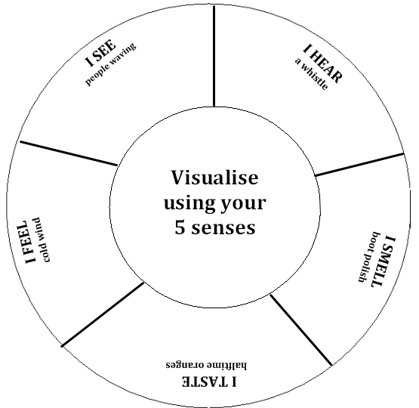

TRAINING

Use visualisation to help you read the following article about Keven. Some of the sentences have numbers. These sentences contain words that put pictures in a reader’s mind. These words are underlined.

- Read the text
- Change the numbered sentences into pictures in your mind
- Draw and label the pictures

Keven grew up in Tokoroa, a small town in the central North Island. Like many New Zealand kids, ¹Keven loved playing rugby, even in the icy frost, with no boots. ‘That’s the way we did it back then!’ he laughs.

A little later Keven’s family moved to South Auckland. Keven joined older brother Luke at Aorere College. ²Keven was a small boy but very good at rugby. He made the Aorere First XV at the age of 14!

But playing in the Auckland competition was going to be a lot different to playing in Tokoroa. ‘³I had never seen guys that big,’ he says. ‘I had never played against guys with beards.’

Getting “smashed” became something Keven slowly got used to! Fortunately Keven had his older brother Luke to protect him. ⁴ ‘He’s a guy who looked after me and still does,’ Keven says. ‘I’m pretty lucky to have a big brother who always had my back.’

Draw and label your pictures here. You don’t have to be good at art to visualise. You just need to use your five senses and your imagination!

You have four minutes. Go!

1. 2.

3. 4.

GAME TIME

Here is another way of using visualisation to help you understand a text

- Read the text.
- Underline sentences that interest you.
- Choose one of these sentences. Discuss with a friend some ways of illustrating it.
- Do your illustration.
- Show a group and ask, ‘What sentence do you think I chose to draw?’ Explain your illustration to them.

Keven uses visualisation in another area of his life too – illustrating children’s books.

Keven has always loved drawing. But he admits he was nervous the first time he was asked to illustrate a children’s book. The book is called Room 22 and Jumbo, the Monster Caterpillar.

‘I had never illustrated a book before . . . and I was hoping for something that was easy to draw!’ he said. ‘The story of Jumbo the caterpillar has been great fun to illustrate.’

Keven’s illustrations help children understand the stories. How does he do it? First he reads the text. As he reads, he pictures the story in his mind. Next, he discusses his ideas with the author, John Parker. Then he draws!

The second book Keven illustrated is The Weather Fish. The third, released in 2010, Paul and the Magic Pencil. ‘I'm not sure if I draw too good,’ Keven said. ‘But having fun with it and using your imagination is always good.’

Keven often draws during break times with the All Blacks. ‘It’s a hobby for me, especially when I’m playing rugby. It’s really nice to get away from it and do something different. Being an illustrator is great fun.’

Money made from the sale of these books goes to Starship Children’s Hospital.

Illustrate the sentence you chose here. You have 2 minutes. Go!

Explanation

EXTRA TIME

Visualising helps you to be an active reader and thinker. Here are other ways of using visualisation when reading:

- Choose one passage or scene from the text and draw it
- Draw the most important moment
- Draw a character that interests you
- Draw an idea or issue in the text that interests you

Choose another article in this workbook. Select one of the visualising ideas above and illustrate it in the box below

WARM DOWN: WRITING

Write a paragraph describing a hobby you enjoy doing. Use each of the five senses in your paragraph. Give it to a friend to read. Ask your friend to find an example of each of the five senses in the paragraph.

Text Patterns

Look at the designs in this box for ten seconds. Your time starts … Now!

Jumbled designs

Cover the box. Now draw as much as you can remember. You have ten seconds. Go!

Did you find that difficult? Don’t be discouraged if you did. It’s hard to remember things that don’t have a pattern. Try it again with this next box. Look at it for ten seconds.

Structured pattern

Cover the box. Now draw as much as you can remember. You have ten seconds.

Was it easier the second time? That’s because the picture was a pattern. It’s easier to understand and remember things when they are in a pattern.
Texts sometimes have patterns too. The next three lessons will teach you some common text patterns:

- Sequence/Listing
- Cause and Effect
- Compare and Contrast

Reading will be easier for you when you recognise these patterns.

Sequence/Listing Pattern

When the All Blacks come together to prepare for a test match, one of the first things they receive is a schedule. The schedule tells them what they will do each day. Thanks to the schedule the players always know what’s coming next.

 | Morning | Afternoon/Evening
Sunday | massage, pool, bike | plan the week
Monday | review the last game | ball games, stretching
Tuesday | field training, skills | media, gym training
Wednesday | DAY OFF!
Thursday | light training | heavy training
Friday | Captain’s run | promotional work

Reading is easier too, when you know what happened first, what happened next and what happened after that. Understanding sequence also helps you remember more.

WARM UP
Use the All Black week schedule above to help you answer the following questions:

Put the events in the correct order by writing 1,2,3 or 4 next to them
₋ captain’s run
₋ day off
₋ plan the week
₋ bike

Put the events in the correct order by writing 1,2,3 or 4 next to them
₋ heavy run
₋ promotions
₋ review
₋ stretching

Which sentence has events in the correct sequence?
  - pool, captain’s run, skills, media
  - plan the week, ball games, heavy training, gym
  - review, day off, bike, captain’s run
  - massage, stretching, light training, promotions
STRETCH

Read the following paragraph. It’s about All Black lock Brad Thorn’s early career.
Brad Thorn was born in 1975, in a small South Island town called Mosgiel. Brad remembers waking up in the early hours to watch All Black tests with his father. He dreamed of being an All Black one day.
But in 1982 Brad’s family moved to Brisbane, Australia. Brad became a rugby league player. And he was good. So good that the Brisbane Broncos signed him when he was still in high school!
Brad played his first NRL game for the Broncos in 1994. Not long after this he made the Queensland State of Origin team, and then the Kangaroos. He was an excellent rugby league player!
Brad hadn’t completely forgotten about rugby though. He often went with his father to watch the All Blacks when they played in Brisbane. As he sat watching one day, a thought came into his mind. ‘If I had grown up in New Zealand, could I have made it into the All Blacks?’
In 2001 he decided to find out. He left the NRL and came back to New Zealand to play rugby.

Place the events in the correct sequence
₋ Brad plays his first game for the Brisbane Broncos
₋ Brad comes back to New Zealand
₋ Brad is born
₋ Brad is signed by the Brisbane Broncos
₋ Brad plays for Queensland State of Origin
₋ Brad’s family moves to Australia
₋ Brad watches All Black tests with his father in the early hours
₋ Brad is selected for the Kangaroos

TRAINING

Whenever you read, keep asking yourself, ‘what happened?’, ‘what happened next?’ and ‘what happened after that?’ Sometimes there are words that help you follow the sequence of events. They are called ‘signal words.’
first, second, third,
to begin with,
next, then, after that, before, during, soon, later, last, finally

When Brad moved to Australia, he wasn’t sure which sport to play. Read about it in the next paragraph. Highlight the signal words.

When Brad first arrived in Australia he wasn’t sure which sport to play. There were so many! To begin with, he tried the sport he knew well – rugby. But rugby wasn’t very popular with the other children and Brad soon gave it away. Next he tried Aussie Rules. He didn’t play that for long – it was too different to what he was used to! Most of Brad’s friends played rugby league. They had often asked him to come and play with them. Finally, Brad decided to give rugby league a go. The rest is history!

GAMETIME

In 2001 Brad came back to New Zealand to see if he could achieve his childhood dream – play for the All Blacks. Brad’s dream came true and today he is one of the most respected players in the team. Read the following paragraph about Brad and highlight the signal words.

Brad Thorn is passionate about the All Blacks! One of his favourite parts is the handing out of the playing jerseys. It’s always a special moment for Brad. First he takes his jersey back to his room. Then he looks at the number. It reminds him of his position and the role he has to play in the team. Next he looks at the silver fern. He remembers what it was like waking up early to watch the All Blacks play. He thinks about the fans, how they always want the All Blacks to play with pride. After this, Brad makes a promise to himself: ‘It doesn’t matter whether I’m hurt, or whether I’m tired, I will give it all I’ve got!’ Finally he folds his jersey and places it carefully on the table. Brad never takes the All Black jersey for granted.

Put the events in the correct order

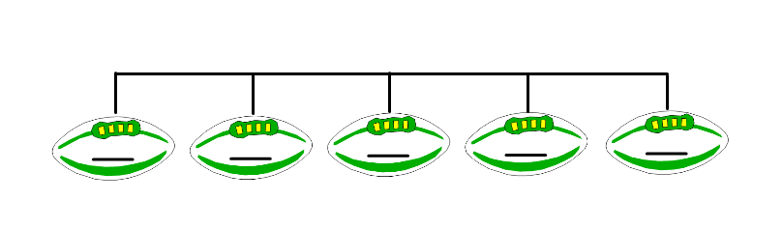

- Brad folds his jersey and puts it neatly away
- Brad thinks about his role
- Brad takes the jersey back to his room
- Brad makes a promise to himself
- Brad thinks about the fans

EXTRA TIME

Read the following paragraph about a major change Brad made in his life. Use visualisation techniques as you read. Then place the main events in the story on the Sequence chart below.

From 1994-2000 Brad was one of the biggest stars in the NRL. He played for the Broncos as a teenager. He won an NRL Premiership, played State of Origin for Queensland and also made the Kangaroos.
He was on top of the world. And he lived like it. Brad enjoyed the fame and money that came with being a famous sportsperson. He partied hard and had lots of girlfriends. He seemed to have everything a young man could want.
But Brad wasn’t happy. He felt empty inside. Sometimes Brad thought about his parents. They never brought him up to live like that.
Then Brad met a Christian sportsman named Jason Stevens. Jason showed Brad a new way of living based on following the Bible. Brad became a Christian and changed his life forever!

Sequence chart

WARM DOWN: WRITING

Brad played loose forward when he first came to rugby. But his coach believed he was more suited to lock. That meant Brad had to learn about lineouts. His coach had an interesting way of teaching Brad.

STEP 1: He tells Brad his idea
STEP 2: He takes Brad to a cow paddock!
STEP 3: Brad stands on top of a fence post
STEP 4: The coach throws shoes at Brad!

Turn the information into a paragraph using the signal words provided. Want a challenge? Try using your own signal words.

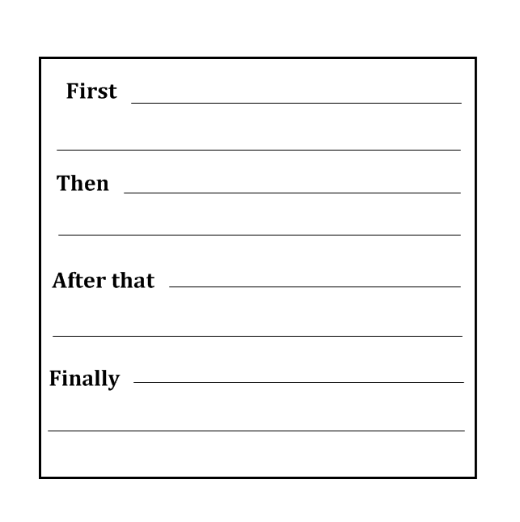

Cause and Effect Pattern

Hosea Gear won the Maori Sportsman of the Year Award in 2010. Why? Because of his amazing achievements:
- gold medal with the New Zealand Sevens team at the Commonwealth Games
- three tries for the New Zealand Maori against England
- one of the best players on the All Blacks Grand Slam tour.

The previous paragraph has a cause and effect pattern. To find the effect ask ‘what happened?’
EFFECT: Hosea won the Maori Sportsman of the Year Award. To find the cause ask ‘why did it happen?’
CAUSE: because of his amazing achievements.

WARM UP

Match each cause with its effect. To get your answer, ask ‘what happened?’ Then ask, ‘why did it happen?’

Cause [why it happened] | Effect [what happened]
Hosea played a lot of basketball when he was young | Hosea went to Gisborne Boys High School
Hosea’s parents believed in the value of sports | Hosea decided to give up basketball and play rugby
Hosea’s older brother Rico persuaded him to try rugby | Hosea can leap higher than most players to catch the ball
Hosea lived in Gisborne when he was growing up | Hosea’s parents encouraged him to try different sports

STRETCH

Hosea has a routine he likes to follow to help him prepare for a big game. Read about it here and at the same time practise your skill at identifying cause and effect. Put a ‘C’ for Cause or an ‘E’ for Effect next to each sentence.

Remember, to find the effect ask ‘what happened?’ To find the cause ask ‘why did it happen?’
1. Hosea listens carefully to the things his coach says to him
He wants to keep improving

2. He wants to know what his opponent’s strengths are
Hosea studies videos of the player he will be marking

3. The needles help to relax his muscles
Hosea puts acupuncture needles into his legs and back!

4. Hosea has a long bath the night before the game
Being in the water helps him visualise the game

5. Music helps put him in the right mood to play
On game day Hosea listens to music on his headphones

TRAINING

Whenever you read, keep asking yourself, ‘what happened?’ and ‘why did it happen?’ Doing this keeps you involved and helps you understand more. There are signal words that can help you find a cause and effect pattern.
so, leads to, causes,
as a result, because,
results in, due to,
for this reason, since
effects, therefore,
in order to

Read the following article about an injury Hosea received in a 2010 test match against Wales. The signal words are bold.
Thirty seconds into the 2010 test against Wales, Hosea tries to charge down a kick. ¹The way he falls causes him to twist his ankle. ‘Oh no,’ he thinks. ²‘I hope I don’t have to have to go off because of this injury.’
Richie McCaw comes over to Hosea. ‘Are you okay H?’ Hosea jumps to his feet. ‘Yeah yeah, sweet as,’ he says. But he’s not really sweet as. ³He says it so he won’t disappoint Richie.
⁴Hosea’s ankle begins to swell due to the sprain. ‘Just strap it,’ he says to the medical staff. ⁵A heavy bandage is wrapped around his ankle in order to keep the swelling down.
⁶The All Black coaches were proud of Hosea because they knew he was playing in pain. ⁷And maybe as a result of the two tries he scored!

Fill in the table using information from the article. The first one is done for you.

 | CAUSE  [why did it happen?] | Signal words | EFFECT  [what happened?]
1 | the way he fell | causes | twisted his ankle
2 |  | because
3 |  | so
4 |  | due to
5 |  | in order to
6 |  | because
7 |  | as a result

GAME TIME
Read the following article about Hosea and his family. Highlight the signal words. Look for the effects of being in a close whanau. Then fill in the table below.
Hosea is very close to his family. When he first shifted to Wellington from Gisborne he found it hard because he missed his parents. Hosea’s parents later moved to Wellington so they could support him. Due to his parents’ support Hosea feels more confident. He plays better because he knows his parents are nearby.
Hosea is also close to his older brother Rico. The brothers had tattoos put on to their forearms in order to stay close to each other. Rico has played for the All Blacks too and knows a lot about rugby. Rico phones Hosea once a week so he can give him advice. Hosea looks forward to his brother’s phone calls because he always feels encouraged afterwards.
Hosea’s pride in his family resulted in him having his shoulder tattooed. The designs represent the tribes he comes from.

CAUSE  [why did it happen?] | Signal words | EFFECT  [what happened?]
he missed his family | because | Hosea found it hard when he moved to Wellington
EXTRA TIME

In 2010 Hosea was a member of the New Zealand Sevens team that won the Commonwealth Games gold medal. Hosea has framed his gold medal and his jersey from the Final. But he got something even better from the tournament. Read about it here.

Hosea is grateful for the opportunity he had to play for the New Zealand Sevens team in 2010. He believes the skills he learned helped him get back into the All Blacks.
First his fitness improved. Sevens coach Gordon Tietjens knows how to get the players fit. He wants them to outlast every other team.
Sevens helped Hosea to increase his workrate. You can’t take rests in a sevens game. There is always something to do, whether it’s supporting a break or scrambling back on defence.
Hosea’s confidence grew as a result of his time in the Sevens team. Sevens teaches you to believe in yourself. Sometimes the challenge is about you and the guy marking you – one on one. You have to have faith in your speed, in your step, in your strength.

Record the information from this article on this chart:

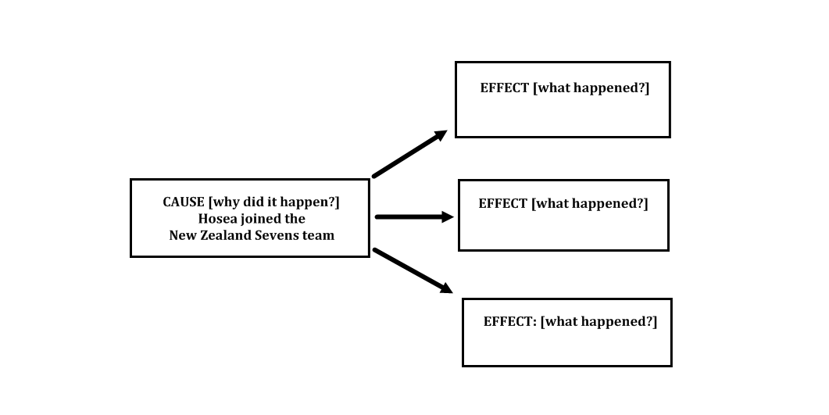

WARM DOWN: WRITING

Hosea has worked hard to learn the skills he needs to be a great winger:
- Catching high balls
- Finishing movements with tries
- Short kicking
- Tackling
- Getting back on counter attack
- Supporting breaks
At the end of 2010 he was rewarded for his commitment. He was selected for the All Blacks’ tour of Europe. Hosea was one of the best players on the tour.

Use this information and your thoughts to write your own cause and effect paragraph. For an extra challenge choose your own signal words.

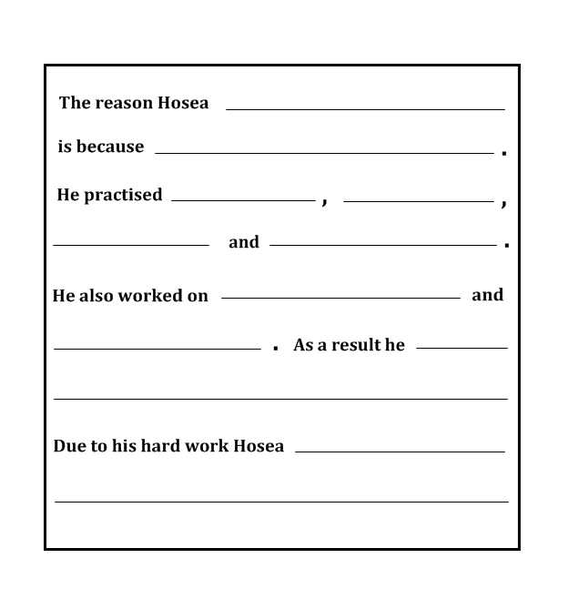

Compare and Contrast Pattern

When you compare things you look at what’s the same. Let’s compare All Black cousins Josevata Rokocoko and Sitiveni Sivivatu:
- they are both Fijian
- both are wingers

When you contrast things you look at what’s different. Let’s contrast Josevata and Sitiveni
- Josevata plays for Auckland but Sitiveni plays for Waikato
- Sitiveni plays on the left wing while Josevata is a right winger

Some texts have a compare and contrast pattern. If you can recognise this pattern when you read you will understand better.

WARM UP

Compare: Explain what is the same about each item.

1. boots, mouthguard, shoulder pads:
2. winger, halfback, fullback:
3. All Blacks, Wallabies, Springboks:
4. Sitiveni Sivivatu, Josevata Rokocoko, Joeli Vidiri:

Contrast: Highlight the item that’s different. Explain how it’s different.

1. prop, flanker, center:
2. Scotland, Fiji, Tonga:
3. hamstring, bicep, calf:
4. try, tackle ,drop goal:

STRETCH

Look closely at the following data. It gives information about Josevata and Sitiveni.

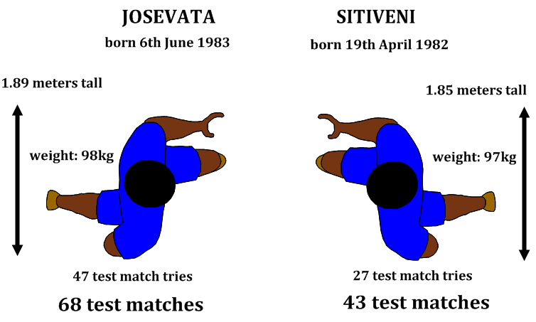

Place a tick in the box next to the player who best answers each item

Josevata | heaviest  shortest  oldest  most experienced  most test tries | Sitiveni

TRAINING

‘How are they the same?’ ‘How are they different?’ Ask these two questions when you come across the compare and contrast pattern. There are signal words that can help you.
COMPARE
also, like, similar, same, both, alike

CONTRAST
although, but, on the other hand, however, in contrast, unlike, different

This article describes some differences between Josevata and Sitiveni’s All Black debuts.
Josevata and Sitiveni are two of the most experienced All Black wingers in history. But their debuts couldn’t be any more different! Josevata’s first All Black test was played against England in 2003. However Sitiveni’s, was two years later, against his home country Fiji.
Sitiveni scored four tries in his debut match. That was a world record for the most tries scored by a player in his test debut! But Josevata did not score any tries in his debut and he broke no records! Sitiveni played the whole game. In contrast, Josevata was replaced.
Unfortunately for Josevata the All Blacks were defeated in his first test match. They lost 15-13. On the other hand, the All Blacks won Sitiveni’s first test . . . 91 -0!

Highlight the signal words. Then write them in the first column of the table below. Beside each signal word write the difference in Sitiveni and Josevata’s debuts. The first one is done for you.

Signal word | Difference
but/different | their debuts

GAME TIME

This article identifies some things the same and some differences between Josevata and Sitiveni’s childhoods. Use a highlighter to follow information about Josevata. Use a different colour for Sitiveni.
Josevata and Sitiveni were both born in Fiji. Josevata was born in 1983 in Nadi. On the other hand, Sitiveni was born in 1982 in Suva. Josevata came to New Zealand when he was five years old. However Sitiveni came when he was a teenager.
Both boys were talented rugby players when they were young. Sitiveni starred for Ratu Kadavulevu School. Josevata played for James Cook High. They were similar in both winning rugby scholarships. Josevata was offered a scholarship by Saint Kentigern’s College. Sitiveni’s scholarship was at Wesley College.
Josevata represented New Zealand at under 16s, under 19s and under 21 levels. He also played for the New Zealand Secondary Schools team, three years in a row! In contrast, Sitiveni did not make any national junior teams.

A useful way to record information from a compare-contrast pattern is on a Venn diagram. You can see an example below. Items that are the same between the two ‘topics’ go in the centre where the circles overlap. Differences go on the sides.

First circle the signal words in the article. Then, use information from the article to fill in the Venn diagram. Things the same go in the centre. Things different go in the player’s own sections. An example has been done for you.

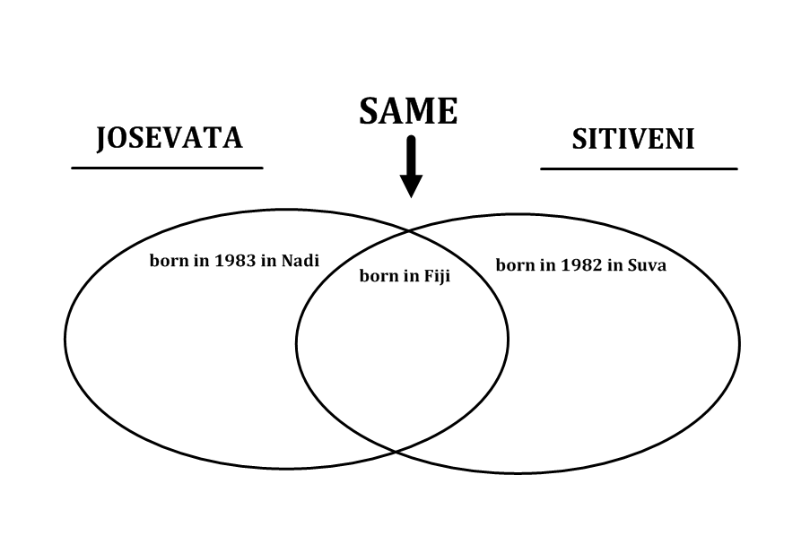

EXTRA TIME

Read the following article about two very different phone messages.

A Tale of Two Phones
Date: June 2005.
Situation: Sitiveni makes the All Blacks for the first time. In five days time he will play against his birth country, Fiji. Sitiveni shuffles nervously outside the room where reporters are waiting to question him.
‘Me, in the All Blacks?’ he thinks. ‘Do I really belong here?’
“TEEP-TEEP! TEEP-TEEP!” A text message flashes on his phone. It’s from his cousin Josevata.

“Congrats cuz, 5 years of hard work has paid off for you!”
Sitiveni smiles. ‘Yeah, I belong here,’ he says to himself opening the door to the media room.

Date: November 2009
Situation: Josevata is waiting to hear if he has been selected for the All Blacks’ tour of Europe. His phone begins vibrating in his pocket. If it’s family or friends calling, he’s made it. If it’s one of the coaches, he hasn’t.
Josevata tentatively looks at the phone screen.
“MISSED CALL” it states. “CALLER:………………. GRAHAM HENRY”

“Bula Josevata, Graham Henry here. Sorry to say you haven’t made the team. All of us coaches feel you need some time off, some rest. We know this will hurt. But don’t be discouraged, we still believe in you.”
Josevata makes a promise to himself. ‘I will make some new goals. I will wear that black jersey again.’

What things are the same about these two stories? | What things are different?
WARM DOWN: WRITING

Look back at the information about Josevata and Sitiveni in this lesson. Use it to write your own compare-contrast paragraph. Signal words have been provided. For an extra challenge, use your own signal words.

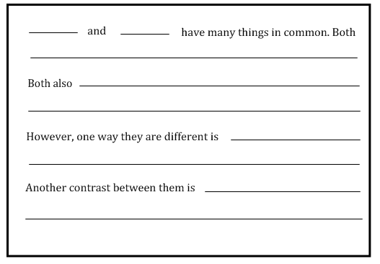

Fact and Opinion

“The All Blacks won the first Rugby World Cup.” That’s a fact. You can read about it in a book or look it up on the Internet.

“The All Blacks will win the 2011 Rugby World Cup.” That’s an opinion. It can’t be proved. It’s what someone thinks. Someone else might say, “The Wallabies will win.”

WARM UP

Write F for Fact or O for Opinion next to each statement.
_ Tony Woodcock is a prop
_ Tony Woodcock is the best prop in history
_ The All Blacks would not be a good team without Tony
_ Tony was born on 27th January 1981
_ Tony lives in Kaukapakapa
_ Kaukapakapa is the most beautiful town in New Zealand
_ Tony plays for the Blues in the Super 15
_ The Super 15 is the best rugby tournament in the world

STRETCH

Knowing the difference between facts and opinions will make you a better reader. You will know when to believe something and when to check something.

Prop is one of the hardest positions to play in rugby. There are two types of props in rugby: loosehead and tighthead. Tony Woodcock is a loosehead prop. He’s one of the toughest props to play against. He’s the most capped All Black prop in Test history.

- Which sentence is a fact?
  - Prop is one of the hardest positions to play in rugby.
  - There are two types of props in rugby: loosehead and tighthead.

- Which sentence is an opinion?
  - Tony Woodcock is a loosehead prop.
  - He’s one of the toughest props to play against.

- How could you find out if the last sentence is an opinion?
  - Ask a friend
  - Research on the internet
  - Read a book about basketball
  - Survey classmates

TRAINING

Read the following article and see if you can find the facts and opinions in it.
Tony knows how it feels to be a world champion. He was a member of the New Zealand Under 19 team that won the Junior Rugby World Cup in 1999.
The 1999 team were one of the best ever. Six players from the team have become All Blacks. They include Tony, Richie McCaw and Mils Muliaina
New Zealand Under 19 also won the World Championship in 2001, 2002, 2004 and 2007! No other country has the talent New Zealand has.

If you think the sentence is a fact, tick the ‘F’ box. If it’s an opinion, tick the ‘O’ box.

Sentence | F | O
The New Zealand Under 19 team won the Junior Rugby World Cup in 1999.

The 1999 team were one of the best ever.

No other country has the talent New Zealand has.

Six players from the team have become All Blacks.

GAME TIME

Read the following article and see if you can tell the facts from the opinions yourself.

In 2010 Tony became the most capped All Black prop in history. He has played over 70 test matches for the All Blacks! ‘I was honoured to just play one test, so to get this far is huge,’ he says.
What makes Tony so good?
Well, there’s his strength. ‘When you hit Tony [in the scrum], there’s no movement,’ says All Black scrum coach Mike Cron. ‘You’re just hitting a brick wall,’
And his fitness. He’s often at the top of All Black statistics for tackles and being first to the breakdown. That’s amazing for a 120kg prop!
‘Every time you pull on the black jersey you treat it as your last and want to do the best you can,’ Tony says. With an attitude like that, rugby fans should be seeing plenty more of the man they call ‘Woody’!

‘Every time you pull on the black jersey you treat it as your last and want to do the best you can,’ he syas.

FACTS | OPINIONS

EXTRA TIME

Sometimes writers use ‘expert opinion’ to support their ideas. Readers usually believe comments by an ‘expert’. In the previous article the writer used expert opinion.

- Name the expert used

- Why did the writer use this person?

- What is good about using expert opinion like this?

WARM DOWN: WRITING

Choose a player…………………………………………………………………………

Write a FACT about this player
……………………………………………………………………………………………………………………………………………………………………………………………………
Explain why this is a FACT
……………………………………………………………………………………………………………………………………………………………………………………………………

Write an OPINION about this player
……………………………………………………………………………………………………………………………………………………………………………………………………
Explain why this is an OPINION
……………………………………………………………………………………………………………………………………………………………………………………………………

Understand Figurative Language

‘Keiran Read was a train today!’ shouted the commentator enthusiastically. ‘He has amazing power and strength. He’s now a world class number eight!’
The sentence ‘Keiran Read was a train today’ is an example of figurative language. The commentator describes the way Keiran plays by comparing him to something similar.
How does Keiran play rugby? He’s fast, tough and just keeps going! What else is like that? The commentator chose a train. Trains are fast, tough, and just keep going!
Figurative language is ‘picture language’. It is words that help the reader to imagine what the author is saying. Figurative language also makes reading and writing more interesting!
Similes and metaphors are types of figurative language.
Simile | Metaphor
Describes something by comparing it to something else. It uses words such as ‘like’ and ‘as’ | Describes something by saying it is something else.
‘Keiran Read was like a train today.’ | ‘Keiran Read was a train today.’
Wellington Stadium is like a cake-tin. | Wellington Stadium is a cake-tin.
The All Black forwards are as powerful as tanks! | The All Black forwards are powerful tanks!
The field is as hard as concrete. | The field is hard concrete.

WARM UP
Change the following similes into metaphors and the metaphors into similes. The first one has been done for you.

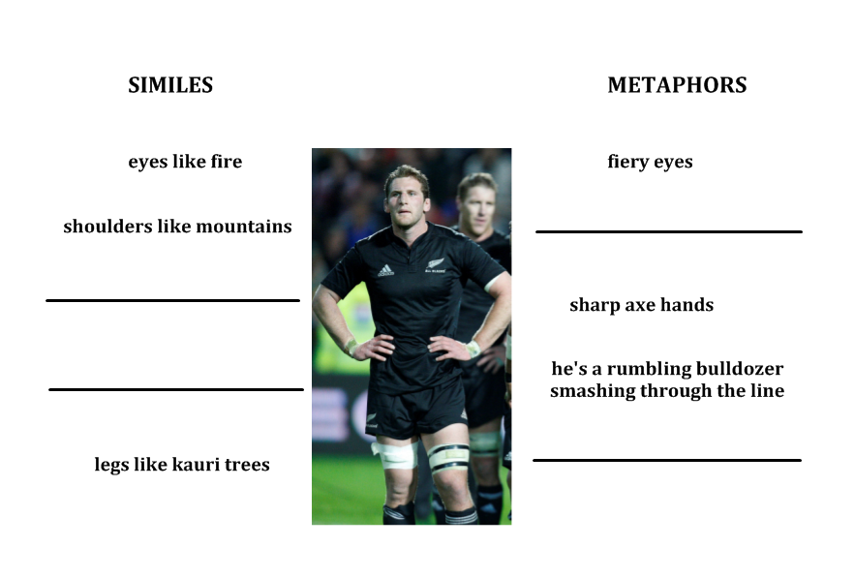

STRETCH
Write ‘S’ on the line, if you think there is a simile in the sentence. If you think there is a metaphor, write ‘M’.

1. _ Keiran is like a rock in the team
2. _ The victorious players danced off the field
3. _ Keiran runs at lightning pace
4. _ He’s as strong as a truck
5. _ Mountains of trophies line Keiran’s shelf
6. _ He exploded off the back of the ruck
7. _ The players raced for the ball like hungry bees
8. _ Keiran torpedo tackled his opponent

TRAINING
Whenever you come across figurative language ask yourself, ‘What does this really mean? ’ or, ‘What is the writer really trying to say?’ The figurative meaning is what the writer says. The literal meaning is what the writer means.
For example, take the sentence ‘the players are dead on their feet’. The figurative meaning is, the players are dead! The literal meaning or, what the writer really means is, the players are exhausted. The metaphor is effective because players who are exhausted sometimes look dead!
Now you try. Underline the metaphor and explain what the writer really means. The first two have been done for you as examples.
Figure of Speech | Literal meaning | Why is it effective?
e.g. the players are dead on their feet | The players are very tired | Because when players are exhausted they look dead.
e.g. it’s a dog fight out there on the field | It’s a close, tough game between the two teams | Because in a close game you can’t tell who will win, just like when two dogs are fighting.
He’s having a nightmare of a game

That was a bullet pass

He’s playing a starring role

The defence is swarming

You can’t go to sleep out there

They’re hitting top gear now

GAME TIME
Read the following description of Keiran Read. It uses figurative language.
He flashes off the back of the scrum, lightning quick. Touch, pause, engage, he’s gone! He’s a ferocious wind with the ball in hand. A cyclone searching for a gap to blast through! His tackles are thunder, pounding you. Shoulders, arms, hands rain down on you. And he does it for 80 minutes too! Relentless, like a flood.

The writer describes Keiran by comparing him to something. Can you tell what it is? Right, a storm.
Underline all the words that have to do with a storm. The first two have been done for you, flashes and lightning.
This paragraph uses an ‘extended metaphor.’ To extend means to make something longer. The metaphor of a storm has been made longer by thinking of other ways the player could be compared to a storm.
Fill in the table below. It will help you understand the extended metaphor the writer uses.
Aspect of the player | Compared to | Literal meaning
the way he runs from the back of the scrum | Flashes of lightning | He picks the ball up quickly and leaves the scrum before the opposition realise he’s gone!
the way he carries the ball
looking for a gap

his tackles feel like

the way he tackles

plays 80 minutes

EXTRA TIME
Revision
- What is figurative language?
- What is a simile?
- What is a metaphor?
- What is an extended metaphor?
- What is one reason writers use figurative language?
WARM DOWN
Choose a player. See if you can write your own extended metaphor to describe him. Here’s one way to do it:
- Brainstorm – describe the way he looks and the way he plays.
- Think – what object, animal, aspect of nature, is the player like?
- Extend – think of all the ways the player could be like the comparison.
- Write – put your ideas into sentences.
Player:

BRAINSTORM

Metaphor chosen:

Now extend it:
Aspect of the player Aspect of the metaphor

Questioning

Sonny Bill Williams knows how important it is to ask questions. As a new player in the All Blacks he has a lot to learn. ‘Everyone’s really helpful,’ he says. ‘You ask one question and you get ten answers!’

Sonny Bill asks questions so that he can better understand what is going on. You can do the same when you are reading. Asking questions about what you are reading helps you understand what you are reading. It keeps you thinking and helps you to be an active reader.

WARM UP

When I look at this picture of Sonny Bill I wonder:
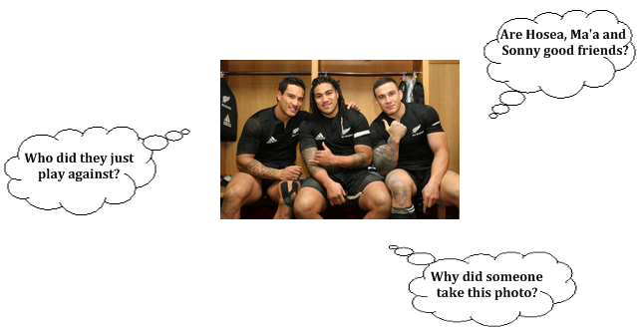

Those are some of the questions I was wondering when I looked at the picture. You might have some questions about the picture too. Write them here:

Now I’m going to read some of the article that goes with this picture. As I read, questions will form in my mind. The questions might be ‘what does that word mean?’ or ‘why did that happen?’ I’m going to write them next to the article. Put your own questions in the last column.
Article | I wonder… | I wonder…
Before the All Blacks November tour, Ma’a Nonu and Conrad Smith made a pact. ‘Let’s help Sonny as much as we can.’  Sonny listens carefully to things Conrad and Ma’a say to him. ‘Anytime they speak, I am all ears,’ Sonny said. ‘I just try and be a sponge when I am around them.’  Sonny has become close with Ma’a on the tour. ‘I've learned more from Ma’a than probably anyone else,’ Sonny said. ‘He's really taken me under his wing and helped me out a lot.’ | What does ‘pact’ mean?  What kinds of things do they say to him?  What does ‘taken me under his wing’ mean?

STRETCH

Asking questions helps you keep interested in what you are reading. Read the following article. Use the 5WIH method to help you think of questions.
Your Questions
It’s five minutes before kick off. Sonny is about to play his first test for the All Blacks. New Zealand’s national anthem begins. Sonny thinks about how far he has come in rugby.

‘I don’t want to let my family down,’ he thinks. ‘And the people that gave me this opportunity.’

The All Blacks have finished the haka. The players move to their kick off positions.

Sonny looks around at the stadium. 80,000 people, sweet! He looks across at the England team. ‘Yeah, bring it!’ He looks at his teammates. There’s Richie McCaw on his left. Dan Carter on his right. ‘Am I doing this?’ he thinks. ‘Am I really playing for the All Blacks?’

The referee’s whistle screams, ‘Yes you are!’ Game on!

Who

What

Where

When

Why

How

Asking questions helps you think more about what you are reading. It makes reading more interesting.

TRAINING

Sometimes the answers to our questions can be found right there in the text. Read the following article. Ask questions as you read. Then see if you can answer your questions.

John Ackland was one of the first people to see Sonny’s potential. John was a talent scout for the NRL’s Canterbury Bulldogs. He convinced the Bulldogs to offer Sonny a contract.  The Bulldogs flew Sonny’s parents to Sydney, to show them the club and the home he would be living in with other young players. Sonny’s parents liked what they saw..  One afternoon, Sonny and his mum were supposed to come to John’s house to sign the contract. But as time ticked by, they had not arrived. John became nervous.  Suddenly, John heard a car pull into his driveway. It was Sonny’s mum, Lee. She was alone. ‘Where’s Sonny?’ John asked. ‘He hasn’t come home from school yet,’ she replied. ‘I’m a bit worried. Maybe he’s having doubts.’  John quickly jumped into his car and drove off to look for Sonny. He spotted him walking down his street with some friends. ‘I grabbed him and got him to sign the contract on the bonnet of my car!’ John laughs.  ‘He didn’t say much. He was just a normal, quiet, humble kid who loved playing football.’ | Your questions | Answers
GAME TIME

Some questions get us thinking and using our brains a lot more. Here are some starters for questions like these:

What if Why might Why should I wonder why How might

Read the following article and ask three of these ‘open’ questions. The answers might not be in the article. That’s okay. The purpose for doing this is to get you thinking.
Sonny enjoyed playing American Football when he was younger. He played for the Metro Lions. His coach was Eugene Meredith.

Eugene remembers the first time Sonny came to training. ‘He was a tall, skinny young boy you didn’t think much of,’ Eugene says.

‘He was very polite and humble. He always asked questions, because he wanted to be better. In his first game, we just told him where to stand. He ended up making all the tackles! Anyone that got through: Boom! Bang! He knocked them over.

Eugene believes Sonny could have gone further in American Football if he had wanted to, even possibly to the NFL. But Sonny’s mother had different ideas!

‘One day Sonny came to me and said, “Sorry Coach, my mum told me I can’t play.” So I said, “Okay, you have to respect your parents.”

Your questions
[remember to make them ‘open’ ones that get you thinking]

1.

2.

3.

Answers
Now try to answer the questions! Use your own prior knowledge and inferring skills to help you.
1.

2.

3.

Asking questions and thinking about the answers is a great reading strategy to use. Asking questions helps you focus when you are reading and that helps you understand more.

EXTRA TIME

Sonny Bill is not afraid to ask questions of his teammates and coaches. He wants to understand. Asking questions while you read is like talking to the text! When you do this you are being an active reader.

Here are some other question starters you can use:
Column 1 | Column 2
WHAT  WHEN  WHERE  WHO  WHY  HOW | should  could  might  will  are  else

Read the following article. To form your questions this time, choose one word from Column 1 above and one from Column 2 e.g. ‘What might…’ Use the two words as a starter. Write a question and then try to answer it.

Remember how Sonny played American Football when he was young? He can’t do that now, not with a Rugby World Cup around the corner.

So he’s taken up a new sport – boxing! ‘I love the sport so much,’ he says. ‘It's doing wonders for me.’

Boxing helps Sonny stay fit and sharp. ‘I have to put myself in different situations to get that edge, to keep myself in contention for that All Blacks jersey.’

Sonny also boxes to support his friend Anthony Mundine. Anthony’s “K.O. To Drugs” events raise money to help get people off drugs.

Sonny is unbeaten in his three fights.

Example

Column 1 word | Column 2 word | Question
WHAT | might | What might happen if Sonny gets injured  in boxing?
Answer
He would probably miss the Rugby World Cup. I wonder if he would regret boxing if that happened.

Your turn

Column 1 word | Column 2 word | Question
Answer

Column 1 word | Column 2 word | Question
Answer

Column 1 word | Column 2 word | Question
Answer

WARM DOWN: WRITING

How does asking questions help the reader?

Check your understanding

It’s halftime in an All Black test match against Australia. Coach Graham Henry speaks to the team. He praises them for what they have done well. The backs then go to one area, the forwards to another. They discuss the things they found difficult. They choose strategies to help them overcome these difficulties.

You can do the same with reading. When you find reading difficult, take a time out. Celebrate what you have done well. Think about where you began to find it difficult. Next, work out what the difficulty was. Then try a reading strategy to solve it.

READING DIFFICULTY

- Don’t know much about the subject

- Found it hard to concentrate

- Read too fast

- Some words are too hard

- Having trouble picturing what’s being said

- Can’t understand a whole section

READING STRATEGIES

Start with an easier text on the same subject, do some research on the internet

Remember your purpose for reading, read again, read out loud

Read it again – slower this time!

Use context clues, keep reading to see if you get the main idea

Use visualising exercises like drawing pictures or making a movie in your mind
Read it again, try to link it to what comes before and what comes after, retell in your own words

GAME TIME

Choose an article in this workbook that you found hard to understand. Practise reading it using the strategies above. Then write about how helpful the strategies were for you.

Reading Strategy:

How did it help you?

Reading Strategy:

How did it help you?

Section 3: After the game

In this section you will learn ways of remembering and using the information you have read.

Here are some of the strategies you could use during and after you finish reading:

- Summarising
- Identify author’s purpose
- Connecting
- Evaluating
- Creating

Summarising
The All Black coaches don’t get time to watch and enjoy test matches like we the fans do. They are too busy taking notes! As they watch they write down the main things that happen and the important details. This is called summarising.
At halftime they give the summary to the players. The summary has to be short because they have only ten minutes. The summary has to be simple too, so the players understand it.
All Black lock Sam Whitelock listens carefully to the summary. When the second half begins he feels confident. He understands what is happening and what to do next.
Good readers summarise as they read too. They think about the main things that happen as they read. Then they put the information into their own words.

WARM UP
Sam’s favourite rugby player is his Crusaders and All Black teammate, Richie McCaw. Richie teaches Sam how to prepare for a big game. He also shows him how to spend his free time. When he’s not playing rugby, Richie loves to fly glider planes! On Sam’s time off, he enjoys hunting and fishing. What else would you expect from someone who grew up on a farm in the Manawatu! His favourite food? Pizza – meat lovers!
Summarise the information in this paragraph by filling in the ‘summary wheel’ below.
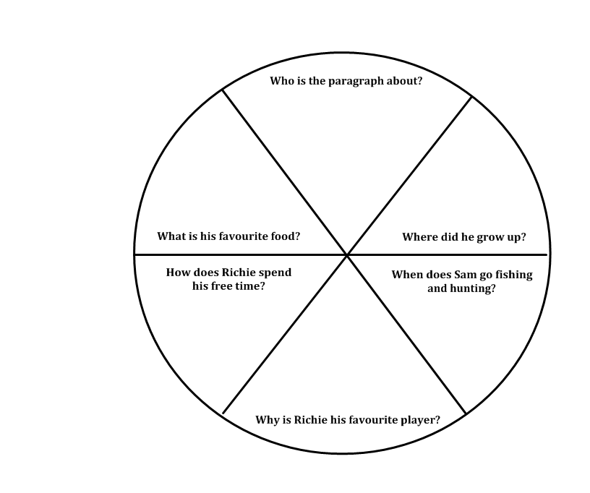
STRETCH
When you summarise look for the main idea and the main supporting details. Then put the information into your own words. Try it with the paragraph below.
Sam played his first test for the All Blacks in June 2010. He came on as a reserve in the victory against Ireland. Sam’s next seven tests were all as a replacement.
Finally, in November 2010 Sam got his first test match start. He was named as lock to play against England.
Sam made the most of his opportunity. He won all of his lineouts and even stole one from the opposition! Sam was also one of the first players to get to rucks. He was one of the hardest working players in the game

Which is the best summary of the paragraph?
- Sam played his first test for the All Blacks in June 2010. He was a reserve in the game.
- Sam won all of his lineouts in the game against England.
- Sam waited a long time for his first test start, but when he got it he made the most of it. He was great in the lineouts and worked hard around the field.
TRAINING
One good way to summarise is to take notes as you read. After each paragraph write a summary. Here’s how to do it:
- Look for the main idea and the main details
- Combine them and put them into your own words
Try it with the article below.

Sam has three brothers: Adam, George and Luke. When the boys were young they played many tough games of rugby against each other on the family farm. Being boys the games could get pretty fiery! Sam learned that if he want- ed to win, then he better bring his best effort, every time!
Sam’s oldest brother is George. In 2005 George captained the New Zealand under 19 team. He was also the first Whitelock to join Canterbury. Sam took note of how professional his brother became. He saw firsthand the sacrifices and training it would take to become a top rugby player.
Though they are all grown up now, the four brothers still help each other. That’s because they all play for Canterbury! Adam, George and Sam are in the Crusaders Super 15 squad. Youngest brother Luke is in the Canterbury Colts. Sam loves having his brothers around. ‘We all look after each other,’ he says.

Which is the best summary of this paragraph?
- Sam and his brothers played rugby on their farm.
- Sam and his brothers competed against each other and that’s how Sam learned to be tough.
Which is the best summary of this paragraph?
- Sam’s oldest brother George is a good rugby player.
- Sam learned what he needed to do to get better by watching his older brother.
Which is the best summary of this paragraph?
- Sam’s youngest brother plays for the Canterbury Colts.
- All four Whitelock boys play for Canterbury and help each other just like they did when they were young.

Which is the best summary of the whole article?
- The four Whitelock brothers are all good rugby players
- Sam’s brothers have played a big part in his success. From them he learned about toughness and professionalism. They continue to support him.
- Sam has three brothers: Adam, George and Luke.
GAMETIME
Now it’s your turn to summarise. Read the following article. Summarise each paragraph as you go. Then summarise the whole article.

Remember, to summarise:
- Look for the main idea and the main details
- Combine them and put them into your own words
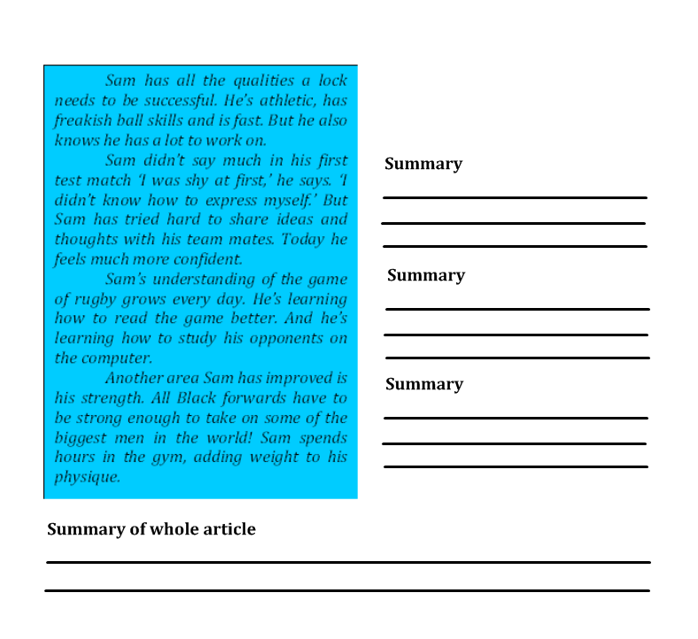

EXTRA TIME

Have you ever wondered where Sam gets his amazing lineout leaping ability from? You can find out in the paragraph below. When you finish reading, write and draw a summary. Drawing a summary is the same as writing it. Do you remember how to summarise? Look back over this lesson to recap, then give it a try.

As well as being one of the best rugby players in the world, Sam is also a great basketball player. That’s right, basketball is his second love.
When he was younger, Sam had the potential to go a long way in basketball. In 2006 he was selected for the New Zealand under 18 training camp.
Sam’s favourite player is NBA legend Michael Jordan. Michael Jordan changed the way people played basketball. He made it exciting and fun. But he was tough as well. He once played an NBA semifinal game with the flu!
Sam has the amazing ball skills and leaping ability of a top basketball player. He likes having fun and he’s tough. He might be the Michael Jordan of rugby!

Written summary | Picture summary

WARM DOWN

Choose two articles in this workbook. Read them again. Then write a summary of each article below.

Article 1 Title:

Summary

Article 2 Title:

Summary

Identify the author’s purpose

All Black centre Conrad Smith plays rugby for many reasons. He plays because he enjoys the game. He plays because it’s his job. And he plays because he likes to win!

When someone writes an article, a story or a book they have a purpose too. Here are three common purposes for writing:
- To entertain: give you something descriptive, funny, sad, scary or inspirational to read
- To inform: tell you some information about something
- To persuade: make you believe or think something

WARM UP

Look carefully at the different types of writing in the first column below. In the second column write the most likely purpose for writing – to entertain, to inform or to persuade.
Style of writing | Purpose
A newspaper article about Conrad’s latest game

A poem about Conrad

A funny story about Conrad

A Wikipedia article about Conrad’s background.

A letter from Conrad’s mum to the All Black coaches, telling them why they should pick Conrad.

STRETCH

Sometimes an author will have many purposes for writing a text. The author of the article below has three purposes for writing. Find examples of each and write them in the table. One has been done for you.

Conrad loves living in New Zealand. He loves the crystal blue coastal waters, the fresh and lush green forests, the dark and magical lakes.
Conrad wants future generations of children to experience New Zealand like this too. That’s why he agreed to be a Project Litefoot Ambassador.
Project Litefoot suggests ways Kiwis can help protect our environment:
- Turn lights off when they are not in use
- Switch electrical appliances off at the wall
- Recycle everything!
- Use cold water instead of hot water
- Drive less walk more
‘We are proud people as Kiwis,’ Conrad says. ‘And if we led the way in this it’s something we could be proud of.’

TO ENTERTAIN  look for words that are interesting to read | TO INFORM  look for new information | TO PERSUADE  look for places the author asks you to do or think something
 | Conrad is a Project Litefoot Ambassador

TRAINING

Knowing the author’s purpose can give you a head start to understanding what you are reading. It helps you figure out why a writer would include some information and leave some out. And why a writer would use a particular style of language.

Try it with the article below.

Are you a small person? Do you sometimes think you can’t achieve your dreams because of your size? Conrad Smith knows how you feel.
Back in 2003 Conrad wasn’t even given a trial for the Hurricanes B team! Why? The coach thought he was too small!
Did Conrad give up? No. He decided to use his size to his advantage. Being small meant he could get through tiny gaps in the defence. That’s how he got the nickname ‘Snake’!
Over the years Conrad has managed to put on weight. He drinks protein shakes and eats lots of fruit and soup after training.
But he never forgets what it was like to be one of the smallest players on the field. ‘There’s a place for every type of player,’ he says.
Conrad never let size stop him from achieving his goals. Neither should you.

1. What do you think is the author’s main purpose for writing this article?

a. to entertain
b. to inform
c. to persuade
d. all of the above

2. What do you think the author is trying to persuade you to think?

3. What words show this?

GAME TIME
Here are more questions you can ask when you are thinking about a writer’s purpose:

Why did the person write this text?
Who is the intended audience?
How does this influence the way it is written?

Practise with the following article. As you read it think, what is the author’s most likely purpose for writing this text? Who is the most likely audience? How can I tell?

So you think you don’t need to go to class? You don’t have time to do English, or Maths, or Science, because you’re gonna be an All Black? You say it’s not possible to play rugby and study. Well I’ve got news for you – you can do both. You want proof? I got your proof. Let me school you on Conrad Smith.
Conrad went to Francis Douglas Memorial College in New Plymouth. He played lots of sports – cricket, rugby, soccer. But Conrad also did well in classwork, debating and drama! He was even deputy head boy. You still wanna tell me there’s no room for both sports and study?
When he finished high school Conrad moved to Wellington, home of the Hurricanes. Home also of Victoria University. Conrad studied Law during the day and trained for rugby at night. In 2003 he graduated with a Law degree.
Some players tease Conrad, the rugby playing lawyer. They call him ‘geek.’ But one day they might need a lawyer. And they’ll be glad Conrad believed in sports and study.
So, do you still think you don’t need to go that class?

1. What kind of person do you think the author is?

2. What makes you think that?

3. Who do you think the intended audience is?

4. What makes you think that?

5. What do you think is the author’s purpose for writing this article?

6. What words show you this?

EXTRA TIME
‘Question the Author’ is another strategy you can use after you have read a text. Here’s how to do it:
  - Read the text
  - What is the author trying to say?
  - Why does the author want to say this?
  - Is it said clearly?
  - How could the author have said it more clearly?
Choose another article in this workbook and try this strategy out.
WARM DOWN
Who is the best rugby player in the world? Write a paragraph that tries to persuade readers to agree with you. Swap your writing with a friend. Underline examples of your friend’s persuasive language.

Connecting
Isaia Toeava studies hard during the week of a big game. He takes notes in his workbook, revises the things his coaches say and practises set moves. When he runs on to the field he connects what he has learned with what he sees in front of him. That’s one of the reasons he’s one of the most versatile rugby players in the world.

Active readers make connections before, during and after reading. You will understand what you are reading better if you can connect it to other things you know. Here are three kinds of connections you could make:

  - PERSONAL - connections to your own personal life, experiences you have had, times you felt the way a character in the text feels.
  - TEXT - connections to other texts like movies, books, songs and tv programs.
  - WORLD - connections to events and people in the world.

WARM UP

Read the following paragraph about Isaia’s early days. Then study the readers’ connections underneath. Decide what kind of connection each reader made.

If it wasn’t for friendship, Isaia may have been a New Zealand Warrior today, rather than a New Zealand All Black! That’s because when he was young he played rugby league. Isaia played standoff for the Papatoetoe Panthers. Isaia loved playing league. So why did he switch to rugby? Because his best friend did!

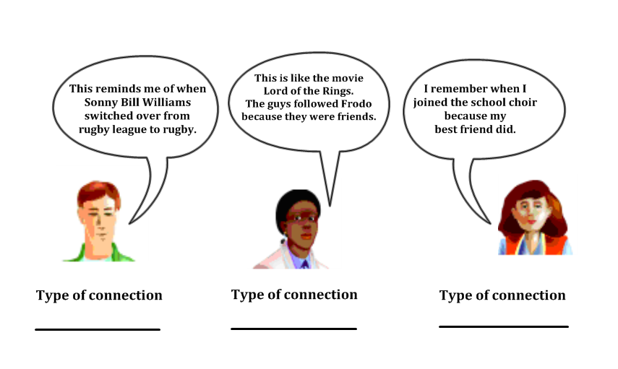

STRETCH
Read the following paragraph. Then make your own connection to it.

Isaia is a very spiritual person. He belongs to Saint Therese Catholic church in Mangere, South Auckland. Isaia prays before and during every game. He asks the Lord to guide him, to give him strength and to look after everyone. 'My faith is very important to me,' he says. | CONNECTION  What kind of connection  did you make?

TRAINING
Read the next article and see if you can make one of each kind of connection.

Isaia was only 19 years old when he was first named in the All Blacks. Here’s how it happened:  It’s a Saturday evening in October 2005. Isaia is on his way to dinner with the Auckland rugby team. His phone rings.  Isaia checks the Caller ID. He doesn’t recognise the number. ‘Hello Isaia, this is Graham Henry. We have selected you for the All Blacks. Congratulations!’  ‘Huh?’  ‘You’re an All Black! But I have to ask you not to tell anyone. The official announcement is tomorrow. Can you keep it secret until then?’  Isaia puts the phone down, in total shock! ‘Who was that?’ asks one of his friends. ‘Oh, just an old mate,’ Isaia replies, smiling from ear to ear. | PERSONAL CONNECTION  TEXT CONNECTION  WORLD CONNECTION

GAME TIME
The best connections are ones that help you understand the text better.

- help you understand how a character feels
- help you visualise what you are reading
- help you understand the author’s main idea

Sometimes you have to think a little longer to make a connection like this.
Read the next paragraph and make a thoughtful connection. Then explain how the connection helps you understand the text better.

Isaia is a very skilful player. He’s quick and strong. He’s a great passer. And he can kick too. He can play every position in the backline except scrum half! ‘I don’t mind too much,’ Isaia says. ‘As long as I get on.’  Isaia is humble too. He once won man of the match after a game against Australia. What did he do with his trophy? ‘It’s a bit too flash for me,’ he said. ‘I’ll take it home and give it mum and dad. They’ll look after it.’  No wonder All Black Coach Graham Henry says, ‘He’s like gold to us.’ | CONNECTION
HOW DOES THE CONNECTION HELP YOU UNDERSTAND THE TEXT BETTER?

EXTRA TIME

Keep practising the skill of making thoughtful connections. Remember: a thoughtful connection is one that helps you understand the text better.

Read the article about Isaia’s rugby journey and see if you can make two thoughtful connections. For each, explain how it helped you understand the article better.

Isaia played his first game for the All Blacks on 26th November 2005. It took place at the famous Murrayfield stadium in Edinburgh, Scotland. The day was cold, overcast and windy!
As 50,000 Scottish fans sang ‘Flower of Scotland,’ Isaia shivered. And it wasn’t just because of the weather. Just a few months earlier he was playing for the New Zealand under 19s. Now here he was . . . in an All Black test match! Isaia wondered if he really belonged.
Fast forward six years and ‘Ice’ is a completely different player. He is one of the senior members of the team. He’s played 30 tests for the All Blacks and scored 7 test tries. The only shivering now comes from Isaia’s opponents, wondering how they can shut him down!

Connection 1

Type of connection

How does it help you understand the article?

Connection 2

Type of connection

How does it help you understand the article?

WARM DOWN

What have you learned about reading from this section?

Evaluating
Jimmy Cowan’s position is scrumhalf. It’s one of the most important positions on the field. He evaluates the situation. Then he decides whether to kick, pass or run.

Evaluation skills are important in reading too. You gain more understanding when you respond to the reading in a personal way.

WARM UP
Have you ever wanted to be an All Black selector? Here’s your chance! Your job is to choose the scrumhalf for the next All Black test match. Here are five contenders. Read the notes and evaluate each player. Make your choice and give three reasons to support your decision.

NAME | BORN | HEIGHT | WEIGHT | ALL BLACK DEBUT | ALL BLACK TESTS | SKILLS
Jimmy Cowan | 1982 | 1.83m | 95kg | 2004 | 44 | - Strong and aggressive  - Clever at kicking  - Defence  - Running
Andy  Ellis | 1984 | 1.81m | 89kg | 2006 | 18 | - Fast  - Passing  - Quick thinker  - Knows how Dan Carter plays
Brendon Leonard | 1985 | 1.82m | 91kg | 2007 | 13 | - Fast  - Hard worker  - Try scorer  - Passing
Alby Matthewson | 1985 | 1.73m | 91kg | 2008 | 4 | - Gets to rucks fast  - Knows right thing to do  - Passing
Piri  Weepu | 1983 | 1.78m | 96kg | 2004 | 44 | - Linebreaker  - Passing  - Knows right thing to do  - Can play #10  - Kicks goals
The scrumhalf I choose is
Reasons

STRETCH
Read each of these comments by or about Jimmy Cowan. Circle AGREE, UNSURE or DISAGREE. Then give a reason for your evaluation.
TRAINING
 |  | Your reason
Jimmy likes to eat chocolate before big games. | WHAT DO YOU THINK ABOUT THIS?  AGREE UNSURE DISAGREE
Jimmy once hurt his knee at training, but hid the injury from his coaches. Every few hours during the night he got up to ice it. He thought he might not get picked if the coaches knew. | WHAT DO YOU THINK ABOUT JIMMY’S ACTIONS?  AGREE UNSURE DISAGREE
Jimmy says he doesn’t need ‘God Defend New Zealand’, or the haka to get him excited. ‘When I put that jersey on I know what I’ve got to do.’ | WHAT DO YOU THINK ABOUT JIMMY’S ATTITUDE?  AGREE UNSURE DISAGREE
Early in his career, the New Zealand Rugby Union asked Jimmy to come to a special meeting. Jimmy had gotten into trouble a few times while out drinking. The NZRU felt they had to do something.

Some people thought the NZRU might cancel Jimmy’s contract with them. But the NZRU believes it’s better to try and help someone than reject them. They gave him a choice – alcohol or rugby?

‘It was a pretty easy sacrifice to make,’ Jimmy says. ‘Playing for the All Blacks means the world to me. I still have a good time with my friends. I just drink lemonade now.’

The sacrifice has paid off for Jimmy. He has become one of the best scrumhalves in the world!

Questions

1. Some people thought the NZRU was too ‘soft’ on Jimmy. They felt Jimmy should have been suspended, even fired. Do you agree with the way the NZRU dealt with Jimmy?

YES UNSURE NO
Explain

2. Who would you recommend should read this article?

Explain why

GAMETIME
In 2004 the All Black coaches wanted more leaders in the team. So they asked some older players to form a leadership group. Their job was to encourage the team to be excited and positive. They also looked after new players, making sure they felt welcome and part of the team.

Jimmy was invited to join the leadership group in June 2009. The All Black coaches were proud of the way he overcame challenges in his life. They believed he was a good role model in the team. Jimmy accepted the invitation. He thought being a leader would help him become a better player.

Questions
1. Do you think asking Jimmy to join the leadership group was a good idea?
YES UNSURE NO
Explain

2. Decide on the five most important qualities you think a player should have to be in the leadership group.



EXTRA TIME

Jimmy has a routine for the way he likes to prepare for a test match. Early in the week he focuses on studying. He memorises the plays. He draws the moves in his workbook. In the middle of the week he focuses on his physical skills. On the night before the game he gets his book out again and reviews everything. Jimmy believes preparation is the key to good performance.

You can also use a PMI chart to evaluate an idea or a piece of text.
P = PLUS – what are the positives/the good things/the benefits?
M =MINUS – what are the negatives/the weaknesses?
I = INTERESTING – what else do you wonder or want to find out?

P  What are the positives of working this way? | M  What negatives might there be? | I  I wonder why…  I wonder what…
Evaluate the paragraph above using the PMI method.

WARM DOWN
‘The All Blacks are good role models for young people.’
Write an argument agreeing or disagreeing with this statement.

Creating
All Black winger Cory Jane knows how to create try scoring opportunities. He thinks about what he knows about his opposition. Then he creates new ways to attack them.

After you have finished reading a text you can start creating too. First, think about things you learned in your reading. Then use the information in new ways.

WARM UP

A useful activity to try is a ‘Category Brainstorm’. Here’s how to do it.
1. Brainstorm everything you learned in your reading
2. Put the ideas into groups
3. Give the groups titles

Here’s an example. The topic is ‘music.’

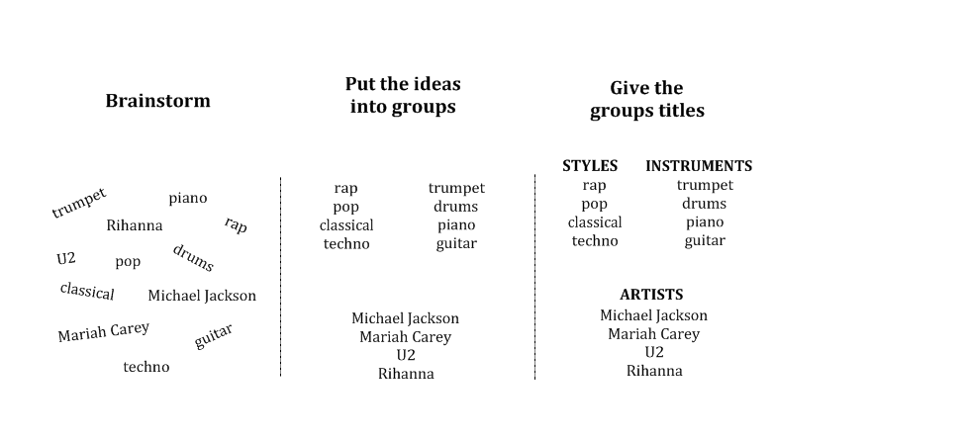

Now it’s your turn. The topic is Cory Jane.
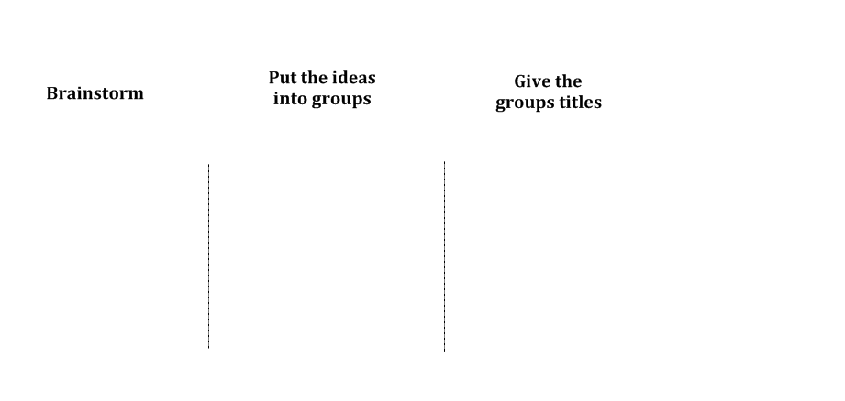
STRETCH

Cory says he has always been a smaller player. But did he see it as a problem? Definitely not! If anything, it makes him a better player. Cory spends a lot of time thinking of ways he can get around his opponents. He’s not going to run over the top of them like Jonah Lomu used to!

How many ways can you think of getting around an opponent?

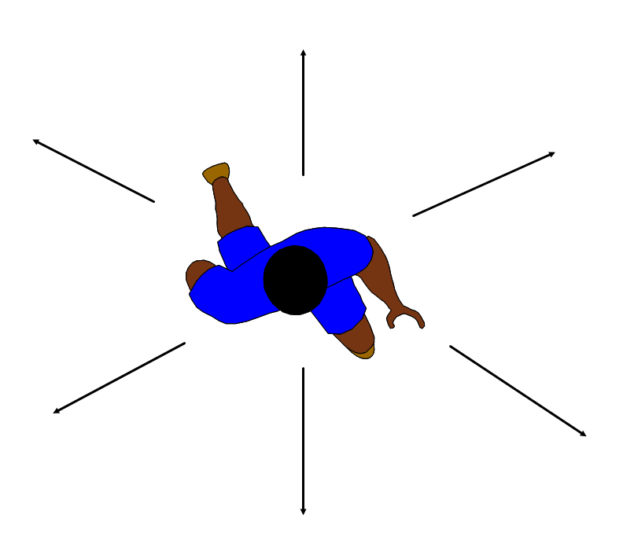

TRAINING
Cory admits that he wasn’t the best student at school. He attended Heretaunga College, a small school in Upper Hutt near Wellington. The school is not known for rugby.

‘I would tell my teachers that I wanted to be an All Black,’ Cory says. ‘I felt that rugby was the only thing I was good at. I didn’t know what else to do.’

Here’s how a typical day at school might go.

CORY: What have we got next period?’
FRIEND: ‘Maths.’
CORY: ‘Aww man, I can’t concentrate in that subject. Look! There’s a reliever going into PE. I’m gonna sneak in there.

Cory just wanted to train all day!

‘It was stupid thinking,’ he says now. ‘If I didn’t make the All Blacks, I would be in trouble.’

Create: Think of ways a Maths teacher could attract young people like Cory to come to class.

GAME TIME
Cory may be one of the best rugby players in New Zealand now. But when he was younger not many people would have predicted that. Cory didn’t get picked in any rep teams when he was growing up. But Cory didn’t let that get in the way of his dream of one day becoming an All Black. He just kept working. ‘It drove me on,’ he says.

Cory’s first real moment of fame came in 2006. He was a member of the New Zealand Sevens team that won the gold medal at the Commonwealth Games. ‘Sevens got my name out there. It gives you confidence … the will to go as hard as you can.’ Cory learned that you don’t have to be the fastest or the strongest. You will succeed if you give everything you have.

On 1st November 2008 Cory’s dream came true - he became an All Black! He came on as a reserve in the 19-14 win over Australia in Hong Kong. ‘To get out there and do the haka was great,’ he says.

After the game Cory asked his teammates to sign his jersey. When the tour was over he put the jersey in a glass frame. Just to be sure he really is an All Black, Cory sometimes spends time staring at his framed jersey. ‘How unbelievable that I accomplished my dream,’ he says.

Create three titles for this article
1.

2.

3.

EXTRA TIME

Cory’s rugby nickname is ‘Soup’. He got the name because he eats what he likes and never puts on weight! Choose three other players in this workbook. Think of a nickname for each one. Explain how the nickname is appropriate.

Player | Nickname | Reason
Cory Jane | ‘Soup’ | Because he eats  whatever he likes  and never puts on weight.

WARM DOWN

Cory enjoys going back to Upper Hutt where he grew up. He likes to inspire children and young people. He wants them to know they can achieve their dreams just like he has.

Write part of an inspirational speech that Cory might give to students at his old school Heretaunga College.

Conclusion
Congratulations! You have reached the end of this workbook. I salute you!

But it doesn’t mean you have finished learning how to read. It’s a lifelong journey and you’ve only just begun!

Remember to always believe in yourself. You have learned strategies to help you whenever you read.

It’s up to you to practise, practise and practise some more. As Dan Carter says, ‘practise makes you perfect.’ He should know – he’s one of the best goal kickers in history!

If you continue to practise the strategies you have learned in this workbook you will become a great reader!

Sources

Preview and Predict

‘He was a fine young man . . .’ Peter White. Pride of the South. NZ Rugby World. Issue 126. October 2009.
‘It’s an unreal feeling. . .’ Sportstar Insider. Beyond Productions. 2009.
‘There are risks . . .’ Cath Bennett. High Flier. Sunday News. 1 November 2009.
‘It's been a good year. . .’ New Zealand Honoured by Trio of IRB Awards. 1 December 2010. www.irb.com. Retrieved 12 December 2010.
Know your purpose for reading

‘No matter where I am . . .’ Rugby Center. Sky TV. 8 September 2010.

Find the main idea

‘I’m not a hothead.’ Richard Knowler. Owen Franks told to keep lid on aggression. The Press. 6 March 2010
‘It’s exciting when someone challenges . . . ’ Richard Knowler. All Blacks prop favours a bit of test match biff. The Press. 6 August 2010.
‘I just have to choose. . . ’ Richard Knowler. Owen Franks told to keep lid on aggression. The Press. 6 March 2010
If I’ve prepared properly. . .’ Brent Edwards. Brothers In Arms. New Zealand Rugby World. Issue 132. June 2010.
‘For guys playing in the front row. . .’ Gregor Paul. New Zealand Rugby World
‘Anything that comes out of the ground . . . ’ Gregor Paul. New Zealand Rugby World
‘Never give up. . .’ Gregor Paul. New Zealand Rugby World
‘We both wanted . . .’ Glenn Mclean. Weights pay off for younger Franks. Taranaki Daily News. 11 June 2010

Find details

‘We’ve got to look after him. . .’ Chris Barclay. NZPA. Ma’a Nonu praises Sonny Bill’s transition.24 October 2010.
‘Just getting out in the water . . .’ Samantha Ives. Ma’a Nonu’s other passion. The Wellingtonian. 20 January 2011
‘Ma’a is a highly skilled player.’ Nonu is a real kicking talent – Smith. NZPA. 2 December 2004.

Inferring

‘If you eat well, you will play well.’ Mils Muliaina with Lynn McConnell. Living the Dream. Hachette: Auckland. 2009.
‘I hadn’t had it for so long . . .’ Mils Muliaina. Living the Dream.
‘I should have really sacrificed . . . ‘Mils Muliaina. Living the Dream.
‘I thought I had let the team down.’ Mils Muliaina. Living the Dream.

Use context clues

‘To get dropped . . .’ Fairfax Media. The third coming of Kaino. 30 October 2008.

Visualise

‘That’s the way we did it . . .’ Gregor Paul. The Wrath of God. New Zealand Rugby World. Issue 135. September 2010.
‘I had never seen guys that big...’ Gregor Paul. The Wrath of God. New Zealand Rugby World. Issue 135. September 2010.
‘He’s a guy who looked after me …’ Gregor Paul. The Wrath of God. New Zealand Rugby World. Issue 135. September 2010.
‘I had never illustrated . . .’ Barfoot and Thompson. Media release. 9 December 2008
‘I'm not sure if I draw too good . . .’ Spasifik Magazine. Issue 41. November/December 2010.
‘It’s a hobby for me . . .’ Spasifik Magazine. Issue 41. November/December 2010.

Sequence

‘It doesn’t matter . . .’ Alan Perrott. Man in Black. Weekend Herald. 1August 2009.

Compare and Contrast

‘five years of hard work . . .’ NZPA. Texts from Joe put Sivivatu at ease. Sportal.co.nz. 8 June 2005.

Fact and Opinion

‘I was honoured . . .’ Jim Kayes. Rock Steady. New Zealand Rugby World. 31 August 2010.
‘When you hit Tony. . . ’ Richard Knowler. Prop combines strength, mobility. The Press. 7 August 2010.
‘Every time you pull on the black jersey . . .’ Marc Hinton. Tony Woodcock: Quiet Achiever. 5 August 2010. NZPA.

Questioning

‘I don’t want to let my family down . . .’ Richard Knowler. Sonny Bill Williams 'disappointed' in performance. Fairfax Media. 7 November 2010.
‘I love the sport so much . . .’ Brad Walter. Sonny Bill sticks to guns despite unfriendly fire. Sydney Morning Herald. 23 December 2010.
‘I have to put myself in different situations . . .’ Ed Jackson. Sonny Bill fends off criticism of his pending boxing bout. The Roar. 16 December 2010.

Summarising

‘We all look after each other . . . ‘ Wynne Gray. Whitelocks formidable force. New Zealand Herald. 16 October 2010.
‘I was shy at first. . .’ Dylan Cleaver. Whitelock’s stature grows on tour. New Zealand Herald. 23 November 2010.

Identify Author’s Purpose

‘We are proud people as Kiwis . . .’ Spice Communications Group. Top sporting heroes become action heroes with Project Litefoot. www.projectlitefoot.co.nz. Retrieved 12 January 2011.
‘There’s a place . . . ’ David Ferguson. ‘Skinny’ Conrad Smith sizes up opponent Max Evans and gets it all wrong. http://sport.scotsman.com/rugby/39Skinny39-Conrad-Smith-sizes-up.6622941.jp. Retrieved 20 January 2011.

Connecting

'My faith is very important to me.' Isaia Toeava. All Black Player Diary – Isaia Toeava. 3 July 2006. www.allblacks.co.nz. Retrieved 25 January 2011.
‘I don’t mind too much . . .’ Fairfax Media. Toeava reveals confidence crisis. 12 August 2008.
‘He’s like gold to us.’ NZPA. Toeava shocked at elevation to All Blacks. 24 October 2005. www.allblacks.co.nz. Retrieved 2 February 2011.
‘It’s a bit too flash for me . . .’ Fairfax Media. Isaia Toeava wins the struggle within. 2 November 2008.

Evaluating

‘It was a pretty easy sacrifice . . .’ Dominion Post. Jimmy Cowan hanging tough. 14 November 2008.

Creating

‘I would tell my teachers . . .’ David Long. Cory Jane in a fight to stay in All Blacks. Sunday News 3 March 2009.
‘It was stupid thinking . . .’ Toby Robson. Cory Jane finally gets a chance. Dominion Post. 17 September 2009.
‘Sevens got my name out there . . . ’ David Long. Cory Jane in a fight to stay in All Blacks. Sunday News 3 March 2009.
‘To get out there . . .’ David Long. Cory Jane in a fight to stay in All Blacks. Sunday News 3 March 2009.

Bibliography

Books
NBA Slam and Jam Reading Skills. Scholastic: New York. 1997.
Muliaina, Mils with McConnell, Lynn. Living the Dream. Hachette: Auckland. 2009.
Tietjens, Gordon with Kidd, Heather. Titch: Sevens Is My Game. Hodder Moa: Auckland. 2006.
Mikulecky, Beatrice S. and Jeffries, Linda. Reading Power. Addison Wesley Publishing. 1998
Matheson, John. Dan Carter. Harper Collins: Auckland. 2010.
Matheson, John. Richie McCaw. Harper Collins: Auckland. 2009.

Websites
www.allblacks.com
www.irb.com
www.rugbymuseum.co.nz

Acknowledgements
Amber Fallow - NZPA
Stephen Berg – NZ Rugby Museum
Gregor Paul – NZ Rugby World

