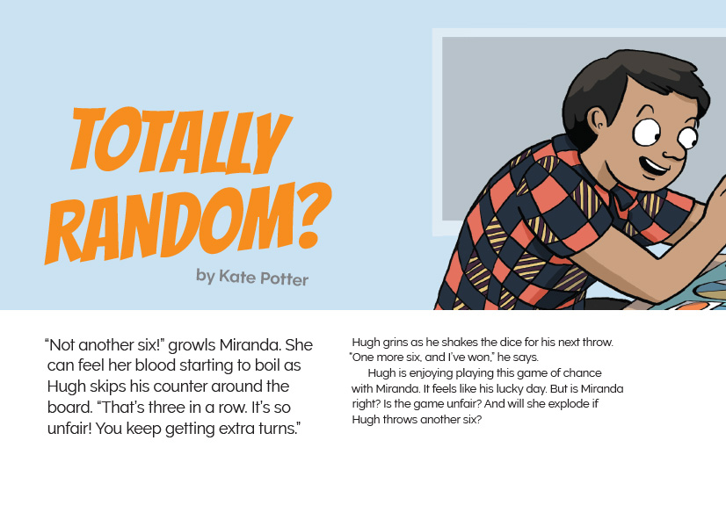
Connected
Level 3
2016

Totally Random?
by Kate Potter

Overview
This article provides an entertaining introduction to the mathematical concepts of randomness, patterns, and fairness and demonstrates the application of these concepts in our everyday lives.
A Google Slides version of this article is available at www.connected.tki.org.nz.

Curriculum contexts

MATHEMATICS and STATISTICS: Statistics: Probability  Level 3 – Investigate simple situations that involve elements of chance by comparing experimental results with expectations from models of all the outcomes, acknowledging that samples vary. | Key mathematics and statistics ideas  - Probability is the chance that something will happen.  - Randomness is the lack of pattern or predictability in events.
ENGLISH: Reading  Level 3 – Ideas: Students will show a developing understanding of ideas within, across, and beyond texts. | Indicators  The student…  - uses their personal experience and world and literacy knowledge confidently to make meaning from texts  - makes meaning of increasingly complex texts by identifying main and subsidiary ideas in them  - starts to make connections by thinking about underlying ideas in and between texts  - makes and supports inferences from texts with increasing independence.

The New Zealand Curriculum

Meeting the literacy challenges

The main literacy demands in the text lie in the use of continuous and non-continuous text, including drawings, diagrams, and tables that support abstract ideas and ideas related to “patterns” and “randomness”. The students need to negotiate these abstract concepts in a narrative text that tells the story of two friends playing a dice game. Tables are used to represent what happens when four students toss a coin forty times, requiring the students to think critically and evaluate the information.  The narrative text contains subject-specific vocabulary, figurative language, and colloquial expressions, requiring the students to think critically in a different context. | The following strategies will support students to understand, respond to, and think critically about the information and ideas.  You may wish to use shared or guided reading, or a mixture of both, depending on the reading expertise of your students and the background knowledge they bring to the text.  After reading the text, support students to explore the activities outlined in the following pages.

INSTRUCTIONAL STRATEGIES

Dealing with abstract ideas  Tell the students the title and ASK QUESTIONS to help them make connections to what they know, then ask them to predict what the article will be about.  What do you think “random” might mean? What does “totally random” mean? What do you expect to find out from reading this text?  TELL them that the article includes definitions of the words “random” and “pattern”. Have them find these definitions, read them, close the book, then tell a partner, in their own words, what they think these words mean. Now ask them to rate their understanding of these terms on a continuum from 1 (“I still have no idea”) to 5 (“I can confidently explain these terms and give examples of when to use them”).  The text includes colloquial phrases that may be unfamiliar to some students, especially English language learners. ASK QUESTIONS to check their understanding.  Why does Miranda feel her “blood starting to boil”?  What does it mean to talk about someone’s “lucky day”? Have you had one recently?  Is Miranda really likely to “explode”? Why or why not?  Have you heard the term “fair’s fair” before? What do you think people mean by it?  When people toss a coin, why do they call “heads” or “tails”?  At the end of the story, Miranda’s “heart is racing”? Is it really? What does that mean? Why do you think her heart is racing?  Using the diagrams and tables to deepen understanding.  Ask the students to read the section “Patterns, Patterns Everywhere”. Have them work in pairs to figure out what comes next in the pattern. Prompt them to think about how the visual representation made it easier for them to work out what came next.  How do these illustrations help you to understand a pattern?  Would you be able to describe the pattern to someone without showing them? How hard or easy would that be? | Now ask the students to look at the tables on page 7.  How do these representations help you to know who did and who didn’t toss a coin?  What information did you draw on to help you know the answer?  Thinking critically about how abstract ideas are conveyed  After reading the article, have the students repeat their explanation to a partner of the meanings of “random” and “pattern”. Then have them rate how confident they are in their understandings now. ASK QUESTIONS to start the students thinking about how the author conveyed these tricky statistical concepts.  How many of you feel that you are better able to explain what these two words mean after reading this article? Why?  Looking back over the article, what techniques did the author use to get you interested and help you understand the words?  LIST the students’ suggestions. These may include (but are not be limited to) the following:  - Lots of direct questions (including the title) that challenge the reader to think about how they could be answered  - Humour, especially in describing Miranda’s feelings about the game  - The familiar situation of playing a game and the feelings of tension it creates  - The use of familiar emotions  - The use of colloquial language to help explain a complex subject in a way that the reader can relate to  - Definitions accompanying the words “random” and “pattern”  - Activities that support the explanation and allow the reader to experience the concept first hand  - Examples that are familiar to us, from playing sport and listening to music  - The photos and illustrations that support the descriptions.

Meeting the literacy challenges

TEACHER SUPPORT
Probability is the  chance that something will happen.  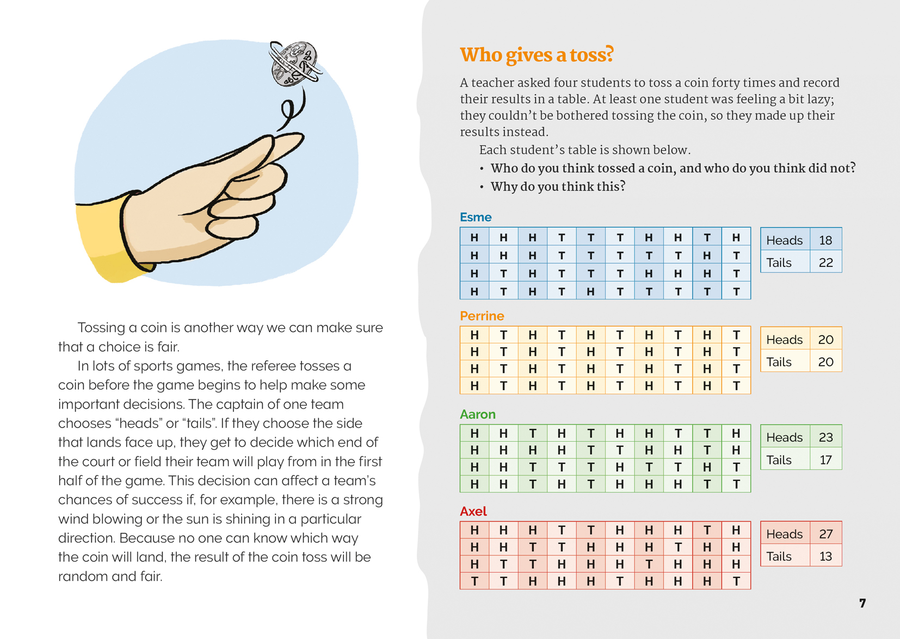  Randomness is the  lack of pattern or predictability in events. | Students investigate outcomes to compare experimental results with expectations.  Randomness is the  lack of pattern or predictability in events.

Reading standard: by the end of year 6
The Literacy Learning Progressions
Effective Literacy Practice: years 5–8

Learning activities – Exploring the
mathematics and statistics
The following activities are a guide for supporting students to explore and develop understandings about the statistics concept of randomness. Some activities extend student content knowledge across the learning areas. Adapt these activities to support your students’ learning needs.

Activity 1 – Tabling data  Discuss the four tables in the coin toss activity “Who gives a toss?” on page 7. Explain that these are called tally sheets and that people use tally sheets to keep a record of data. Have the students create their own tally sheets and test whether it is true that, in a game that uses a normal dice, every player has the same chance of throwing a six.  To make this activity even more interesting, you could include one or more secretly weighted dice and, once the students have filled in their tally sheets, invite them to guess which dice was/were weighted. Instructions for creating a loaded dice are included under “Resource links”. Note that you will need to make sure you know who has the weighted dice and make sure they don’t swap their dice during the test!  Extending the learning  An Experiment with Dice is an interactive activity that explores probability. The activity asks students to work out the most likely total score if they throw two dice together and add the scores. The students create a tally sheet and record their data. They can then use an interactive tool to graph their data. The activity explains the reason for the shape of the graph and the difference between theoretical and experimental results.  Students can choose to create a pie, line, or bar graph. This gives them the opportunity to compare the similarities and differences between the three different types of graph and think about which was most effective in showing the results. | Activity 2 – Fun with probability  The game Two-up originated in colonial Australia and was popular with Australian troops during the First and Second World Wars. Today it is illegal in Australia on all days but ANZAC Day. However, a children’s version provides a fun way to learn about probability (see “Resource links” below for details on the rules and history of the game). Having played a game, discuss why the adult game is illegal. What makes it different from other games of probability?  See “Resource links” below for more probability games and activities. After they have tried some, ask the students to suggest other games they know about that involve an element of chance. Have some examples on hand and talk about the aim of each game, the most important rules, and the role that chance plays in each game. Draw out the idea that a large part of what makes such games fun is the uncertainty.  Encourage the students to invent their own game of chance. It should be reasonably simple, and they will need to write down the rules so that they are clearly understood before people begin to play. Keep the rules for the earlier games close at hand so that the students can refer to them as they put together their rules. Give the students time to try each other’s games and then discuss whether or not the outcome for each game really was random.

RESOURCE LINKS

NZMaths  “Random or not” (a range of statistics activities relating to probability): http://nzmaths.co.nz/taxonomy/term/317?page=2  “Long running” (theoretical probability versus experimental estimates of probability): http://nzmaths.co.nz/resource/long-running  Statistics New Zealand  Statistical investigation interactive games: www.stats.govt.nz/tools_and_services/schools_corner/Activities/Interactive-Games.aspx  Figure It Out  Statistics, Level 2–3 (Revised edition)  http://nzmaths.co.nz/figure-it-out-carousel-interface#c=11;p=0  - Sneaky Snakes, page 21  - Way to Go, page 22  - Which When?, page 23  - In Between, page 24 | Statistics, Level 3 (Revised edition) http://nzmaths.co.nz/figure-it-out-carousel-interface#c=24;p=0  - Scratch ’n’ Win, page 18  - Superbeans, page 20  - Dicey Differences, page 24  Statistics, Level 3–4 (Revised edition) http://nzmaths.co.nz/figure-it-out-carousel-interface#c=33;p=0  - Left to Chance, page 1  - Crossing the Line, page 20  - The Unit Fraction Game, page 21  - Dylan’s Dominoes, page 22  Probability  Number games: Probability game for kids: www.kidsmathgamesonline.com/numbers/probability.html  Teaching primary school children about probability: Teacher Handbook (Unit 1: Randomness, pages 16–33): www.education.ox.ac.uk/wordpress/wp-content/uploads/2011/11/Teachers-Probability-Handbook.pdf

Learning activities – Exploring the mathematics and statistics

RESOURCE LINKS (continued)

Randomness  Census at school: Teaching randomness: http://new.censusatschool.org.nz/wp-content/uploads/2012/11/Teaching-randomness21.pdf  Randomness and chance activities: www.tinkerplots.com/activities/randomness-and-chance-activities  Playing with dice  How to load dice (four ways to load dice): www.wikihow.com/Load-Dice  Maths Fun: Activity: An experiment with dice: www.mathsisfun.com/activity/dice-experiment-2.html | Two-up  Kidspot: How to play Two-up for kids: www.kidspot.com.au/things-to-do/activities/how-to-play-two-up-for-kids  Two-up or ‘Swy’, the Digger’s gambling game: www.diggerhistory.info/pages-asstd/two_up.htm  RSL Magnetic Island: Two-up (history and rules): http://rslmagneticisland.com/two-up  The Sydney Morning Herald: Anzac 100: The mathematics behind two-up (article): www.smh.com.au/national/ww1/anzac-100-the-mathematics-behind-twoup-20150414-1mkygh.html [For teachers only]  iPod shuffle  BBC News Technology article “How random is random on your music player?” www.bbc.com/news/technology-31302312

