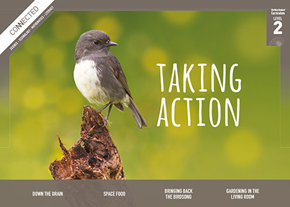
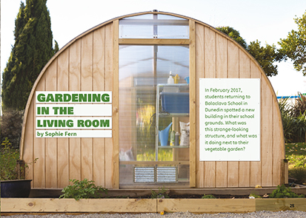
Connected
Level 2
2017

Gardening in the Living Room
by Sophie Fern

Overview
This article describes how students at Balaclava School plan to use a greenhouse (the Living Room) to grow vegetables during the cold Dunedin winter. They investigate which vegetables grow best inside and outside. The article explains how plants grow and how a greenhouse works, and it links to the wider idea that we can use technology to adapt environments to grow more food.
A Google Slides version of this article is available at www.connected.tki.org.nz.
Curriculum contexts

SCIENCE: Nature of Science: Participating and contributing  Level 2 – Students will explore and act on issues and questions that link their science learning to their daily living. | Key Nature of Science ideas  When we engage scientifically with an issue, we:  - Look for a range of scientific information that relates to the issue  - Check that information we use is from a trustworthy source  - Consider the reliability and validity of the evidence  - Decide if and how to respond to the issue, justifying our decisions based on evidence and/or reliable scientific information  - Monitor the effects of any actions we take.
SCIENCE: Living World: Life processes  Level 2 – Students will recognise that all living things have certain requirements so they can stay alive.  SCIENCE: Living World: Ecology  Level 2 – Students will recognise that living things are suited to their particular habitat. | Key science ideas  - To grow and stay healthy, plants need water, sunlight, air, and nutrients.  - Many plants can grow outdoors given the right conditions.  - Over time, different types of plants have adapted to the conditions that are common where they usually grow.
ENGLISH: Reading  Level 2 – Ideas: Students will show some understanding of ideas within, across, and beyond texts. | Indicators  - Uses their personal experience and world and literacy knowledge to make meaning from texts.  - Makes meaning of increasingly complex texts by identifying main ideas.  - Makes and supports inferences from texts with some independence.
TECHNOLOGY: Nature of Technology: Characteristics of technological outcomes  Level 2 – Understand that technological outcomes are developed through technological practice and have related physical and functional natures. | Key technology ideas  - The framework of a building or other structure helps to hold it up.  - Some shapes make stronger frameworks than others.

The New Zealand Curriculum

Science capability: engage with science

Capability overview
This capability requires students to use the other capabilities to engage with science in real-life contexts. It requires students to take an interest in science issues, participate in discussions about science, and at times, take action.  The dimensions of this capability can be demonstrated when students engage in discussions about science issues, including those in the media. If these discussions build on the ideas of others, emphasise logical connections, and draw reasonable conclusions, and if the speakers make the evidence behind their claims explicit, then students have the opportunity to practise playing the “game of science” (Resnick, Michaels, & O’Connor, 2010). | This allows them to deepen their understanding of what science is.  Students also need opportunities to be actively engaged in exploring real-life science issues that are relevant to them and their communities. This could involve building new knowledge with others and taking action to address local or global concerns.

More about the capability

The capability in action
Real-life science issues:  - may involve a mix of scientific issues and forms of social-science inquiry, including values and ethics  - provide opportunities to build awareness of which questions can be investigated and which questions science does not answer  - provide opportunities to see science as tentative, that is, developing over time as evidence is gathered or reinterpreted  - provide experiences of uncertainty where there is no clear explanation or solution  - allow students to gather and interpret data about a local situation or to critique a range of evidence and claims  - may generate a range of student views, responses, and possible actions.  Students  Students should have opportunities to:  - take an interest in a range of scientific issues  - participate in discussions about scientific issues  - use their developing capabilities of gathering and interpreting data, using and critiquing evidence, and interpreting representations to create a viewpoint, response, or action on scientific issues.  Teachers  Teachers can:  - establish a science classroom culture by:  - taking a personal interest in scientific issues, modelling questions, explicitly critiquing evidence, and seeking further evidence  - maximising everyday opportunities to introduce learning conversations that engage students with science and scientific issues | - helping their students to notice and investigate science in their everyday surroundings, such as ice on a puddle, the health of a local stream or river, or what happens as materials are mixed or heated  - listening to and discussing socio-scientific items in the news  - exploring locally relevant and contentious scientific issues, such as irrigation, intensive farming, or the effects of climate change  - support students to identify scientific aspects of an issue  - provide a range of resources and investigation opportunities pertaining to scientific issues that require students to use a range of science capabilities  - encourage students to seek and critically evaluate a range of scientific evidence, opinions, and actions from a variety of sources about an issue  - manage with sensitivity situations where students and their whānau may hold differing and strongly held opinions about a science-related issue, such as irrigation  - support students to identify and take appropriate actions in response to science-related issues.  It is important that students are empowered to be hopeful and see opportunities for positive action and change when considering local and global issues.

More activities to develop the capability

Meeting the literacy challenges

The main literacy demands of this text include descriptions of the investigative process a Dunedin teacher and her students used to solve the problem of growing vegetables all year round. Specific explanations provide information about how plants grow and what they need.  A diagram and explanatory text provide a basic explanation of photosynthesis. Readers will need to interpret information from diagrams and photos, as well as ideas and information from the explanations in the text, to understand the information and ideas. Mostly these explanations follow a simple cause-and-effect structure. In particular, two diagrams comparing different growing conditions for two different vegetables may need explaining. The headings guide the reader through the text. Topic-specific vocabulary is supported by a glossary. | The following instructional strategies will support students to understand, respond to, and think critically about the information and ideas.  You may wish to use shared or guided reading, or a mixture of both approaches, depending on the reading expertise of your students and the background knowledge they bring to the text.  After reading the text, support students to explore the activities outlined in the following pages.

INSTRUCTIONAL STRATEGIES

Finding the main ideas  Have the students read the title and text on page 25. DISCUSS how it hooks the reader in.  Gardening? Living room? That doesn’t seem possible. What do you think it means? Why do you think the author gave the article such a strange title?  Why does the author use questions in the introduction?  Have the students read page 26 and identify the problem that the teacher and students at Balaclava School were addressing. ASK QUESTIONS to help your students make connections to their prior knowledge.  How does cold affect plants?  How do gardeners protect plants from the cold?  Where is Dunedin? What do you know about the climate there?  EXPLAIN that the students in this article are going to test a possible solution to their problem.  It’s the job of a scientist to find solutions to problems. They test their ideas about possible solutions to find out which works best. An idea that a scientist tests is called a hypothesis. Mrs Frost has presented her students with a possible solution to the problem of growing vegetables in the Dunedin winter. What is her idea … and how does it connect to the building we saw on page 25? Let’s read on to find out more about Mrs Frost’s hypothesis and how her students will test it.  EXPLAIN that the article describes the entire process of a scientific investigation. This includes sharing the results with others so that scientific knowledge grows over time. Support the students to summarise the scientific investigation, using a chart like the one below. | The process Investigation into the effect of temperature on plant growth  The problem or question  The hypothesis  The investigation The procedure The materials and equipment they will use The single variable they will change  The data they will collect and record  The evidence they will look for to decide whether their hypothesis is correct  The message they will share with other gardener scientists  Using design features for deeper understanding  Have the students look closely at the photograph of the Living Room on page 25 and IDENTIFY the features that might make it suitable for its purpose. Then have them look at pages 29 and 30.  What additional information did you get from looking at the diagrams and text?  How did the photograph, diagrams, and text work together to help you understand how The Living Room works?

Meeting the literacy challenges

ASK the students to look closely at the pictures and text on page 27. EXPLAIN that the author has included the pictures to show how plants use water, light, warmth, air, and nutrients to grow. Point out the labels and the magnified image that show the process of photosynthesis. Create a simple flow diagram that illustrates this process. Depending on your students, you could complete the whole diagram with them or scaffold them so they can complete their own in pairs. Have each pair work with another to critique their diagrams, checking for accuracy.  Have the students look closely at the diagram about the growing needs of plants on page 28 and ask them to summarise the main ideas from the labels on the diagram.  ASK QUESTIONS to help the students understand the purpose of this diagram and how it works.  What is the main idea in this diagram?  What features of this diagram are common to most diagrams?  How does the diagram help you to compare the growing needs of the two types of vegetable?  Have them create a simple retrieval chart (see example below) to RECORD what is being shown about the two kinds of vegetables. You will need to support them to find words to capture these differences. It could help to have some seed packets on hand for reference.  Capsicum Brussels sprouts  Air temperature  Hardiness (e.g., against frost)  Soil temperature  Sun/shade  Water requirements  Have the students compare the two diagrams of The Living Room on pages 29 and 30.  What is the same?  What is different?  Is this an effective way to communicate this information? | Dealing with unfamiliar vocabulary  Point out that there are many phrases that have double meanings (for example, “Living Room”, “overcooking”, “built to last”, “room for rain”, “apply the heat”, “weigh it up”). Provide some examples and PROMPT the students to find more. Help them to notice the importance of using the context to clarify the meaning of such phrases. Have the students work in pairs to draw up a table that lists the phrases, their meaning in this context, and another possible meaning.  The phrase What this means in this article What it usually means  Living room An outdoor room where plants can live and grow A room in a house where people relax  Extending the learning  ASK the students to review what they have learned about the Living Room. Have them use what they have learned to create an advertisement for the Living Room. EXPLAIN that to be persuasive, they will need to integrate what they know about the growing needs of plants with what they know about the design of the Living Room.

Reading standard: by the end of year 4
The Literacy Learning Progressions
Effective Literacy Practice: years 1–4

Meeting the literacy challenges

TEACHER SUPPORT
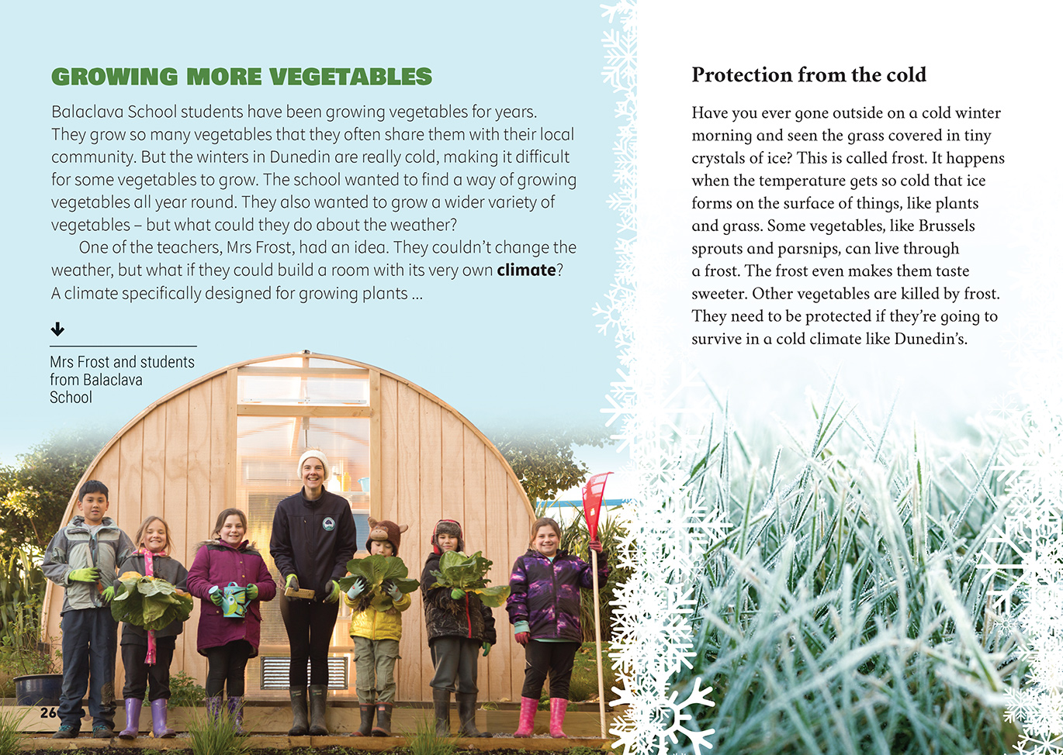  Technological outcomes are developed through technological practice and have related physical and functional natures. |  | Students explore and act on an issue that links their science learning to their daily living.  Many plants can grow outdoors given the right conditions.  Students investigate science in their everyday surroundings.
 | [Grab your reader’s attention with a great quote from the document or use this space to emphasize a key point. To place this text box anywhere on the page, just drag it.]

Learning activities – Exploring the science
The following activities and suggestions are designed as a guide for supporting students to explore and develop understandings about the science capability “engage with science”. Some activities focus directly on the science capability. Other activities extend student content knowledge across the learning areas. Adapt these activities to support your students’ learning needs.

Activity 1 – Grow your own
Initiate discussion about what vegetables are and why people may want to grow them. Check that the students understand that vegetables are plants – some young people have the misconception that they are not. Also note that, scientifically, many things we call vegetables are actually fruit.
What vegetables do you like to eat?
What are some unusual vegetables you’ve eaten? Where are they grown? What did they taste like?
What vegetables might you like to try?
Why do you think people like growing their own vegetables? Why might a school do this?
Check the students’ understandings about what keeps a plant healthy by doing the activity described in Building Science Concepts, Book 63: Growing Plants Indoors: What an Indoor Plant Needs (Section Three, Activity 1). Connect this activity to what the students learned from the article. Have them put this information into a diagram of how photosynthesis works.
Working in groups, the students examine seed packets and use a retrieval chart (see example below) to record the information about the growing needs of a particular vegetable (for example, germination, time to mature, water requirements, and the expiry date). They compare this with the information in the article.
Why is this additional information included on the packet? Why would a gardener want to know this?
The students add a second column to their retrieval chart to record why this information is useful. They can find this information by reading the Connected, School Journal, and Junior Journal articles listed in the resource links below, with each group reading one or two of the texts. They can then share this information with the class to create a single chart summarising what they have learned.
 | Information on packet | Reason for this information
Air temperature
Hardiness (e.g., against frost)
Soil temperature
Soil type (e.g., dry, moist, sandy)
Sun/shade
Water requirements
The students gather data about the growing conditions in their area. The teacher support material for “Garden with Science” (Connected 2014, level 2) includes activities for testing the pH of soil and gathering data about the local climate. Other sources of information include Landcare’s digital soil map and the knowledge of local gardeners.
Have the groups identify two or three types of vegetables they would like to grow. Give each group a copy of the retrieval chart and have them go online or visit a local nursery to find out which vegetable would be the best choice for growing outside at this time of year.
Review the summary charts that set out the steps of the Balaclava School scientific investigation. Prompt them to generate questions they could investigate, then decide on a hypothesis and design an experiment to test it. Remind them of the importance of keeping records so the information grows over time.

Activity 2 – Where are you from?
Have the students investigate where different vegetables and fruit originate. Have them mark the places on a world map and then go online to investigate the climate in those places.
With this information, have them predict the growing conditions for those plants in New Zealand. Have students justify their predictions.
What knowledge did you use to make your prediction?
What made you think that?
They can then visit a nursery and look at seed packets to check whether their predictions are correct.
Necessary growing conditions
Fruit / vegetable | Originates from | Our prediction about best conditions for growth | We found

Extending the learning
Invite a keen gardener who has lived overseas or in different parts of New Zealand (for example, in the far north, the far south, on a coast, or in the mountains) to talk about the different climate and the implications for what crops were grown. Have the students prepare questions for their visitor, for example:
What were the growing conditions where you lived?
What were you able to grow?
Are you able to grow those plants here? If so, have you had to make special adaptations to grow them? What are they?

Learning activities – Exploring the science

Activity 3 – Māori gardening
Explain that the students are going to investigate the crops that were traditionally grown by the local iwi. Prompt them to think about what they would like to find out. Questions might include:  What did they plant?  What were the gardens like?  How did they know when to plant or harvest?  How did they collect and store the seeds?  What traditional practices are still used today? And why?  How could traditional practices be useful in addressing current gardening issues due to climate change?  Use “What Will the Weather be Tomorrow?” (Connected 3, 2016) to learn about traditional methods for forecasting the weather.  How do you think the climate affected what pre-European Māori could plant? What other conditions affected this? | How were these conditions different from those in their place of origin? How might they have had to adapt their planting techniques?  The students will find answers to some of their questions online. Others may not be so easy to answer. Invite a local expert to share their knowledge and answer students’ questions. If possible, visit a local site where students can see the signs of traditional Māori horticulture, such as terracing, kumara pits, or charcoal and ash (from burning plants to increase fertility).  This investigation could conclude with a link to the celebration of Matariki. Alternatively, the students may be interested in how Māori horticultural practices influenced early settlers and vice versa.

RESOURCE LINKS

Building Science Concepts  Book 63: Growing Plants Indoors: What an Indoor Plant Needs  Making Better Sense of the Living World  “Science Focus: Classification” pages 22–28  Making Better Sense of Planet Earth and Beyond  “Te Maramataka Māori (The Māori Calendar)” pages 123–124  Connected and School Journal  “Garden with Science”, Connected 2014, level 2, How Do You Know? http://instructionalseries.tki.org.nz/Instructional-Series/Connected/Connected-2014-level-2-How-Do-You-Know/Garden-with-Science  “Winning the Bledisloe Cup”, Connected 2014, level 2, How Do You Know? http://instructionalseries.tki.org.nz/Instructional-Series/Connected/Connected-2014-level-2-How-Do-You-Know/Winning-the-Bledisloe-Cup  “Hukanui Enviroschool: Ten Years On”, “Moturoa Students: They Grow and Share the Very Rare”, “Gardens with Edge”, Connected 2, 2010, Working with Nature.  “What Will the Weather be Tomorrow? Connected 3, 2012 and TSM, Watching the Weather.  “Our Gifted Garden”, Junior Journal 49, 2014, level 2: http://instructionalseries.tki.org.nz/Instructional-Series/Junior-Journal  “Seeds”, Junior Journal 50, 2015, level 2. http://instructionalseries.tki.org.nz/Instructional-Series/Junior-Journal  “Dig In!”, Junior Journal 52, 2016, level 2. http://instructionalseries.tki.org.nz/Instructional-Series/Junior-Journal  “Killer Plants”, School Journal, Part 2: Number 1: 2010 http://instructionalseries.tki.org.nz/Instructional-Series/School-Journal | “Tons of Tomatoes”, School Journal, November 2014, level 2. http://instructionalseries.tki.org.nz/Instructional-Series/School-Journal  “Seed Savers”, School Journal, May 2016, level 3. http://instructionalseries.tki.org.nz/Instructional-Series/School-Journal  Science Learning Hub  Flowering plant life cycles www.sciencelearn.org.nz/resources/82-flowering-plant-life-cycles  Flowering plants www.sciencelearn.org.nz/resources/81-flowering-plants  The seed-flower life cycle www.sciencelearn.org.nz/resources/101-the-seed-flower-life-cycle  Attracting pollinators www.sciencelearn.org.nz/resources/80-attracting-pollinators  Fertiliser www.sciencelearn.org.nz/resources/964-fertiliser  Taewa (Māori potatoes) www.sciencelearn.org.nz/resources/781-taewa-maori-potatoes  Other sources  Herb Federation of New Zealand Gardening with Children booklet – Resource on building a school garden www.herbs.org.nz/wp-content/uploads/2016/06/gardeningwithchildren.pdf  Māori Gardening www.archaeopedia.com/wiki/index.php?title=Maori_Gardening  Māori Gardens www.teara.govt.nz/en/gardens/page-1  envirohistory NZ https://envirohistorynz.com/2010/06/07/maori-gardening-in-pre-european-nz/

Learning activities – Exploring the technology

Activity 1 – Standing firm | Extend the learning  Activate students’ prior knowledge about building construction and the need to strengthen many of our buildings. Read “The Cardboard Cathedral” (Connected 2014, level 2). Try some of the activities in the teacher support materials or have the students attempt the Siemens STEM Day Build This Structure activity that has them developing a construction that will withstand movement.  Activity 2 – Gardening indoors  Have the students use online information to find out about materials and techniques for designing an indoor garden (for example, under glass, under plastic film, using artificial light, using hydroponics, or building a cold frame). Have the students select three methods and provide reasons for why they would work.  Have the students work in groups to design and build their gardens. Invite local gardening experts to help. Have the students monitor how well their plants grow, using the methods outlined in Building Science Concepts Book 63, Growing Plants Indoors: What an Indoor Plant Needs.  Activity 3 – The gardens of the future  Reread the breakout text on page 32. Explore how technological developments have allowed us to produce more food to feed bigger populations … but at what cost to the environment? Link this to the concept of climate change and the likelihood that we will need to make rapid adaptations to what we grow and where.  Investigate new approaches to gardening that help us address these challenges, such as roof gardens, vertical gardens, and biodomes. Have the students create tables summarising the advantages and disadvantages of these different techniques.
Select activities from Sections 1 and 2 of Building Science Concepts Book 51, Standing Up: Skeletons and Frameworks to help students understand the concept that the framework of a building or other structure helps it to stand up.
Support the students to investigate the strengths of different structures under different conditions, using a data table to record their findings. They could investigate structures made from different shapes such as triangles, squares, pentagons, and hexagons. They could experiment with a range of materials, such as straws, ice block sticks, and bamboo skewers. Encourage the students to ask questions about their discoveries, for example:
How strong is this structure?
Do the number of sides make a difference?
Is the structure stronger when sides are equal?
Explain that people can fold paper to create structures of surprising strength and versatility. Have the students follow the instructions on YouTube to create a truncated tetrahedron.
How might you create a dome or sphere with these basic shapes?
What are some other structures you could create with your paper?
Can you recall any examples of structures that have been created using these shapes?
Explore the impact of force on structure by challenging students to build a paper structure at least 30 centimetres high that can support the weight of a book.

RESOURCE LINKS

Building Science Concepts  Book 63, Growing Plants Indoors: What an Indoor Plant Needs  Connected and School Journal  “The Cardboard Cathedral”, Connected 2014, level 2, How Do You Know?  Other sources  Home Aquaponics System: What Is a Biodome? http://homeaquaponicssystem.com/greenhouses/what-is-a-biodome/  Queenstown Remarkables School’s green roof: www.livingroofs.org.nz/greenroofs-remarkables-primary-school/ | Herb Federation of New Zealand Gardening with Children booklet – Resource on building a school garden: www.herbs.org.nz/wp-content/uploads/2016/06/gardeningwithchildren.pdf  Planet Natural Research Centre: Indoor Gardening 101: www.planetnatural.com/growing-indoors/  Paper Structure: http://teachers.egfi-k12.org/lesson-paper-structures-civil-engineering/  Truncated Tetrahedron video: www.youtube.com/watch?v=7aujpCKeuYw  Siemens STEM Day – Build this Structure: www.siemensstemday.com/educators/activities  The Eden Project: www.edenproject.com/visit

