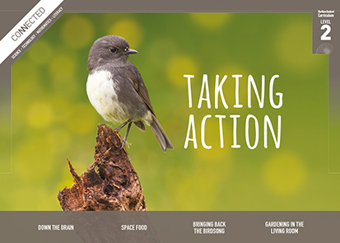
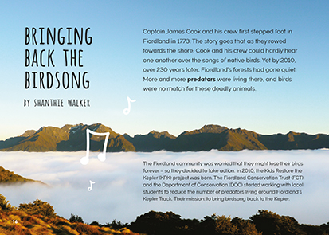
Connected
Level 2
2017

Bringing Back the Birdsong
by Shanthie Walker

Overview
This article describes how young people in the Kids Restore the Kepler project are working with the Department of Conservation and Fiordland Conservation Trust to increase the population of native birds in Fiordland. It investigates the negative impact of introduced pests and how we can work together to help our environment recover.
A Google Slides version of this article is available at www.connected.tki.org.nz. This text also has additional digital content, which is available online at www.connected.tki.org.nz.
Curriculum contexts

SCIENCE: Nature of Science: Participating and contributing  Level 2 – Students will explore and act on issues and questions that link their science learning to their daily living. | Key Nature of Science ideas  When we engage scientifically with an issue, we:  - Look for a range of scientific information that relates to the issue  - Check that information we use is from a trustworthy source  - Consider the reliability and validity of the evidence  - Decide if and how to respond to the issue, justifying our decisions based on evidence and/or reliable scientific information  - Monitor the effects of any actions we take.
SCIENCE: Living World: Ecology  Level 2 – Students will recognise that living things are suited to their particular habitat. | Key science ideas  - If you add anything new to an ecosystem (or take something away) there will be consequences – some of which will be unpredictable.  - Changes in any element of the living or non-living environment may affect the relationships between living things and lessen or improve the chances of some species surviving.  - People can cause changes to habitats from which recovery may be difficult. People can also intervene to aid that recovery.
ENGLISH: Reading  Level 2 – Ideas: Students will show some understanding of ideas within, across, and beyond texts. | Indicators  - Uses their personal experience and world and literacy knowledge to make meaning from texts.  - Makes meaning of increasingly complex texts by identifying main ideas.  - Makes and supports inferences from texts with some independence.

The New Zealand Curriculum

Science capability: engage with science

Capability overview
This capability requires students to use the other capabilities to engage with science in real-life contexts. It requires students to take an interest in science issues, participate in discussions about science, and at times, take action.  The dimensions of this capability can be demonstrated when students engage in discussions about science issues, including those in the media. If these discussions build on the ideas of others, emphasise logical connections, and draw reasonable conclusions, and if the speakers make the evidence behind their claims explicit, then students have the opportunity to practise playing the “game of science” (Resnick, Michaels, & O’Connor, 2010). | This allows them to deepen their understanding of what science is.  Students also need opportunities to be actively engaged in exploring real-life science issues that are relevant to them and their communities. This could involve building new knowledge with others and taking action to address local or global concerns.

More about the capability

The capability in action
Real-life science issues:  - may involve a mix of scientific issues and forms of social-science inquiry, including values and ethics  - provide opportunities to build awareness of which questions can be investigated and which questions science does not answer  - provide opportunities to see science as tentative, that is, developing over time as evidence is gathered or reinterpreted  - provide experiences of uncertainty where there is no clear explanation or solution  - allow students to gather and interpret data about a local situation or to critique a range of evidence and claims  - may generate a range of student views, responses, and possible actions.  Students  Students should have opportunities to:  - take an interest in a range of scientific issues  - participate in discussions about scientific issues  - use their developing capabilities of gathering and interpreting data, using and critiquing evidence, and interpreting representations to create a viewpoint, response, or action on scientific issues.  Teachers  Teachers can:  - establish a science classroom culture by:  - taking a personal interest in scientific issues, modelling questions, explicitly critiquing evidence, and seeking further evidence  - maximising everyday opportunities to introduce learning conversations that engage students with science and scientific issues | - helping their students to notice and investigate science in their everyday surroundings, such as ice on a puddle, the health of a local stream or river, or what happens as materials are mixed or heated  - listening to and discussing socio-scientific items in the news  - exploring locally relevant and contentious scientific issues, such as irrigation, intensive farming, or the effects of climate change  - support students to identify scientific aspects of an issue  - provide a range of resources and investigation opportunities pertaining to scientific issues that require students to use a range of science capabilities  - encourage students to seek and critically evaluate a range of scientific evidence, opinions, and actions from a variety of sources about an issue  - manage with sensitivity situations where students and their whānau may hold differing and strongly held opinions about a science-related issue, such as irrigation  - support students to identify and take appropriate actions in response to science-related issues.  It is important that students are empowered to be hopeful and see opportunities for positive action and change when considering local and global issues.

More activities to develop the capability

Meeting the literacy challenges

The main literacy demands of this text require students to interpret a range of visual features. These features include:  - two diagrams with symbols comparing two different birds and two different predators  - a diagram of a tracking tunnel  - a data table recording the pests caught in a tracking trap  - photos with captions  - a graph tracking the decline in pests in two areas over a twelve-week period.  The content and ideas in the text require some background knowledge of native and endangered birds and the threats to their survival from pests and predators. The text shows several ways that scientists gather, share, and communicate information. It explains how students from three local schools, with a DOC ranger, set up teams to monitor the pest population in a chosen area. | Headings indicate the teams’ processes and actions with specific details describing what they did and what information they gathered. There are also some detailed descriptions and explanations of the technology they used.  Most descriptions are supported by a visual image. Students will need to distinguish between the running text and breakouts that provide supporting information. Topic-specific and technical vocabulary is usually explained in the text, though several of these words are supported in a glossary.  The following instructional strategies will support students to understand, respond to, and think critically about the information and ideas in the text.  You may wish to use shared or guided reading, or a mixture of both approaches, depending on your students’ reading expertise and background knowledge.  After reading the text, support students to explore the activities outlined in the following pages.

INSTRUCTIONAL STRATEGIES

Finding the main ideas  Introduce the title and show the students the first page. ASK QUESTIONS to prompt thinking about what the title might mean. Remind them that one of the ways we make meaning is to make inferences and that this requires us to draw on our prior knowledge while we look for clues in the text and images.  What does “bringing back” mean? The title talks about “bringing back the birdsong”. What do you think might have happened to the birdsong? What do you think this article might be about?  What strategy did you use to make these guesses? Yes, you used inference. What prior knowledge did you use to make these inferences? What clues could you see in the imagery?  EXPLAIN that scientists also make inferences as they interpret their observations. Like readers, they need to look for information and clues to justify their inferences.  Have the students read page 16 and support them to IDENTIFY and SUMMARISE the problem in Fiordland by using a simple graphic organiser like the one below.  Before and during reading What is the problem in Fiordland?  After reading What are people doing to address the problem? | As you read, look for evidence that your understanding is correct.  PROMPT the students to make inferences as they read.  Did the students keep setting up tracking tunnels once they started trapping? What tells you that in the text?  How was the information from the tracking tunnels useful when the students were thinking about what traps to use? What other data did they use?  DISCUSS the use of breakouts on pages 17–18.  Why has the author provided this information?  Compare the information about birds with the information about predators. What do you learn from this?  What are your feelings as you read this information? Why do you think green and red have been used as the background for these two different diagrams? (Note that the colours red and green can provoke different emotional responses.)  Use the illustrations of the tracking tunnels (page 19) to reinforce the difference between observations and inferences.  What did the students observe? What did they infer from these footprints?  How did this data help the project?  ASK QUESTIONS to help the students draw meaning from the data.  How might the students interpret the data recorded in their notebooks? (page 20)  What do the two colours in the graph show? (page 22) What does the graph tell us about the pests in the area? How sure would you be of the results?  How do the students use the data to come up with the next steps?

Meeting the literacy challenges

CHECK that the students understand the problem caused by the beech mast. Create a flow diagram of the process or get them to do this in pairs or small groups.  Have the students return to their graphic organisers about the problem in Fiordland and amend them if necessary. Then have them add more information, in phrases or sentences, summarising what they have learned.  Dealing with unfamiliar vocabulary  Have the students think, pair, and share their understanding of the word “predator”, then use the glossary to check that they are correct. DISCUSS examples of predators they know about in the local environment. | Have the students think, pair, and share their understandings of the meanings of “native” and “endangered” in the sentence “It is also home to many native and endangered birds …” (page 17). Have them use the glossary and a dictionary to check that their definitions are correct. DISCUSS examples of native and endangered birds they know about in the local environment.  DISCUSS the name “Kids Restore the Kepler”. Have the students investigate the meaning of the prefix “re-”. ASK if they can infer a connection to the title. (They will discover that “re” can mean “back” or “backward”, and connect to the definition of “restore” as “give back”.)

Reading standard: by the end of year 4
The Literacy Learning Progressions
Effective Literacy Practice: years 1–4

Meeting the literacy challenges

TEACHER SUPPORT
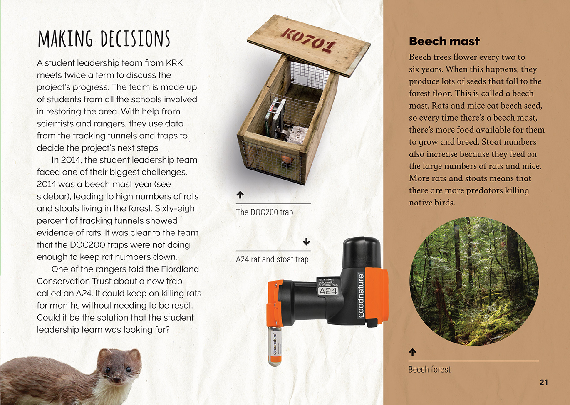 |  | Students participate in discussions about a scientific issue.  Students interpret data to create a response, or action on a scientific issue.  Scientists decide how to respond to an issue, justifying their decision based on evidence and/or reliable scientific information.
Environmental issues can influence what technological outcomes are made.
[Grab your reader’s attention with a great quote from the document or use this space to emphasize a key point. To place this text box anywhere on the page, just drag it.]

Learning activities – Exploring the science
The following activities and suggestions are designed as a guide for supporting students to explore and develop understandings about the science capability “engage with science”. Some activities focus directly on the science capability. Other activities extend student content knowledge across the learning areas. Adapt these activities to support your students’ learning needs.

Activity 1 – Predator Free 2050: Can we do it?
The impact of pests on our native flora and fauna is a hot topic in New Zealand (see Resource links on page 7). Wherever you are, there are likely to be problems with pests and people working to address them. The approach outlined here has the students finding out about Predator Free 2050. As you work through this activity, try to incorporate discussion about the ethics of the issue and the benefits of restoring our ecology.

Setting the vision
Ask the students if they know anything about Predator Free 2050.
Have you heard this mentioned in the media? Or at home?
Explain that Predator Free 2050 is described as “an ambitious programme to rid New Zealand of three of the most damaging introduced predators threatening our natural taonga, our economy, and our primary sector. As a class, read the Department of Conservation’s Predator Free 2050 brochure.
Ask the student to visualise what a pest-free New Zealand would be like. If possible, show them old photos or pictures of your area so they can see what it was like in the past. Prompt thinking about the need for collaboration across a range of groups. Link this back to the article and the collaboration it describes between schools, community groups, and the Department of Conservation.
What would New Zealand be like if it were pest free?
How would things be different where we live?
Do you think it is achievable?
Do you think it is important?
What would have to happen for the vision to be achieved?
Who would need to be involved?
Have the students stand in a line to show where they see themselves on a continuum in response to the following two questions. (Note that some may feel that while the vision cannot be achieved, it is still worth pursuing.) Ask each student to explain their thinking.
Can the vision be achieved? Why, or why not?
Is it worth putting effort into the predator-free vision? Why, or why not?

Taking action
The Science Learning Hub article “Predator Free 2050 Vision” links to a series of lesson plans and resources called “Can we make New Zealand pest free? – introduction”. The lessons are designed to support students to become actively involved in contributing to a pest-free New Zealand. They include opportunities for students to explore the concept of biodiversity and to set tracking tunnels and traps in the school area.

Evaluation
The final lesson on the Science Learning Hub includes opportunities to reflect on the learning. You could also have the students repeat the continuum exercise. Ask them to explain what they think now compared with before.

Activity 2 – Exploring ecosystems
Use the living web game described in Building Science Concepts Book 21, Life between the Tides: Sandy Shores, Mudflats, and Rocky Shores to help the students understand the concept that birds, like all living things, are part of an ecosystem in which they have a specific role to play. Prepare for this by activating their prior knowledge about what lives on the beach and how these organisms relate to each other and to their environment. (Note: If your students don’t live near a beach, you could choose an alternative ecosystem, like a lake or a river.) Have students share their ideas of what an ecosystem is and write a definition.
How do you think our native birds contribute to New Zealand’s ecosystem? What is their role?
Share the Science Learning Hub article “Birds’ roles in ecosystems” to find out whether the students are correct. Clarify the terms “fauna” and “flora” and have the students sketch diagrams to show the relationship between native birds and native fauna.
Looking at your diagrams, what is likely to happen if you take some of the fauna or the flora out of our ecosystem? What would happen to the rest of the system?
What would happen if you add something new?
What did we learn about this in the article?
Select activities from the Department of Conservation’s In your local environment series to help the students explore how introduced pests are impacting the ecosystem in a local green space. (Note that the series includes an item on plant as well as animal pests.)
Have students reread pages 17–18. Challenge the students to create a similar table that gives information about a native bird or animal in your area, including local predators they are at risk from.

Extending the learning
Investigate the impact of other pests on New Zealand’s ecosystem. The resource links include other items in the instructional series that have addressed this issue.

Learning activities – Exploring the science

Activity 3 – Taking action
Most communities have projects addressing the impact of introduced pests. Have the students investigate what these are, the impact they are having, and how they might get involved. Questions to consider include:
What information do we need?
What is known already?
How will we know what we need to do?
What observations and data do we need to collect?
How will we monitor what effect our actions are having?
Who can help us?
Connect students’ learning to the concept of the 2050 vision and the role we can all play in working towards it.

RESOURCE LINKS

Connected and School Journal  “An Invasion of Yellow Crazies”, Connected 2016, level 2, Show and Tell  http://instructionalseries.tki.org.nz/Instructional-Series/Connected/Connected-2016-Level-2-Show-and-Tell/An-Invasion-of-Yellow-Crazies  “The Takeaway Table”, Connected 2013, level 2, I Spy…  http://instructionalseries.tki.org.nz/Instructional-Series/Connected/Connected-2013-level-2-I-Spy/The-Takeaway-Table  “Keep Your Cat Inside”, Connected 2013, level 4, Are You Sure?  http://instructionalseries.tki.org.nz/Instructional-Series/Connected/Connected-2013-level-4-Are-You-Sure/Keep-Your-Cat-Inside  “The Man in the Outside Office”, Connected 2, 2010, Working with Nature  “The Jungle in My Garden”, Junior Journal 52, 2016, level 2 http://instructionalseries.tki.org.nz/Instructional-Series/Junior-Journal/Junior-Journal-52-Level-2-2016/The-Jungle-in-my-Garden  “The Possum Problem”, School Journal August 2017, level 3  http://instructionalseries.tki.org.nz/Instructional-Series/School-Journal  Science Learning Hub  Birds’ roles in ecosystems: www.sciencelearn.org.nz/resources/1163-birds-roles-in-ecosystems  Predator Free 2050 vision (article): www.sciencelearn.org.nz/resources/2195-predator-free-2050-vision  Can we make New Zealand pest-free?  www.sciencelearn.org.nz/resources/2196-can-we-make-new-zealand-pest-free-introduction | Reptiles and amphibians are also threatened by predators – this timeline gives an overview of key events:  www.sciencelearn.org.nz/resources/1907-saving-reptiles-and-amphibians-timeline  Conserving native birds: www.sciencelearn.org.nz/resources/1158-conserving-native-birds-introduction  Conserving native birds – unit plan: www.sciencelearn.org.nz/resources/1174-conserving-native-birds-unit-plan  Native bird losses affect plant species:www.sciencelearn.org.nz/resources/1164-native-bird-losses-affect-plant-species  Predation of native birds: www.sciencelearn.org.nz/resources/1159-predation-of-native-birds  Protecting native birds: www.sciencelearn.org.nz/resources/1157-protecting-native-birds  Kaitiaki of the kiwi: www.sciencelearn.org.nz/resources/1388-kaitiaki-of-the-kiwi  Ethics in bird conservation: www.sciencelearn.org.nz/resources/1172-ethics-in-bird-conservation  Building Science Concepts  Book 21: Life between the Tides: Sandy Shores, Mudflats, and Rocky Shores  Other sources on Kids Restore the Kepler  Kids Restore the Kepler project www.kidsrestorethekepler.co.nz  2015 Southland Environment Awards (Nina, Will, Blake and Oliver: Kids Restore the Kepler) 0.05 –1.57: www.youtube.com/watch?list=PLBjgrK7mZgAh06AVw98lR5Nnx3-556RQR&v=N6q4Fuj5V_E

Learning activities – Exploring the science

RESOURCE LINKS (continued)

Landcare Research  Landcare Research: Garden Bird Survey: www.landcareresearch.co.nz/science/plants-animals-fungi/animals/birds/garden-bird-surveys  Landcare Research: How to read prints from tracking tunnels: www.landcareresearch.co.nz/__data/assets/pdf_file/0005/127472/22_How-to-read-prints-from-tracking-tunnels.pdf  Department of Conservation  Bird songs and calls: www.doc.govt.nz/nature/native-animals/birds/bird-songs-and-calls/  Birds A–Z: www.doc.govt.nz/nature/native-animals/birds/birds-a-z/  Forest and mountain birds: www.doc.govt.nz/nature/native-animals/birds/forest-and-mountain-birds/  Kiwi and predators’ facts and figures (infographic): www.doc.govt.nz/our-work/battle-for-our-birds/kiwi-and-predators-facts-and-figures/  Fiordland Kiwi Diaries (blog): https://blog.doc.govt.nz/2017/08/21/fiordland-kiwi-diaries-saving-our-iconic-kiwi/ and https://blog.doc.govt.nz/2017/09/05/fiordland-kiwi-diaries-catching-the-mysterious-tokoeka/  Battle for our Birds: Predator Response 2016: www.doc.govt.nz/Documents/conservation/threats-and-impacts/battle-for-our-birds-2016/battle-for-our-birds-2016.pdf  Beech mast and the predator explosion 2014: www.doc.govt.nz/our-work/battle-for-our-birds/beech-mast/  In your local environment (education resources): www.doc.govt.nz/get-involved/conservation-education/in-your-local-environment/ | Other sources on New Zealand birds and pests  Tokoeka Kiwi: www.kiwisforkiwi.org/about-kiwi/kiwi-species/tokoeka  Birds and their conservation (Fiordland National Park): www.teanau.net.nz/Birds-and-conservation  Forest & Bird: Saving Our Environment: www.forestandbird.org.nz/saving-our-environment  Battle for our Birds: Beech Mast 2014: www.osnz.org.nz/sites/osnz.org.nz/files/DOC%20brochure%20battle%20for%20our%20birds.pdf  New Zealand Birds Online: http://nzbirdsonline.org.nz/  http://nzbirdsonline.org.nz/species/southern-brown-kiwi  http://nzbirdsonline.org.nz/species/south-island-robin  Kiwis for kiwi: www.kiwisforkiwi.org/  Parliamentary Commissioner for the Environment: Report – Taonga of an island nation: Saving New Zealand’s birds: www.pce.parliament.nz/publications/taonga-of-an-island-nation-saving-new-zealands-birds  Rat Control Harts Hill – Fiordland Project Report: www.goodnature.co.nz/fileadmin/documents/Manuals/DOC_Project_Report_-_100m_x_50m_.pdf  Good Nature (videos and information about pests): www.goodnature.co.nz/

