Connected
Level 3
2017

Pet Power
by Renata Hopkins

Overview
This article looks at research on the positive effects pets can have on human health. It provides an engaging context for learning about how scientists seek answers to their questions and the importance of critical thinking when planning an investigation and reflecting on its outcomes.
A Google Slides version of this article is available at www.connected.tki.org.nz.

Curriculum contexts

SCIENCE: Nature of Science: Understanding about science  Level 3 – Students will appreciate that science is a way of explaining the world and that science knowledge changes over time.  SCIENCE: Nature of Science: Participating and contributing  Level 3 – Students will use their growing science knowledge when considering issues of concern to them. | Key Nature of Science ideas  When we engage scientifically with an issue, we:  - Look for a range of scientific information that relates to the issue  - Check that information we use is from a trustworthy source  - Consider the reliability and validity of the evidence  - Decide if and how to respond to the issue, justifying our decisions based on evidence and/or reliable scientific information  - Monitor the effects of any actions we take.
ENGLISH: Reading  Level 3 – Ideas: Students will show a developing understanding of ideas within, across, and beyond texts. | Indicators  - Uses their personal experience and world and literacy knowledge confidently to make meaning from texts.  - Makes meaning of increasingly complex texts by identifying main and subsidiary ideas in them.  - Starts to make connections by thinking about underlying ideas in and between texts.  - Makes and supports inferences from texts with increasing independence.
MATHEMATICS and STATISTICS: Statistics: Statistical literacy  Level 3 – Evaluate the effectiveness of different displays in representing the findings of a statistical investigation or probability activity undertaken by others. | Key mathematics ideas  - Data can be used to answer multiple questions.  - Organising data can reveal information, patterns, and trends.  - Looking for patterns is an important part of statistical thinking.

The New Zealand Curriculum

Science capability: engage with science

Capability overview
This capability requires students to use the other capabilities to engage with science in real-life contexts. It requires students to take an interest in science issues, participate in discussions about science, and at times, take action.  The dimensions of this capability can be demonstrated when students engage in discussions about science issues, including those in the media. If these discussions build on the ideas of others, emphasise logical connections, and draw reasonable conclusions, and if the speakers make the evidence behind their claims explicit, then students have the opportunity to practise playing the “game of science” (Resnick, Michaels, & O’Connor, 2010). | This allows them to deepen their understanding of what science is.  Students also need opportunities to be actively engaged in exploring real-life science issues that are relevant to them and their communities. This could involve building new knowledge with others and taking action to address local or global concerns.

More about the capability

The capability in action
Real-life science issues:  - may involve a mix of scientific issues and forms of social-science inquiry, including values and ethics  - provide opportunities to build awareness of which questions can be investigated and which questions science does not answer  - provide opportunities to see science as tentative, that is, developing over time as evidence is gathered or reinterpreted  - provide experiences of uncertainty where there is no clear explanation or solution  - allow students to gather and interpret data about a local situation or to critique a range of evidence and claims  - may generate a range of student views, responses, and possible actions.  Students  Students should have opportunities to:  - take an interest in a range of scientific issues  - participate in discussions about scientific issues  - use their developing capabilities of gathering and interpreting data, using and critiquing evidence, and interpreting representations to create a viewpoint, response, or action on scientific issues.  Teachers can:  - establish a science classroom culture by:  - taking a personal interest in scientific issues, modelling questions, explicitly critiquing evidence, and seeking further evidence  - maximising everyday opportunities to introduce learning conversations that engage students with science and scientific issues | - helping their students to notice and investigate science in their everyday surroundings, such as ice on a puddle, the health of a local stream or river, or what happens as materials are mixed or heated  - listening to and discussing socio-scientific items in the news  - exploring locally relevant and contentious scientific issues, such as irrigation, intensive farming, or the effects of climate change  - support students to identify scientific aspects of an issue  - provide a range of resources and investigation opportunities pertaining to scientific issues that require students to use a range of science capabilities  - encourage students to seek and critically evaluate a range of scientific evidence, opinions, and actions from a variety of sources about an issue  - manage with sensitivity situations where students and their whānau may hold differing and strongly held opinions about a science-related issue, such as irrigation  - support students to identify and take appropriate actions in response to science-related issues.  It is important that students are empowered to be hopeful and see opportunities for positive action and change when considering local and global issues.

More activities to develop the capability

Meeting the literacy challenges

The main literacy demands of this text require the students to interpret infographics along with explanations in the text to explore the connection between human interactions with pets and well-being. An infographic explaining what can be learnt from heart rates requires the students to integrate this technical information with the information in the text.  Various scenarios involving the roles of animals or pets are described and explained. Each context is discrete although the students need to combine information from all contexts to gain an understanding of the main science ideas. An explanation of hormones contains complex information that will require close reading and discussion. | The scientific vocabulary requires students to use text and visual cues, as well as word knowledge, to understand their meanings in the context.  The following instructional strategies will support students to understand, respond to, and think critically about the information and ideas in the text.  You may wish to use shared or guided reading, or a mixture of both, depending on your students’ reading expertise and background knowledge.  After reading the text, support students to explore the activities outlined in the following pages.

INSTRUCTIONAL STRATEGIES

Read page 10 out loud and invite the students to predict what the article is about. Show them the title and illustration to confirm their prediction and ask them to imagine what Scruffy’s job might be. Have them read page 11 to CHECK whether their predictions are correct.  DISCUSS the students’ responses to the text.  Do you think everyone feels calmer when they are around animals? How do you know?  Can you think of other reasons why people love pets? Is there anything else you would add to the infographic?  Are there some people who don’t like pets … or some pets that are not very likeable?  How could you find out whether a pet could be good for our health? How might a scientist inquire into this?  Point out that the last two sentences on page 11 are questions. Have the students SKIM the text, to identify its purpose. As they do, ask them to look for other examples of questions in the headings and breakout boxes.  What clues do the questions on page 11 give you about the purpose of this article?  What evidence supports your inference?  What do you notice about the questions in this article?  What do you think the author is telling us about the importance of questions in scientific inquiry?  Give each student some Post-it® notes. As the students read, have them use their notes to RECORD the questions the author asks and any of their own questions. Use different coloured Post-it® notes for the two types of questions.  After the reading, have the students read through their questions. DISCUSS reasons scientists might ask questions. As a class, develop categories of questions – what is the asker trying to find out? Categories may include: to set their purpose for inquiry, to generate data, to critique their inquiry, and to identify new questions that could be looked at in another inquiry.  Have the students work in pairs to sort their questions into the categories. Then have the pairs combine into small groups to compare each other’s ideas. Have the groups REPORT on any student-generated questions that they think could be important to explore in a scientific investigation. | Help the students to MAKE CONNECTIONS to their learning about hauora (health and well-being). DISCUSS the four dimensions of hauora: taha tinana (physical well-being); taha hinengaro (mental and emotional well-being); taha whānau (social well-being); and taha wairua (spiritual well-being). Record the students’ responses on a diagram similar to the one below.  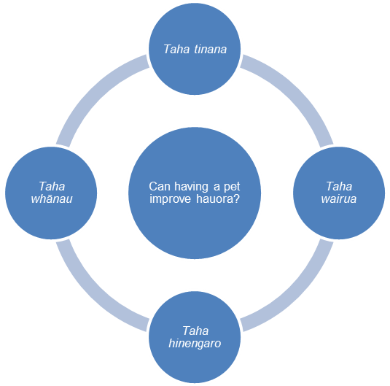  Dealing with scientific vocabulary  PROMPT the students to notice that this text contains a number of terms that are important to understand if you are conducting a scientific investigation, terms such as “existing research”, “control group”, “sample size”, and “trustworthy data”. Ask them to work in small groups to IDENTIFY these terms and construct definitions for them, using their prior knowledge, information from the text, and classroom resources such as dictionaries. Have the groups present their definitions to the class, explaining why they think it is important for scientists to know them. DISCUSS the definitions, working towards agreement on a short glossary of key scientific terms that will become part of the regular classroom language.  Extending the learning  ASK the students to select one of the two experiments and write it up as a formal report. The report should:  use the language of science  be set out under clear headings relating to the process (such as, the question for investigation, the set-up, and so on)  conclude by suggesting a next step for inquiry.

Meeting the literacy challenges
Organising data can reveal information, patterns, and trends.

TEACHER SUPPORT
Real-life science issues provide opportunities to see science as tentative, that is, developing over time as evidence is gathered or reinterpreted.

Scientists consider the reliability and validity of the evidence.

Scientists look for a range of scientific information that relates to the issue.

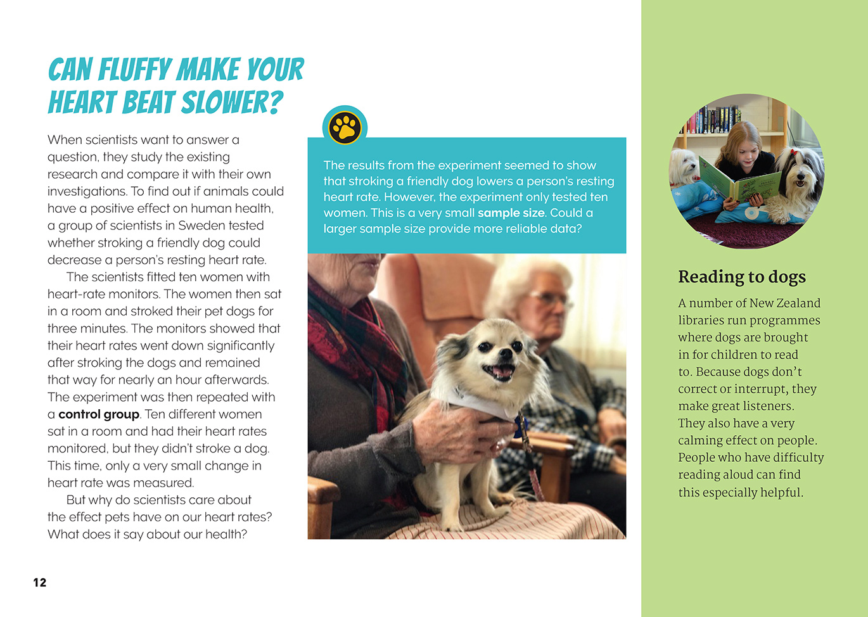

Reading standard: by the end of year 6
The Literacy Learning Progressions
Effective Literacy Practice: years 5–8
The above page: Text and images copyright © Crown except: stoat (bottom left) by Nick Goodrum https://goo.gl/5k4VpX, which is used under a Creative Commons licence (CC BY 2.0), A24 trap (bottom middle) which is copyright © Goodnature, and beech forest (bottom right) from https://goo.gl/1kZqA3, which is in the public domain.

Learning activities – Exploring the science
mathematics and statistics
The following activities and suggestions are designed as a guide for supporting students to explore and develop understandings about the science capability “engage with science”. Some activities focus directly on the science capability. Other activities extend student content knowledge across the learning areas. Adapt these activities to support your students’ learning needs.

Activity 1 – Sensible sampling  This activity reinforces the concept that the size of the sample affects the trustworthiness of the data. Have students complete a simple investigation. Start with a very small sample size.  For example, you could ask two students to stand up and say which hand they write with. If one is left-handed and one is right-handed, you could state your hypothesis that this must mean that half the students in the class are right-handed and half are left-handed. You could generalise from that result to two classes, then to the syndicate, and then to the school.  Repeat the experiment with a larger sample size, for example, the entire class. Compare the results to help students understand the importance of sample size. Discuss how many participants are needed for an investigation to be trustworthy – support students to the understanding that you need to increase your sample size until you keep getting the same result – this means the sample size is large enough to generalise. Have students identify the sample size in the experiments in the article and reflect on whether these sample sizes were suitable, and if they weren’t, how they might have been improved.  Discuss whether the size of the sample might be different depending on the investigation. Examples could include investigations where there is not a large group affected or where the investigation is not about how many people are affected (quantitative data) but about how it is experienced (qualitative data).  Have the students record what they learnt in their science notebooks.  Activity 2 – Pets and hauora: What do we think?  Introduce this activity by asking the students to place themselves on a continuum to show their response to this proposition: “The bond between humans and animals is good for human health”. Ask them to explain their thinking and what evidence they drew on. They can record this in their science notebooks.  Invite the students to design an experiment to test the proposition that pets are good for our health. Students should do this in groups.  Students can use the questions in the article and the questions that they generated themselves. Students might focus their investigations on:  - whether reading to animals increases students’ enjoyment of reading  - whether the Reading to Dogs programme has been implemented in the local library and what its impact has been  - whether animals make us behave in friendlier ways  - whether some animals might have negative impacts  - the impact of cats compared with dogs  - how people’s heart rates respond to different pets  - how people at a local rest home respond to pet visits  - which animals are considered most friendly and why. | Discuss what they will measure and how. The investigation process should include peer critiques between groups. Support them to deepen their understandings about the importance of critical thinking through reading one of the Connected articles listed in the resource links. To support students’ ability to critique each other’s work, co-construct a list of questions to answer when critiquing. These should focus on reliability and validity. Developing a list of respectful critique sentence starters could support students with giving feedback. For example, “Have you thought about …?” “Would ... work better?”  After the students have completed their investigations and critiqued each other’s findings, repeat the continuum exercise. Have the students explain whether their thinking has changed and why. Is their position consistent with the data they collected? Talk about confirmation bias before they record their position in their science notebooks.  Extending the learning  If the students feel strongly enough about their findings, they may want to take action. For example, they may want to propose that the Reading to Dogs programme be implemented at school. If so, support them to shape their reports into clear and persuasive presentations supported by robust evidence. Remind them that the audience will have questions, just as the students did at the beginning of the investigation. Make it clear the students will need to be able to answer these questions. This may prompt further investigation before giving the presentation.

Learning activities – Exploring the science, mathematics and statistics

RESOURCE LINKS

Connected  “Super Senses”, Connected 2013, level 2, How Do You Know? http://instructionalseries.tki.org.nz/Instructional-Series/Connected/Connected-2014-level-2-How-Do-You-Know/Super-Senses  “Sleep Sleuths”, Connected 2015, level 3, Is That So? http://instructionalseries.tki.org.nz/Instructional-Series/Connected/Connected-2015-level-3-Fact-or-Fiction/Sleep-Sleuths  “Pseudoscience”, Connected 2015, level 3, Is That So? http://instructionalseries.tki.org.nz/Instructional-Series/Connected/Connected-2015-level-3-Fact-or-Fiction/Pseudoscience  “Can You Hear That?”, Connected 2016, level 4, Getting the Message http://instructionalseries.tki.org.nz/Instructional-Series/Connected/Connected-2016-Level-4-Getting-the-Message/Can-You-Hear-That  “Don’t Sit If You Want to Keep Fit”, Connected 2015, level 4, Is That So? http://instructionalseries.tki.org.nz/Instructional-Series/Connected/Connected-2015-level-4-Is-That-So/Don-t-Sit-If-You-Want-to-Keep-Fit  YouTube videos  Cute cat performs miracles doing pet therapy: www.youtube.com/watch?v=QXrhGzcGWDI  When Fraser met Billy: www.youtube.com/watch?v=bOcyUTjYGn4  EukanubaEurope: Assistance Dogs / Extraordinary Dogs: www.youtube.com/playlist?list=PLLXK1wf2gxWE_QvEqV4vJHDJTr7WLW16h | Other sources  Assistance Dogs New Zealand Trust: http://assistancedogstrust.org.nz/  Mobility Dogs: www.mobilitydogs.co.nz/  Canine Friends Pet Therapy: www.caninefriends.org.nz/  The Press: Appeal to help families in need with assistance dogs: www.stuff.co.nz/the-press/news/94970108/appeal-to-help-families-in-need-with-assistance-dogs  Golden Carers: Pet Therapy in Nursing Homes: www.goldencarers.com/pet-therapy-in-nursing-homes/4405/  Golden Carers: 10+ Benefits of Pets for the Elderly: www.goldencarers.com/10-benefits-of-pet-therapy/3846/  Disabled World – Therapy Cats: www.disabled-world.com/disability/serviceanimals/cats.php  CensusAtSchool: http://new.censusatschool.org.nz

