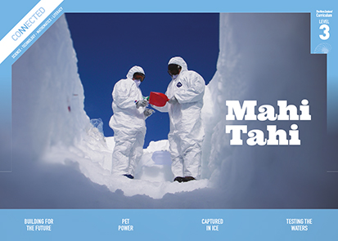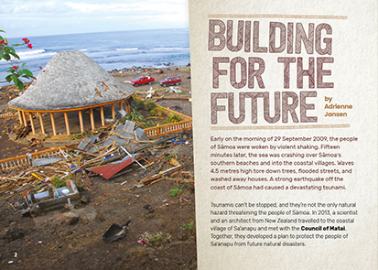
Connected
Level 3
2017

Building for the Future
by Adrienne Jansen

Overview
The Samoan village of Sa’anapu is drawing on cultural, scientific, and technological knowledge to address the problems caused by the combined threats of earthquakes, tsunamis, and climate change.
A Google Slides version of this article is available at www.connected.tki.org.nz. This text also has additional digital content, which is available online at www.connected.tki.org.nz.

Curriculum contexts

SCIENCE: Nature of Science: Participating and contributing  Level 3 – Students will:  - use their growing science knowledge when considering issues of concern to them  - explore various aspects of an issue and make decisions about possible actions. | Key Nature of Science ideas  When we engage scientifically with an issue, we:  - Look for a range of scientific information that relates to the issue  - Check that information we use is from a trustworthy source  - Consider the reliability and validity of the evidence  - Decide if and how to respond to the issue, justifying our decisions based on evidence and/or reliable scientific information  - Monitor the effects of any actions we take.
SCIENCE: Planet Earth and Beyond: Interacting systems  Level 3 – Students will investigate the water cycle and its effect on climate, landforms, and life. | Key science ideas  - Catastrophic weather events speed up the rate of erosion causing changes to the physical environment.  - Scientists use models to explore ideas about how things work.
ENGLISH: Reading  Level 3 – Ideas: Students will show a developing understanding of ideas within, across, and beyond texts. | Indicators  - Uses their personal experience and world and literacy knowledge confidently to make meaning from texts.  - Makes meaning of increasingly complex texts by identifying main and subsidiary ideas in them.  - Starts to make connections by thinking about underlying ideas in and between texts.  - Makes and supports inferences from texts with increasing independence.
TECHNOLOGY: Nature of Technology: Characteristics of technological outcomes  Level 3 – Students will understand that technological outcomes are recognisable as fit for purpose by the relationship between their physical and functional natures. | Key technology ideas  - Environmental issues can influence what technological outcomes are made.  - People develop technologies using the structural principles that occur in living things.  - People choose strong materials to build the frameworks and foundations of buildings.  - The framework of a building helps to hold it up.  - Some shapes make stronger frameworks than others.

The New Zealand Curriculum

Science capability: engage with science

Capability overview
This capability requires students to use the other capabilities to engage with science in real-life contexts. It requires students to take an interest in science issues, participate in discussions about science, and at times, take action.  The dimensions of this capability can be demonstrated when students engage in discussions about science issues, including those in the media. If these discussions build on the ideas of others, emphasise logical connections, and draw reasonable conclusions, and if the speakers make the evidence behind their claims explicit, then students have the opportunity to practise playing the “game of science” (Resnick, Michaels, & O’Connor, 2010). | This allows them to deepen their understanding of what science is.  Students also need opportunities to be actively engaged in exploring real-life science issues that are relevant to them and their communities. This could involve building new knowledge with others and taking action to address local or global concerns.

More about the capability

The capability in action
Real-life science issues:  - may involve a mix of scientific issues and forms of social-science inquiry, including values and ethics  - provide opportunities to build awareness of which questions can be investigated and which questions science does not answer  - provide opportunities to see science as tentative, that is, developing over time as evidence is gathered or reinterpreted  - provide experiences of uncertainty where there is no clear explanation or solution  - allow students to gather and interpret data about a local situation or to critique a range of evidence and claims  - may generate a range of student views, responses, and possible actions.  Students  Students should have opportunities to:  - take an interest in a range of scientific issues  - participate in discussions about scientific issues  - use their developing capabilities of gathering and interpreting data, using and critiquing evidence, and interpreting representations to create a viewpoint, response, or action on scientific issues.  Teachers can:  - establish a science classroom culture by:  - taking a personal interest in scientific issues, modelling questions, explicitly critiquing evidence, and seeking further evidence  - maximising everyday opportunities to introduce learning conversations that engage students with science and scientific issues | - helping their students to notice and investigate science in their everyday surroundings, such as ice on a puddle, the health of a local stream or river, or what happens as materials are mixed or heated  - listening to and discussing socio-scientific items in the news  - exploring locally relevant and contentious scientific issues, such as irrigation, intensive farming, or the effects of climate change  - support students to identify scientific aspects of an issue  - provide a range of resources and investigation opportunities pertaining to scientific issues that require students to use a range of science capabilities  - encourage students to seek and critically evaluate a range of scientific evidence, opinions, and actions from a variety of sources about an issue  - manage with sensitivity situations where students and their whānau may hold differing and strongly held opinions about a science-related issue, such as irrigation  - support students to identify and take appropriate actions in response to science-related issues.  It is important that students are empowered to be hopeful and see opportunities for positive action and change when considering local and global issues.

More activities to develop the capability

Meeting the literacy challenges

The main literacy demands of this text include a mix of description and explanation of the natural hazards. The text is interspersed with maps, photos, and diagrams adding specific details and explanations of the scientific and technical information in the text. In particular, the students will need to interpret the map by using the key to follow the changing coastline over the past eighty years. Quotes from three key experts provide important information.  Vocabulary challenges include Samoan names for people and places, as well as technical and topic-specific language. A glossary is provided for unfamiliar vocabulary not supported in the text. | The following instructional strategies will support students to understand, respond to, and think critically about the information and ideas in the text.  You may wish to use shared or guided reading, or a mixture of both approaches, depending on the reading expertise of your students and the background knowledge they bring to the text.  After reading the text, support students to explore the activities outlined in the following pages.

INSTRUCTIONAL STRATEGIES

Finding the main ideas  TELL the students the title and explain that this article describes how a community drew on expert help to address a complex problem. EXPLAIN that this type of problem is known as a “wicked problem”. Typically, wicked problems can only be addressed when a range of people come together with different kinds of knowledge and skills.  As the students read, ASK QUESTIONS to help them explore the ideas in the text and make connections to their prior knowledge.  Page 2: Notice how the author tells the reader about the tsunami. What strategy does the writer use? Why? (The description of a tsunami comes before it is named – we need to infer what it is. This is confirmed in the last sentence.)  What do you notice about the way the author sets the scene?  What do you know about Sāmoa?  What do you know about tsunamis? How can they affect communities in the Pacific?  Page 3: Identify the problem the village is facing. How is this problem different from a tsunami? What is the impact of this problem?  Where is the village located? How does the map help you to understand the huge problem the village faces? What features of the map help you?  Page 4: What do you know about the role of a matai?  How does the diagram at the top of this page connect with the text in the final paragraph? Skim ahead. How are these three types of knowledge integrated into the article?  Page 5: What have the villagers already done to take action against these threats?  Why do you think some of the villagers don’t want to move? How would you feel about moving? | Page 6: What does Geoffroy mean when he says, “A model is only as good as the data you put in”? How did the model help you to understand the impact of a tsunami? How does this model help the villagers? What does the cutaway of the fale add to your understanding? Why do you think it was included?  Page 7: What does Cecile mean when she says, “The architect is like the conductor of an orchestra”?  How did scientists and architects work together in the article?  Page 8: Evaluate the plan for the new cultural centre. What are the positives and negatives?  Page 9: How do you think this project could help lots of different people?  Have the students create a chart (see example below) to SUMMARISE the problem, the contribution of the three kinds of knowledge and expertise, and the solution.  The problem The knowledge and expertise The solution  Natural hazards  Architecture  Community  DISCUSS the value of this kind of integrated approach. PROMPT the students to make connections to other examples of people bringing together different kinds of knowledge to try to address difficult problems, such as the impact of the Christchurch earthquake or the pollution of local waterways. Or they might recall examples from other Connected articles.  Extending the learning  Give the students a collection of previous Connected articles and have them use a chart like the one above to unpack the different kinds of knowledge people can bring together to find out about and try to address difficult problems. Examples include “Learning from the Tangata Whenua” (Connected 2015, level 2), “The Science of Rongoā” (Connected 2015, level 3), or “Counting Kākahi” (Connected 2014, level 3).

Reading standard: by the end of year 6
The Literacy Learning Progressions
Effective Literacy Practice: years 5–8

Meeting the literacy challenges

TEACHER SUPPORT
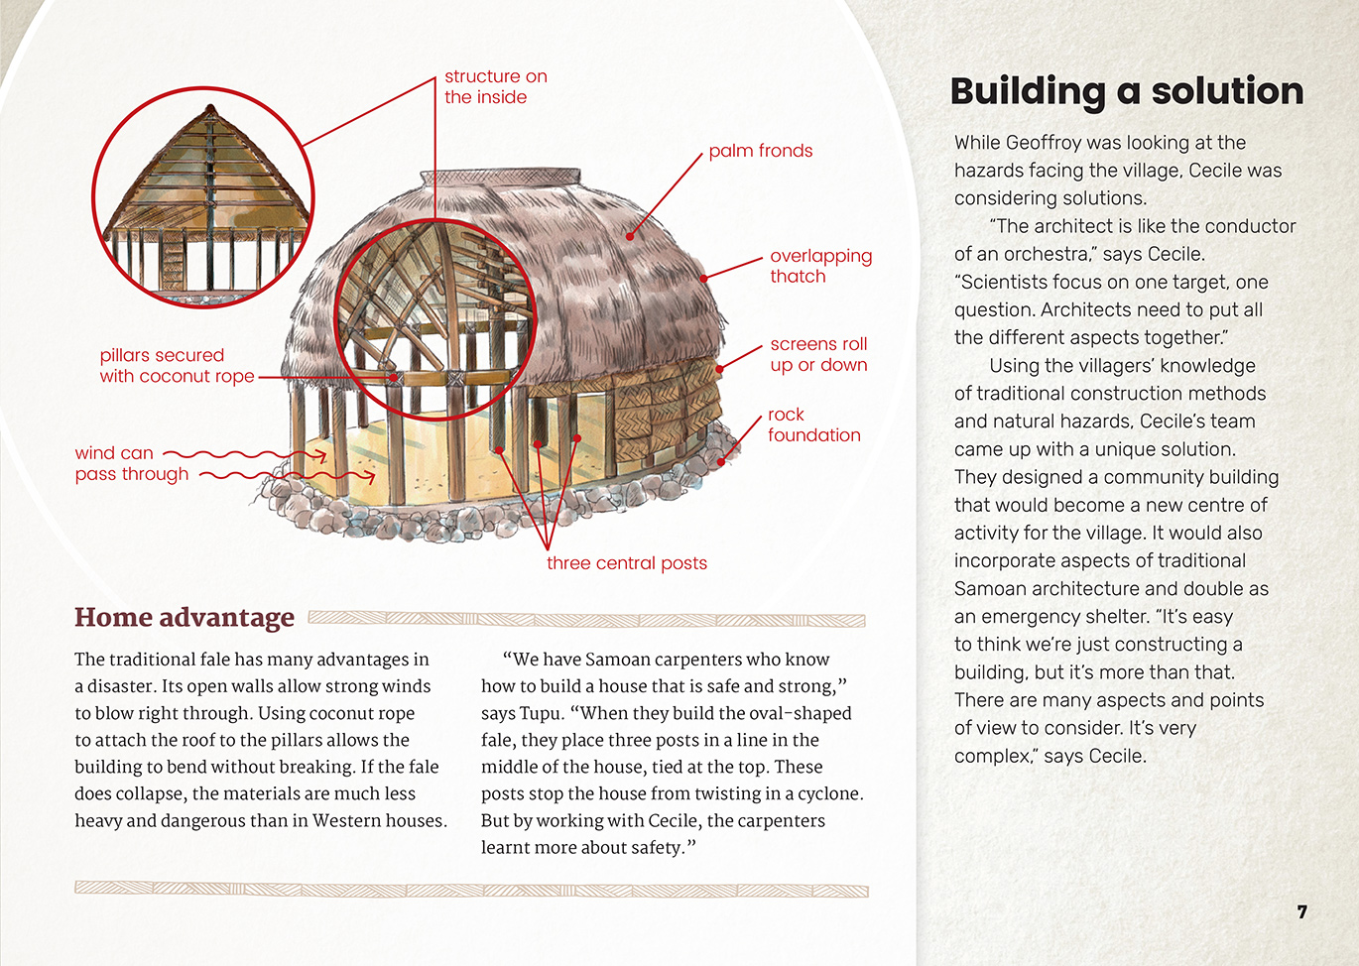
People explore various aspects of an issue and make decisions about possible actions.

People choose strong materials to build the frameworks of buildings.
Technological outcomes are recognisable as fit for purpose by the relationship between their physical and functional natures.
The framework of a building helps to hold it up.

The above page: Text and images copyright © Crown except: stoat (bottom left) by Nick Goodrum https://goo.gl/5k4VpX, which is used under a Creative Commons licence (CC BY 2.0), A24 trap (bottom middle) which is copyright © Goodnature, and beech forest (bottom right) from https://goo.gl/1kZqA3, which is in the public domain.
The above page: Text and images copyright © Crown except: stoat (bottom left) by Nick Goodrum https://goo.gl/5k4VpX, which is used under a Creative Commons licence (CC BY 2.0), A24 trap (bottom middle) which is copyright © Goodnature, and beech forest (bottom right) from https://goo.gl/1kZqA3, which is in the public domain.
The above page: Text and images copyright © Crown except: stoat (bottom left) by Nick Goodrum https://goo.gl/5k4VpX, which is used under a Creative Commons licence (CC BY 2.0), A24 trap (bottom middle) which is copyright © Goodnature, and beech forest (bottom right) from https://goo.gl/1kZqA3, which is in the public domain.
The above page: Text and images copyright © Crown except: stoat (bottom left) by Nick Goodrum https://goo.gl/5k4VpX, which is used under a Creative Commons licence (CC BY 2.0), A24 trap (bottom middle) which is copyright © Goodnature, and beech forest (bottom right) from https://goo.gl/1kZqA3, which is in the public domain.

Learning activities – Exploring the science
The following activities and suggestions are designed as a guide for supporting students to explore and develop understandings about the science capability “engage with science”. Some activities focus directly on the science capability. Other activities extend student content knowledge across the learning areas. Adapt these activities to support your students’ learning needs.

Activity 1 – Making models
Share the Science Learning Hub article on scientific modelling to help students understand the concept of a scientific model. Explain that scientists use models to investigate something and to communicate findings and that models are like the real thing in some ways and not others.
In what ways are models like and not like the thing they are representing?
Have the students reread page 6 of the article. Help them unpack the way Geoffroy would have developed and used the model to predict what might happen.
What kind of data would have been used to develop the computer model?
Have the students write their own explanations of what makes an effective scientific model.
Remember that scientific evidence is built over time. We can’t expect one model with just one set of data to provide all the evidence we need to address a wicked problem.
Check the students’ understandings by having them research and share examples of models. They need to explain what the model is representing, how it is being used, and how accurate they think it is.
Have the students create their own models to represent an idea, object, process, or system from the article. They could:
read the information on the Science Learning Hub about modelling tsunamis and surf waves and complete the activities
make models of houses and see how they stand up to wind (from a hairdryer or fan) and torrential rain (watering can)
make model islands in a tote tray or baking dish and see what happens as the “sea level” rises
design and test a model of a fale that they have adapted to the New Zealand environment
make a 3D model of an atoll to show the extent of tsunami damage.
Have the students use their explanations of an effective scientific model to evaluate their models and consider how they could be improved.

Activity 2 – Climate change and people
Have the students read “Rising Seas” (Connected 2014, level 3) to learn more about climate change and the threat that rising sea levels are posing to communities in the Pacific.
Have the students investigate other Pacific nations threatened by rising seas, such as Tokelau, Tuvalu, or Kiribati. This could involve face-to face-interviews or Skyping. They will need to prepare for their interviews by thinking about the questions they want to ask. Afterwards, prompt them to think about our responsibility as New Zealanders.
How are we part of the problem? How can we be part of the solution?
Have students explore consequences of climate change to New Zealand, such as rising sea levels, droughts, and floods. Have them identify a predicted consequence of global warming that is likely to affect their local area and think about adaptations their community could make.
What information is online about how our area could be affected? What is the evidence?
How could these changes affect the people living in our area? (Think about safety, comfort, loss of heritage, house and land value, insurance, and so on.)
What plans do our local authorities have in place?
What are the strengths and resources in our community that will help us cope?
What kinds of knowledge would we need?
Use the diagram in the GNS resource on natural hazards to prompt thinking about Māori approaches to dealing with natural hazards. How might this help?

Activity 3 – Tsunami alert
Have the students read “The Tsunami That Washed Time Away” (Connected 2014, level 3) to learn more about how scientists find evidence to support their ideas about the impact of tsunamis. The teacher support materials include an activity that has students investigating a model of a tsunami.

Learning activities – Exploring the science

RESOURCE LINKS

Connected  “Rising Seas”, Connected 2014, level 3, Why Is That? http://instructionalseries.tki.org.nz/Instructional-Series/Connected/Connected-2014-level-3-Why-Is-That/Rising-Seas  “The Tsunami That Washed Time Away”, Connected 2014, level 3, Why Is That? http://instructionalseries.tki.org.nz/Instructional-Series/Connected/Connected-2014-level-3-Why-Is-That/The-Tsunami-That-Washed-Time-Away  “Lighting the Way with Solar Energy”, Connected 2015, level 4, Is That So? http://instructionalseries.tki.org.nz/Instructional-Series/Connected/Connected-2015-level-4-Is-That-So/Lighting-the-Way-with-Solar-Energy  Science Learning Hub  Modelling tsunamis and protecting the coast: www.sciencelearn.org.nz/resources/115-modelling-tsunamis-and-protecting-the-coast  Wave tank modelling (activity): www.sciencelearn.org.nz/resources/131-wave-tank-modelling  Similarities and differences: tsunamis and surf waves (activity): www.sciencelearn.org.nz/resources/129-similarities-and-differences-tsunamis-and-surf-waves  Ministry for the Environment  Climate change – 3 implications for New Zealand’s coastal margins:  www.mfe.govt.nz/publications/climate-change/coastal-hazards-and-climate-change-guidance-manual-local-government-n-21  Climate change projections for New Zealand: www.mfe.govt.nz/publications/climate-change/climate-change-projections-new-zealand | RISE Climate Change and Coastal Communities (videos on sea rising in the San Francisco Bay area)  “Beside the Tide”: http://searise.org/webstories/beside-the-tide/  “Hard Choices”: http://searise.org/webstories/hard-choices/  “The Flood Next Time”: http://searise.org/webstories/the-flood-next-time/  Other sources  GNS – Natural Hazards 2013: www.gns.cri.nz/static/download/NHRP/Natural_Hazards_2013.pdf  Parliamentary Commissioner for the Environment – Regional Land Elevation Maps: www.pce.parliament.nz/publications/regional-land-elevation-maps  eSchool Today – Introduction to climate change: www.eschooltoday.com/climate-change/Introduction-to-climate-change-for-children.html  Grade Stack – Cyclones and the damage they cause: http://gradestack.com/CBSE-Class-10th-Course/Safe-Construction/Cyclones-and-the-Damage/15085-3005-4300-study-wtw  The New York Times – The Dutch have solutions to rising seas. The world is watching: www.nytimes.com/interactive/2017/06/15/world/europe/climate-change-rotterdam.html

Learning activities – Exploring the technology

Activity 1 – Designing a home  Have the students explore traditional designs for buildings from their own and other cultures. They should consider:  - the conditions for which they are designed and the features that make them appropriate for those conditions  - the materials used and the properties of those materials that make them fit for purpose.  Support the students’ understandings by using Building Science Concepts Book 48, Fabrics: Origins, Properties, and Uses and Book 51, Standing Up: Skeletons and Frameworks to help them learn more about structure and the properties of materials.  Using the diagram and description of the traditional fale on page 7, have the students share what they have learned.  Activity 2 – Designing a community  Many coastal parts of New Zealand are under threat from rising seas due to climate change. To identify at-risk areas, students could use the map in The Ministry for the Environment resource on the implications of climate change for New Zealand’s coastal margins. Explain that some of these communities may have to move inland over time because of the effects of climate change. | Have the students select a community in one of the areas that is at risk (see the drop-down menu in the link above). Tell them that they have been given the task of redesigning the community in a new place. They will need to consider the following questions:  Where could the community go?  What is necessary in a community? How would you position the various components?  How would you want to live?  Whose views would you need to consider? How would you ensure everyone’s view were taken into account?  How will you support the spiritual and cultural connections with the land and preserve waahi tapu (sacred areas) such as urupa (burial grounds)?  What other data would you need to gather? How would you gather the data?  How would you present your findings?  This activity could be conducted as a role play. The students could take on the characters of people with a range of perspectives and types of knowledge (for example, member of the local iwi, urban planner, owner of a tourism enterprise, farmer, long-time resident, church minister, new parents, child, teenager). They could work together to create a model of a community that meets everybody’s needs.

RESOURCE LINKS

Connected  “Rising Seas”, Connected 2014, level 3, Why Is That? http://instructionalseries.tki.org.nz/Instructional-Series/Connected/Connected-2014-level-3-Why-Is-That/Rising-Seas  Science Learning Hub  Modelling tsunamis and protecting the coast: www.sciencelearn.org.nz/resources/115-modelling-tsunamis-and-protecting-the-coast  Wave tank modelling (activity): www.sciencelearn.org.nz/resources/131-wave-tank-modelling  Similarities and differences: tsunamis and surf waves (activity): www.sciencelearn.org.nz/resources/129-similarities-and-differences-tsunamis-and-surf-waves  Figure It Out – Technology in Practice, Levels 3–4+  Building specs (page 1): https://nzmaths.co.nz/resource/building-specs  Emergency shelters (pages 14–15): https://nzmaths.co.nz/resource/emergency-shelters  RISE Climate Change and Coastal Communities (videos on sea rising in the San Francisco Bay area)  “Beside the Tide”: http://searise.org/webstories/beside-the-tide/  “Hard Choices”: http://searise.org/webstories/hard-choices/  “The Flood Next Time”: http://searise.org/webstories/the-flood-next-time/ | Ministry for the Environment  Climate change – 3 implications for New Zealand’s coastal margins: www.mfe.govt.nz/publications/climate-change/coastal-hazards-and-climate-change-guidance-manual-local-government-n-21  Climate change projections for New Zealand: www.mfe.govt.nz/publications/climate-change/climate-change-projections-new-zealand  Other sources  UNESCO –The Samoan Fale: http://unesdoc.unesco.org/images/0013/001398/139897eo.pdf  Grade Stack – Cyclones and the damage they cause: http://gradestack.com/CBSE-Class-10th-Course/Safe-Construction/Cyclones-and-the-Damage/15085-3005-4300-study-wtw  The New York Times – The Dutch have solutions to rising seas. The world is watching: www.nytimes.com/interactive/2017/06/15/world/europe/climate-change-rotterdam.html

