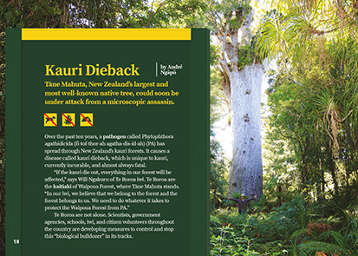
Connected
Level 4
2017

Kauri Dieback
by André Ngāpō

Overview
This article describes the threat to kauri from an introduced pathogen and looks at the work being done to track and limit its spread. It details how combatting this threat requires expertise from both western science and mātauranga Māori, and needs the engagement of scientists, schools, iwi, and communities.
A Google Slides version of this article is available at www.connected.tki.org.nz.

Curriculum contexts

SCIENCE: Nature of Science: Participating and contributing  Level 4 – Students will:  - use their growing science knowledge when considering issues of concern to them  - explore various aspects of an issue and make decisions about possible actions. | Key Nature of Science ideas  When we engage scientifically with an issue, we:  - Look for a range of scientific information that relates to the issue  - Check that information we use is from a trustworthy source  - Consider the reliability and validity of the evidence  - Decide if and how to respond to the issue, justifying our decisions based on evidence and/or reliable scientific information  - Monitor the effects of any actions we take.
SCIENCE: Living World: Ecology  Level 4 – Students will explain how living things are suited to their particular habitat and how they respond to environmental changes, both natural and human-induced. | Key science ideas  - Living things are suited to their habitat.  - Introduced pathogens can threaten the survival of species that have previously not been exposed to them.  - By gathering evidence about how a pathogen infects and affects its host, scientists create ways to protect the host species.
ENGLISH: Reading  Level 4 – Ideas: Students will show an increasing understanding of ideas within, across, and beyond texts. | Indicators  - Makes meaning of increasingly complex texts by identifying and understanding main and subsidiary ideas and the links between them.  - Makes connections by thinking about underlying ideas within and between texts from a range of contexts.  - Recognises that there may be more than one reading available within a text.  - Makes and supports inferences from texts with increasing independence.
TECHNOLOGY: Nature of Technology: Characteristics of technology  Level 4 – Students will understand that technological outcomes can be interpreted in terms of how they might be used and by whom and that each has a proper function as well as possible alternative functions. | Key technology idea  - Environmental issues can influence what technological outcomes are made.

The New Zealand Curriculum

Science capability: engage with science

Capability overview
This capability requires students to use the other capabilities to engage with science in real-life contexts. It requires students to take an interest in science issues, participate in discussions about science, and at times, take action.  The dimensions of this capability can be demonstrated when students engage in discussions about science issues, including those in the media. If these discussions build on the ideas of others, emphasise logical connections, and draw reasonable conclusions, and if the speakers make the evidence behind their claims explicit, then students have the opportunity to practise playing the “game of science” (Resnick, Michaels, & O’Connor, 2010). | This allows them to deepen their understanding of what science is.  Students also need opportunities to be actively engaged in exploring real-life science issues that are relevant to them and their communities. This could involve building new knowledge with others and taking action to address local or global concerns.

More about the capability

The capability in action
Real-life science issues:  - may involve a mix of scientific issues and forms of social-science inquiry, including values and ethics  - provide opportunities to build awareness of which questions can be investigated and which questions science does not answer  - provide opportunities to see science as tentative, that is, developing over time as evidence is gathered or reinterpreted  - provide experiences of uncertainty where there is no clear explanation or solution  - allow students to gather and interpret data about a local situation or to critique a range of evidence and claims  - may generate a range of student views, responses, and possible actions.  Students  Students should have opportunities to:  - take an interest in a range of scientific issues  - participate in discussions about scientific issues  - use their developing capabilities of gathering and interpreting data, using and critiquing evidence, and interpreting representations to create a viewpoint, response, or action on scientific issues.  Teachers  Teachers can:  - establish a science classroom culture by:  - taking a personal interest in scientific issues, modelling questions, explicitly critiquing evidence, and seeking further evidence | - maximising everyday opportunities to introduce learning conversations that engage students with science and scientific issues  - helping their students to notice and investigate science in their everyday surroundings, such as ice on a puddle, the health of a local stream or river, or what happens as materials are mixed or heated  - listening to and discussing socio-scientific items in the news  - exploring locally relevant and contentious scientific issues, such as irrigation, intensive farming, or the effects of climate change  - support students to identify scientific aspects of an issue  - provide a range of resources and investigation opportunities pertaining to scientific issues that require students to use a range of science capabilities  - encourage students to seek and critically evaluate a range of scientific evidence, opinions, and actions from a variety of sources about an issue  - manage with sensitivity situations where students and their whānau may hold differing and strongly held opinions about a science-related issue, such as irrigation  - support students to identify and take appropriate actions in response to science-related issues.  It is important that students are empowered to be hopeful and see opportunities for positive action and change when considering local and global issues.

More activities to develop the capability

Meeting the literacy challenges

The main literacy demands of this text require the students to unpack several complex botanic names and enviro-biological processes describing kauri dieback. The first two pages of the article are the most challenging and contain most of the key information.  A diagram explains the kauri dieback cycle, and in order to make sense of this cycle, students will first need to understand “spores”, “oospores”, “zoospores”, and “sporangia”. | The following instructional strategies will support students to understand, respond to, and think critically about the information and ideas in the text.  You may wish to use shared or guided reading, or a mixture of both, depending on your students’ reading expertise and background knowledge.  After reading the text, support students to explore the activities outlined in the following pages.

INSTRUCTIONAL STRATEGIES

Finding the main ideas  TELL the students that there are a lot of different ideas in this article. Before reading, have them SCAN the title, headings, and images to get a sense of what the text is about. Tell the students what the article is about and ask them what they know, or have heard, about kauri dieback.  What do you learn from the headings? What do you expect to find out from reading this article?  Who do you think the people are in the photographs? What are they doing?  What do the photographs tell you about what is happening to kauri?  What are we being shown in the diagrams?  Have the students create a K-W-L chart (see example below). As they read, they can record their current knowledge about kauri dieback and what they would like to know. After the reading, they will use it to RECORD what they have learned.  What I think I know What I want to know What I have learned  Give the students a map of the North Island and have them IDENTIFY the places named on page 11, then track the spread of kauri dieback.  Have students draw a graph (on graph paper) showing the rate of spread to trees in the Waitakere Ranges. PROMPT them to find the relevant information in the text:  in 2016, close to 20 percent of trees were affected  4,275 trees out of 22,500 were affected  the number of trees affected had almost tripled from 2011.  ASK students to consider the implications of this.  At this rate, how long will it take for all the trees in the Waitakere Ranges to be affected?  PROMPT the students to look closely at the information about the kauri dieback cycle and ASK QUESTIONS to help them make sense of the information about zoospores.  What are zoospores?  What is their effect on kauri? | How do they spread?  What is the significance of Dr Gerth’s research into zoospores?  Why does Dr Gerth want help from Māori experts in ngāhere kauri?  Why does Dr Gerth think the search for a way to prevent kauri dieback is similar to the search for a cancer cure? (Some sensitivity may be needed if you have students affected by cancer.)  What is the most important thing you learned from this diagram?  ASK QUESTIONS to help the students make sense of the information about treating the disease:  How are phosphite injections helping trees that are already infected with kauri dieback? Why is this important?  Have you heard anything about this recently in the media?  What is the difference between a “treatment” and a “cure”?  What is a “citizen scientist”? How are citizen scientists helping to combat kauri dieback? Do you know of any other examples of people acting as citizen scientists?  ASK QUESTIONS to help the students make sense of the information about “fishing for phytophthora”.  What new idea is introduced in the first sentence on page 14?  What was the innovation of the Dawson Primary and Rongomai School students? Why was it important?  ASK the students to sketch timelines showing how the Phytophthora “fishing” devices evolved.  DISCUSS the measures being taken at Waipoua Forest.  Do you think the rules for Waipoua Forest visitors will be successful? Why? Why not?  What do you know about rāhui? Do you know any examples? How do they work?  Do you think a rāhui is inevitable in this case?

Meeting the literacy challenges

ASK the students to read the whakataukī. Then have them think, pair, and share what it means.  What do you know about Tāne Mahuta? Why is the tree described as the “impressive descendant from the beginning of Aotearoa”? What story is this referring to?  Why do you think kauri are important to iwi who connect to Waipoua Forest? Why this tree in particular?  What do you know about the relationship between Māori and the environment?  What makes “Guardians of the forest” an appropriate heading for this final part of the article?  Dealing with unfamiliar vocabulary  Have the students create a chart (see example below) and IDENTIFY and LIST the scientific terms and DISCUSS what they might mean. They should use their prior knowledge and information from the text. Then ask them to use a dictionary to find the meaning and origin of each term. | Scientific term What we think it means What we now know it means The origin of this word  EXPLAIN that many scientific words come from Latin or ancient Greek.  They’re often not very common and can be hard to remember! The words can often be broken up into parts, and often there are words that sound similar and are related. For example, “phosphite” is related to the word “phosphorous”, which is a chemical element. Looking at your table, how does this work for the word “zoospore”?

Reading standard: by the end of year 8
The Literacy Learning Progressions
Effective Literacy Practice: years 5–8

Meeting the literacy challenges

TEACHER SUPPORT
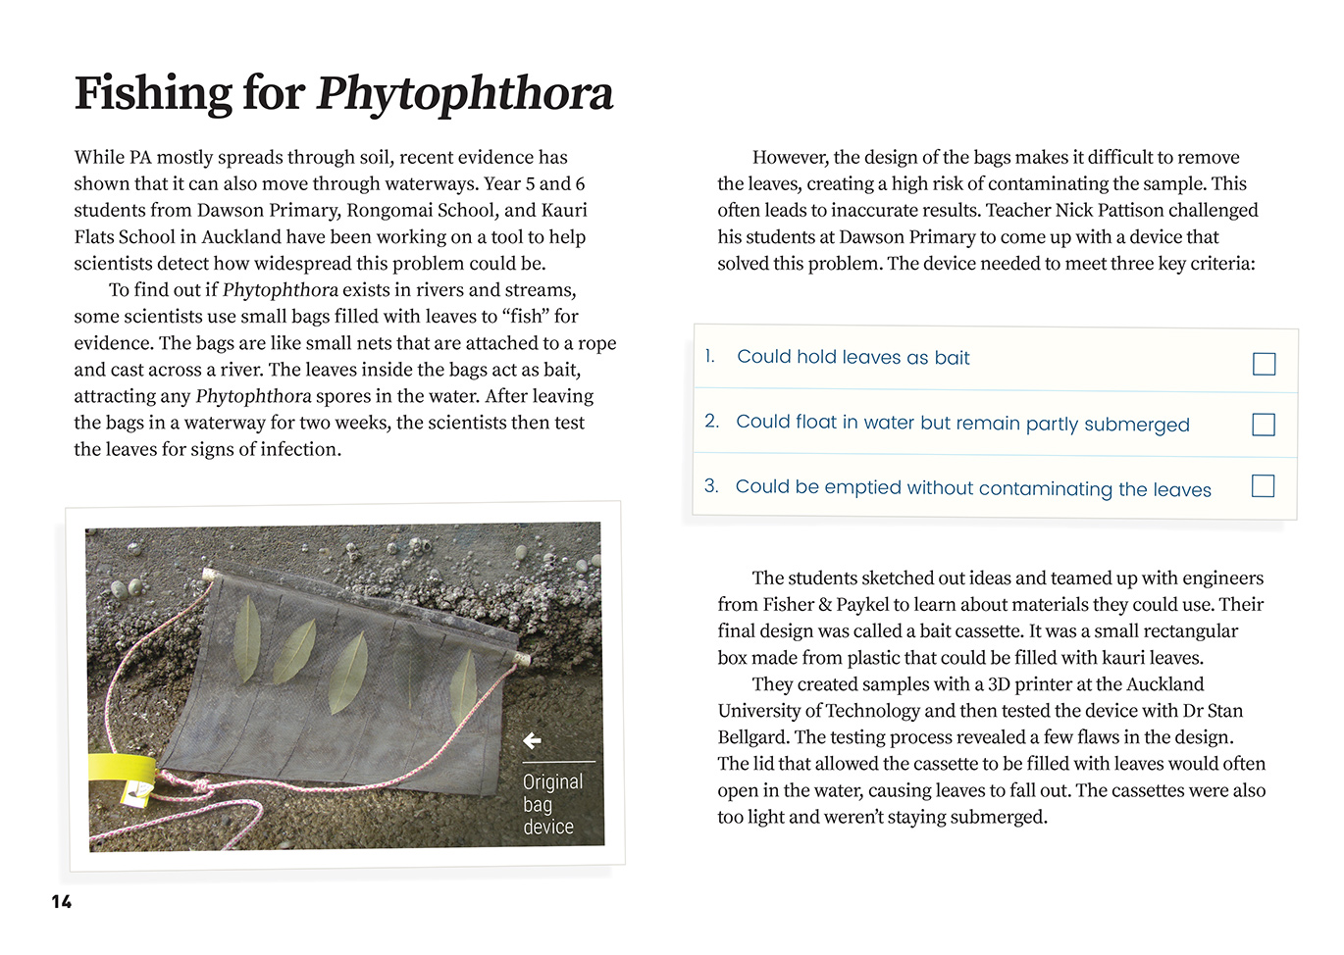 | Students use their growing science knowledge when considering issues of concern to them.  Environmental issues can influence what technological outcomes are made.  Students understand that technological outcomes can be interpreted in terms of how they might be used and that each has a proper function.  Students explore various aspects of an issue and make decisions about possible actions.

Learning activities – Exploring the science
The following activities and suggestions are designed as a guide for supporting students to explore and develop understandings about the science capability “engage with science”. Some activities focus directly on the science capability. Other activities extend student content knowledge across the learning areas. Adapt these activities to support your students’ learning needs.

Activity 1 – What is happening in our own backyard?
Prepare students to visit an area of local bush.
Use the Science Learning Hub activity New Zealand bush ecosystems to look at the relationships between different organisms in a typical bush ecosystem. As part of this activity, students will create a food web.
Explore the Our changing ecosystems timeline to help students understand historical changes in New Zealand’s ecosystems.
Support students to organise a panel of experts to discuss the issue of protecting the ngāhere (native forests). This will allow them to integrate different kinds of knowledge. Have the students discuss who they would like to invite. Groups of students could take responsibility for inviting different people and for researching and writing questions. For example:
A local kaumātua could talk to the class about whakapapa and the interrelationships between all living things. Why is the bush so important? What are the stories that explain this? What are the protocols for entering our bush? What are the reasons for them?
A scientist could talk about what they have observed and discuss any threats. What is the biggest issue in our area? If not kauri dieback, perhaps there is myrtle rust? Or animal pests? How are you investigating these issues?
An environmentalist or citizen scientist could talk about their work in helping to protect the local bush. What is being done? What is the impact? How could we get involved? Could our involvement have negative effects? Kauri dieback is spread by humans. How can we help in ways that don’t risk causing further damage?
Someone from the local council or another authority, such as the Department of Conservation, could talk about the role of government in protecting the bush. What is your role in protecting our native bush? What information do you use to make your decisions? Who do your work with?
Have the students create a chart with headings summarising what they have learned from their visitors. Have them review each other’s charts and reflect on what they have learned.
Explain that you are going to visit the local ngāhere. Prompt them to set a specific purpose for their visit.
What do you want to get out of our visit to the ngāhere?
What are you most interested in exploring?
What do we need to do to make sure our visit does not damage the ngāhere?

Visit to the bush
The visit might involve:
looking for signs of kauri dieback, myrtle rust, or other disease and look for ways to reduce its spread
making observations to create a food web for the local bush
identifying the plants in the local bush, including the “keystone” species – these are species that have a significant impact on the habitats and food webs in the area
taking part in a local initiative to protect the bush
recording observations and impressions to incorporate into a campaign on protecting the bush.

Reflection
Have the students reflect on what they have learned and how it might affect their future behaviour in the bush:
What are some rules or protocols you think we should follow when entering the bush?
What are some things you think we should all know?

Extending the learning
The students could make a visual poster using a program like Google docs. They could write captions explaining the problem and how we can prevent it becoming worse when we enter the forest. They could make each image a link to more information about each issue. They could use this to educate others about threats to the bush and to encourage people to protect it.

Activity 2 – Fighting phytophthora
Have the students identify all the ways that the scientists are finding out about how Phytophthora agathidicida works.
What are the scientists trying to find out? How are they doing this?
How could their findings help to protect kauri?
Have the students go online to find out more current information on the phosphite injections method.

Activity 3 – Sharing the knowledge
An important theme of this article is the way western scientific knowledge and knowledge from mātauranga Māori are increasingly being brought together to help us understand and address significant issues. Go to the episode of Project Mātauranga on kauri dieback (hosted on the Science Learning Hub) to help the students learn more about it.
The Connected 2015, level 2, article “Learning from the Tangata Whenua” focuses on how scientific, cultural, and local knowledge can be brought together to address significant problems. Its teacher support material suggests activities you can use to help students better understand these concepts. These include identifying how they are explored in other Connected articles and investigating examples in their own community.

Learning activities – Exploring the technology

Activity 1 – Design and redesign  Revisit the text and have the students create diagrams to demonstrate the development of the Phytophthora “fishing” devices. Discuss the innovation process. Support students to understand these concepts:  This innovation drew together different perspectives and different kinds of knowledge and expertise.  There is always room for further improvement. | Have the students use information from the article to design their own solutions to the problem of protecting Tāne Mahuta and other kauri from Phytophthora agathidicida. They could suggest further innovations on the existing design or they may look at other approaches, such as the most effective method of cleaning boots to avoid spreading the disease.

RESOURCE LINKS

Connected  “Learning from the Tangata Whenua”, Connected 2015, level 2, Have You Checked? http://instructionalseries.tki.org.nz/Instructional-Series/Connected/Connected-2015-Level-2-Have-You-Checked/Learning-from-the-Tangata-Whenua  Science Learning Hub  Kauri dieback: www.sciencelearn.org.nz/resources/1598-kauri-dieback  Kauri Dieback: Death in the Ngāhere (video – 25:45): www.sciencelearn.org.nz/videos/902-kauri-dieback-death-in-the-ngahere  New Zealand bush ecosystems: www.sciencelearn.org.nz/resources/1173-new-zealand-bush-ecosystems  Our changing ecosystems – timeline: www.sciencelearn.org.nz/resources/1599-our-changing-ecosystems-timeline  Department of Conservation  Kauri Dieback Recreation Project: www.doc.govt.nz/our-work/kauri-dieback-recreation-project/  Tāne Mahuta Walk: www.doc.govt.nz/parks-and-recreation/places-to-go/northland/places/waipoua-forest/things-to-do/tane-mahuta-walk/  Extra protection for Tāne Mahuta: Beehive.govt.nz press release (3 April 2017): www.doc.govt.nz/news/media-releases/2017/extra-protection-for-tane-mahuta/  Myrtle Rust: www.doc.govt.nz/our-work/biosecurity/myrtle-rust/  Serious fungal plant disease found: www.doc.govt.nz/news/media-releases/2017/serious-fungal-plant-disease/ | Ministry for Primary Industries  Kauri dieback: www.mpi.govt.nz/protection-and-response/long-term-pest-management/kauri-dieback/  Protection & Response – Myrtle Rust: www.mpi.govt.nz/protection-and-response/responding/alerts/myrtle-rust  Other sources  Auckland Council – Report on the spread of kauri dieback between 2011 and 2016: http://ourauckland.aucklandcouncil.govt.nz/media/14014/kauri-dieback-waitakere-ranges-report.pdf  Kauri Dieback website: www.kauridieback.co.nz  Keep Kauri Standing – Save Our Kauri Forests (video, 20:57): www.youtube.com/watch?v=B51B5zilO3s  Kauaeranga Forest Education Camp – The Facts on Kauri Dieback (PDF): http://kfec.org.nz/kfec/wp-content/uploads/2015/05/Kauri-Dieback-Fact-Sheet.pdf  Forest & Bird – Kauri dieback disease: Help protect our kings of our forest: www.forestandbird.org.nz/saving-our-environment/threats-and-impacts-/kauri-dieback-disease-help-protect-the-kings-our-forest  Nature Space – Kauri PTA (kauri dieback) disease: www.naturespace.org.nz/kauri-pta-kauri-dieback-disease  Biosecurity Alert – Myrtle Rust: http://img.scoop.co.nz/media/pdfs/1705/2017MyrtleRustFactSheet_MPI.pdf

