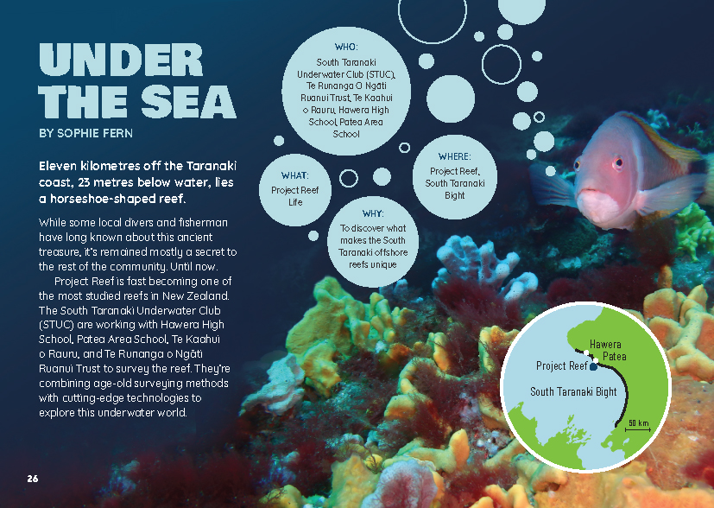
Connected
Level 4
2018

Under the Sea
by Sophie Fern

Overview
This article reports on a survey of a 100-metre long rocky reef located 11 kilometres off the Taranaki coast. Students from local high schools are partnering with divers, biologists, engineers, fishers, and the local iwi to discover and record the plants and animals that make the reef their home. The article focuses on the survey methods being used and the different technologies involved in each method.
A Google Slides version of this article is available at www.connected.tki.org.nz.
This text also has additional digital content, which is available online at www.connected.tki.org.nz.
Curriculum contexts

SCIENCE: Living World: Ecology  Level 4 – Students will explain how living things are suited to their particular habitat and how they respond to environmental changes, both natural and human-induced.  SCIENCE: Living World: Evolution  Level 4 – Students will begin to group plants, animals, and other living things into science-based classiﬁcations.  Science capabilities  This article provides opportunities to focus on the following science capabilities:  - Gather and interpret data  - Engage with science. | Key science ideas  - Biologists classify living things and group them together according to their shared features.  - Habitats can be affected by natural phenomena and humans.
ENGLISH: Reading  Level 4 – Ideas: Students will show an increasing understanding of ideas within, across, and beyond texts. | Indicators  - makes meaning of increasingly complex texts by identifying and understanding main and subsidiary ideas and the links between them  - makes connections by thinking about underlying ideas within and between texts from a range of contexts  - recognises that there may be more than one reading available within a text  - makes and supports inferences from texts with increasing independence.
TECHNOLOGY: Nature of Technology: Characteristics of technology  Level 4 – Students will understand how technological development expands human possibilities and how technology draws on knowledge from a wide range of disciplines. | Key technology idea  - Science and technology together produce a range of surveying methods and tools for a specific need or opportunity.
MATHEMATICS and STATISTICS: Geometry and Measurement: Measurement  Level 4 – Students will use appropriate scales, devices, and metric units for length, area, volume and capacity, weight (mass), temperature, angle, and time.  MATHEMATICS and STATISTICS: Statistics: Statistics Investigation  Level 4 – Students will plan and conduct investigations using the statistical enquiry cycle:  - determining appropriate variables and data collection methods;  - gathering, sorting, and displaying multivariate category, measurement, and time-series data to detect patterns, variations, relationships, and trends;  - comparing distributions visually;  - communicating findings, using appropriate displays. | Key mathematics ideas  - Surveying all of a large area would not be practical.  - Scientists use a sampling approach to survey large areas to determine the most accurate numbers.

The New Zealand Curriculum

Meeting the literacy challenges

The main literacy demands of this text arise from some unfamiliar vocabulary. However, most of the subject-specific words are defined in the text or in the glossary or can be understood through reading on. The text also includes the alternative names for some species, including words in te reo Māori and in Latin.  There are some long sentences, but the article as a whole has a supportive structure. An introduction and conclusion bookend four sections, each describing a different survey method.  Interest is added though the results and speculation on their implications, the descriptive language, the photographs, and the direct address to the reader. The latter includes an invitation to participate in the bigger project. Some students may require support to get the full meaning from hyphenated adjectives, such as “diver-shy fish”. | The following strategies will support students to understand, respond to, and think critically about the information and ideas in the text. It may be appropriate to use all or only one or two of these strategies, depending on your students’ literacy knowledge and skills. You are encouraged to reword the suggested questions that will best suit your learners’ strengths and needs.  You may wish to use shared or guided reading, or a mixture of both, depending on the reading expertise of your students and the background knowledge they bring to the text.  After reading the text, support students to explore the activities outlined in the following pages.

INSTRUCTIONAL STRATEGIES

Finding the main ideas  Have the students read the first page to establish what this article will be about. Clarify that it is a report about the survey of a reef off the coast of Taranaki. ASK QUESTIONS to support the students to make connections to their prior knowledge of underwater life and of how to conduct and report on a scientific investigation. RECORD the students’ responses.  What information do you get from the text boxes on page 26? Why do you think the writer has presented the information like this?  What language and features on this page tell you what this article is going to be about?  What do you know about reefs? Where is this reef located? What does it look like?  What does the word “survey” mean? What are some survey methods you know about? Imagine you were conducting a survey of bird life in your local park. How would you go about it? What are some technologies that might help?  Why would scientists want to find out about the plants and animals under the sea?  What sort of challenges might the team face? How do you think they will overcome these?  Have the students read page 27. ASK QUESTIONS to clarify their initial understandings about the reef and the survey. Support the students to understand the nature of the article and how it is structured.  Have you learnt anything new about reefs and how they are formed? What was it? Did any of this surprise you?  What have you learnt about the challenges the team faces?  What are the typical features of a scientific report? [An introduction, methods and materials, results, and a conclusion or discussion.] Where are these features located in this article? Let’s go back to the beginning and SCAN the whole article to check. | DISCUSS how the students can use what they have learnt about the purpose of this article to create a graphic organiser that summarises the main ideas. For example:  What do we learn from the introduction? That’s right – we learnt about the purpose of the investigation. How can we state that in one sentence?  When scientists discuss their methods, they usually tell you why they chose that method. How can we show that in our organiser?  What else do we learn from the introduction that we need to take account of in our summary? [They’re using four different methods and specialised surveying equipment.]  We found that the survey results are reported separately for each of the methods, so let’s add another column to our table.  What do we expect to find when we read the conclusion? [A general statement that points out general findings from the data, and implications or next steps]

Meeting the literacy challenges

Project Reef  Introduction The purpose of this survey was to …  Method Equipment Why this method was chosen Results  1. Underwater camera survey  2. Diver transect survey  3. Hook-and-line survey  4. Acoustic survey  Conclusion/discussion  After the reading, DISCUSS the difference between observations and inferences. (You could support this discussion, in your own mind, with a prereading of the Science Online page on gathering and interpreting data.) Have the students review the results column and use coloured highlighters to distinguish between the survey team’s observations and the inferences they have drawn. | Using design features for deeper understanding  PROMPT the students to look closely at the map on page 26. ASK them if they have ever been to this part of New Zealand.  Where is it in relationship to the rest of New Zealand?  What is the coast like there? What sort of sea creatures can you imagine living there?  DISCUSS how the photographs, diagrams, and captions help to explain the text.  Why are there so many photographs? How do they add to your understanding? Did you find any of them surprising?  How did the diagrams help you understand the information? What additional information do you get from them?  What did you learn from the captions and labels?  Have the students move into pairs. Each pair should select and read through one of the diagrams and then explain the survey method to another pair. Encourage the students to ask each other questions to ensure the explanations are clear and correct. They should rotate around the class so that when the activity is completed, each pair will have provided their explanation at least four times and will have listened to at least one explanation of all the other methods. As a class, EVALUATE whether this was a helpful approach for developing and embedding their understandings and whether it would be helpful for other learning tasks.  Dealing with unfamiliar vocabulary  PROMPT the students to refer to the glossary on page 32 for support with some of the vocabulary and to notice the definitions of words that are bolded in the text. If they find an unfamiliar word or phrase that isn’t defined in this way, PROMPT them to read on for a sentence or two and to look out for further clues in the visual text.  From the information in the text, what do you think “age-old surveying methods” means? What words or information helped you to work it out?  You may not know what a transect survey is, but read on for a sentence or two until you can find enough information to be able to infer what it means. What additional information can you get from the diagrams and photographs?

Meeting the literacy challenges

TEACHER RESOURCES

Want to know more about instructional strategies? Go to:  - http://literacyonline.tki.org.nz/Literacy-Online/Planning-for-my-students-needs/Effective-literacy-practice-years-5-8  - “Engaging Learners with Texts” (Chapter 5) from Effective Literacy Practice in Years 5 to 8 (Ministry of Education, 2006).  Want to know more about what literacy skills and knowledge your students need? Go to:  - http://nzcurriculum.tki.org.nz/Assessment/Reading-and-writing-standards  - http://www.literacyprogressions.tki.org.nz/ | We have retained the links to the National Standards while a new assessment and reporting system is being developed. For more information on assessing and reporting in the post-National Standards era, see:  - http://assessment.tki.org.nz/Assessment-and-reporting-guide

Reading standard: by the end of year 8
The Literacy Learning Progressions
Effective Literacy Practice: years 5–8

Illustrating the key ideas
Living things are suited to their particular habitat.

TEACHER SUPPORT
Scientists use a sampling approach to survey large areas to determine the most accurate numbers.  Science and technology together produce a range of surveying methods and tools for a specific need or opportunity. | 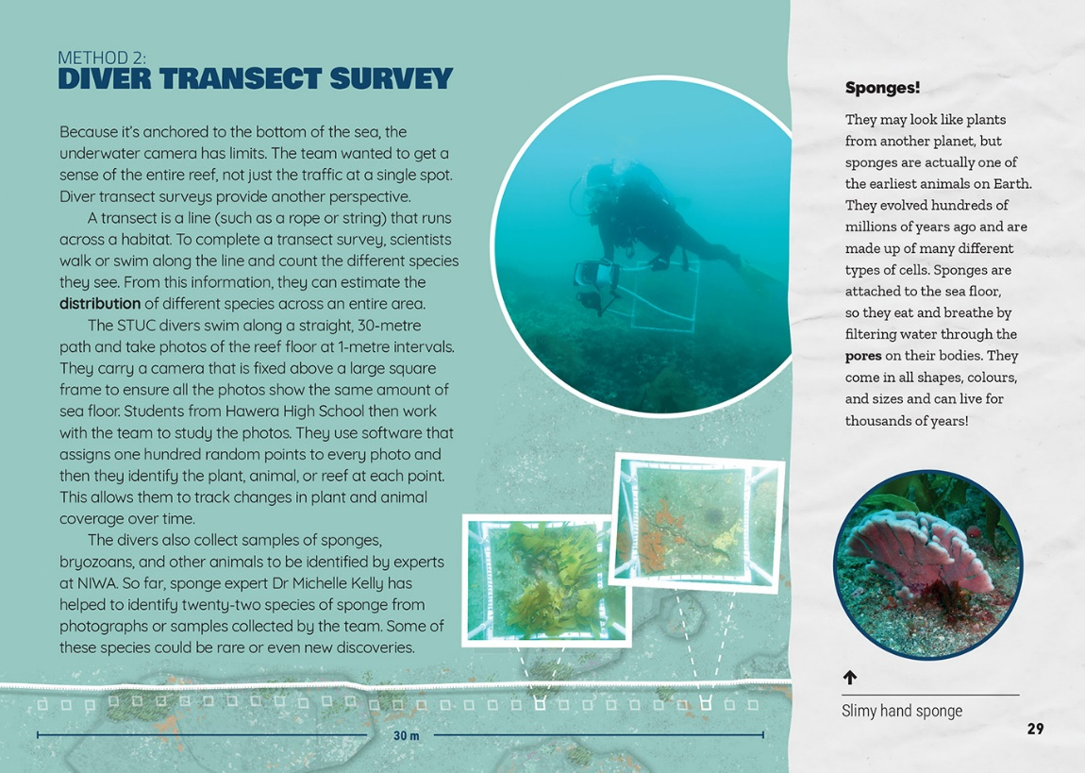  Biologists classify living things and group them together according to their shared features.

Learning activities – Exploring the science,
technology, and mathematics and statistics
The following activities and suggestions are designed as a guide for supporting students to explore and extend student content knowledge across the learning areas. Adapt these activities to support your students’ learning needs.

Activity 1 – Ordering our world  Living or non-living?  Explain that soon after birth, human beings have a need to classify the world around them so that we can make sense of it. That’s as true for a young baby as it is for a scientist! One of the first things we differentiate between is things that are alive and things that are not alive.  What do I mean by not alive? Do I just mean things that are dead? What is something that is not alive but not dead?  Tell the students that all living things have seven things in common. If something cannot perform all seven of these functions, they cannot be classified as living. Can you guess what these seven functions are? Introduce the acronym Mrs Gren, which stands for:  - Movement: the ability to move to find food or light or keep away from predators  - Reproduction: the ability to produce offspring in order to keep the species going  - Sensitivity: the ability to respond to things in the environment  - Growth: the ability to get bigger and stronger  - Respiration: the ability to turn food into energy  - Excretion: the ability to get rid of waste products  - Nutrition: the ability to take in food or minerals for energy.  Use a resource, such as the interactive activities or the video listed in the resource links, to explain this further. Challenge the students with questions to test their understanding.  Is a robot a living thing?  Is a fossil a living thing?  What do plants use as food? [While plants convert light energy into chemical energy through photosynthesis, they still need minerals like phosphorous from the soil.]  What sort of waste would come out of plant? [oxygen from photosynthesis, carbon dioxide and water vapour from cellular respiration]  Have the students reread the breakout text about sponges on page 29 and identify what it tells them about how sponges perform the seven functions of a living thing. Discuss this and then fill out a template with this data.  What does it say in the article?  From our reading of the article, how do scientists know this?  How sure can they be?  Where are the gaps in what we know?  How could we find out more? | Sponges  What do scientists think? What is the evidence?  Movement  Reproduction  Sensitivity  Growth  Respiration  Excretion  Nutrition  Have the students move into groups to find out and record how each of the animals named in the article carries out the seven life processes. They should use information from the article and from further research. As an extra challenge, have them find out how scientists gather information, how reliable their data is likely to be, and how valid their conclusions are. The resource links include many resources that will support this task.  What’s in a name?  Discuss the alternative names for blue cod on page 28. Explain that plants and animals are given common names by the people who live in an area, but that when people from different places are talking about the same thing, this can be confusing! For this reason, a Swedish scientist called Carl Linnaeus developed a system of scientific names that could be used by researchers and scientists all around the world. These names come from Latin and usually have two parts. One part refers to the species of the plant or animal and the other refers to the genus that this species belongs to.  Show the students the video “How to name organisms” or read the “Classification system” article on the Science Learning Hub to help them understand why it is so helpful for us to have a system for classifying living things.  Have the students draw up a table with the names of all the animals in the article and see if they can find a common English name, a te reo Māori name, and a scientific name for them all.  Common English name Te reo Māori name Scientific name

Learning activities – Exploring the science, technology, and mathematics and statistics

Where do we fit on the family tree?  Clarify that Linnaeus’s system has seven levels: kingdom, phylum, class, order, family, genus, species. The plants and animals at each level share certain characteristics. Note that since Linnaeus’s time, another level has been added: domain.  Ask the students if they know the species and genus we belong to. Have them create posters on which they identify where humans sit within the Linnaean classification system, how we are characterised, and who our closest relatives are. They could extend this to other species, using a graphic organiser like the one below.  Classification level Name Characteristics Relatives  Extension  Prompt the students to use this activity to surface, discuss, and debate some of humanity’s bigger questions, such as:  What makes us distinctly human? What rights do we have that our relatives do not? What responsibilities?  How did we evolve? Given the advance of artificial intelligence, are we under threat?  Activity 2 – Satisfying our curiosity  Have the students design their own monitoring project for a local habitat of significance. This activity will involve making and using quadrants, recording their observations and drawing inferences, and using the iNaturalistNZ website to report their data. You will find resources to support this work on the Science Learning Hub and on Marine Metre Squared. You could use the following tasks to help the students develop the mathematical and statistical expertise they will need. | - Using the data from a 50 x 50 quadrant, how do you work out the possible number of fish or sponges on a hectare of ocean floor?  - How could you use the formula for calculating CPUE to estimate the number of students in the playground per minute? Students could take a different section of the playground and use that as the equivalent of a line.  - What are some examples of plant or animal life being monitored in your area? How are the observations being recorded and organised? What inferences are being drawn from the data? How reliable is the data and how valid are the inferences? What are some other ways the data could be organised and presented?  Encourage the students to think of ways that digital technologies could be introduced into observation and data gathering. If their ideas appear realistic, particularly in terms of cost, they could write this up as a suggestion for a local environmental group, council, or farmer.  Activity 3 – Listening to the ocean  Reread the section on the acoustic survey on page 31. Play the Science Learning Hub videos that describe reef noise and how sound travels. The students could then make their own hydrophones and use them to listen to underwater sounds.

Learning activities – Exploring the science, technology,
and mathematics and statistics

RESOURCE LINKS

Building Science Concepts  Book 22 – Tidal Communities: Interdependence and the Effects of Change  Connected and School Journal  “Oceans: A Source of Life”, Connected 2012, Level 4  “Spying on Starfish”, Connected 2012, Level 4, Oceans: A Source of Life  “Giving the Ocean a Voice”, Connected 2013, level 2, I Spy ...  “Tiakina a Tangaroa”, School Journal Level 2, October 2011  “The Great Barrier Reef”, School Journal Level 4, May 2013  Science Learning Hub  Classification system: www.sciencelearn.org.nz/resources/1438-classification-system  Making and using a quadrat: www.sciencelearn.org.nz/resources/2318-making-and-using-a-quadrat  Examples of where quadrats are used: www.sciencelearn.org.nz/search?term=quadrat  Noisy kina: www.sciencelearn.org.nz/resources/567-noisy-kina  Life on a reef: www.sciencelearn.org.nz/resources/1268-life-on-a-reef  Make and use a hydrophone (activity): www.sciencelearn.org.nz/resources/581-make-and-use-a-hydrophone  Biodiscovery: www.sciencelearn.org.nz/resources/1593-sea-sponges-and-rongoa  Science Online  Gather and interpret data: http://scienceonline.tki.org.nz/Science-capabilities-for-citizenship/Introducing-five-science-capabilities/Gather-interpret-data  Other sources  Project Reef Life: www.projectreeflife.org/  Curious Minds: What lives in the South Taranaki reef?: www.curiousminds.nz/stories/what-lives-in-the-south-taranaki-reef/  South Taranaki Underwater Club – TRC Environmental Award winner (video): www.youtube.com/watch?v=rcWxaRra4oo  Patea Reef Dive (13 Feb 2016) video: www.youtube.com/watch?v=5ay_zAhl_sI | Dream-flux: www.dreamflux.io/  International Year of the Reef: www.iyor2018.org/ & www.icriforum.org/about-icri/iyor  Hydrophone (includes good diagram): www.azosensors.com/article.aspx?ArticleID=13  Fish species identification: www.oceanhunter.co.nz/ NEED+TO+KNOW/Species+Identification.html  Department of Conservation – Coral identification guide: www.doc.govt.nz/our-work/conservation-services-programme/csp-identification-guides/coral-identification-guide/  NIWA: Splendid Sponges (ID guide): www.niwa.co.nz/coasts-and-oceans/marine-identification-guides-and-fact-sheets/Splendid%20Sponges  NIWA: Splendid Sponges (Intertidal) (ID Guide): www.niwa.co.nz/coasts-and-oceans/marine-identification-guides-and-fact-sheets/intertidal_sponges  Shape of Life: Sponges: Origins: www.shapeoflife.org/video/sponges-origins  Marine Metre Squared: www.otago.ac.nz/marine-studies/resources/metresquared/index.html  Naming nature, putting life in order: www.nhm.ac.uk/discover/naming-nature-putting-life-in-order.html  Findout! What is a living thing?: www.dkfindout.com/us/animals-and-nature/what-is-living-thing/  You Tube – Mrs Gren: www.youtube.com/watch?v=q8q3KecirZw  Annenberg Learner – Taxonomic Classification: www.learner.org/courses/essential/life/session2/closer4.html  Mensa for Kids – Classifying Animals: www.mensaforkids.org/teach/lesson-plans/classifying-animals/  iNaturalistNZ: https://inaturalist.nz/  Newspaper articles:  www.noted.co.nz/currently/science/south-taranakis-project-reef-life-is-citizen-science-in-action/  www.stuff.co.nz/taranaki-daily-news/93521650/national-recognition-for-reef-life-project  www.stuff.co.nz/business/96388516/epa-predicts-serious-damage-to-reef-life-project-from-seabed-mining  www.nzherald.co.nz/technology/news/article.cfm?c_id=5&objectid=11706762

