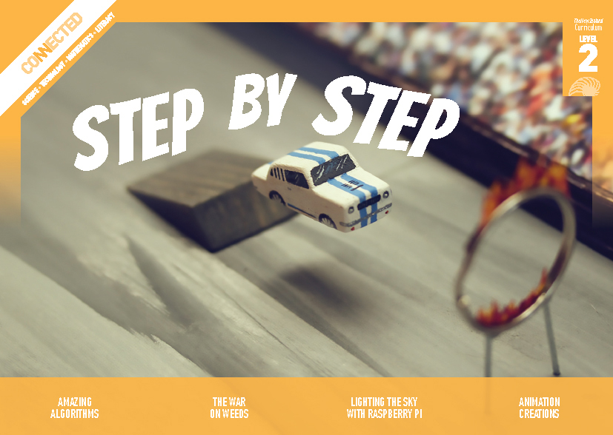
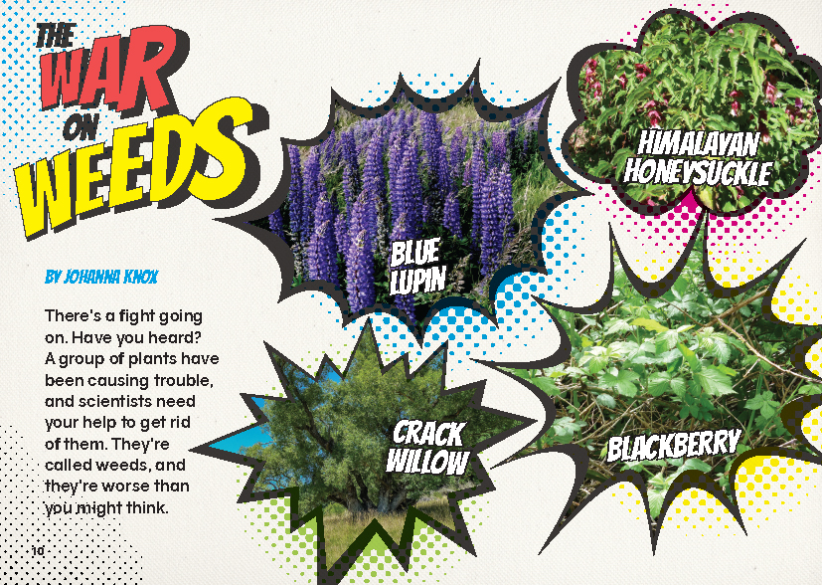
Connected
Level 2
2018

The War on Weeds
by Johanna Knox

Overview
This article describes how students at Kaniere School are helping scientists combat the spread of weeds. It demonstrates how simple digital technology can be used to identify weeds and the native plants they are threatening. It shows how students can become citizen scientists and act locally on a national issue.
A Google Slides version of this article is available at www.connected.tki.org.nz

Curriculum contexts

SCIENCE: Living World: Evolution  Level 2 – Students will recognise that there are lots of different living things in the world and that they can be grouped in different ways.  Science capabilities  This article provides opportunities to focus on the following science capabilities:  - Gather and interpret data  - Engage with science. | Key science ideas  - Classifying involves careful observation and comparison.  - Citizen scientists collect data to help identify environmental issues of concern.
TECHNOLOGY: Nature of Technology: Characteristics of technological outcomes  Level 2 – Students will understand that technological outcomes are developed through technological practice and have related physical and functional natures. | Key technology idea  - We use a wide variety of technologies to observe, investigate, and record data.
ENGLISH: Reading  Level 2 – Ideas: Students will show some understanding of ideas within, across, and beyond texts. | Indicators:  - uses their personal experience and world and literacy knowledge to make meaning from texts  - makes meaning of increasingly complex texts by identifying main ideas  - makes and supports inferences from texts with some independence.
MATHEMATICS and STATISTICS: Statistics: Statistical investigation  Level 2 – Students will conduct investigations using the statistical enquiry cycle:  - posing and answering questions;  - gathering, sorting, and displaying category and whole-number data;  - communicating findings based on the data. | Key mathematics idea  - Statistics involves identifying problems that can be explored by the use of appropriate data.

The New Zealand Curriculum

Meeting the literacy challenges

This is a straightforward text that explains a problem, describes an investigation, and concludes with a summary of what is being learned and what might be done about it. The text is supported by photographs, a map, and informational text boxes.  Apart from the names of the weeds and the name of the app, the vocabulary and ideas will be accessible to most students. English language learners may need support with the colloquial language and sayings. | The following strategies will support students to understand, respond to, and think critically about the information and ideas in the text. It may be appropriate to use all or only one or two of these strategies, depending on your students’ literacy knowledge and skills. You are encouraged to reword the suggested questions that will best suit your learners’ strengths and needs.  You may wish to use shared or guided reading, or a mixture of both, depending on the reading expertise of your students and the background knowledge they bring to the text.  After reading the text, support students to explore the activities outlined in the following pages.

INSTRUCTIONAL STRATEGIES

Finding the main ideas  EXPLAIN that it is the job of a scientist to find solutions to problems. Tell the students that they will be reading an article in which a group of students help scientists deal with a really big problem.  Present the students with a problem–solution map like the one below. Explain that, as they read, they will use the map to RECORD what they find out about the problem and identify the solution. Talk through the map, then model how to SCAN the article to IDENTIFY where they are most likely to find the information they need. Then have the students read and complete their maps in pairs. After the reading, match each pair to another pair so they can compare their maps.  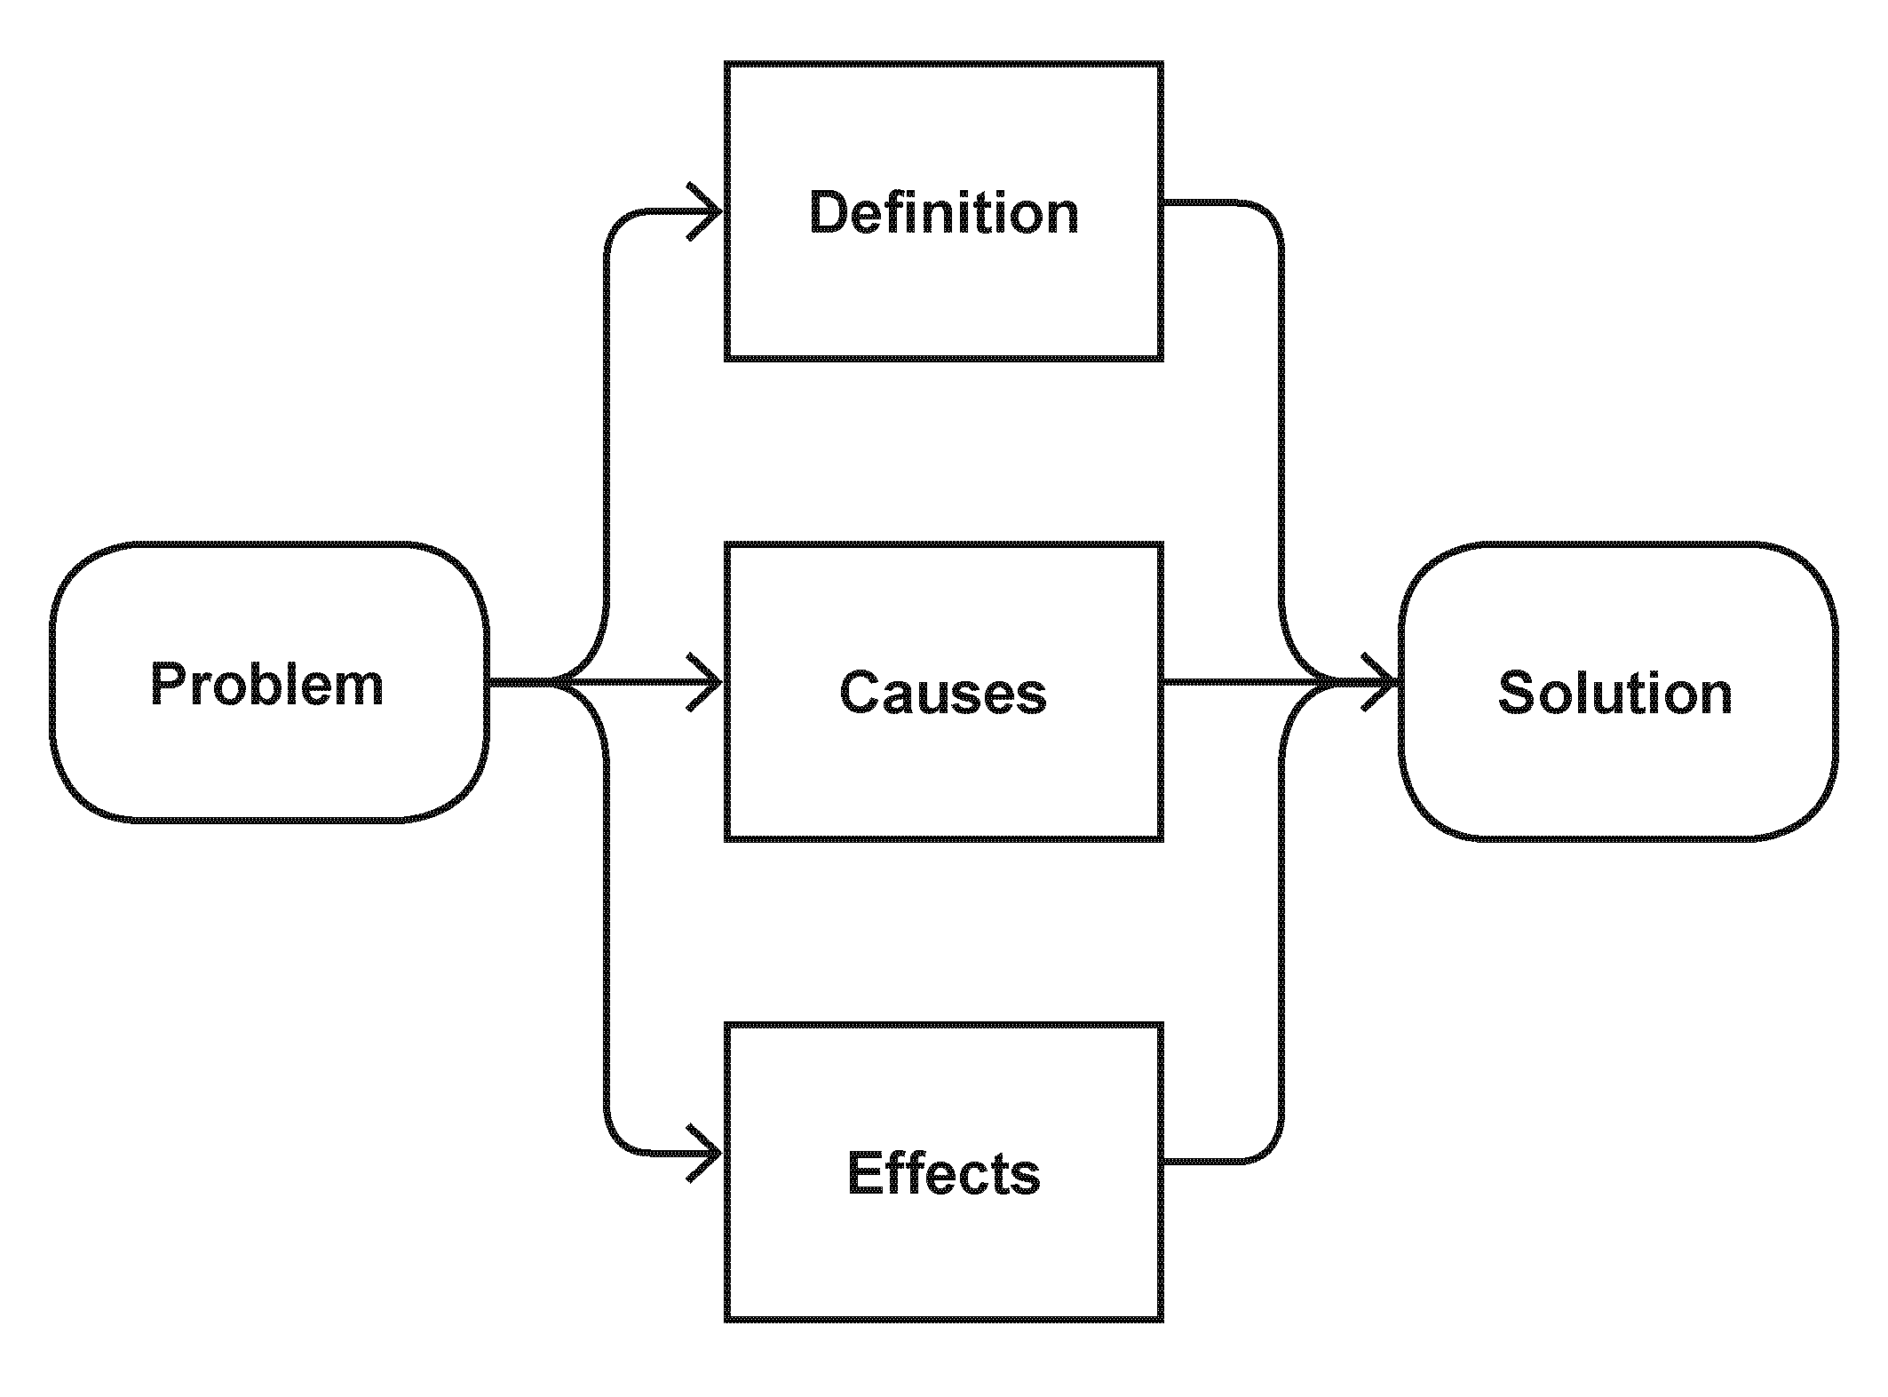  Using design features for deeper understanding  Before the students start to read, have them create a “picture walk” in which they describe each of the visual images in detail, connecting what they see to their prior knowledge and making inferences. They can do this in pairs, with students taking turns to ask each other questions to add detail. Use the photograph on page 12 to MODEL how to do this. | I see three students in a classroom. They are standing at a table looking at some plants. The plants are prickly and look like they might be weeds. One of the students is looking closely at the plants though a magnifying glass. Another student is looking through a microscope. All this evidence makes it obvious that the students are conducting a scientific investigation. They’ve collected data – the plants – and now they’re conducting an observation. I wonder how they collected the data, how they will record their observations, and what they will do with them.  After the students have conducted their picture walks, ask them to share what they learnt.  What did you find out from your picture walk?  How can you use what you learnt from your picture walk to prepare for reading this text?  Dealing with unfamiliar vocabulary  TELL the students that there are at least three interesting groups of words and phrases in this article:  - words and phrases to do with plants and biology, like “weeds”, “sprouting”, and “nutrients”  - words and phrases to do with science and digital technology, like “Manaaki Whenua – Landcare Research”, “uploaded”, and “plant identification tools”  - colloquial words and phrases, like “get rid of them”, “know your enemy”, and “poop”.

Meeting the literacy challenges

PROMPT the students to recall their strategies for dealing with unfamiliar words. Divide the class into three groups and give each group one category. Tell them that they are to locate the words relating to that category. It’s OK that there are overlaps. They are to REVIEW the words and phrases they have identified and then select four or five interesting examples. They can work in pairs and then share with another pair. Each small group then prepares a presentation for the class using visual images, examples of words, and written explanations. | Identifying the author’s purpose  After the reading, ASK the students why they think the author wrote this article. Draw out the idea that this is a persuasive text. PROMPT the students to recall what they know about the features of a persuasive text (for example, rhetorical questions, emotive language, exclamation marks, humour, imagery, and personification). Have them SCAN the text to find examples of these features. ASK QUESTIONS to help the students reflect on the text.  How does the writer want us to respond?  What effect did this have on you? Did you respond as the writer intended? Why or why not?  What have you learnt about the ways scientists use written language?  Should scientists try to persuade you to think something or do something about it? Why or why not?

TEACHER RESOURCES

Want to know more about instructional strategies? Go to:  - http://literacyonline.tki.org.nz/Literacy-Online/Planning-for-my-students-needs/Effective-Literacy-Practice-Years-1-4  - “Engaging Learners with Texts” (Chapter 5) from Effective Literacy Practice in Years 1 to 4 (Ministry of Education, 2003).  Want to know more about what literacy skills and knowledge your students need? Go to:  - http://nzcurriculum.tki.org.nz/Assessment/Reading-and-writing-standards  - http://www.literacyprogressions.tki.org.nz/ | We have retained the links to the National Standards while a new assessment and reporting system is being developed. For more information on assessing and reporting in the post-National Standards era, see:  - http://assessment.tki.org.nz/Assessment-and-reporting-guide

Reading standard: by the end of year 4
The Literacy Learning Progressions
Effective Literacy Practice: years 1–4

Illustrating the key ideas

TEACHER SUPPORT
Scientists collect data to identify and monitor issues.
Citizen scientists collect data to help identify environmental issues of concern.

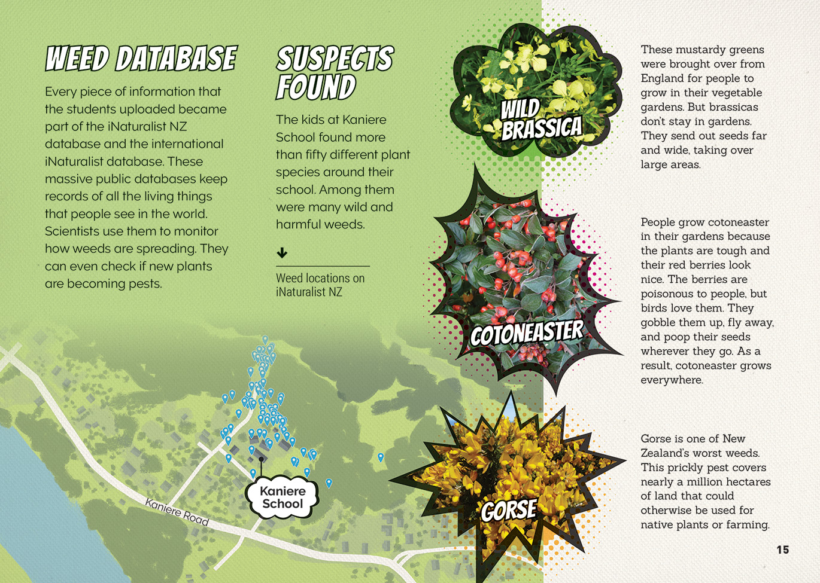
A wide variety of technologies is used to observe, investigate, and record data.
Classifying involves careful observation and comparison.
[Grab your reader’s attention with a great quote from the document or use this space to emphasize a key point. To place this text box anywhere on the page, just drag it.]

Learning activities – Exploring the science,
technology, and mathematics and statistics
The following activities and suggestions are designed as a guide for supporting students to explore and extend student content knowledge across the learning areas. Adapt these activities to support your students’ learning needs.

Activity 1 – Plant classification  What is a weed and what is a plant?  Review the definition of a weed. Take the students for a walk around the school or neighbourhood and identify the weeds and the plants. Take photos of the plants the students say are weeds. As you walk, challenge the students’ thinking.  We’ve got agapanthus growing in this flower bed and some more growing in this crack in the footpath. Is agapanthus a plant or a weed?  From what you observe, what are the most common weeds in our local area? Why do you think we have so many of them?  Can you see any evidence of weeds causing problems? What have you noticed? What do you think the problem is?  How do we classify plants?  Show the students the iNaturalist website and demonstrate how they can use it to find out about the plants identified in the article. Allow time for them to look at the photographs of plants and speculate, in groups, about how the Kaniere School students classified the plants.  Select activities from Building Science Concepts Book 35: Is This a Plant?: Introducing the Plant Kingdom to support the students to understand how we can group and name plants by observing distinctive features, such as their leaves, flowers, cones, or spores.  Checking out our own backyards  Display the photographs of the weeds the students saw on their walk. Have them name as many as they can. Ask them where they could look to check their answers and to find out the names of weeds they couldn’t identify. Note that the resource links below link to both the iNaturalist app and to a key to the weed species of New Zealand, developed by Murray Dawson and others at Landcare Research.  Have the students collect samples of the plants they think are weeds and use microscopes and magnifying glasses to identify them.  Have the students share and compare their conclusions about the plants’ names. If there are discrepancies, remind them that even on iNaturalist, where a lot of the contributors are adults, the uploads are checked by a community of experts.  Taking action  Discuss whether the students’ observations show if any of the weeds they have identified are a problem in their local area. If they think they are, support them to clarify their hypothesis and design and carry out a scientific investigation to check whether it is true. The investigation will need to include the further collection, recording, and analysis of data. When they have drawn conclusions from their findings, prompt them to reflect on whether they have identified a problem that needs a solution and what they might do about it. | Activity 2 – Join the fight!  If the students are excited by the article and want to volunteer, support them to do so. The project is still live. It gives them the opportunity to take action alongside other people around New Zealand and the world. They will be able to engage with the same processes and tools as the students at Kaniere School, becoming familiar with the way digital tools can be used to address threats to our environment.  Other opportunities for learning while taking action include:  - collecting data for the local area and presenting it in ways that persuade people of the size of the problem  - exploring reliability in science and statistics and how the number of people contributing in an area increases the reliability of the data  - learning about animal pests in their area and carrying out a survey, recording the results on the iNaturalist app  - inviting someone from the city council, regional council, Department of Conservation, local iwi, or an environmental group to visit and share what they know about the impact of invasive weeds in the local area and what is being done about it.  Extension  Students who engage in this activity may have ideas about how to develop more student-led or student-friendly applications for gathering and analysing information. They may also want to think about young people in places where digital technology is not so accessible – including some parts of Aotearoa – and design a process for them to collect data on weeds that does not require digital tools or access to the internet.

Learning activities – Exploring the science, technology, and mathematics and statistics

Activity 3 – Why the fuss?  The article explains that most weeds come from other countries and take over areas of land where there were once native plants or farms. In other words, they disturb the natural ecosystem. The resource links include Connected and School Journal articles that help students understand the concept of an ecosystem and the importance of defending our borders (for example, “It Seemed Like a Good Idea at the Time” and “What is Biosecurity?”). There are also articles that highlight the seriousness of the problem when pests such as weeds, possums, or viruses get out of hand (for example, “The Possum Problem”). | The big picture  Various pest invasions are currently hot topics in the media. The students could investigate examples, share what they find, and discuss why this is such a concern for many people.  What are some of the common threads?  How do you feel about all these issues? What does it say about our country and our world?  What should we be doing about all this, if anything?  What should we do if we think we’ve found a pest plant or animal?  When citizens join up with scientists to conduct an investigation, we call them citizen scientists. What are some other examples of citizen scientists acting to address attacks on New Zealand’s natural ecosystem?  What do you think drives people to take action as citizen scientists?

Learning activities – Exploring the science, technology, and mathematics and statistics

RESOURCE LINKS

Building Science Concepts  Book 35 – Is This a Plant?: Introducing the Plant Kingdom  Connected and School Journal  “What Is Biosecurity”, Connected 2011, Level 3, Border Security  “It Seemed Like a Good Idea at the Time”, Connected 2011, Level 3, Border Security  “Winning the Bledisloe Cup”, Connected 2014, Level 2, How Do You Know?  “Garden with Science”, Connected 2014, Level 2, How Do You Know?  “On the Move”, Connected 2016, Level 3, Picture This  “Gardening in the Living Room”, Connected 2017, Level 2, Taking Action  “The Jungle in My Garden”, Junior Journal 52, Level 2, 2016  “The Parapara Detectives”, School Journal Level 3, October 2013  “Seed Savers”, School Journal Level 3, May 2016  “The Possum Problem”, School Journal Level 3, August 2017  “Talking to the River”, School Journal Level 3, June 2018  Science Learning Hub  Weeding: www.sciencelearn.org.nz/images/3321-weeding  Weevils eat pesky buddleia weeds: www.sciencelearn.org.nz/resources/1578-weevils-eat-pesky-buddleia-weeds  Biosecurity: www.sciencelearn.org.nz/resources/1494-biosecurity  Manaaki Whenua – Landcare Research  Kaniere School visits Landcare Research botanical facilities and collections: www.facebook.com/landcareresearch/videos/10155439555222534/?hc_ref=ARS6fG8vsWYo_EiQgdAqdYtL6GGM5CgkXLXzz7H9vIsUbocZFaGc84DHI99GAWhe8Mo  Enabling curious minds to join the war against weeds: www.landcareresearch.co.nz/publications/newsletters/biological-control-of-weeds/issue-79/enabling-curious-minds-to-join-the-war-against-weeds  Weeds gallery: www.landcareresearch.co.nz/information-for/citizen-science/weeds/gallery  Plant identification and interactive keys: www.landcareresearch.co.nz/resources/identification/plants  The great weeds hunt Aotearoa: www.landcareresearch.co.nz/information-for/citizen-science/weeds | Biocontrol and ecology of weeds: www.landcareresearch.co.nz/science/plants-animals-fungi/plants/weeds/biocontrol  Weed biocontrol education resources: www.landcareresearch.co.nz/science/plants-animals-fungi/plants/weeds/biocontrol/education  Weeds on iNaturalist NZ: www.landcareresearch.co.nz/resources/identification/plants/weeds-key/weeds-on-naturewatch  Key to the weed species of New Zealand: www.landcareresearch.co.nz/resources/identification/plants/weeds-key  Other sources  Department of Conservation (DOC):  www.doc.govt.nz/nature/pests-and-threats/war-on-weeds/  www.doc.govt.nz/get-involved/conservation-activities/be-a-warrior-in-the-war-on-weeds/  iNaturalist: www.inaturalist.org  iNaturalistNZ: https://inaturalist.nz/  iNaturalist app: https://play.google.com/store/apps/details?id=org.inaturalist.android&hl=en  Weedbusters (find out more about what you can do to take part in the “war on weeds”): www.weedbusters.org.nz/  Weed list with images: www.weedbusters.org.nz/weed-information/weed-list/  Curious Minds – Why are weeds bad?: www.curiousminds.nz/stories/why-are-weeds-bad/  Weeds of agriculture: https://teara.govt.nz/en/weeds-of-agriculture  Weeds of the bush (Find the answers to the questions: What is a weed? Why do they cause problems? How to control them?): https://teara.govt.nz/en/weeds-of-the-bush  Biosecurity New Zealand – Reporting a pest or disease: www.mpi.govt.nz/protection-and-response/finding-and-reporting-pests-and-diseases/report-a-pest-or-disease/

