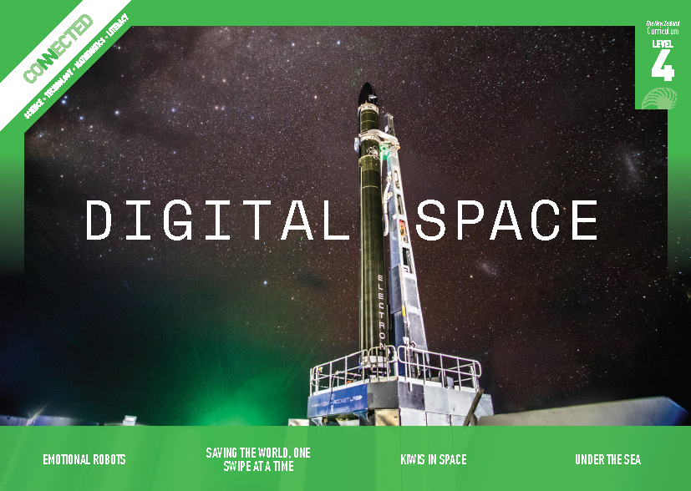
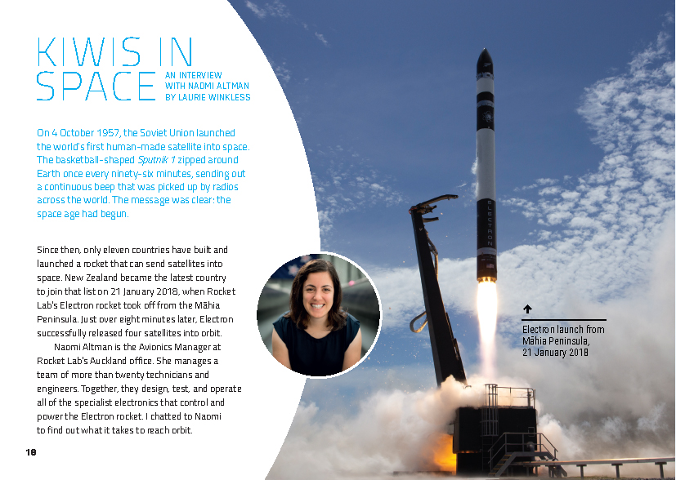
Connected
Level 4
2018

Kiwis in Space
by Laurie Winkless

Overview
In January 2018, New Zealand became one of only eleven countries that have successfully built and launched a rocket capable of sending satellites into space. This interview with Rocket Lab Avionics Manager Naomi Altman explains the science and technology behind that incredible achievement.
A Google Slides version of this article is available at www.connected.tki.org.nz

Curriculum contexts

SCIENCE: Physical World: Physical inquiry and physics concepts  Level 4 – Students will explore, describe, and represent patterns and trends for everyday examples of physical phenomena, such as movement, forces, electricity and magnetism, light, sound, waves, and heat. For example, identify and describe the effect of forces (contact and non-contact) on the motion of objects; identify and describe everyday examples of sources of energy, forms of energy, and energy transformations. | Key science ideas  - The mass and velocity of the burning fuel as it escapes from the rocket engine launches a rocket into the air.  - Objects in orbit are called satellites. Satellites can be natural or man-made.  - Satellites are pulled towards Earth by gravity, but they move horizontally fast enough to continually miss Earth, instead of falling around it.
NATURE OF SCIENCE: Understanding about science  Level 4 – Students will appreciate that science is a way of explaining the world and that science knowledge changes over time.  Science capability  This article provides opportunities to focus on the science capability: Engage with science. | Key Nature of Science idea  - A “law” in science describes a relationship or phenomenon. It describes the way something behaves in nature.
TECHNOLOGY: Technological Knowledge: Technological products  Level 4 – Students will understand that materials can be formed, manipulated, and/or transformed to enhance the fitness for purpose of a technological product. | Key technology idea  - Carbon composite materials are lightweight and very strong.
ENGLISH: Reading  Level 4 – Ideas: Students will show an increasing understanding of ideas within, across, and beyond texts. | Indicators:  - makes meaning of increasingly complex texts by identifying and understanding main and subsidiary ideas and the links between them  - makes connections by thinking about underlying ideas within and between texts from a range of contexts  - recognises that there may be more than one reading available within a text  - makes and supports inferences from texts with increasing independence.
ENGLISH: Writing  Level 4 – Ideas: Students will select, develop, and communicate ideas on a range of topics. | Indicators:  - forms and communicates ideas and information clearly, drawing on a range of sources  - adds or changes details and comments to support ideas, showing thoughtful selection in the process  - ideas show increasing awareness of a range of dimensions or viewpoints.
MATHEMATICS and STATISTICS: Geometry and Measurement: Position and Orientation  Level 4 – Students will communicate and interpret locations and directions, using compass directions, distances, and grid references.  MATHEMATICS and STATISTICS: Geometry and Measurement: Measurement  Level 4 – Students will use appropriate scales, devices, and metric units for length, area, volume and capacity, weight (mass), temperature, angle, and time; interpret and use scales, timetables, and charts.  MATHEMATICS and STATISTICS: Statistics: Statistical investigation  Level 4 – Students will plan and conduct investigations using statistical enquiry cycle:  - determining appropriate variables and data collection methods;  - gathering, sorting, and displaying multivariate category, measurement, and time-series data to detect patterns, variations, relationships, and trends;  - comparing distributions visually;  - communicating findings, using appropriate displays. | Key mathematics ideas  - Engineers use measurement data and mathematical thinking to solve problems (for example, debugging).  - Tracking where the rocket is in space, how much fuel is needed, size of payload, and the trajectory of satellites all require mathematics.

The New Zealand Curriculum

Meeting the literacy challenges

The main literacy demands of this text arise from the density and complexity of the scientific and technical information and vocabulary. While it is a subject of great interest to many students, the content means that they will need at least some prior knowledge of space travel and rockets to make sense of the article.  Most of the key concepts are explained in the text, in the glossary, and in the diagrams. Photographs, maps, and breakout text add further interest and detail.  The article is structured as an interview with a few additional sidebars. The major subheadings are couched as interview questions and point the reader to the main ideas in each section. | The following strategies will support students to understand, respond to, and think critically about the information and ideas in the text. It may be appropriate to use all or only one or two of these strategies, depending on your students’ literacy knowledge and skills. You are encouraged to reword the suggested questions that will best suit your learners’ strengths and needs.  You may wish to use shared or guided reading, or a mixture of both, depending on the reading expertise of your students and the background knowledge they bring to the text.  After reading the text, support students to explore the activities outlined in the following pages.

INSTRUCTIONAL STRATEGIES

Given the high-level, high-interest scientific and technological content, this would be an excellent text for embedding within a larger cross-curricular focus on space science. This could commence with the students reading one of the simpler texts suggested in the resource links.  Finding the main ideas  TELL the students that they are going to read an article about New Zealand’s first rocket company. PROMPT them to share anything they know about Rocket Lab and Electron and then ask them to read the title and SCAN the article to find out more information.  From what you’ve seen, what do you think we will find out from this article?  Have the students read the hook on page 18. ASK QUESTIONS to further activate the students’ prior knowledge about space travel, rockets, and satellites. Have them discuss their responses in pairs.  What do the words “space age” mean to you? What do you think changed for the world with the launch of the 1957 satellite?  It says that Sputnik 1 was a satellite. What do you think a satellite is? What are some kinds of satellites you know about? What are “human-made satellites” used for?  TELL the students that there is a lot of information in this text. Ask them if they noticed anything about the way the text is structured that will help them find the main ideas. DISCUSS the fact that the interview questions provide clues about the main ideas in each section.  We might not understand all the detail the first time we read the article, but if we can answer those questions, we will be well on track.  Use the subheadings to create a graphic organiser where the students can record the main ideas and any answers to their questions. Encourage them to keep their answers succinct and to focus on the main points. PROMPT their awareness of how the visual information supports the written information by having them add a column to their graphic organisers, as in the following example. | Kiwis in Space  Interview questions Information from the written text Information from the visual text  Who are Rocket Lab?  What kind of satellites can be launched on Electron rockets?  What’s unique about the Electron rocket?  What role does computer programming have in Rocket Lab operations?  What’s next for Rocket Lab?  Questions for the breakout text Information from the written text Information from the visual text  Who is caring for the land, and how?

Meeting the literacy challenges

PROMPT the students to notice that there is additional information in the breakout text. MODEL how they could turn the subheadings for those sections into additional questions that will help them find the main ideas.  The heading “Caretakers of the Land” is above a map of the Māhia Peninsula, indicating that this is the launch site. I know that this is a fairly isolated part of the country that is very beautiful and where not too many people live. Space technology seems a strange fit. I think the question this part of the article will answer is “Who is caring for the land and how?”  - Refer students to the original whakataukī that is referred to in this section: “Whatungarongaro te tangata, toitū te whenua”. This translates to: “As man disappears, the land remains”. Ask the students why George Mackey used this particular whakataukī when discussing the Māhia launch site.  After the reading, have students REVIEW and revise their responses to the questions.  Did we capture the main ideas?  How well did we understand them on the first reading?  What reading strategies helped us to deepen our understanding?  What would we like to know more about as we explore the scientific and technological concepts behind Electron?  Using design features for deeper understanding  PROMPT the students to recall their strategies for getting information out of diagrams and photographs. Remind them that whenever they encounter a diagram or photograph, they should ask themselves questions, such as the following:  - Given the focus of this part of the text, what is the illustration likely to show?  - Does the caption confirm my prediction?  - Is there a specific part of the text that this illustration is explaining? Do I need to reread it?  - What do the labels say? Can I describe what I am looking at in my own words?  - Are there arrows, numbers, or letters that tell me how I should read the illustrations?  - What questions does this illustration prompt in my mind? What inferences can I make? | RECORD these questions on the board and have the students share any others. Have the students practise this activity, in pairs, with the diagram on page 19. Listen in to their conversations and select a pair to explain this diagram to the rest of the class, sharing their inferences and any questions they asked. (For example, they might infer that Rocket Lab’s launch azimuth range is limited to the area over the ocean because this is safer. They might ask about how this affects other nations’ abilities to develop this technology.) ASK the class if anybody can think of another way of explaining this diagram and any other questions or inferences it prompted.  Repeat this activity for the diagram describing orbit (page 20) and for the photograph of Electron (pages 22–23).  Dealing with technical and subject-specific vocabulary  EXPLAIN to the students that this text uses a lot of words that are specific to the topic and that some of them are quite difficult. Part of learning to think and act like a scientist, technician, or engineer is learning the language they use! Point out that the meaning of some of the words is explained in the glossary and that the photographs actually show what some of the items look like. As they read, have them record the words that are new to them. Afterwards, create a bank of the words. Be selective – four or five terms is plenty. The following graphic organiser is a template that you and the students could use to present these terms with the contextual information.  Definition  Synonym  Word  Sentence  Picture  Synthesising information  Have the students read the “software engineering morals” from the CS4FN Computer Science for Fun site. Have them review the article with those morals in mind, then select one of the morals and write a paragraph explaining why this moral would have been important when designing and building Electron.

Meeting the literacy challenges

TEACHER RESOURCES

Want to know more about instructional strategies? Go to:  - http://literacyonline.tki.org.nz/Literacy-Online/Planning-for-my-students-needs/Effective-literacy-practice-years-5-8  - “Engaging Learners with Texts” (Chapter 5) from Effective Literacy Practice in Years 5 to 8 (Ministry of Education, 2006).  Want to know more about what literacy skills and knowledge your students need? Go to:  - http://nzcurriculum.tki.org.nz/Assessment/Reading-and-writing-standards  - http://www.literacyprogressions.tki.org.nz/ | We have retained the links to the National Standards while a new assessment and reporting system is being developed. For more information on assessing and reporting in the post-National Standards era, see:  - http://assessment.tki.org.nz/Assessment-and-reporting-guide

Reading standard: by the end of year 8
The Literacy Learning Progressions
Effective Literacy Practice: years 5–8

Illustrating the key ideas

TEACHER SUPPORT
A ‘law’ in science describes a relationship or phenomenon – it describes the way something behaves in nature.  The mass and velocity of the burning fuel as it escapes from the rocket engine launches a rocket into the air.  Materials can be formed, manipulated, and/or transformed to enhance the fitness for purpose of a technological product. | 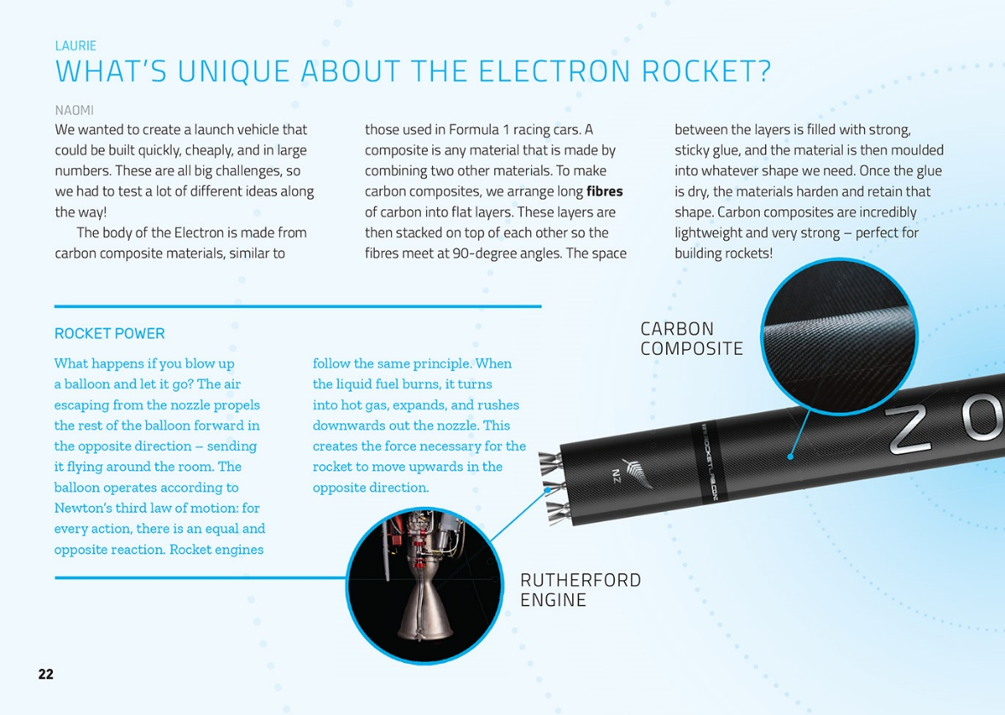

Learning activities – Exploring the science,
technology, and mathematics and statistics
The following activities and suggestions are designed as a guide for supporting students to explore and extend student content knowledge across the learning areas. Adapt these activities to support your students’ learning needs.

Activity 1 – Exploring the science and technology  The students could investigate other composite materials and other uses of carbon fibre using articles from the Science Learning Hub and the activity plan on Rocket Lab’s education page. The Rocket Lab activity teaches students that composite materials are made by combining two different materials and that composite materials can have different properties from the starting materials. They learn the meaning of the word reinforcement and apply this to examples of everyday reinforced materials, such as concrete.  Both the Science Learning Hub and Rocket Lab’s education page suggest ideas for exploring concepts about rockets.  - The Science Learning Hub includes an activity where students make an effervescent canister rocket using baking soda and vinegar. They develop their understanding of rocket propulsion and can scientifically investigate the amount of vinegar that will make the rocket go the highest.  - The Science Learning Hub also includes a story about how Sinead Senek from Sts Peter and Paul School in Lower Hutt used material from the Science Learning Hub to refine her students’ inquiries into rockets and forces. Her story demonstrates how this study can also offer a powerful context for developing students’ literacy and numeracy. (See also the mathematics suggestions below.)  - The Rocket Lab Rockets activity teaches students that rockets burn fuel in one direction to fly in the opposite direction, a phenomenon that depicts Newton’s third law of motion. They learn the meaning of force, action, and reaction and apply the third law of motion to everyday examples.  Revisit the paragraph in the article about Newton’s first law of motion (page 20) and point out the special meaning of the word “law” when used in science. (A scientific law describes and predicts natural phenomena, often mathematically. They can change if new evidence is identified.) Building Science Concepts Book 42: Marbles summarises Newton’s three laws of motion and offers ideas for practical studies into forces and motion.  Extension  There are multiple avenues for inquiry into space exploration. Encourage the students to move beyond facts and figures to deeper questions about the implications of new aerospace technologies, for example:  Employment: Naomi has a job that didn’t exist before the advent of the space age. What do the people at Rocket Lab do? What do they like about their jobs and what do they dislike? What would we have to do to get a job there? What new types of jobs might emerge in the next ten or twenty years as space technology continues to develop?  Rockets: How was the rocket that launched Sputnik 1 designed? How does the design of that rocket compare with the design of Electron? What are the basic principles of rocket design? What kinds of innovations might we expect? | Satellites: Rocket Lab is busy launching satellites into space. How many human-made satellites are already up there? What do they do? How do they work? (For example, how do they help make the internet work?) Are they always helpful or can they be used to hurt people (for example, to spy on people or for use in warfare)? What happens to satellites when they have served their purpose – are we creating space junk?  Space age: How do “space age” technologies impact our daily lives? Have they changed the way we interact? The way we play? What have we gained and what have we lost?  The Humanity Star: The Humanity Star was another Peter Beck creation. What was it and why did it spark so much controversy?  Activity 2 – Exploring the mathematics and statistics  Rockets and space provide an engaging context for learning and applying mathematical and statistical concepts.  - In the Rocket Balloon activity on the NZMaths site, students build balloon rockets that travel along strings and use them to explore what happens when the angles change. This activity could be incorporated into a wider unit of learning about measuring angles.  - Challenge the students to work out the direction for the rocket or to describe a particular point in space (for example, bearings from north, distance to travel, elevation required). Support this learning by having them build their own 3D co-ordinate systems, as described in the TeachEngineering activity.  - Encourage the students to construct and pose each other mathematical and statistical questions, based on the information in the article and any additional research (see the resource links), for example:  - Cost: How much fuel does Electron use in a minute? Is there a rough formula to work out cost? Given the cost of Electron, how much does it need to return in profit per payload?  - Speed: If the rocket travels at 11 kilometres per second, how many kilometres is that per hour? How long would it take to get from X to Y? How fast is Electron compared with other rockets? What factors affect speed?

Learning activities – Exploring the science, technology, and
mathematics and statistics

RESOURCE LINKS

Building Science Concepts  Book 17 – Flight: Control in the Air  Book 27 – Exploring Space: Discovering Our Place in the Universe  Book 42 – Marbles  Connected and School Journal  “Catching a Space Duck”, Connected 2015, Level 3, Fact or Fiction?  “Space Food”, Connected 2017, Level 2, Taking Action  Sky High, School Journal Story Library Level 4, 2012  Living the Dream, School Journal Story Library Level 3, 2017  “Becoming a Martian”, School Journal Level 3, May 2017  Science Learning Hub  Composite materials: www.sciencelearn.org.nz/resources/1466-composite-materials  Radical bike redesign: www.sciencelearn.org.nz/resources/1467-radical-bike-redesign  Rockets: www.sciencelearn.org.nz/topics/rockets  Effervescent canister rockets: www.sciencelearn.org.nz/resources/405-effervescent-canister-rockets  Learning about Rockets: https://www.sciencelearn.org.nz/videos/1582-learning-about-rockets  NZMaths  Measurement Information: https://nzmaths.co.nz/measurement-information  Rocket Balloon: https://nzmaths.co.nz/resource/rocket-balloon  Measuring Angles: https://nzmaths.co.nz/resource/measuring-angles | Other sources  Rocket Lab: www.rocketlabusa.com/  Rocket Lab – Electron: www.rocketlabusa.com/electron/  Rocket Lab YouTube channel (launch livestreams): www.youtube.com/RocketLabNZ  Rocket Lab education activities: www.rocketlabusa.com/education/  Humanity Star: www.thehumanitystar.com/  Stuff businessday – Lift off! New Zealand’s Rocket Lab launches first rocket into orbit from Māhia Peninsula: www.stuff.co.nz/business/100757521/rocket-lab-launches-electron-test-rocket-from-mhia-peninsula-hawkes-bay  National Aeronautics and Space Administration (NASA): www.nasa.gov/  NASA – Rocketry Lesson Plans: www.nasa.gov/audience/foreducators/rocketry/lessonplans/index.html#.W0_YntUzZhF  New Zealand Herald – Blast off! Rocket Lab successfully reaches orbit on second attempt: www.nzherald.co.nz/business/news/article.cfm?c_id=3&objectid=11979201  Computer Science for Fun – NASA Mariner 1, Venus probe, 1962: http://www.cs4fn.org/softwareengineering/mariner1.php  Computer Science for Fun – Mars climate orbiter, 1999: http://www.cs4fn.org/softwareengineering/marsclimate.php  Teach Engineering – A place in space: https://www.teachengineering.org/activities/view/duk_dimension_tech_act

