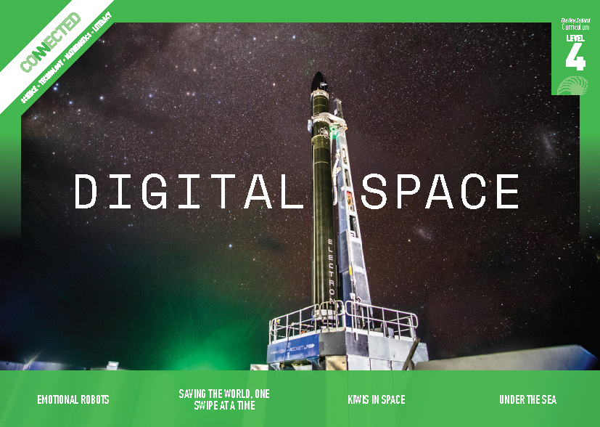
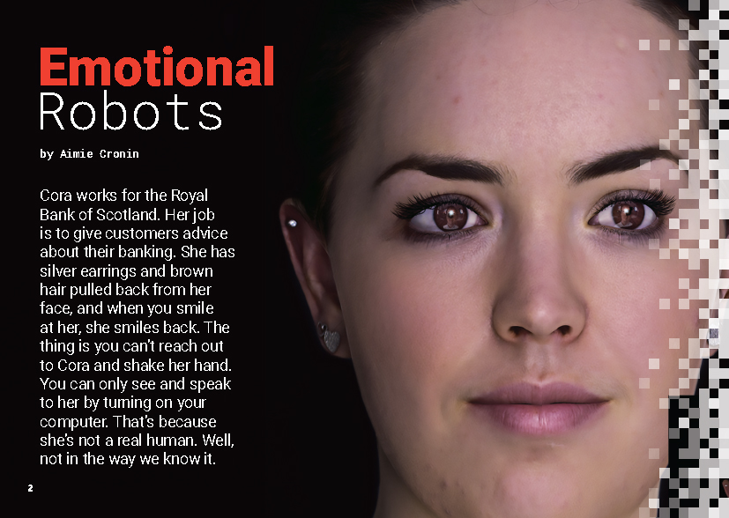
Connected
Level 4
2018

Emotional Robots
by Aimie Cronin

Overview
This article explores the development of artificial intelligence (AI) from a social and ethical perspective. It invites the reader to consider high-level questions about the future for this technology, what emotional intelligence is, how humans think, the ethical implications of building AI that act like humans, and what would happen if AI became more intelligent than us. The engaging style and relatively simple vocabulary makes the content accessible to most readers, ensuring all students can engage in a discussion about issues that will have increasing relevance to their lives.
A Google Slides version of this article is available at www.connected.tki.org.nz
Curriculum contexts

TECHNOLOGY: Nature of Technology: Characteristics of technology  Level 4 – Students will understand how technological development expands human possibilities and how technology draws on knowledge from a wide range of disciplines. | Key technology ideas  - Societal and environmental issues can influence what technological outcomes are made.  - Humans are developing machines (robots) and programs that imitate human emotion and thought.
ENGLISH: Reading  Level 4 – Ideas: Students will show an increasing understanding of ideas within, across, and beyond texts. | Indicators:  - makes meaning of increasingly complex texts by identifying and understanding main and subsidiary ideas and the links between them  - makes connections by thinking about underlying ideas within and between texts from a range of contexts  - recognises that there may be more than one reading available within a text  - makes and supports inferences from texts with increasing independence.

The New Zealand Curriculum

Meeting the literacy challenges

The main literacy demands of this text lie in the complexity of the ideas, the unfamiliar concepts (for example, artificial intelligence, emotional intelligence, neuroscience), and the need to make connections and synthesise information across disparate topics (technology, neuroscience, ethics, and history). The text also includes quotations from two people who bring different perspectives to the topic. Students need to recall who each person is and their expertise and to think about how this might inform their thinking.  The simplicity of the vocabulary and clear, personable narration will support the reader to make meaning of the text. Most unfamiliar vocabulary is explained in the text or in the glossary. Subheadings break up the text and point the reader to key ideas. Sidebars add additional information.  The writer has included an unusually large number of rhetorical questions intended to prompt readers to engage actively with the ideas in the text. If they succeed, then students will take at least a moment to think about their response. | The following strategies will support students to understand, respond to, and think critically about the information and ideas in the text. It may be appropriate to use all or only one or two of these strategies, depending on your students’ literacy knowledge and skills. You are encouraged to reword the suggested questions that will best suit your learners’ strengths and needs.  You may wish to use shared or guided reading, or a mixture of both, depending on the reading expertise of your students and the background knowledge they bring to the text.  After reading the text, support students to explore the activities outlined in the following pages.

INSTRUCTIONAL STRATEGIES

Finding the main ideas  Have the students read the title and SCAN the subheadings and images.  From scanning the images and headings, what do you think this article is about? What information can you get from the headings? What can you get from the images?  From what you’ve seen, what do you think the purpose of this article might be?  Have the students read to the bottom of page 3. ASK them what they notice about the questions in the final paragraph.  Why has the writer included these questions?  What effect do they have?  CLARIFY that these are rhetorical questions – questions that don’t require an answer. They’re there to make a point, get people thinking, or start a discussion. EXPLAIN that this article includes a lot of rhetorical questions.  There’s even a rhetorical question in one of the subtitles. Can you see which one? What is the effect of this question?  What does this question make you think about? Turn to a buddy and tell them. Did we all have the same thoughts?  Knowing what we know about the topic and the presence of all these questions, do you have anything to add or change in your prediction about the purpose of this text?  CLARIFY that the writer wants us to think about the advantages and disadvantages of artificial intelligence. As the students read, have them use sticky notes to highlight the rhetorical questions and jot down their immediate responses. The responses might be thoughts or ideas, or they may be additional questions. After the reading, have the students partner with a buddy to share and discuss their initial responses to the rhetorical questions. Ask the students to share any new questions with the rest of the class. | Dealing with unfamiliar vocabulary  Working in groups, have the students SKIM the text to identify, list, and construct definitions of the topic-specific vocabulary. Have them use these words as they construct concept circles for key terms, such as “artificial intelligence”, “human thought”, and “machine learning”. If needed, model this process. Have the groups construct sentences for each of their concept circles. As they do this, they may find that they need to add additional key terms from their prior knowledge or online research. New terms can be shared with the rest of the class.  Identifying and evaluating different perspectives  Have the students SKIM the text to identify and highlight the direct quotes from Greg Cross and Nick Agar. Construct a PMI chart that represents what Greg and Nick believe to be the positives, negatives, and interesting points about artificial intelligence.  Plus Minus Interesting  Greg Cross  Nick Agar  When they have completed their charts, PROMPT the students to think critically about Greg and Nick’s perspectives and what may influence them.  What is Greg’s job? How might that influence his perspective on artificial intelligence?  What about Nick’s background? How might that influence his thinking about artificial intelligence?  Whose perspective do you trust the most? Why?  Should a person’s background influence your view of their opinion? Why do you say that?  Has this discussion prompted any more questions for you?

Meeting the literacy challenges

TEACHER RESOURCES

Want to know more about instructional strategies? Go to:  - http://literacyonline.tki.org.nz/Literacy-Online/Planning-for-my-students-needs/Effective-literacy-practice-years-5-8  - “Engaging Learners with Texts” (Chapter 5) from Effective Literacy Practice in Years 5 to 8 (Ministry of Education, 2006).  Want to know more about what literacy skills and knowledge your students need? Go to:  - http://nzcurriculum.tki.org.nz/Assessment/Reading-and-writing-standards  - http://www.literacyprogressions.tki.org.nz/ | We have retained the links to the National Standards while a new assessment and reporting system is being developed. For more information on assessing and reporting in the post-National Standards era, see:  - http://assessment.tki.org.nz/Assessment-and-reporting-guide

Reading standard: by the end of year 8
The Literacy Learning Progressions
Effective Literacy Practice: years 5–8

Illustrating the key ideas

TEACHER SUPPORT
Humans are developing machines (robots) and programs that imitate human emotion and thought.  Societal and environmental issues can influence what technological outcomes are made.  Technology draws on knowledge from a wide range of disciplines. | 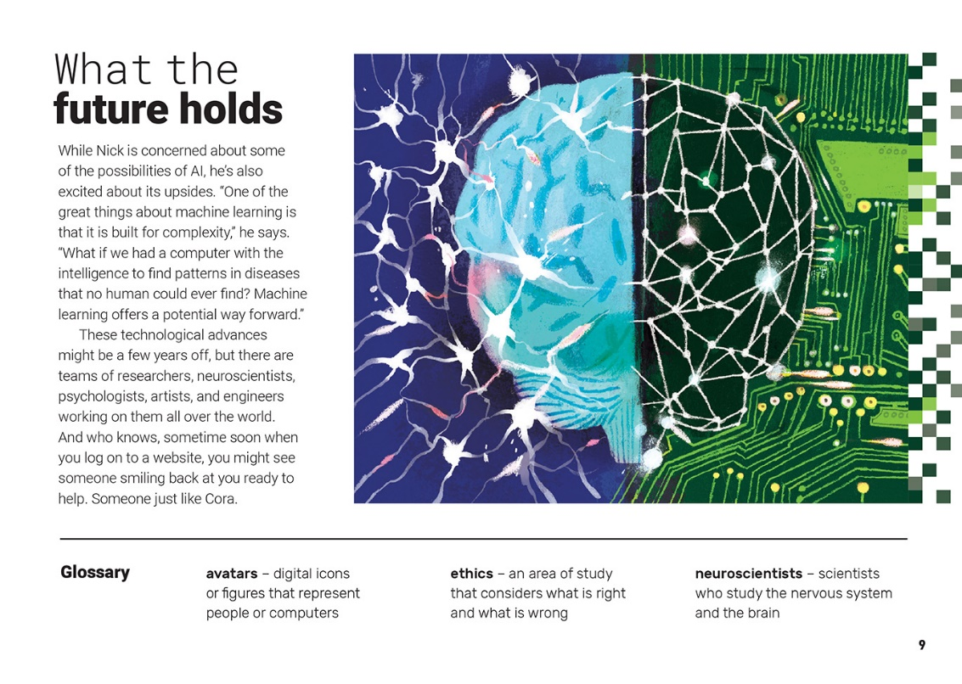

Learning activities – Exploring the technology
The following activities and suggestions are designed as a guide for supporting students to explore and extend student content knowledge across the learning areas. Adapt these activities to support your students’ learning needs.

Activity 1 – How smart is “smart” technology?  Have the students work through two tasks that will help them find out how good today’s “digital humans” really are. This will allow them to explore the ethics of these technologies and where they may take us.  Task 1  Have the students reread the section on the Turing test and try one of the versions that is available online (see the resource links). Armed with this information, have them design and conduct their own version of the test, using chatbots like Eliza or Cleverbot.  Beware of the questions students pose to their chatbots – some of the answers may not be age appropriate. Note also that to conduct the test under perfect conditions, the students will need to have human respondents whose voices are unfamiliar.  Task 2  Have the students find examples of automated assistants like Siri, Cortana, Google Assistant, and Alexa. Note that the examples they can access depends on the devices they have available. After each student has familiarised themselves with at least two or three examples, have them move into groups to set up experiments where they compare the smart assistants according to a set of variables. These might include speech recognition, clarity, relevance of the answers, accuracy of the answers, speed of the answers, or range of functions. Have the students use their findings to rate and review the assistants.  Exploring the implications  Have the students research and debate ethical issues related to artificial intelligence and the creation of robots with increasingly human attributes. Questions to get them started could include:  Who will choose the cultures of the robots? How could a chatbot be programmed to behave in culturally appropriate ways? What about the gender of the robot?  In books, movies, and TV shows, the drive is for robots to be “faster, stronger, better”. How does this fit with the ideas about inclusivity? What are the implications for people with disabilities?  The AI may require personal information about you so you can interact with it. Who would own the information? What are the potential consequences of sharing your personal information with an automated assistant? What regulations are needed to prevent organisations selling identity information without permission?  Extension  Ask the students to design an AI teacher or parent.  What can your AI do? What can’t it do?  What could go wrong? How would you prevent that from happening?  Have the students create advertisements for their designs, showing off their functions and explaining how they work and what has been done to ensure they are safe and fit for purpose. | Activity 2 – Machine learning  Provide the students with hands-on experience of machine learning. Options could include the following:  - Have the students play Google’s Teachable Machine, a free online experiment that lets the user get a feel for how to train a machine.  - Have the students use Scratch to programme simple robots.  - Have the students observe a robotic vacuum cleaner in action. Have them predict how it learns, and then check this, using the item on Appliance Science. (Note the possibilities for mathematics learning in this activity: mapping the robot’s path, measuring distances and angles, comparing the dust collection capacity of different models of cleaner, comparing changes in speed as the robot “learns” the room.)  Surface and explore the students’ questions about machine learning, for example:  How does machine learning work? Can we write this up as a process?  What can we instruct our machines to do? Could we customise a talk-to-text program?  Why are machine learning and artificial intelligence topical at the moment?  Most often, humans feed machines data so the machines can learn. Does this mean there is a risk of bias? Whose intelligence is it?  What jobs could the growth of AI lead to for humans?  What jobs might AI put at risk?  Extension  Have the students write an opinion piece on the difference between being a machine and being human.  Activity 3 – Artificial intelligence: past, present, and future  Have the students research and present a timeline outlining key moments in the development of artificial intelligence from its origins seventy years ago to the present day. Then have them predict the next big steps in the development of AI, supporting their predictions with evidence from their research. Prompt their thinking with questions.  What sort of tasks are most suited to AI? Why?  What are some tasks we may not wish to give up?  People often talk about jobs today that never used to exist. Can you think of some examples? What are some tasks you think AI could accomplish in the future?  When do you think artificial intelligence could surpass human intelligence? What consequences could there be to this?  Are the developments in AI unstoppable or is this something we could control?  Extension  Having asked so many questions themselves, the students could survey people in their community on their views of AI  – its possibilities, its dangers, and the role it should play in community life.

Learning activities – Exploring the technology

RESOURCE LINKS

Science Learning Hub  Develop students’ “futures thinking” skills: www.sciencelearn.org.nz/resources/2438-teaching-futures-thinking  Other sources  ESOL Online – Concept circles: http://esolonline.tki.org.nz/ESOL-Online/Planning-for-my-students-needs/Resources-for-planning/ESOL-teaching-strategies/Vocabulary/Concept-circle  Reading to Learn in Science – Four corners: http://serpmedia.org/rtls/4corners.html  Techopedia – What is artificial intelligence?: www.techopedia.com/definition/190/artificial-intelligence-ai  Amazon Alexa: https://developer.amazon.com/alexa  Google Assistant: https://assistant.google.com/#?modal_active=none  Cleverbot: www.cleverbot.com/  Eliza, computer therapist: www.manifestation.com/neurotoys/eliza.php3  Milo the robot helps students with autism: www.wjhl.com/local/its-just-amazing-milo-the-robot-helps-students-with-autism-learn-in-new-ways/1101372799  Josie – ASB digital assistant for small business outcomes: www.stuff.co.nz/business/money/101887745/meet-josie-asbs-digital-assistant-and-a-new-zealand-banking-first  Jamie – ANZ digital assistant/customer FAQs: www.stuff.co.nz/business/money/105342680/anzs-new-digital-person-jamie-likes-science-fiction-and-lives-in-uncanny-valley  Siri: www.apple.com/uk/ios/siri/  Cortana: www.microsoft.com/en-us/cortana  Vai (Virtual Assistant Interface) – MPI Auckland airport biosecurity arrivals area: www.reseller.co.nz/article/634408/robots-here-auckland-airport-hires-first-digital-employee/  FaceMe (Vai and Josie): www.faceme.com/  Soul Machines: www.soulmachines.com/  YouTube – Birth of a Digital Assistant: Raising Cora [1/7]: www.youtube.com/watch?v=70drfmMG8uU  YouTube – Birth of a Digital Assistant: Teaching Cora [2/7]: www.youtube.com/watch?v=EuaQ298fhqc | My Publications – Alan Turing: a short biography: www.turing.org.uk/publications/dnb.html  Encyclopaedia Britannica – Turing Test: www.britannica.com/technology/Turing-test  Independent – John McCarthy: Computer scientist known as the father of AI: www.independent.co.uk/news/obituaries/john-mccarthy-computer-scientist-known-as-the-father-of-ai-6255307.html  BBC – Ethics: A general introduction: www.bbc.co.uk/ethics/introduction/intro_1.shtml  The Spinoff – The AI-powered chatbot that can help you learn te reo Māori: https://thespinoff.co.nz/business/26-04-2018/the-ai-powered-chatbot-that-can-help-you-learn-te-reo-maori/  National Library of New Zealand – Any questions (robots): https://anyquestions.govt.nz/many_answers/robots  TED: Guy Hoffman – Robots with “soul”: www.ted.com/talks/guy_hoffman_robots_with_soul/transcript  Designing (and Learning from) a Teachable Machine: https://design.google/library/designing-and-learning-teachable-machine/  Teachable Machine: https://teachablemachine.withgoogle.com/  Scratch: https://scratch.mit.edu/  Robots Kits for Kids – mBots: www.makeblock.com/steam-kits/mbot  Appliance Science – How robotic vacuums navigate: www.cnet.com/news/appliance-science-how-robotic-vacuums-navigate/  New Scientist – Visual Turing test: www.newscientist.com/article/visual-turing-test/  Bot or Not: http://botpoet.com/

