Connected
Level 2
2019

Kimihia Kermit
by Philippa Werry

The Literacy Learning Progressions: Meeting the Reading and Writing Demands of the Curriculum describe the literacy-related knowledge, skills, and attitudes that students need to draw on to meet the demands of the curriculum.  The Learning Progression Frameworks (LPF) describe significant signposts in reading and writing as students develop and apply their literacy knowledge and skills with increasing expertise from school entry to the end of year 10.  Overview  This article describes how Ngāti Mutunga and students from Uruti, Mimi, and Urenui schools are working with scientists to find out which frogs are still living in their rohe (local area). It provides an opportunity for students to understand how scientific, local, and cultural knowledge can contribute to an investigation. Frogs are a good hook for engaging students with information about life processes and ecology.  A Google Slides version of this article including additional digital content is available at www.connected.tki.org.nz | 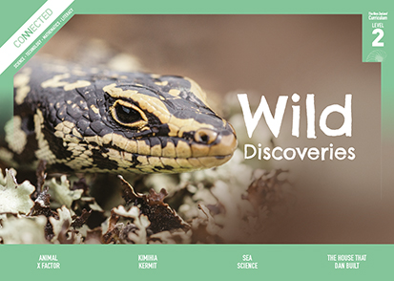  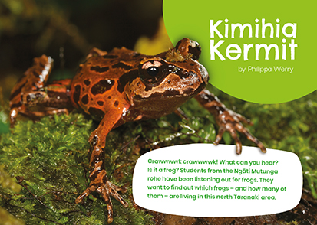
Curriculum contexts

SCIENCE: Nature of Science: Understanding about science  Level 2 – Students will appreciate that scientists ask questions about our world that lead to investigations and that open-mindedness is important because there may be more than one explanation.  SCIENCE: Nature of Science: Participating and contributing  Level 2 – Students will explore and act on issues and questions that link their science learning to their daily living.  SCIENCE: Living World: Ecology  Level 2 – Students will recognise that living things are suited to their particular habitat.  SCIENCE: Living World: Life processes  Level 2 – Students will recognise that all living things have certain requirements so they can stay alive. | Key science ideas  - Animals meet their needs from their habitat. Changes to that habitat can threaten their survival.  - Scientists make careful observations to gather data.  - Scientists use a variety of ways to collect data to make sure they have sound evidence.
MATHEMATICS and STATISTICS: Statistics: Statistical investigation  Level 2 – Students will conduct investigations using the statistical enquiry cycle:  - posing and answering questions  - gathering, sorting, and displaying category and whole-number data  - communicating findings based on the data. | Key mathematics ideas  - Data can be used to answer multiple questions.  - Organising data can reveal information, patterns, and trends.  - Looking for patterns is an important part of statistical thinking.

ENGLISH: Reading  Level 2 – Language features: Students will show some understanding of how language features are used for effect within and across texts. | Indicators:  - recognises that oral, written, and visual language features can be used for effect  - uses a large and increasing bank of high-frequency, topic-specific, and personal-content words to make meaning  - shows an increasing knowledge of the conventions of text  - recognises that authors have different voices and styles.

The New Zealand Curriculum

Meeting the literacy challenges

The main literacy demands of this text lie in the combination of a wide range of text features, which include bullet points, quotations, photographs, illustrations, a map, and breakouts. The text moves in a logical way from information about frogs to a recount of the investigation. The recount is told in the past tense while the breakouts and facts about frogs are in the present tense. One of the breakouts is about kaitiakitanga (a Māori worldview of guardianship and caring of our land for future generations), and the whole article approaches the subject using this Māori concept.  The science project introduces the procedures and practices of a scientific inquiry project (recording data, repeating the test, and using technology). Topic-specific vocabulary, technical terms, and words in te reo Māori are given sentence-level support or explained in the text or in a glossary on the same page. The repetition of some words will help reinforce them. | The instructional strategies below support students to meet the literacy challenges of this text. For each strategy, there are links to the relevant aspect of The Learning Progression Frameworks (Reading). The signposts on each of these aspects provide detailed illustrations on what to notice as your students develop their literacy knowledge and skills for different purposes in different curriculum areas.  The following strategies will support students to understand, respond to, and think critically about the information and ideas in the text.  You may wish to use shared or guided reading, or a mixture of both approaches, depending on the reading expertise of your students and the background knowledge they bring to the text.  After reading the text, support students to explore the activities outlined in the following pages.

INSTRUCTIONAL STRATEGIES

Finding the main ideas  [LPF Reading: Acquiring and using information and ideas in informational text]  Have the students read the title and text on page 9. PROMPT them to think, pair, and share their experiences and knowledge of frogs.  Have the students read page 10 to find out why some students in North Taranaki are participating in a survey of frogs. Check that they have made the connection between “this North Taranaki area” and “the Ngāti Mutunga rohe”. If necessary, use the map on page 15 to clarify where this is.  Have the students preview the text to understand the structure and features. CLARIFY that the article moves from informational text to a recount of a science investigation. Briefly DISCUSS what might be different about these two types of text.  Does your preview so far remind you of other things you know about frogs?  Have you thought of other things you would like to know?  How will you know when you are reading about the investigation and when you are reading general information about frogs?  Which features help to guide you through the text? | PROMPT the students to notice the transition from informational text to a recount on page 12. INTRODUCE or REVIEW the steps in the statistical enquiry cycle. DISCUSS how scientists work. (They pose and find answers to questions by gathering and analysing data, then communicate their findings and raise new questions.) Talk through how the students can summarise the investigation carried out by Kimihia Kermit using a template similar to the one below:  Kimihia Kermit investigation  Question  Prediction  Data gathering: Survey one: listening survey Survey two: acoustic survey How did they gather the data?  Data analysis  Conclusion  Next steps  As the students read, PROMPT them to make inferences and predictions.  What does the reference to “warning signs” suggest about the reason for the investigation?  What does this mean: “If it was too wet or windy, the surveys didn’t happen”?  I wonder how they could tell what sort of frog they were listening to.  I see they did two surveys. Why do you think that was?

Meeting the literacy challenges

After the reading, encourage them to make a personal response.  What did we learn about the writer’s purpose?  We know what motivated the writer. What motivated the project team? Do you think they thought all their work was worth it? How could you tell?  What is your response to the article? Do you think we could help protect the frogs? How could we do that?  Using visual features for deeper understanding  [LPF Reading: Making sense of text: using knowledge of text structure and features]  Point out that this text has a lot of visual features. Focus on the section on page 11 headed “Frog facts”.  Why do we have these pictures? How do they help us understand the facts that the students learned about frogs?  Why does one of the pictures have arrows? Why do the arrows point in two different directions?  What about that unusual picture in the middle of the bottom row? What does it show?  Have the students cover the text and use the pictures to explain the “frog facts” to a partner. Then have them cover the pictures and just use their words. DISCUSS what this reveals about the role of visual information in a scientific text.  How easy was it to do these activities? What difference did it make to your explanations when you had only the pictures or only the words?  How do the pictures work? Why did the designer choose to create these cartoon-like images instead of using photographs?  What does this tell you about the use of pictures in science articles?  DISCUSS the variety of visual features in this article.  Have each pair of students select three examples of visual features and identify their purposes and how they work. Then have them work with another pair to talk through the visual features they chose.  Page Visual feature Purpose How it works | Dealing with unfamiliar vocabulary  [LPF Reading: Making sense of text: vocabulary knowledge]  ASK the students the meaning of the word “Kimihia” and where the word “Kermit” comes from. If they don’t know or are unsure, have them go online to find out. DISCUSS whether this is a good name for the project.  PROMPT the students to use the surrounding text to confirm the meaning of the word “bio-indicators”. DISCUSS the clues to meaning that are inside the word.  DISCUSS the terms “kaitiaki” and “kaitiakitanga”. What is the relationship between these words? (The “tanga” makes it a noun – this is a common part of words in te reo Māori.) How could we check? (A good reference is the online Māori Dictionary.)  DISCUSS the terms in the glossary on page 10.  What is the relationship between a “species” and a “population”? Could you draw a diagram to show the connection?  “Ecology” is made up of a prefix, “eco”, and a suffix, “ology”. “Eco” means the environment, habitat, or house, and “ology” means “study of”. Can you find other scientific words that use “eco” or “ology”? What do they mean?  ASK the students to locate all the words related to the biology of frogs and use them to write a paragraph describing frogs or write labels for a diagram of a frog.  Have the students IDENTIFY the words related to scientific inquiry and review their summaries to ensure that they used them.

The Learning Progression Frameworks
The Literacy Learning Progressions
Effective Literacy Practice: Years 1–4

Illustrating the key ideas

Scientists ask questions about our world that lead to investigations.  Animals meet their needs from their habitat. Changes to that habitat can threaten their survival. | 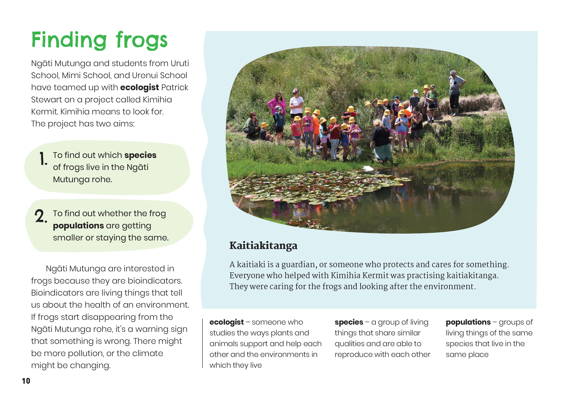
Scientists use a variety of ways to collect data to make sure they have sound evidence. | 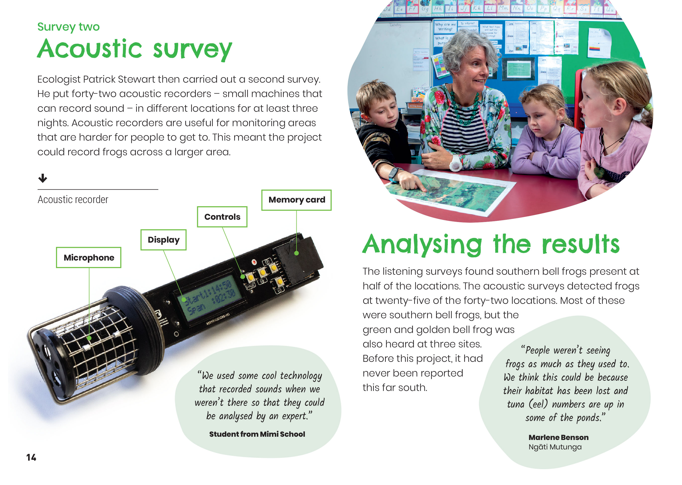  Data can be used to answer multiple questions.

Learning activities – Exploring the science
and technology

Activity 1 – More frog fact files  Review the way headings are used to organise sets of information on page 12 and in the reporting card pictured on page 13. Discuss why it is important to organise scientific information in a regular, patterned way like this. (When collecting data, it helps us to ensure all necessary data is gathered and valid, and makes it faster and easier to collate. When presenting data, it helps us find patterns.)  Have the students use the sets of frog facts on page 12 as a model for creating “fact files” for other frogs. This could be done on a shared platform, such as Google Classroom. Prompt the students to ask and seek answers to questions that arise when they look at the information they have collated.  Do you notice any patterns in the information we have collected? What ideas do we have that could explain the patterns? How could we test these ideas?  What do you notice when you compare different frogs according to their habitats?  What do you notice about the places where frogs seem to be doing well and the places where they are in danger?  Have the students use what they have learned about frogs to create Venn diagrams, comparing introduced frogs with native frogs.  Extending the learning  For a more complex activity, have the students compare the life cycle of a native frog to that of an introduced frog. This is an opportunity for ensuring students understand the conventions for creating diagrams, such as headings and captions. In particular, you can highlight the importance of arrows in a life cycle. Discuss the fact that three of New Zealand’s four native frogs don’t have a tadpole stage. | Activity 2 – Take action for frogs!  Explain that Kimihia Kermit is an example of citizen science. This is when everyday people work with scientists on specific projects, asking questions and seeking solutions to local problems.  As a class, investigate local organisations and online projects that engage in citizen science. Use ideas from the article to design a survey that could be used to investigate frogs or other organisms in your area. There are resources below to help, such as the FrogID app, which allows users to conduct a listening survey by recording frog calls and uploading the audio.  See the Connected article link below for an example of students using digital technology in a similar way to combat weeds.  Support students to create their own digital tools for engaging in citizen science. Both of the ideas below require the students to go beyond engaging in statistical enquiry themselves to teaching others how to engage with it. Students will need to think about how to communicate with others, persuade them to take part, and explain how.  - The students could create a Scratch or ScratchJr programme that teaches people how they can monitor frogs and/or protect them.  - The students could create a QR code that links to a digital outcome that explains to people how to listen for frogs. This could be linked to an online form that asks the public to record what they hear. They could explore what makes QR codes so reliable.  A Science Learning Hub item offers teacher support for leading citizen science projects.  The following activities and suggestions are designed as a guide for supporting students to explore and extend their content knowledge across the learning areas. Adapt these activities to support your students’ interests and learning needs.  Extending the learning  Pūtātara is a new website that supports schools and teachers to incorporate sustainability and global citizenship across the curriculum. Students and teachers can engage in rich inquiry that reflects their local context and integrates learning areas. They can go on to explore how Expo 2020 Dubai encourages countries to collaborate in tackling issues such as preserving the planet.

RESOURCE LINKS

Connected  “The War on Weeds”, Connected 2018, Level 2, 2018, Step by Step  Science Learning Hub  Native frogs: https://www.sciencelearn.org.nz/resources/1380-native-frogs  Frogs (video): https://www.sciencelearn.org.nz/videos/1779-frogs  FrogID: https://www.sciencelearn.org.nz/resources/2764-frogid  Unique New Zealand: Reptiles and amphibians (interactive): https://www.sciencelearn.org.nz/image_maps/59-unique-new-zealand-reptiles-and-amphibians  Threats to native reptiles and amphibians: https://www.sciencelearn.org.nz/resources/1185-threats-to-native-reptiles-and-amphibians  Investigating frog disease: https://www.sciencelearn.org.nz/resources/1181-investigating-frog-disease  Conservation rankings: https://www.sciencelearn.org.nz/resources/1379-conservation-rankings  Saving reptiles and amphibians – Introduction: https://www.sciencelearn.org.nz/resources/1180-saving-reptiles-and-amphibians-introduction  Observation: Learning to see: https://www.sciencelearn.org.nz/resources/1400-observation-learning-to-see  Bioindicators: https://www.sciencelearn.org.nz/resources/1538-bioindicators  Planning for students to be citizen scientists: https://www.sciencelearn.org.nz/resources/2740-planning-for-students-to-be-citizen-scientists  Department of Conservation  Archey’s frog: https://www.doc.govt.nz/nature/native-animals/reptiles-and-frogs/frogs-pepeketua/archeys-frog/  Frogs/pepeketua: https://www.doc.govt.nz/nature/native-animals/reptiles-and-frogs/frogs-pepeketua/  NZFrog  Native frogs: http://www.nzfrogs.org/NZ+Frogs/Native+frogs.html  Introduced frogs: http://www.nzfrogs.org/NZ+Frogs/Introduced+frogs.html  Frog ID key: http://www.nzfrogs.org/Resources/Frog+ID+Key.html  Keeping frogs: http://www.nzfrogs.org/Resources/Kids+Information/Keeping+Frogs.html  Endangered Species Foundation  Archey’s Frog: http://www.endangeredspecies.org.nz/store/doc/Archeys%20frog%20Leiopelma%20archeyi%20Endangered%20species%20factsheet.pdf  Hamilton’s Frog: http://www.endangeredspecies.org.nz/store/doc/Hamiltons%20frog%20Endangered%20species%20factsheet.pdf | Radio New Zealand: Critter of the Week  Archey’s frog: https://www.radionz.co.nz/national/programmes/afternoons/audio/201776747/critter-of-the-week-archey's-frog  Hamilton’s frog: https://www.radionz.co.nz/national/programmes/afternoons/audio/2018659596/critter-of-the-week  Hochstetter’s frog: https://www.radionz.co.nz/national/programmes/afternoons/audio/201859596/critter-of-the-week-the-hochstetter-frog  NSW Office of Environment & Heritage  Southern Bell Frog – profile: https://www.environment.nsw.gov.au/threatenedSpeciesApp/profile.aspx?id=10491  Green and Golden Bell Frog – profile: https://www.environment.nsw.gov.au/threatenedSpeciesApp/profile.aspx?id=10483  YouTube  Archey & Friends – A Helping Hand for the Future: https://www.youtube.com/watch?v=hOlO2FoRqXQ  Auckland Zoo: Zoo Tales – Archey’s frog: https://www.youtube.com/watch?v=gRasIH6muiU  BushTellyTV: Pepeke / Frog (Maud Island Frog): https://www.youtube.com/watch?v=0gwUBOGduHA  Other sources  Te Ara: Frogs: https://teara.govt.nz/en/frogs  The University of Waikato: New Zealand Frogs (e-book): https://www.waikato.ac.nz/__data/assets/pdf_file/0007/405565/3456-UOW-New-Zealand-Frog-Book-web.pdf  Curious Minds: Kimihia Kermit: https://www.curiousminds.nz/projects/kimihia-kermit/  Auckland Zoo: Archey’s frog: https://www.aucklandzoo.co.nz/animals/archeys-frog  EDGE: Archey’s frog: http://www.edgeofexistence.org/species/archeys-frog/  NZ Herald: NZ’s unique native frogs “just hanging on”: https://www.nzherald.co.nz/nz/news/article.cfm?c_id=1&objectid=12112069  Stuff: Our fascinating frogs: http://www.stuff.co.nz/environment/7787401/Our-fascinating-frogs  IUCN (International Union for Conservation of Nature) Red List of Threatened Species: https://www.iucn.org/resources/conservation-tools/iucn-red-list-threatened-species  New Zealand Geographic: Citizen Science: https://www.nzgeo.com/stories/citizen-science/?state=registrationCompleted  nzmaths: Statistical investigation units of work: https://nzmaths.co.nz/statistical-investigations-units-work  CensusAtSchool: Data detective poster: https://new.censusatschool.org.nz/resource/data-detective-poster/

RESOURCE LINKS – Continued

Digital technology
Scratch: https://scratch.mit.edu/
ScratchJr: https://www.scratchjr.org/
Enabling e-Learning Teaching: Coding: http://elearning.tki.org.nz/Teaching/Future-focused-learning/Coding
Enabling e-Learning Teaching: Using QR codes: http://elearning.tki.org.nz/Teaching/Future-focused-learning/QR-codes
QR code generator: https://www.qr-code-generator.com/
Unplugged: Error detection and correction: https://csunplugged.org/en/topics/error-detection-and-correction/
Pūtātara: https://putatara.education.govt.nz/#/about

