Sea Science
by Marie McEntee and Joe Fagan
Connected
Level 2
2019
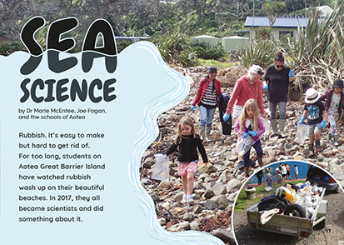
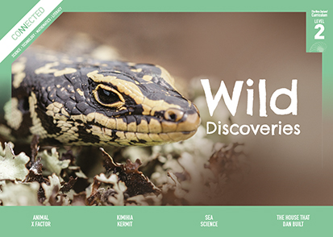

The Literacy Learning Progressions: Meeting the Reading and Writing Demands of the Curriculum describe the literacy-related knowledge, skills, and attitudes that students need to draw on to meet the demands of the curriculum.
The Learning Progression Frameworks (LPF) describe significant signposts in reading and writing as students develop and apply their literacy knowledge and skills with increasing expertise from school entry to the end of year 10.

Overview
This article describes a citizen science project carried out by three schools on Aotea Great Barrier Island. Concerned by the amount of marine debris washing up on their beaches, the students partnered with scientists from the University of Auckland to investigate what was happening and to take action to bring about change. The actions they took included a community-wide hui and a range of art projects.
A Google Slides version of this article is available at www.connected.tki.org.nz
Curriculum contexts

SCIENCE: Nature of Science: Participating and contributing  Level 2 – Students will explore and act on issues and questions that link their science learning to their daily living. | Key science ideas  - Marine debris is harmful to marine life.  - Animals meet their needs from their habitat. Changes caused by marine debris can threaten their survival.  - People can cause changes to habitats and environments from which recovery may be difficult.  - People can intervene to aid the recovery.
MATHEMATICS and STATISTICS: Statistics: Statistical investigation  Level 2 – Students will conduct investigations using the statistical enquiry cycle:  - posing and answering questions  - gathering, sorting, and displaying category and whole-number data  - communicating findings based on the data. | Key mathematics ideas  - Data can be used to answer multiple questions.  - Organising data can reveal information, patterns, and trends.  - Looking for patterns is an important part of statistical thinking.
THE ARTS: Visual Arts: Communicating and interpreting  Level 2 – Students will share the ideas, feelings, and stories communicated by their own and others’ objects and images. | Key visual art ideas  - Art can be created using a variety of materials.  - Art is a visual image or object created to represent an idea.

ENGLISH: Reading  Level 2 – Language features: Students will show some understanding of how language features are used for effect within and across texts. | Indicators:  - recognises that oral, written, and visual language features can be used for effect  - uses a large and increasing bank of high-frequency, topic-specific, and personal-content words to make meaning  - shows an increasing knowledge of the conventions of text  - recognises that authors have different voices and styles.

The New Zealand Curriculum

Meeting the literacy challenges

The main literacy demands of this text lie in the organisation and presentation of scientific information about the Great Pacific Garbage Patch and the damage caused by marine debris. Rhetorical questions, descriptive language, and comparisons help the reader understand why it is important to address this problem.  Students are required to interpret a range of visual features, including maps, diagrams, photographs, and pie graphs. They need to combine this with the information in the body text.  The text is structured as a recount with breakouts. Subheadings support students to make connections to their knowledge of scientific investigations.  Topic-specific and technical vocabulary includes words related to collecting scientific data. Most are explained in the text. Several are also supported in the illustrations and glossary. | The instructional strategies below support students to meet the literacy challenges of this text. For each strategy, there are links to the relevant aspect of The Learning Progression Frameworks (Reading). The signposts on each of these aspects provide detailed illustrations on what to notice as your students develop their literacy knowledge and skills for different purposes in different curriculum areas.  The following strategies will support students to understand, respond to, and think critically about the information and ideas in the text.  You may wish to use shared or guided reading, or a mixture of both approaches, depending on the reading expertise of your students and the background knowledge they bring to the text.  After reading the text, support students to explore the activities outlined in the following pages.

INSTRUCTIONAL STRATEGIES

Finding the main ideas  [LPF Reading: Acquiring and using information and ideas in informational text]  EXPLAIN that the students are going to read an article about how students in three schools used a scientific approach to tackle a big community problem. Have them read page 19 and PROMPT them to make connections to their personal experiences of similar issues. Ask them to predict how the students on Aotea Great Barrier Island might use science to address their problem.  Is rubbish something that bothers you? Have you seen rubbish turn up in places where it shouldn’t be?  Have you ever been involved in a clean-up campaign? Tell us about that.  How might science help? Look for clues in the photographs.  IDENTIFY aspects of the structure that will help the students navigate the text, such as the subheadings, sections, photographs, and diagrams. Use this discussion to decide on the headings for a flow chart the students can use to construct summaries of the investigation.  What do you notice about the subheadings? What do they tell us about how the students used science to solve their problem?  As a class, read the breakout text on page 21. ASK the students to share any experiences of using compasses. Have a compass on hand or use an app (see Resource links below) for students who are not familiar with them. | Using visual features for deeper understanding  [LPF Reading: Making sense of text: using knowledge of text structure and features]  DISCUSS the purpose of the photograph and diagram on page 18 and how the information relates to the breakout text. CHECK that the students understand that:  - everything on this page is intended to help answer the question in the subheading  - they are looking at a map of the Pacific with the major land masses, which they can identify  - the blue arrows represent the ocean currents and their directions.  To help understand currents, you could give the students the opportunity to experiment with floating balls of paper on bowls of swirling water.  MODEL how to integrate the information from the photographs, text, and maps on pages 18 and 20 to clarify which school cleaned which beaches. Support them to use this information to make some predictions about possible answers to their questions. RECORD their predictions.  PROMPT the students to look closely at the photograph on page 24 to clarify what a mussel lanyard is.  Help the students interpret the graphs on page 22. Have them explore the three different graphs in pairs and discuss what they think each one is showing. If necessary, explain that each circle is a pie graph showing the proportions of different types of rubbish the students found. Use think aloud to show how to work out the numbers, why the graphs are different sizes, and what the different coloured segments represent. Have the students continue to explore the graphs in pairs, including the explanations at the bottom of the page. ASK:  Do these make sense to you?  Does the information in the graphs match the predictions we made? Does anything surprise you?

Meeting the literacy challenges

Dealing with unfamiliar vocabulary  [LPF Reading: Making sense of text: vocabulary knowledge]  Point out that there are three interesting uses of vocabulary in this article:  - Words that are related to the topic, like “microplastic” and “lanyard”  - Words that are related to science, like “sample areas” and “predict”  - Descriptive words and phrases, including similes and metaphors, like “look like a floating island of bottles” and “plastic hitchhikers”.  Have the students locate examples of words belonging to each of these categories. DISCUSS the purpose of each category in the context of science writing. EXPLAIN that:  Scientists develop knowledge about the world through doing observations and conducting experiments. They have to be precise and accurate, so they use precise, accurate language. That is why we have special words for doing science. Scientists need to be able to explain their findings to other people. That is why science also includes descriptive language. Often, scientists make comparisons to help people understand things. | Have the students review the words they have identified and explain them to a partner. If they have difficulty explaining them, have them co-construct definitions of these words.  REVIEW the flow chart the students have created. DISCUSS whether it could be improved with more precise language. Remind the students that we avoid descriptive language in diagrams because diagrams are intended to summarise information using as few words as possible.  Extension  The students could use their subheadings and the words about science to write paragraphs summarising what they learned from the article.

The Learning Progression Frameworks
The Literacy Learning Progressions
Effective Literacy Practice: Years 1–4

Illustrating the key ideas

Marine debris is harmful to marine life.  Animals meet their needs from their habitat. Changes caused by marine debris can threaten their survival. | 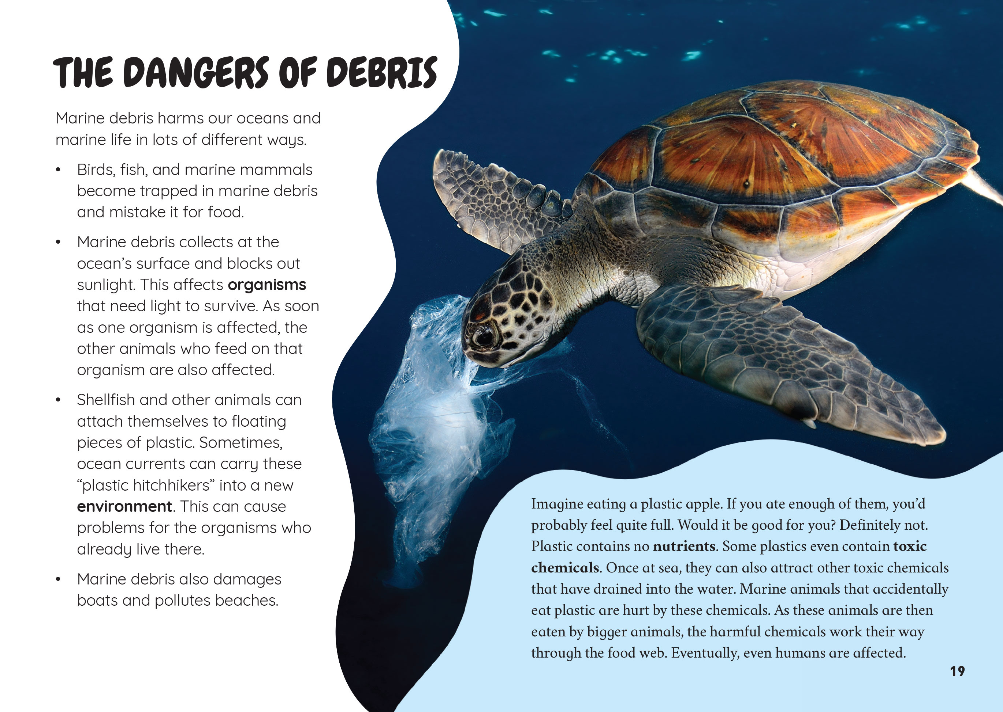
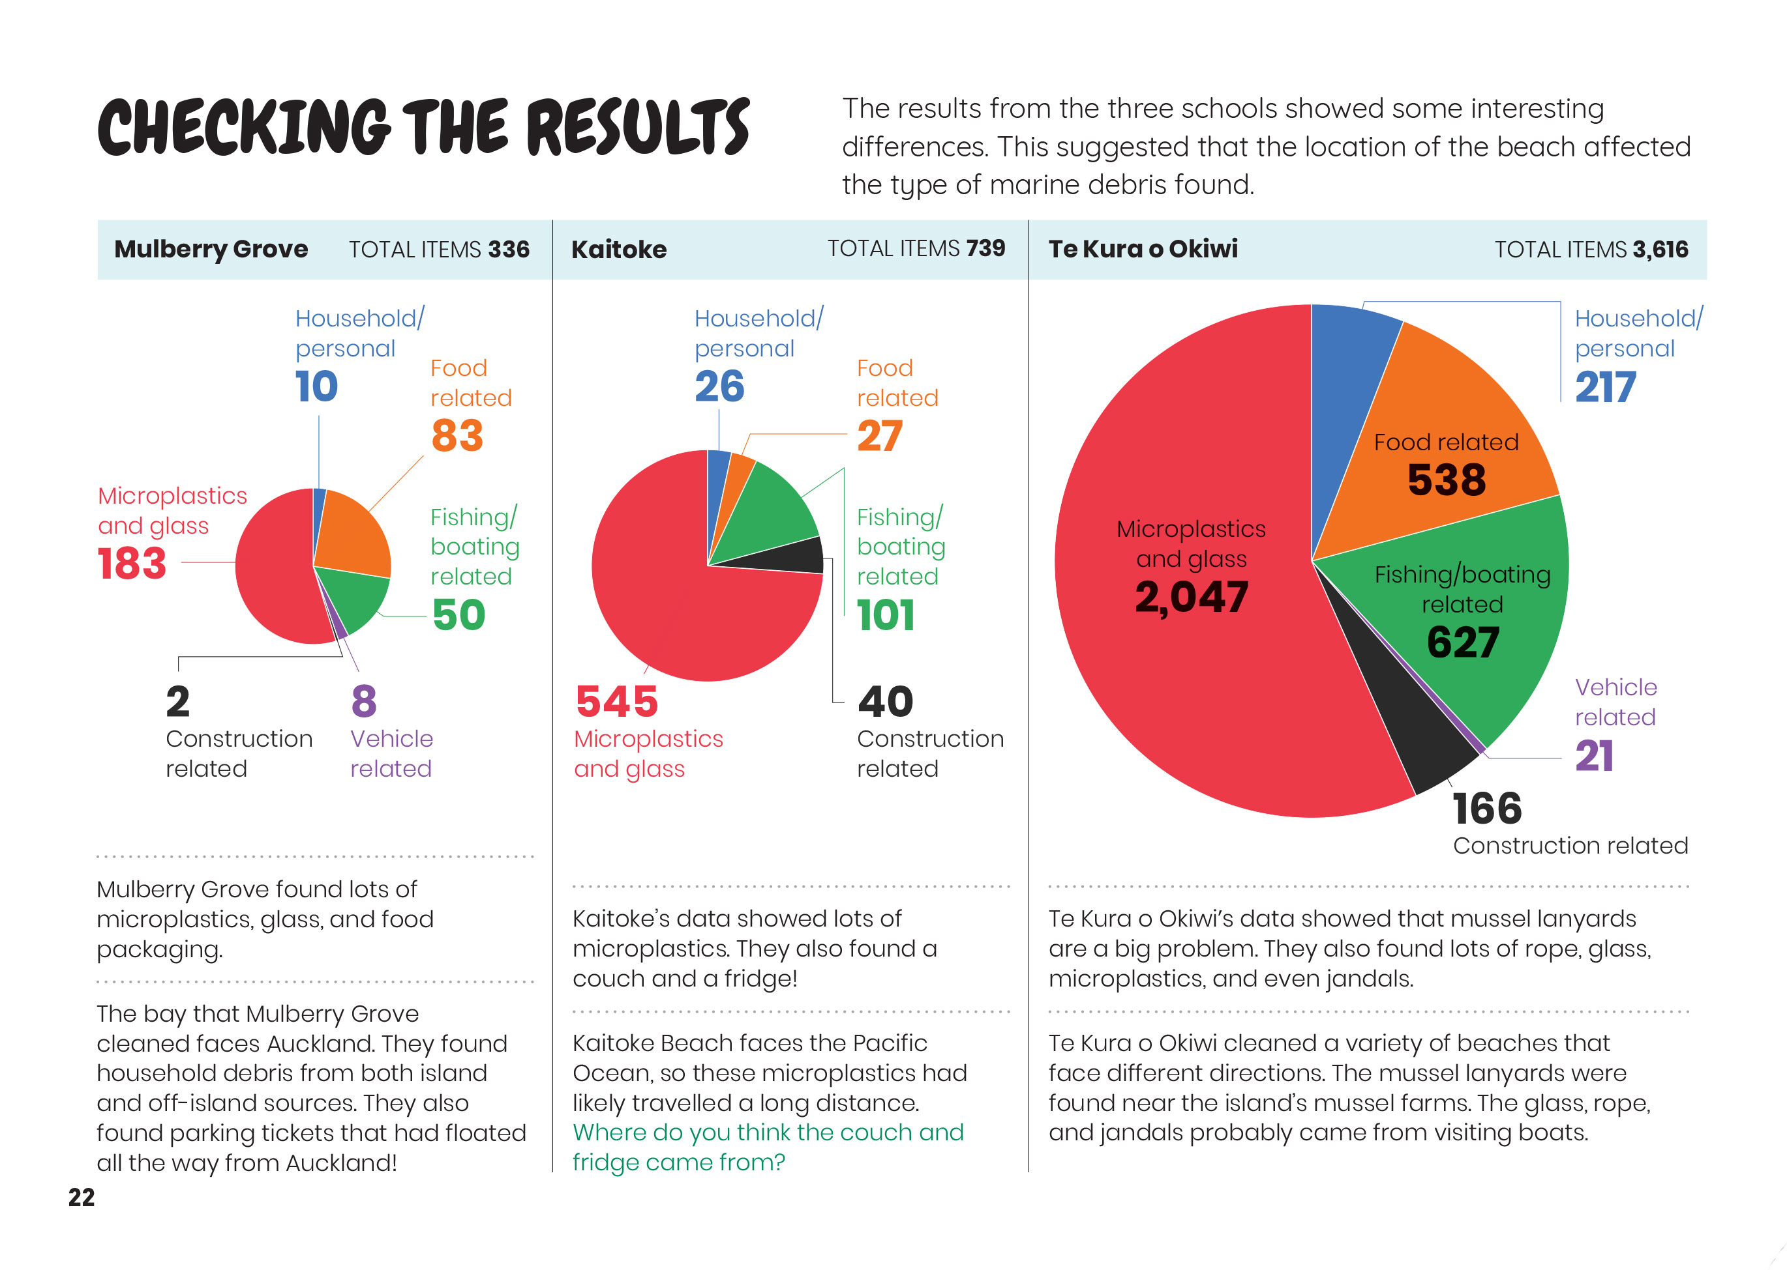  Organising data can reveal information, patterns, and trends. |  | Data can be used to answer multiple questions.

Learning activities – Exploring the science,
mathematics and statistics

Activity 1 – Food web  Looking at the map, it might be easy for students to think that the Pacific Ocean is vast and the impact of plastic, while not pleasant for the sea creatures, may not have much impact on humans. Have the students reread pages 18 and 19 and create a food web. You will find material for teaching food web concepts on the Science Learning Hub (see Resource links below).  Have the students conduct further research into human impacts on marine environments so that they can develop their food webs further. Have them use their food webs to explain to others why it is important to keep plastic out of the food chain.  Activity 2 – Using science to clean up our neighbourhood  Many students are already aware of the problem of pollution in their local environment and will be keen to take action. A number of Connected, School Journal, and Building Science Concepts articles describe scientific inquiry into this issue and potential responses (see Resource links below). Some other options are:  - Team up with local scientists and other local schools to conduct your own investigation and response, using the approach of the Aotea Great Barrier Island schools. You might also work with local environmental groups and with mana whenua, incorporating Mātauranga Māori as an integral part of your approach.  - Explore the use of the LittatrapTM. You can see how two different groups of students did this: one in the “Down the Drain” article and one in the video “Online citizen science meets environmental care” (see Resource links below). The latter example included the use of drones and introduced the students to the notion of machine learning. Students can compare the two approaches. Discuss creating a campaign for the LittatrapTM to be used locally.  - Investigate large online projects, such as The Litter Project and Litterati. Both offer training and tools for citizen scientists and incorporate the use of digital technology. This means that as well as cleaning up their local marine environments, students can explore data and track trends, asking and answering questions, for example:  - What sort of waste is most prevalent in our area? How does this compare with other places and why?  - What measures are most effective for reducing rubbish in the long term?  - What is the best way to store and retrieve data about rubbish and its impact?  - What are the advantages and disadvantages of different kinds of technology for data collection and analysis? | The following activities and suggestions are designed as a guide for supporting students to explore and extend their content knowledge across the learning areas. Adapt these activities to support your students’ interests and learning needs.  - As part of their projects, students could design their own digital solutions, for example:  - designing their own process for recording, processing, and sharing data from a clean-up (for example, using a GPS smartphone app, Google Maps, and a Google Sheets shared database).  - Explore creative ways to communicate their findings and use them to raise awareness of the issues. These could include turning waste products into something new, like the students in the article did. Design an additional survey to look at what people know about waste management and to what degree their campaign raises awareness.  Activity 3 – Investigating plastic  Listen to the Radio New Zealand item “How does microplastic get into the sea?” in which Nanogirl and some students from Breens Intermediate School try to answer to this question. Before listening, talk about how to capture all the interesting information in the podcast. You may also want to follow Nanogirl’s instructions for making plastic of your own.  Explain that plastic is a topical issue. Our concern about the negative impact of plastics can obscure the fact that plastics provide a technological solution to many of our needs, including food preservation and hygiene. Ask the students why they think people use plastic. Prompt them to ask questions about plastic and to plan an investigation. Questions could include:  - Why did humans create plastic? What was the problem we were trying to solve?  - What are the properties of plastic?  - Which of these properties make them a good solution to a problem?  - Which of these properties make them such a problem in our oceans and landfills?  - What could we use instead? What are some alternatives people are already exploring?  - How could we promote our ideas to others?  - What is Plastic Free July? What could we do for Plastic Free July?  Have the students use what they learn to write reports explaining the pros and cons of plastic and suggesting ways forward. Alternatively they could make a podcast like Nanogirl’s.

RESOURCE LINKS

Connected and School Journal  “Giving the Ocean a Voice”, Connected 2013, Level 2, I Spy …  “Down the Drain”, Connected 2017, Level 2, Taking Action  “Turning Old into New”, Connected 2017, Level 4, Where to Next?  “Learning from the Tangata Whenua: An Interview with James Ataria”, Connected 2015, Level 2, Have you Checked?  “A Work of Art”, School Journal, Level 2, October 2015  “The Plastic-free Challenge”, School Journal, Level 2, November 2018  Science Learning Hub  Human impacts on marine environments: https://www.sciencelearn.org.nz/resources/144-human-impacts-on-marine-environments  Thinking about plastic – planning pathways: https://www.sciencelearn.org.nz/resources/2824-thinking-about-plastic-planning-pathways  Oceans of rubbish: https://www.sciencelearn.org.nz/resources/2074-oceans-of-rubbish  Biodegradability experiment: https://www.sciencelearn.org.nz/resources/1549-biodegradability-experiment  Litterati: https://www.sciencelearn.org.nz/resources/2752-litterati  Litter intelligence: https://www.sciencelearn.org.nz/resources/2755-the-litter-project  What happens to our plastic bottles? (activity): https://www.sciencelearn.org.nz/resources/2528-what-happens-to-our-plastic-bottles  Plastic – reuse, recycle, or rubbish game (activity): https://www.sciencelearn.org.nz/resources/2527-plastic-reuse-recycle-or-rubbish-game  Flight plastics recycling technology: https://www.sciencelearn.org.nz/resources/2517-flight-plastics-recycling-technology  DIY plastic recycling plant (activity): https://www.sciencelearn.org.nz/resources/2526-diy-plastic-recycling-plant  Microplastics: https://www.sciencelearn.org.nz/resources/2808-microplastics  How harmful are microplastics? https://www.sciencelearn.org.nz/resources/2809-how-harmful-are-microplastics  The future of plastics: Reusing the bad and encouraging the good: https://www.sciencelearn.org.nz/resources/2811-the-future-of-plastics-reusing-the-bad-and-encouraging-the-good  Bioplastics: https://www.sciencelearn.org.nz/resources/1474-bioplastics  The Zespri biospife: https://www.sciencelearn.org.nz/resources/1472-the-zespri-biospife | Making potato plates: https://www.sciencelearn.org.nz/resources/1076-making-potato-plates  Teaching food web concepts: https://www.sciencelearn.org.nz/resources/2221-teaching-food-web-concepts  Myths of the nature of science: https://www.sciencelearn.org.nz/resources/415-myths-of-the-nature-of-science  Planning for students to be citizen scientists: https://www.sciencelearn.org.nz/resources/2740-planning-for-students-to-be-citizen-scientists  Online citizen science meets environmental care: https://www.sciencelearn.org.nz/videos/1884-online-citizen-science-meets-environmental-care  Building Science Concepts  Book 21: Life between the Tides: Sandy Shores, Mudflats, and Rocky Shores  Book 22: Tidal Communities: Interdependence and the Effects of Change  Book 60: Rubbish: How Do We Deal with It?  Book 61: Recycling: New Uses for Rubbish  Radio New Zealand  How does microplastic get into the sea? https://www.rnz.co.nz/programmes/nanogirls-great-science-adventures/story/2018694763/how-does-microplastic-get-into-the-sea  Sustainable coastlines  Citizen science litter data and solutions platform: http://sustainablecoastlines.org/litterproject/  Treasure: http://sustainablecoastlines.org/education/treasure/  Other sources  Sea science: A partnership with the schools on Aotea Great Barrier Island to manage marine debris: http://www.mariemcentee.nz/sea-science.html  Curious Minds: https://www.curiousminds.nz/stories/can-litter-art-help-keep-our-islands-clean/  The University of Auckland: Keeping islands clean with litter art: http://www.env.auckland.ac.nz/en/about/news-and-events/news/news-2017/10/keeping-islands-clean-with-litter-art.html  Keep New Zealand Beautiful: Litter audit (September 2019): https://www.knzb.org.nz/resources/research/nla/  The plastic tide: https://www.theplastictide.com/the-problem-main  RNZ: Ghost fishing: Cleaning up the rubbish in our waters: https://www.rnz.co.nz/national/programmes/first-up/audio/2018701370/ghost-fishing-cleaning-up-the-rubbish-in-our-waters

RESOURCE LINKS – Continued

askHRgreen.org: Suffolk uses art to fight litter: http://askhrgreen.org/suffolk-using-art-fight-litter/  CountryLiving: Durham mum makes amazing animal art using nothing but plastic and rubbish: https://www.countryliving.com/uk/news/a24426253/all-that-is-she-animal-art-from-litter-interview/  A greener future: Jennifer Richardson – Turning litter into something beautiful: https://www.agreenerfuture.ca/art  New Zealand Geographic: Citizen science: https://www.nzgeo.com/stories/citizen-science/?state=registrationCompleted  The Great Pacific Garbage Patch: https://theoceancleanup.com/great-pacific-garbage-patch/  National Geographic: Great Pacific Garbage Patch: https://www.nationalgeographic.org/encyclopedia/great-pacific-garbage-patch/  The Ocean Cleanup: https://theoceancleanup.com/  The Atlantic: How plastic cleanup threatens the ocean’s living islands: https://www.theatlantic.com/science/archive/2019/01/ocean-cleanup-project-could-destroy-neuston/580693/ | The ocean cleanup and the Neuston: https://theoceancleanup.com/updates/the-ocean-cleanup-and-the-neuston/  Google Play Compass: https://play.google.com/store/apps/details?id=com.myapps.dara.compass&hl=en_US  Spyglass: http://www.spyglass.co.nz/  Commander Compass: http://happymagenta.com/compass/  Searching algorithms: https://csunplugged.org/en/topics/searching-algorithms/  Resource portal for rethinking plastics in Aotearoa New Zealand: https://www.pmcsa.ac.nz/2019/04/18/rethinkplastic-resources/  Innocent packaging: https://innocentpackaging.co.nz/  YouTube: Nanogirl’s Great Science Adventures: making plastic: https://www.youtube.com/watch?time_continue=12&v=b-2s-g8_JHU  Royal Society: Plastics in the environment: https://royalsociety.org.nz/major-issues-and-projects/plastics

