Connected
Level 3
2019

Betty Batham: Biologist
by Kate Hannah

The Literacy Learning Progressions: Meeting the Reading and Writing Demands of the Curriculum describe the literacy-related knowledge, skills, and attitudes that students need to draw on to meet the demands of the curriculum.  The Learning Progression Frameworks (LPF) describe significant signposts in reading and writing as students develop and apply their literacy knowledge and skills with increasing expertise from school entry to the end of year 10.  Overview  This comic biography tells the story of Betty Batham, a pioneering marine biologist. Born in an era when a woman’s place in society was largely limited to home and family, Betty rose to become a noted scientist whose legacy in the sciences lives on.  A Google Slides version of this article is available at www.connected.tki.org.nz | 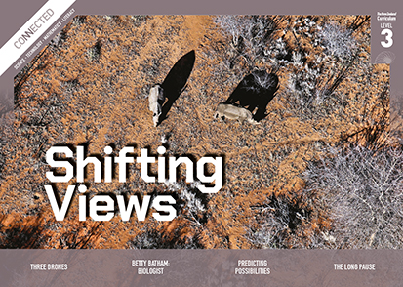  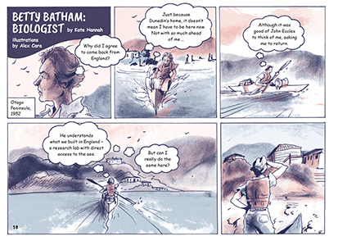
Curriculum contexts

SCIENCE: Nature of Science: Understanding about science  Level 3 – Students will:  - appreciate that science is a way of explaining the world and that science knowledge changes over time  - identify ways in which scientists work together and provide evidence to support their ideas.  SCIENCE: Living World: Ecology  Level 3 – Students will explain how living things are suited to their particular habitat and how they respond to environmental changes, both natural and human-induced. | Key science ideas  - Scientists carefully observe the world around them, gathering a range of evidence to develop possible explanations about how it works.  - All animals and plants have adapted to their habitat over many generations.  - Environmental changes in an ecosystem affect the survival of living organisms.
ENGLISH: Reading  Level 3 – Ideas: Students will show a developing understanding of ideas within, across, and beyond texts. | Indicators:  - uses their personal experience and world and literacy knowledge confidently to make meaning from texts  - makes meaning of increasingly complex texts by identifying main and subsidiary ideas in them  - starts to make connections by thinking about underlying ideas in and between texts  - recognises that there may be more than one reading available within a text  - makes and supports inferences from texts with increasing independence.

The New Zealand Curriculum

Meeting the literacy challenges

The main literacy demands of this text lie in the need to make inferences to fully understand the challenges for women who want to make a career in science. For the most part, the text progresses in a chronological fashion, except for the first page, which opens with a scene from halfway through Betty’s life. Further inferences are required to understand the author’s purpose in pulling back to look at the wider achievements of women scientists in New Zealand at the time.  The comic format requires readers to integrate information from an invisible narrator, thought bubbles, dialogue, and the illustrations. By integrating information, readers can deepen their understanding of the work of scientists.  Scientific and technical vocabulary is supported by illustrations, contextual clues, and two glossary items. | The instructional strategies below support students to meet the literacy challenges of this text. For each strategy, there are links to the relevant aspect of The Learning Progression Frameworks (Reading). The signposts on each of these aspects provide detailed illustrations on what to notice as your students develop their literacy knowledge and skills for different purposes in different curriculum areas.  The following strategies will support students to understand, respond to, and think critically about the information and ideas in the text.  You may wish to use shared or guided reading, or a mixture of both approaches, depending on the reading expertise of your students and the background knowledge they bring to the text.  After reading the text, support students to explore the activities outlined in the following pages.

INSTRUCTIONAL STRATEGIES

Finding the main ideas  [LPF Reading: Acquiring and using information and ideas in informational text]  Tell the students to read the title and first page. PROMPT them to make the inferences necessary to orient them to the text. Clarify that this is a biography written in the form of a comic. Check that the students know how to read a comic.  DISCUSS the features of a biography. Remind the students that a good reader asks and answers questions as they read. The questions often begin with “what”, “when”, “where”, “why”, “who”, and “how”.  What kinds of questions would you ask yourself when reading a biography?  Have the students skim the text to begin forming questions that they can answer as they read. Give them a graphic organiser such as the one below to record their questions and answers, adding any new questions that arise as they read.  Question types Questions Answers from the text  What?  When?  Where?  Why?  Who?  How?  REVIEW the students’ questions and the answers they found in the text.  Do you have any unanswered questions? How could we answer them?  Imagine Betty Batham was still alive and we could interview her today. What questions would you like to ask her? | EXPLAIN that we can listen to an interview with Betty Batham on Te Ara. Play the interview.  Did listening to the interview change the way you imagined Betty?  Look at your questions and answers. Is there anything you could now add or change?  Making sense of abstract concepts  [LPF Reading: Making sense of text: reading critically]  PROMPT the students to reflect on the writer’s purpose for writing and whether it was justified.  Do you feel Betty Batham was a good subject for a biography? Why or why not?  On page 13, we’re told about other women who were doing science at the same time as Betty. Why do you think the writer included them?  On page 17, the writer says that “Her legacy as a pioneering marine biologist – and a woman in the sciences – lives on.” What does “legacy” mean? What evidence does the writer provide of this legacy?  Encourage the students to summarise her legacy, using a table like the one below.  Betty’s legacy  … as a marine biologist … as a woman in the sciences

Meeting the literacy challenges

Summarising the information  [LPF Reading: Reading to organise ideas and information for learning]  It may support some students to construct a simple timeline summarising the major events in Betty’s life. DISCUSS how they could use the adverbs of time to do this. Note that free timeline makers are available online, including TimeGraphics and ReadWriteThink.  Betty Batham: Biologist  Time Event | Dealing with scientific and technical vocabulary  [LPF Reading: Making sense of text: vocabulary knowledge]  PROMPT the students to IDENTIFY any unfamiliar vocabulary and use the text and illustrations to write definitions. Then have them use reference materials to review and improve their definitions. This could be done in pairs. Have the students use their words in sentences that demonstrate their understanding.

The Learning Progression Frameworks
The Literacy Learning Progressions
Effective Literacy Practice: Years 5–8

Illustrating the key ideas

Scientists work together to provide evidence to support their ideas.

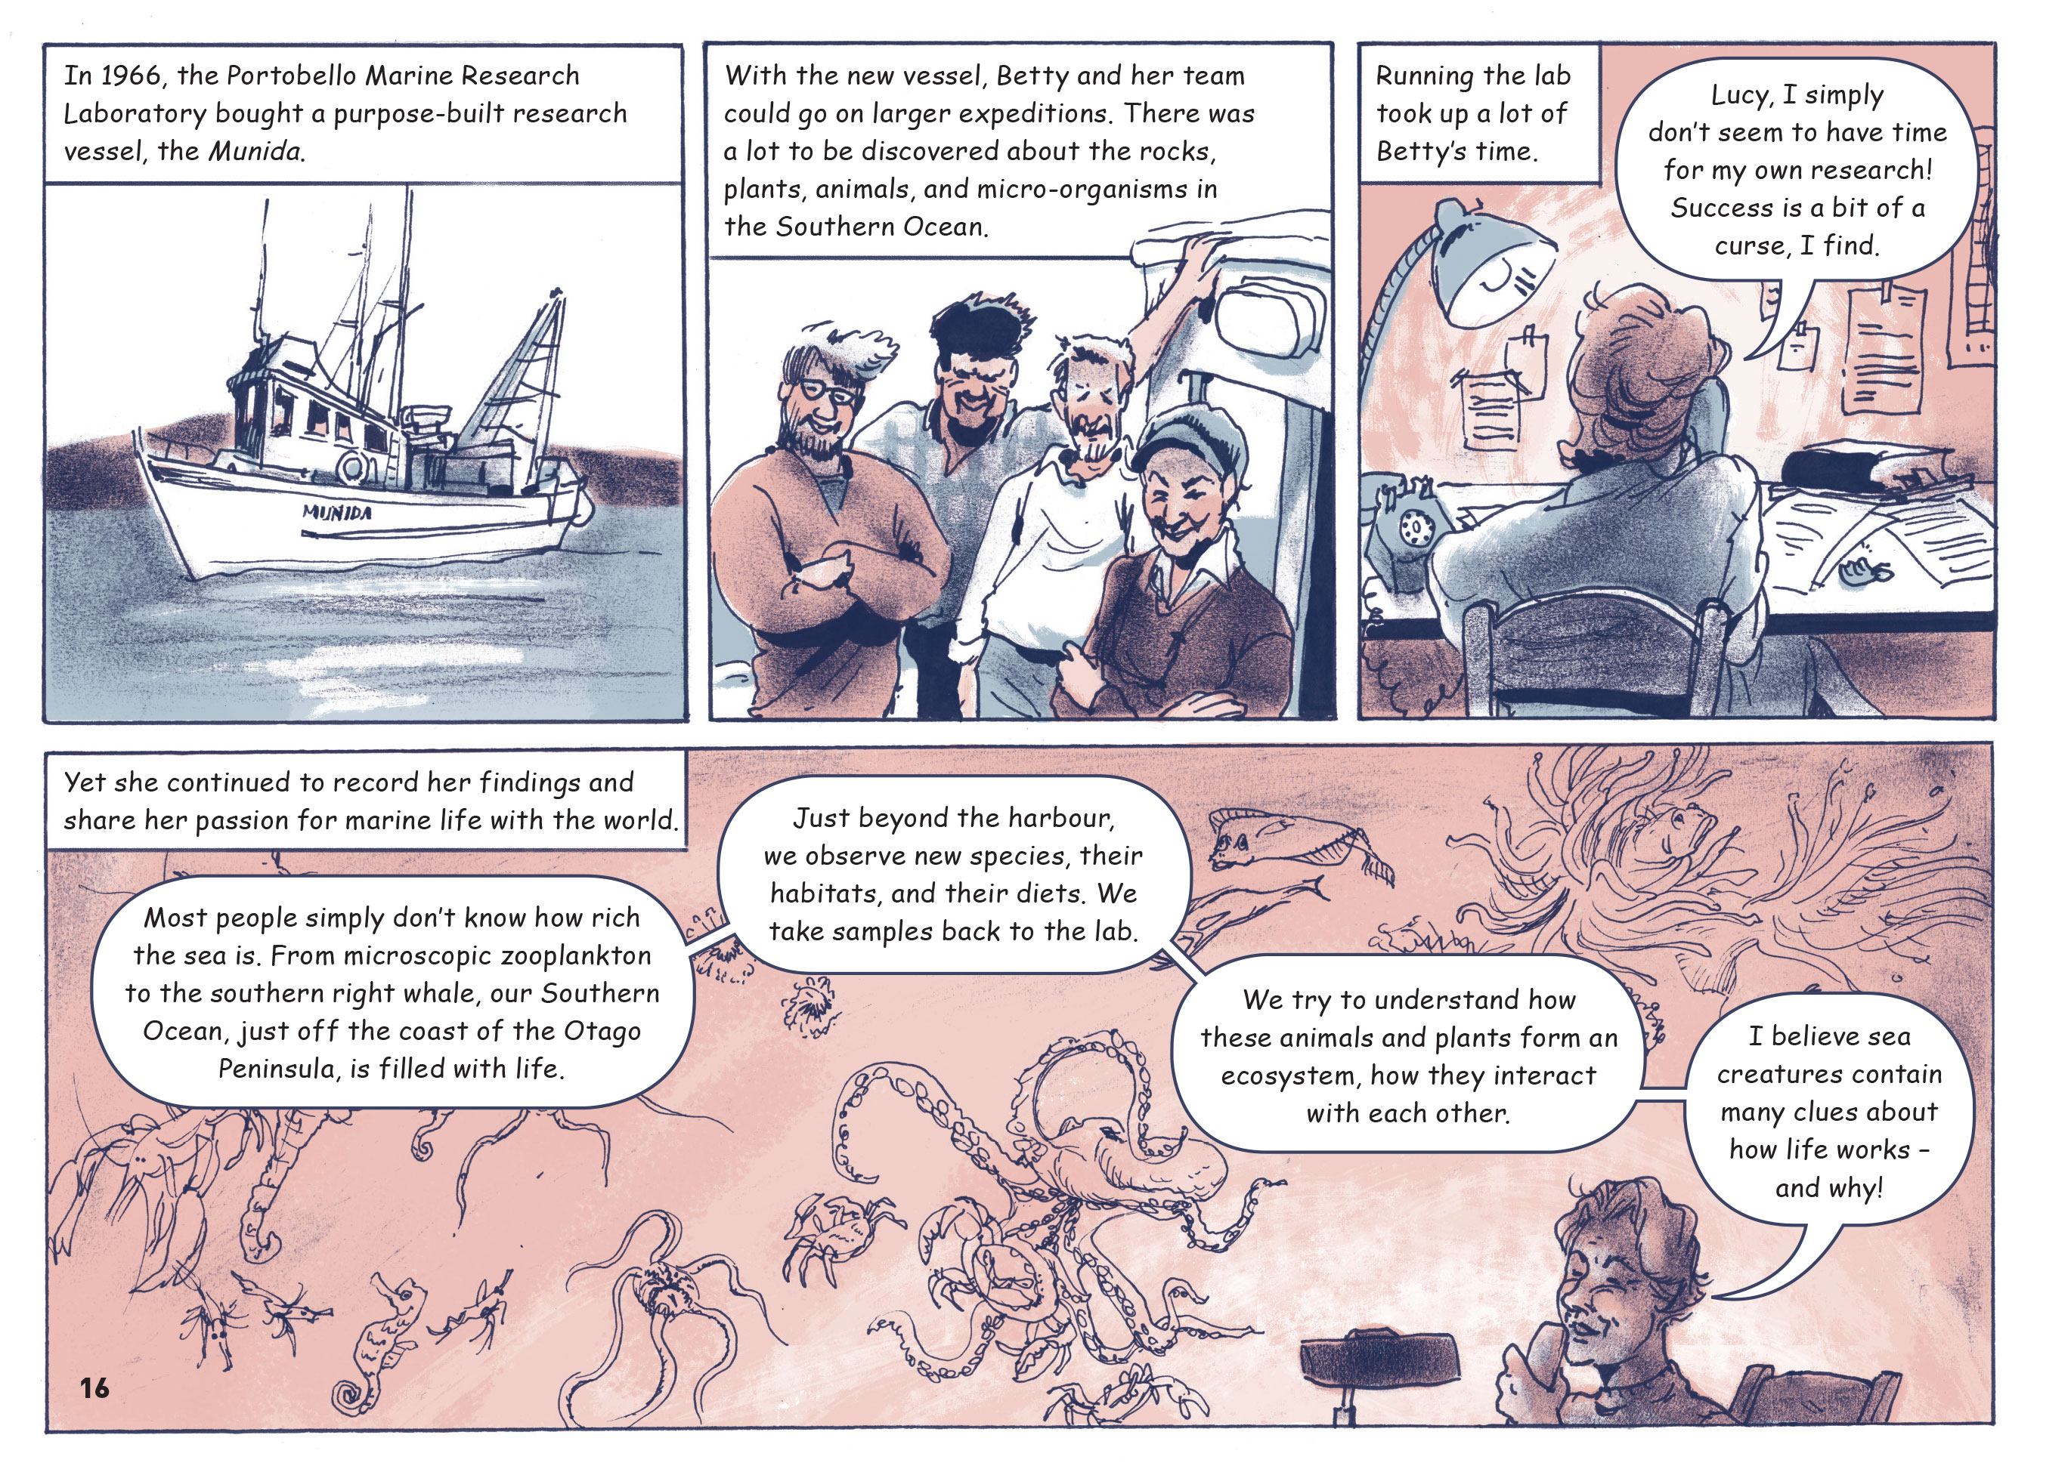
All animals and plants have adapted to their habitat and ecosystem over many generations.
Scientists carefully observe the world around them, gathering a range of evidence to develop possible explanations about how it works.

Learning activities – Exploring the science

Activity 1 – Different fields of science  Point out that the article mentions a range of people who do scientific work in different fields, from Betty’s mother, who we could call a citizen scientist, to eminent figures such as her uncle, the Director of Otago Museum. List the examples the students recall.  Have the students create a table that records the different branches of science the article mentions and what they learned about them. This activity may bring up more questions, such as “What does the director of a museum have to do with science?” Encourage the students to go online to find answers to their questions.  Branch of science What this work involves Why this work is useful  Discuss what we learn from the article about the work of scientists and how science knowledge develops and changes over time.  What is your image of a scientist? How do you imagine them working? Was this changed at all by reading the article?  Betty spent a lot of her time teaching students and working with other scientists in teams. What does that tell you about the way we grow our science knowledge?  Think about the way we learn science here at school. How much of our learning and discovery is by ourselves and how much does it involve working together?  On page 17, the writer says that Joe is “continuing the work started by Betty”. What does she mean by that?  Extending the learning  Invite the students to investigate the work of another New Zealand scientist or to address an issue or question that has arisen for them through reading the article. An activity on the Science Learning Hub suggests one approach where students write introductions of individual scientists. Another approach might be for the students to create an interactive timeline or to use the article as a model for creating a comic biography.  If focused on people, the students might explore:  - the lives and scientific work of the other women mentioned in the article  - the lives and contributions of other New Zealanders who have been Royal Society fellows, like Betty Batham  - women who have been involved in science in their local regions and how their research and legacy has been carried on  - how Betty’s story compares with that of another pioneering scientist, such as Grace Hopper, an American computer scientist and United States Navy rear admiral. | The following activities and suggestions are designed as a guide for supporting students to explore and extend their content knowledge across the learning areas. Adapt these activities to support your students’ interests and learning needs.  If focused on issues or questions, the students might explore:  - what current world-leading research is being done by New Zealanders  - the changing role and circumstances of women in science  - other examples of innovative scientific and technological research being carried out by New Zealanders in the face of adversity, isolation, and limited resources  - the possibilities for studying science in New Zealand  - the relationship between science and war.  Activity 2 – Continuing Betty’s legacy  Return to Betty’s statement about why it was so important to her to share her passion for marine life with the world. If you haven’t already done so, play the interview on Te Ara.  Have the students use the Marine Life Database to explore the wide variety of living things found in the ocean.  What is the purpose of this database? How might people use this information? How does it contribute to Betty’s legacy?  What do you learn from it about how marine plants and animals are categorised?  How many of these organisms have you seen before?  What do you notice about plants and animals in different habitats?  As a class, investigate Marine Metre Squared. Discuss how this citizen science project is another part of Betty’s legacy. It provides a way for students as citizen scientists to contribute to all our knowledge about organisms living in different parts of our coastline. Users can add their own survey data and use the mapping and analysis tool to compare their findings with others.  The Connected items listed in the resource links below provide insights into the work others are doing to learn about and protect our marine ecosystems. Their TSMs offer further ideas for knowledge building and engaging in citizen science.  Extending the learning  Pūtātara is a new website that supports schools and teachers to incorporate sustainability and global citizenship across the curriculum. Students and teachers can engage in rich inquiry that reflects their local context and integrates learning areas. They can go on to explore how Expo 2020 Dubai encourages countries to collaborate in tackling issues.

RESOURCE LINKS

Connected and School Journal  “The Fish Highway”, Connected 2013, Level 3, Food for Thought …  “Counting Kākahi”, Connected 2014, Level 3, Why is That?  “Black is Back”, Connected 2014, Level 4, What’s the Evidence?  “Mary Anning Fossil Hunter”, School Journal, Level 3, September 2012  Science Learning Hub  Working as a scientist: https://www.sciencelearn.org.nz/resources/2585-working-as-a-scientist  Scientist introduction: https://www.sciencelearn.org.nz/resources/1032-scientist-introduction  Heritage scientist timeline – Joan Wiffen: https://www.sciencelearn.org.nz/resources/2426-heritage-scientist-timeline-joan-wiffen  Heritage scientist timeline – Beatrice Hill Tinsley: https://www.sciencelearn.org.nz/resources/2422-heritage-scientist-timeline-beatrice-hill-tinsley  Muriel Bell – nutritionist (interactive): https://www.sciencelearn.org.nz/interactive_timeline/5-muriel-bell-nutritionist  Categorising marine organisms: https://www.sciencelearn.org.nz/resources/140-classifying-marine-organisms  Planning for students to be citizen scientists: https://www.sciencelearn.org.nz/resources/2740-planning-for-students-to-be-citizen-scientists | Te Ara  Batham, Elizabeth Joan: https://teara.govt.nz/en/biographies/5b13/batham-elizabeth-joan  Dr Batham discussing the Portobello aquarium: https://teara.govt.nz/en/speech/114/dr-batham-discussing-the-portobello-aquarium  University of Otago  Marine Studies Centre: Resources: https://www.otago.ac.nz/marine-studies/resources/index.html  Department of Marine Science: History of marine science at the University of Otago: https://www.otago.ac.nz/marinescience/about/history/otago045025.html  Marine life database: http://www.marinelife.ac.nz/  National Library  Graphic novels: https://natlib.govt.nz/schools/reading-engagement/childrens-and-youth-literature/graphic-novels  What makes a good comic? https://natlib.govt.nz/blog/posts/what-makes-a-good-comic  Other  Royal Society Te Apārangi: https://royalsociety.org.nz/  Association for Women in the Sciences: https://www.awis.org.nz/  Marine Metre Squared: https://www.mm2.net.nz  Pūtātara: https://putatara.education.govt.nz/#/about

