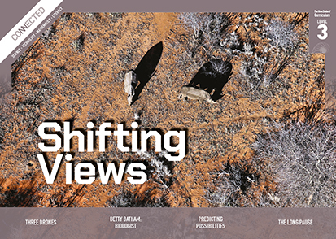
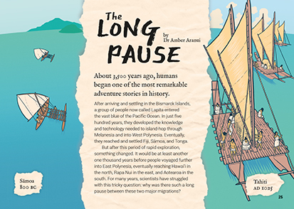

The Long Pause
by Amber Aranui
Connected
Level 3
2019

The Literacy Learning Progressions: Meeting the Reading and Writing Demands of the Curriculum describe the literacy-related knowledge, skills, and attitudes that students need to draw on to meet the demands of the curriculum.
The Learning Progression Frameworks (LPF) describe significant signposts in reading and writing as students develop and apply their literacy knowledge and skills with increasing expertise from school entry to the end of year 10.

Overview
This article explores the mystery of the long pause between the two major periods of Pacific migration. It demonstrates how the science of archaeology can be used to explain and understand the world and how scientists provide evidence to support ideas.
A Google Slides version of this article including additional digital content is available at www.connected.tki.org.nz

Curriculum contexts

SCIENCE: Nature of Science: Understanding about science  Level 3 – Students will:  - appreciate that science is a way of explaining the world and that science knowledge changes over time  - identify ways in which scientists work together and provide evidence to support their ideas. | Key science ideas  - As scientists accumulate a range of evidence, they develop possible explanations.  - New explanations can be developed as new evidence comes to light or existing evidence is reinterpreted.  - Scientists sometimes interpret the same data or observations in different ways.
SOCIAL SCIENCES: Social Studies  Level 3 – Understand how the movement of people affects cultural diversity and interaction [in New Zealand]. | Key social studies ideas  - Advances in technology affect how we live and how we understand things like our human past.  - People sometimes migrate over very large distances to find food, water, or shelter.
ENGLISH: Reading  Level 3 – Ideas: Students will show a developing understanding of ideas within, across, and beyond texts. | Indicators:  - uses their personal experience and world and literacy knowledge confidently to make meaning from texts  - makes meaning of increasingly complex texts by identifying main and subsidiary ideas in them  - starts to make connections by thinking about underlying ideas in and between texts  - recognises that there may be more than one reading available within a text  - makes and supports inferences from texts with increasing independence.

The New Zealand Curriculum

Meeting the literacy challenges

The main literacy demands of this text lie in interpreting the abstract ideas about science and culture. It requires students to track and synthesise information to weigh up evidence and consider different possibilities. This reinforces the ideas about the nature of science that the article is intended to convey. Support is provided by the invisible narrator’s use of rhetorical questions, the inclusion of statements that explicitly point out contradictions and missing evidence, and the use of modal verbs (“might”, “could’ve”). The overall structure of the text is relatively straightforward.  There are some significant vocabulary challenges. Support is provided at the sentence level, with contextual clues, and in a glossary. Breakouts, maps, and diagrams help the reader understand technical information and visualise the achievement of the Pacific voyagers. | The instructional strategies below support students to meet the literacy challenges of this text. For each strategy, there are links to the relevant aspect of The Learning Progression Frameworks (Reading). The signposts on each of these aspects provide detailed illustrations on what to notice as your students develop their literacy knowledge and skills for different purposes in different curriculum areas.  The following strategies will support students to understand, respond to, and think critically about the information and ideas in the text.  You may wish to use shared or guided reading, or a mixture of both approaches, depending on the reading expertise of your students and the background knowledge they bring to the text.  After reading the text, support students to explore the activities outlined in the following pages.

INSTRUCTIONAL STRATEGIES

Finding the main ideas  [LPF Reading: Acquiring and using information and ideas in informational text]  Have the students read the title and first page to establish what this article is about. ASK QUESTIONS to help them make connections to their prior knowledge and identify the purpose of the article.  What do you know about the migration of people across the Pacific?  “Melanesia”, “West Polynesia”, “East Polynesia”. Where are these places?  Have you seen waka like these before? What do you know about them?  What is this article going to be about?  What does this page make you wonder?  Using text structure and features  [LPF Reading: Reading to organise ideas and information for learning]  Have the students PREVIEW the text, reading the headings and looking at the text structure and features.  What clues do the headings give you about possible reasons for the long pause?  There’s lots of additional information in the visual text. How might these features help with your reading?  Have the students read the text on page 26 and DISCUSS what it says about the work of scientists and of archaeologists in particular.  Scientists are like detectives looking for clues. They can suggest an explanation, but if new evidence comes up, they have to be ready to change their thinking. | DISCUSS the way features of the text help to reinforce the message that the science is not settled. Point out the statement on page 26 that explicitly signals uncertainty (“What it doesn’t show us is why such a delay occurred.”). Give the students sticky notes to identify other signals of uncertainty. Students may not notice the modal verbs. Point them out if needed.  PROMPT the students to make connections to their ideas about why people migrate. What are some of the factors that push people to migrate and what might be pull factors? Have them chart the factors suggested in the article and add their own ideas.  Human migration  Push factors Pull factors  Using the visual features to clarify the text  [LPF Reading: Making sense of text: using knowledge of text structure and features]  Briefly REVIEW the purpose of each of the design features. Then have the students work in groups to unpack one of them, explaining:  - its purpose  - its relationship to the running text  - the information and/or ideas it conveys  - things it made them think about or wonder about  - what they had to do to make sense of it.  Have the groups present their explanations and offer each other feedback.

Meeting the literacy challenges

Exploring the nature of science  [LPF Reading: Reading to organise ideas and information for learning]  Have the students use a graphic organiser such as the one below to RECORD the explanations suggested for the long pause in the text and the evidence presented to support those explanations. The students should use the third column to record their own thinking about the evidence needed to prove the explanations. Have them share and debate their thoughts, first in groups and then as a class.  Suggested explanation for the long pause in eastward migration (from the text) Evidence from the text that supports this explanation Further evidence needed to prove this explanation is correct  Give the students the two Level 3 Nature of Science, Understanding about science statements. DISCUSS what they mean, referring to the students’ shared experiences of science learning. Then have them go to the text to find evidence of these in the practice of archaeologists seeking to explain the long pause.  Nature of Science Evidence from “The Long Pause”  Appreciate that science is a way of explaining the world and that science knowledge changes over time  Identify ways in which scientists work together and provide evidence to support their ideas | Dealing with unfamiliar vocabulary  [LPF Reading: Making sense of text: vocabulary knowledge]  PROMPT the students to refer to the glossary on page 32 to deal with some of the unfamiliar vocabulary and to use the breakout text and visual images to explore the concepts of radiocarbon dating, waka technology, and the development of Polynesian culture.

The Learning Progression Frameworks
The Literacy Learning Progressions
Effective Literacy Practice: Years 5–8

Illustrating the key ideas
Advances in technology affect how we live and how we understand things like our human past.

As scientists accumulate a range of evidence, they develop possible explanations. | 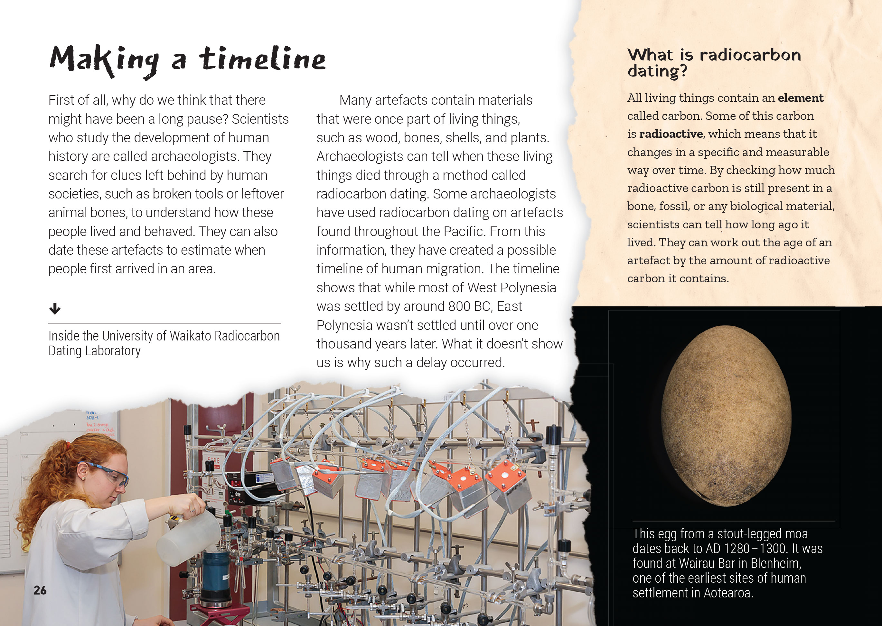  Scientists sometimes interpret the same data or observations in different ways.
People sometimes migrate over very large distances to find food, water, or shelter.  New explanations can be developed as new evidence comes to light or existing evidence is reinterpreted. | 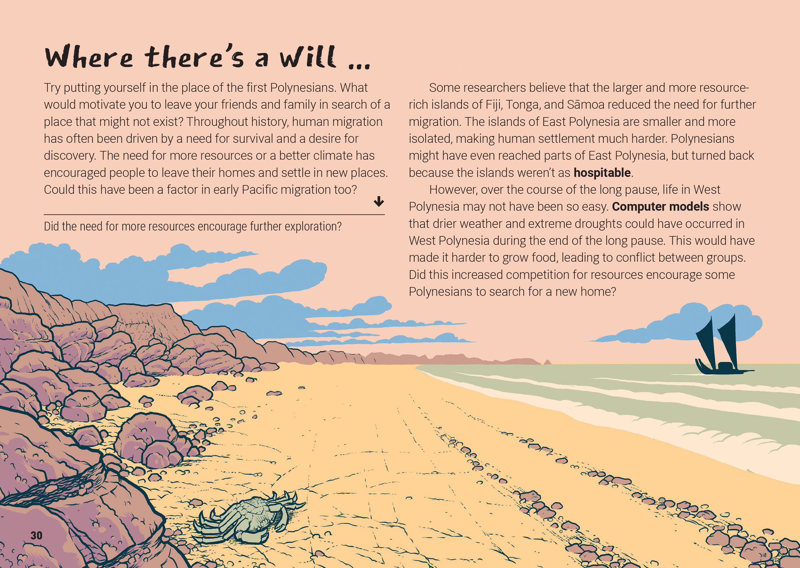

Learning activities – Exploring the science
and technology

Activity 1 – Waka voyaging  Cultural importance  Show students the “He Waka He Tangata” and “Keeping Traditional Polynesian Navigation Alive” videos. Discuss why waka hourua are so important to people today and what we can learn from them.  Why do these people believe it is so important to pass on their ancestors’ traditions?  What is their message?  Construction  Reread the section in the article on technology, and follow this up by reading the Connected articles “Giving the Ocean a Voice” and/or “Explorers of the Sunrise” listed in the resource links below. Students could also read the School Journal article “Where No Boats Could Live” to learn about the waka used by Moriori. Have the students use what they have read to develop a diagram that allows them to:  - compare the design of an outrigger canoe with a double-hulled waka hourua  - identify the specific features that enabled the waka hourua to travel so much farther than the single-hulled canoes.  Surface and record the students’ questions about the construction of waka and the experience of sailing them. Discuss where and how they can find answers to their questions. If possible, invite a modern-day navigator for the students to interview or arrange for them to visit a real waka.  Use the suggestions in the TSM for “Giving the Ocean a Voice” as a springboard for the students to create, test, and compare their own models of the two waka.  Navigation  View “The Polynesian Wayfinders” to reinforce the magnitude of the achievement of the Polynesian navigators. Note the possibility that Polynesians may even have sailed to and traded with people in the Americas.  What evidence is provided for this?  How does this connect with what we have been learning about how scientists work?  Surface the students’ questions about how Polynesians were able to navigate vast distances across the Pacific. Have the students work in groups to research, develop, present, and critique explanations of how this was achieved.  Extension  At the time of writing these TSMS, Ian Taylor was developing a resource to track the voyage of the Fa‘afaite, a Tahitian ocean-going waka, from Tahiti to New Zealand. This Spinoff article is interesting for what it says about the neglect of the migration story. But the article also indicates that this will be part of a body of resources that will help us learn more about the story. As well as the article, you can link to the Tuia 250 Voyage website. This provides an opportunity to explore the feats of the Polynesian navigators and the role that digital technology can play in bringing their story to life. | The following activities and suggestions are designed as a guide for supporting students to explore and extend their content knowledge across the learning areas. Adapt these activities to support your students’ interests and learning needs.  Activity 2 – Science versus Disney  Have the students compare the story of the long pause as told in the article to the way it is told in the Disney film Moana. If they haven’t seen the film, it may be enough to view the trailer.  Does the information here provide insights into the movie?  Do the messages in the movie provide insights into the information in the article?  Given what you have learned, how respectful do you think the movie is to Pacific people and the achievements of the first Polynesians?  The article “How the Story of ‘Moana’ and Maui Holds Up Against Cultural Truths” explores interesting questions and ideas that could feed into this discussion.  Activity 3 – Archaeological adventures  Have the students reread the article to identify what it teaches them about the work of an archaeologist. Extend students’ learning by using activities from Building Science Concepts: Book 41 – Fossils: Digging up the Past and by visiting a museum or local site where fossils can be found. Support them to understand that fossil records add to our understanding of the past, and how exciting this can be. You can find locations where significant fossils have been discovered on the GNS site, as well as images, videos, games, and other learning materials.  Have the students profile multi-talented archaeologists and researchers to find out about the diverse knowledge, skills, experiences, and opportunities offered by archaeology. Some examples are Dr Amber Aranui from Te Papa (the author of the article) and academic Atholl Anderson. Students could go on to create advertisements encouraging people to consider a career in archaeology.

RESOURCE LINKS

Connected and School Journals  “Giving the Ocean a Voice”, Connected 2013, Level 2, I Spy …  “The Past Beneath Our Feet”, School Journal Level 3, May 2016  “Explorers of the Sunrise”, School Journal Story Library, Curriculum Level 4, January 2014  “Mary Anning Fossil Hunter”, School Journal Level 3, September 2012  “Where No Boats Could Live”, School Journal Part 3, Number 3 2010  Building Science Concepts  Book 41 – Fossils: Digging up the Past  Science Learning Hub  Rediscovering traditional Māori navigation: https://www.sciencelearn.org.nz/resources/597-rediscovering-traditional-maori-navigation  Waka revival: https://www.sciencelearn.org.nz/resources/632-waka-revival  Waka hourua: https://www.sciencelearn.org.nz/resources/633-waka-hourua  The Waka Tapu voyage: https://www.sciencelearn.org.nz/resources/619-the-waka-tapu-voyage  Navigating without instruments – introduction: https://www.sciencelearn.org.nz/resources/1910-navigating-without-instruments-introduction  Revitalising Māori astronomy: https://www.sciencelearn.org.nz/resources/1274-revitalising-maori-astronomy  The star compass: https://www.sciencelearn.org.nz/resources/622-the-star-compass-kapehu-whetu  Jack Thatcher: https://www.sciencelearn.org.nz/resources/634-jack-thatcher  Activities associated with navigation: https://www.sciencelearn.org.nz/resources/639-compass-treasure-hunt  https://www.sciencelearn.org.nz/resources/637-how-s-your-memory  https://www.sciencelearn.org.nz/resources/636-navigating-by-the-stars  https://www.sciencelearn.org.nz/resources/635-constellations-in-the-night-sky  Piecing it all together (Activity): https://www.sciencelearn.org.nz/resources/2427-piecing-it-all-together – relates to fossils and the nature of science | YouTube  He Waka He Tangata: navigating our past and future through science: https://www.youtube.com/watch?v=13e3r7d2emE  Keeping traditional Polynesian navigation alive aboard the Haunui: https://www.youtube.com/watch?v=_8F0sPIjSfU  The Polynesian wayfinders: https://www.youtube.com/watch?v=r4E00iQcuyE  LEARNZ  Matariki and navigation – Kupe, Cook and today: http://www.learnz.org.nz/location192  Tūhura ahuahu – cultural and ecological stories from Great Mercury Island: http://rata.learnz.org.nz/summary.php?vft=ahuahu193  Other sources  National Library: Curiosity cards for inquiry: https://natlib.govt.nz/schools/teaching-and-learning-resources/teaching-tools-resource-guides/curiosity-cards-for-inquiry  Australian Geographic: Polynesian migration mystery solved: https://www.australiangeographic.com.au/news/2014/10/polynesian-migration-mystery-solved/  Science: Unusual climate gave Polynesian explorers a boost: https://www.sciencemag.org/news/2014/09/unusual-climate-gave-polynesian-explorers-boost  The Conversation: What wind, currents, and geography tell us about how people first settled Oceania: https://theconversation.com/what-wind-currents-and-geography-tell-us-about-how-people-first-settled-oceania-67410  The New York Times: How ancient humans reached remote South Pacific islands: https://www.nytimes.com/2016/11/02/science/south-pacific-islands-migration.html  Living by the stars with Professor Rangi Matamua: https://www.facebook.com/Livingbythestars/  The Spinoff: The man hijacking the Cook commemorations to tell the story of Polynesian exploration: https://thespinoff.co.nz/atea/11-08-2019/the-man-hijacking-the-cook-commemorations-to-tell-the-story-of-polynesian-exploration/  Tuia 250 Voyage: https://www.tuia250.nz/tuia250-voyage/  How the story of “Moana” and Maui holds up against cultural truths: https://www.smithsonianmag.com/smithsonian-institution/how-story-moana-and-maui-holds-against-cultural-truths-180961258/  GNS science fossils: https://www.gns.cri.nz/Home/Learning/Science-Topics/Fossils

