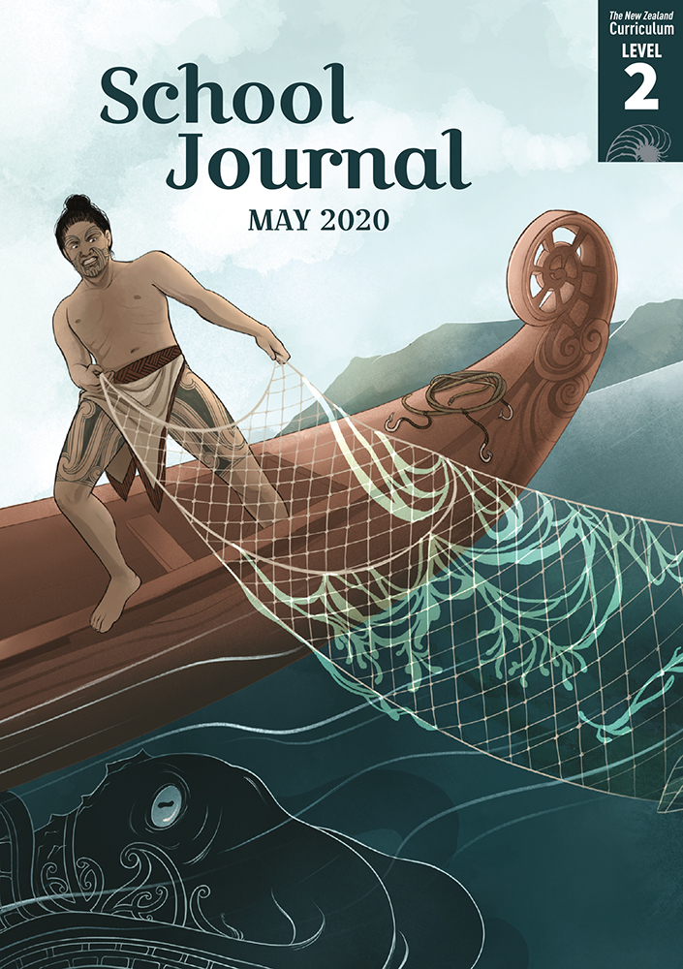

School Journal

Level 2, May 2020

**Year 4**

# Megabyte

by Greg O’Connell

The[Learning Progression Frameworks](https://curriculumprogresstools.education.govt.nz/lpf-tool) describe significant signposts in reading and writing as students develop and apply their literacy knowledge and skills with increasing expertise from school entry to the end of year 10.

## Overview

This humorous poem describes the poet’s pet monster and its dining habits. It links to the article “Monsters” in the same journal and shows how a topic can be approached in different ways. It also provides a model for students’ poetic writing.

A PDF of the text is available at [www.schooljournal.tki.org.nz](http://www.schooljournal.tki.org.nz)

## Themes

* Humour
* Manners

## Related texts

“**My ‘What If’ Planet**” SJ L2 Oct 2015 | “**Acrostic Poem**” SJ L3 Aug 2018 | “**Plastic Planet**” SJ L2 Nov 2018 |   
“**In the Manawatū**” *JJ* 54 | “**Tortoise**” *JJ* 48

## Strengthening reading behaviours (what to notice)

|  |  |
| --- | --- |
| Text structure and features | Requiring students to: |
| * Implied information or ideas * Some metaphors and other figurative or connotative language * Two stanzas of six lines each, a repeated rhyme scheme (a, b, c, c, c, b), a similar rhythm in each stanza, and ideas in sentences that run on across lines | * use their prior knowledge about monsters from fairy tales and conventional table manners to appreciate the humour * form a mental picture of the creature from the description by the poet and check this against the illustration * pay attention to the punctuation, rhythm, and rhyme scheme to read the poem effectively. |

|  |  |
| --- | --- |
| Vocabulary | |
| Possibly unfamiliar words and phrases | Megabyte, rare (as in unusual), enormous, bloodshot, fangs, to dine, gobbles, to report, napkin, tusks, claws, scales, clears his plate, never fails |

|  |
| --- |
| Helpful prior knowledge (pre-reading and introducing the text) |
| * Monsters from fairy tales often have fangs, tail, tusks, claws, and scales. * The conventions of fine dining include particular table manners and such things as candles and napkins. * “Mega” means huge, and “byte” is a measure of data memory size, which connects to the idea that the monster has a “huge bite”. |

## Possible reading and writing purposes

* Find out what Megabyte is like
* Identify and record their response to reading this poem
* Identify, record, and organise the structure and features of the poem

See *Effective Literacy Practice Years in 1–4* for suggestions on using this text with your students ([Approaches to teaching reading](http://literacyonline.tki.org.nz/Literacy-Online/Planning-for-my-students-needs/Effective-Literacy-Practice-Years-1-4/Approaches-to-teaching-reading)) and for information about teaching comprehension strategies ([Building comprehension](http://literacyonline.tki.org.nz/Literacy-Online/Planning-for-my-students-needs/Effective-Literacy-Practice-Years-1-4/Building-comprehension) and [Text processing strategies](http://literacyonline.tki.org.nz/Literacy-Online/Planning-for-my-students-needs/Effective-Literacy-Practice-Years-1-4/Text-processing-strategies)).

## Possible curriculum contexts

This text has links to level 2 of the New Zealand Curriculum in:[**ENGLISH**](http://nzcurriculum.tki.org.nz/The-New-Zealand-Curriculum/English)

## Understanding progress

The following aspects of progress are taken from the [Learning Progression Framework](https://curriculumprogresstools.education.govt.nz/lpf-tool/)s and relate to the specific learning tasks below. See the LPFs for more about how students develop expertise and make progress in these aspects:

* Reading for literary experience
* Making sense of text: reading critically
* Using writing to think and organise for learning
* Creating texts for literary purposes.

## Strengthening understanding through reading and writing

The *School Journal* provides rich texts that can be returned to many times. The following suggestions are based on the premise that rereading the text is a fundamental part of developing students’ understanding and reading skills. **Select from and adapt** them, according to your students’ strengths, needs, and experiences.   
Note: Most of these activities lend themselves to students working in pairs or small groups.

* Explore what the students thought of the poem. They could work independently or in pairs to complete a reflection using the **Response chart** template provided. They can use their reflections to summarise what they thought or comment on any aspect of the poem they wish to respond to. Use this to share and compare as a group.
* Ask the students to point out any patterns they have noticed in the poem. They may identify some rhyming words or notice the same number of lines in the two verses. Draw their attention to where the commas are placed and the lines that run on. Model how it can be read aloud, before giving the students time to have a go on their own. The class could also choral-read the poem together. Then they could read it to a friend or record themselves reading it.
* Use a T-chart to list Megabyte’s good manners and bad manners. Make a comparison between how Megabyte eats and how we eat. Discuss how different occasions might require different behaviour and that there can sometimes be different cultural expectations about what is considered good manners.
* Discuss the noun phrases: enormous hairy hands, five bloodshot eyes, ten yellow fangs. Innovate phrases that describe his tail, tusks, claws, and scales.
* Have the students draw their own monster and write some noun phrases to describe it.  Alternatively, you could provide a Pinterest page showing a selection of monsters that offer interesting noun phrase opportunities. The students could then write a poem about this monster, using these phrases and some of the patterns discussed earlier. Some English language learners may need explicit instruction about the order of adjectives, which is something that English first-language speakers know intuitively – it just “sounds right”. Quantity adjectives are written first, followed by opinion adjectives, factual adjectives, comparing adjectives, classifying adjectives, and then the noun. (For example, several, ugly, old, bigger, flying monsters.)
* Link to the “Monsters” article in the same journal. Ask the students to create a culture for their monster and give it a purpose.
* Explore the vocabulary, discussing the meaning of any unfamiliar words and phrases. Discuss the meaning of “mega” and “byte” and why the poet gave him that name.
* For more ideas and strategies to support English language learners, see [ESOL Online](https://esolonline.tki.org.nz/).

“Megabyte” Response chart

It made me smile when …

I think …

because …

Poem:

Poet:

I wonder …

I see, hear, smell, taste …

It surprised me when …

I liked …