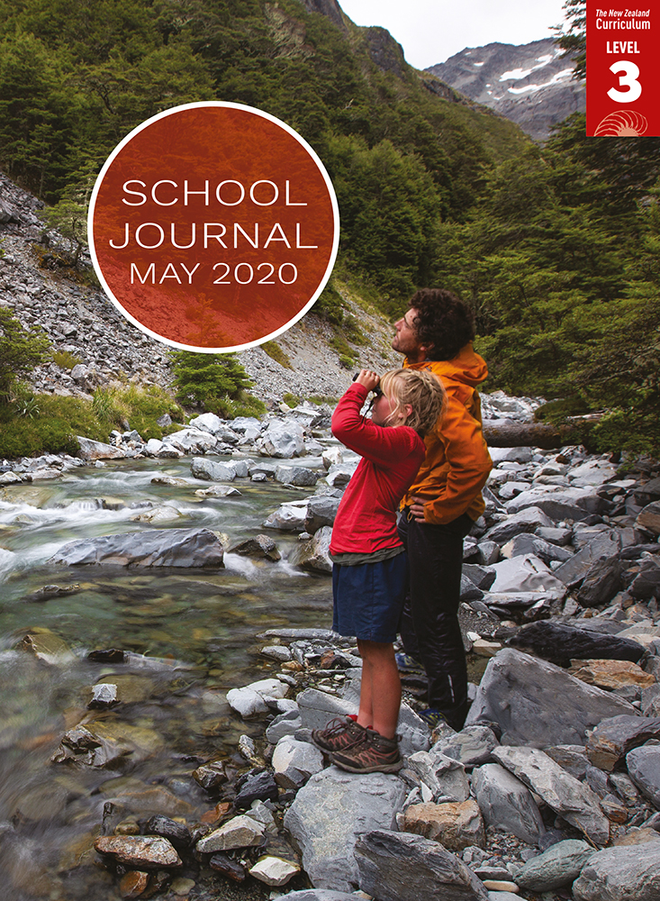

School Journal

Level 3, May 2020

**Year 6**

# Want Relief

by Paul Mason

[TheLearning Progression Frameworks](https://curriculumprogresstools.education.govt.nz/lpf-tool/) describe significant signposts in reading and writing as students develop and apply their literacy knowledge and skills with increasing expertise from school entry to the end of year 10.

## Overview

The Auckland Islands, a New Zealand territory in the Southern Ocean, were the site of nine shipwrecks in the nineteenth century. Paul Mason uses this as a starting point for his fictional story about Nell, who becomes a castaway with several others and must play her part in keeping their precious fire going.

A PDF of the text is available at [www.schooljournal.tki.org.nz](http://www.schooljournal.tki.org.nz)

## Themes

* Responsibility
* Resilience and courage
* Hardship and danger

## Related texts

“**Last Match**” SJ L4 May 2020 | “**My Name Is Davy Lowston**” SJ L2 May 2016 | “**Pencarrow: New Zealand’s First Lighthouse**”   
SJ L2 Aug 2019

## Strengthening reading behaviours (what to notice)

|  |  |
| --- | --- |
| Text structure and features | Requiring students to: |
| * A mix of simple, compound, and complex sentences, many carrying a considerable volume of information * Metaphor and other figurative or connotative language * Unusual and unfamiliar vocabulary in the first few paragraphs | * identify key ideas and supporting information in clauses to track the sequence of events * draw on their prior knowledge of figurative language and language features and the context in order to interpret the intended meaning * use prior knowledge and contextual clues to visualise the setting. |

|  |  |
| --- | --- |
| Vocabulary | |
| Maritime words | ballast, bow, gunwales, hull, keel, stern, mast, due north |
| Figurative language | a whisper of smoke, The anxiety of her movements spread through the hut like contagion, That fire’s the only thing that stands between us and the grave, the confusion of trees, Despair lay like ballast on her chest, When their ship *Oxford* perished on the rocks, an idea showed itself – like another shiny treasure from the forest floor |
| Other possibly unfamiliar words and phrases | hovel, castaways, marooned, hearth, shrub, embers, muster, beacons, nourished, shuddering, bloated, repulsive, gnawing, weevil, canopy, haunches, downy, fledgling, burbling, tapered, whittle, sheath, rummaging, miniature, prospect |

|  |
| --- |
| Helpful prior knowledge (pre-reading and introducing the text) |
| * In the 1800s, many sailing ships were shipwrecked. * The Auckland Islands are cold, desolate, and remote. * Transport and communication were a lot slower and more difficult in the 1800s. |

## Possible reading and writing purposes

* Find out how a young castaway has an idea for a clever way of attracting help
* Identify the hardships faced by a group of castaways on the Auckland Islands
* Explore the importance of a little bird to Nell
* Explore the literary features Paul Mason has used to engage the audience and tell his story
* Organise, record, and communicate ideas and information from the text

See *Effective Literacy Practice in Years 5–8* for information about teaching comprehension strategies ([Teaching comprehension](http://literacyonline.tki.org.nz/Literacy-Online/Planning-for-my-students-needs/Effective-Literacy-Practice-Years-5-8/Teaching-comprehension)) and for suggestions on using this text with your students ([Approaches to teaching reading](http://literacyonline.tki.org.nz/Literacy-Online/Planning-for-my-students-needs/Effective-Literacy-Practice-Years-5-8/Approaches-to-teaching-reading)).

## Possible curriculum contexts

This text has links to level 3 of the New Zealand Curriculum in:[**ENGLISH**](http://nzcurriculum.tki.org.nz/The-New-Zealand-Curriculum/English)[**HEALTH AND PHYSICAL EDUCATION**](http://nzcurriculum.tki.org.nz/The-New-Zealand-Curriculum/Health-and-physical-education)

## Understanding progress

The following aspects of progress are taken from the [Learning Progression Frameworks](https://curriculumprogresstools.education.govt.nz/lpf-tool/) and relate to the specific learning tasks below. See the LPFs for more about how students develop expertise and make progress in these aspects:

* Reading for literary experience
* Making sense of text: reading critically
* Reading to organise ideas and information for learning
* Using writing to think and organise for learning.

## Strengthening understanding through reading and writing

The *School Journal* provides rich texts that can be returned to many times. The following suggestions are based on the premise that rereading the text is a fundamental part of developing students’ understanding and reading skills. **Select from and adapt** them, according to your students’ strengths, needs, and experiences.   
Note: Most of these activities lend themselves to students working in pairs or small groups.

* Ask the students to reread the story and use stickies to record any questions that remain unanswered. They can research one or more of these questions, for example, about the Auckland Islands, what “Want relief” means, how close this story is to truth, what happened to other shipwrecks, and how to keep a fire going long term.
* Using a T-chart, find and list the hardships faced by these castaways. Beside each item, record the ways that these characters showed resilience or courage when facing these hardships. The students could add anything they might do in a similar situation.
* In pairs, students could discuss what they thought of Nell’s way of getting help (they might also discuss the ideas in the author’s note). They could brainstorm some of their own ideas and find out about current maritime safety rules and equipment.
* Have the students play Hot-seat, taking it in turns to be one of the characters in the story. The other students then question the student sitting on the “hot-seat”, who replies to the questions in role as the character.
* Read related stories, such as *My Story: Castaway – The Diary of Samuel Abraham Clark, Disappointment Island, 1907* by Bill O’Brien.
* Profile Nell as a character. The students could identify how she changed across the story, for example, “At the start” and “At the end”. They could find the words and phrases the author has chosen to describe her, her actions, her relationships, and how she felt. They could also add their own descriptions. Ask them to reflect on how the author has helped them to visualise Nell and the time period.
* Focus on the visual images created by the author. Use a Senses chart and record what students can imagine about the Auckland Islands – what the islands look like, sound like, smell like, feel like, and taste like.
* Have the students write a continuation to the story, exploring what happened when Nell returned.
* Ask the students to describe how an animal or pet helped them or made them feel better about a situation.
* Have the students tell the story, either orally or in writing, through the eyes of one of the other characters.
* Have the students explore the vocabulary by drawing a ship and labelling it using words from the text or by selecting some unfamiliar phrases and using the **Exploring words and phrases** template provided. Phrases might include “despair lay like ballast on her chest”, “leaning in she could barely muster the strength to blow”, “she began to whittle the wood, comforted by the sound of Boss rummaging in the background, sometimes calling”.
* For more ideas and strategies to support English language learners, see [ESOL Online](https://esolonline.tki.org.nz/).

“Want Relief” Exploring words and phrases

|  |  |  |
| --- | --- | --- |
| **Phrase** | **Key words** | **I think this means** |
|  |  |  |
|  |  |  |
|  |  |  |
|  |  |  |
|  |  |  |
|  |  |  |