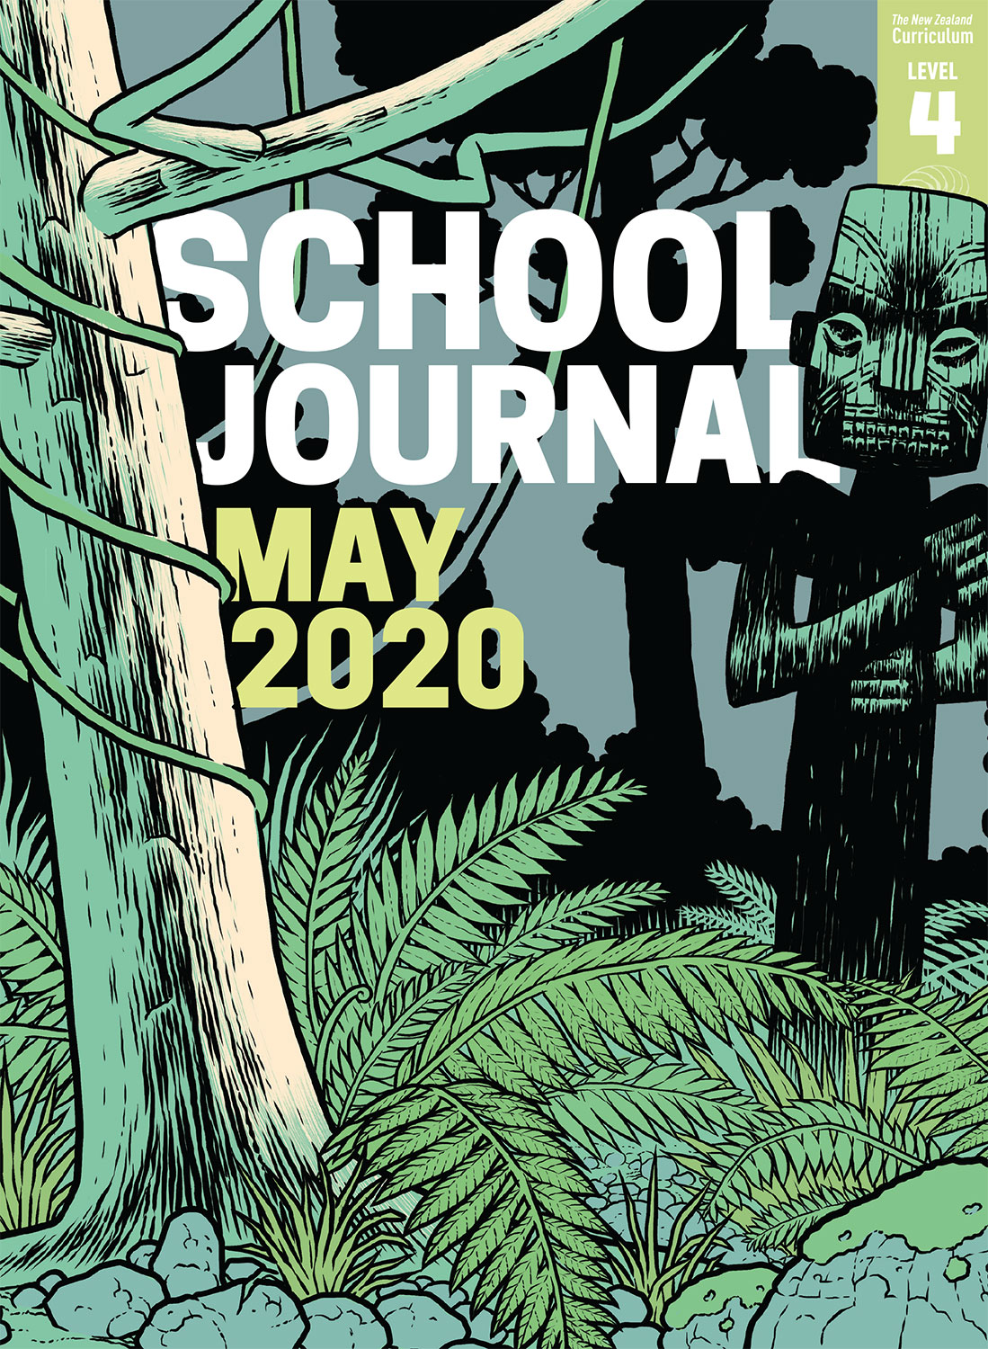

School Journal

Level 4, May 2020

**Year 7**

# Muse

by Paul Mason

The[Learning Progression Framework](https://curriculumprogresstools.education.govt.nz/lpf-tool/)s describe significant signposts in reading and writing as students develop and apply their literacy knowledge and skills with increasing expertise from school entry to the end of year 10.

## Overview

This is the third instalment in this series, which is set in a dystopian future. Although it follows on from “Hushed” and “Wind Chimes”, the story can stand alone.

A PDF of the text is available at [www.schooljournal.tki.org.nz](http://www.schooljournal.tki.org.nz)

## Themes

* Loyalty and betrayal
* Courage
* Sacrifice
* Friendship

## Related texts

“**Hushed**” SJ L4 May 2017 | “**Wind Chimes**” SJ L4 Nov 2017 | “**Thirst**” SJ L3 Aug 2015 | “**Kahawai**” SJ L3 Oct 2013 |   
“**Wind Chimes**” SJSL L4 March 2017 | “**Frogs**” SJSL L4 Jan 2013

## Strengthening reading behaviours (what to notice)

|  |  |
| --- | --- |
| Text structure and features | Requiring students to: |
| * Implied information and ideas * Metaphor and other figurative or connotative language * Third-person past tense, with lots of dialogue containing essential information, underscoring the themes and moving the plot along * Some unattributed dialogue | * make connections to the text and prior knowledge to fill in the gaps and infer the intended meaning * use prior knowledge and make inferences and connections to interpret deeper meaning * interpret what the characters say to track the developing story * piece together the sequence of events to identify the speakers and the unfolding story. |

|  |  |
| --- | --- |
| Vocabulary | |
| Possibly unfamiliar words and phrases | chimes, chinking, silhouette, ponga, pouwhenua, fatigues, notched, bivouacs, brawny, Radicals, Voids, pou, wedged, squads, searing, home in on |
| Figurative language | a careful smile, low canvas tents huddling beneath a veil of netting, not yet earnt the right to use them, misgiving still in his eyes, snored like a hog, keeping this place alive, someone to follow in his steps |

|  |
| --- |
| Helpful prior knowledge (pre-reading and introducing the text) |
| * The two earlier instalments, “[Hushed](http://instructionalseries.tki.org.nz/Instructional-Series/School-Journal/School-Journal-Level-4-May-2017/Hushed)” and “[Wind Chimes](http://instructionalseries.tki.org.nz/Instructional-Series/School-Journal/School-Journal-Level-4-November-2017/Wind-Chimes)”, provide background. * Dystopian fiction is a common genre in books and films. |

## Possible reading and writing purposes

* Find out what happens when Tre and Muse reach a hidden camp
* Consider the consequences of the decisions Tre and Muse each make
* Examine how Paul Mason creates tension and engages the audience
* Identify and analyse the features of dystopian fiction

See *Effective Literacy Practice in Years 5–8* for information about teaching comprehension strategies ([Teaching comprehension](http://literacyonline.tki.org.nz/Literacy-Online/Planning-for-my-students-needs/Effective-Literacy-Practice-Years-5-8/Teaching-comprehension)) and for suggestions on using this text with your students ([Approaches to teaching reading](http://literacyonline.tki.org.nz/Literacy-Online/Planning-for-my-students-needs/Effective-Literacy-Practice-Years-5-8/Approaches-to-teaching-reading)).

## Possible curriculum contexts

This text has links to level 4 of the New Zealand Curriculum in: [**ENGLISH**](http://nzcurriculum.tki.org.nz/The-New-Zealand-Curriculum/English)

## Understanding progress

The following aspects of progress are taken from the [Learning Progression Framework](https://curriculumprogresstools.education.govt.nz/lpf-tool/)s and relate to the specific learning tasks below. See the LPFs for more about how students develop expertise and make progress in these aspects:

* Reading for literary experience
* Making sense of text: reading critically
* Making sense of text: using knowledge of text structure and features
* Creating text to communicate current knowledge and understanding.

## Strengthening understanding through reading and writing

The *School Journal* provides rich texts that can be returned to many times. The following suggestions are based on the premise that rereading the text is a fundamental part of developing students’ understanding and reading skills. **Select from and adapt** them, according to your students’ strengths, needs, and experiences.   
Note: Most of these activities lend themselves to students working in pairs or small groups.

* Review the previous chapters to this story.
* Have the students respond to the revelation on page 47 “Tre snorted … used me”. Some possible responses might start: “When I read this I felt …”, “I wonder why …”, “I am surprised that …”.
* Tease out the decisions made by Tre and Muse and their consequences. The students might organise their information visually.  They could use [Mindmup](https://www.mindmup.com/) to create a branching diagram to show the decisions made, who made them, and the consequences.
* Debate the following: “Is Muse a traitor or a hero?” or “Is Tre foolish or brave?” The students could formulate their views by using the **Debate planner** template provided.
* Provide sentence frames and model texts to help English language learners form their argument. Support them to notice and use text connectives to link their ideas (for example, first, second, in addition, therefore, however, on the other hand, in conclusion). Text and paragraph reconstruction tasks will also help them to notice the connectives.
* Analyse what makes this story gripping and the language features the author has used to keep the tension.
* With the students, identify and evaluate the effectiveness of the dystopian features of the story.
* Have the students write another chapter to the story or write a dystopian story of their own.
* Ask the students to write an alternative dialogue when Tre discovers Muse’s secret.
* Have the students write about a time when they had to make a difficult choice. Encourage them to include the consequences of the decision.
* Ask the students to create a Venn diagram to show the connections with another text or with events in the real world.
* For more ideas and strategies to support English language learners, see [ESOL Online](https://esolonline.tki.org.nz/).

“Muse” Debate planner

**Topic/argument:**

|  |  |
| --- | --- |
| Opening statement: my position |  |
| Supporting evidence 1 |  |
| Supporting evidence 2 |  |
| Supporting evidence 3 |  |
| Persuasive words I can use |  |
| Reminders about presentation and manner |  |
| Closing statement |  |