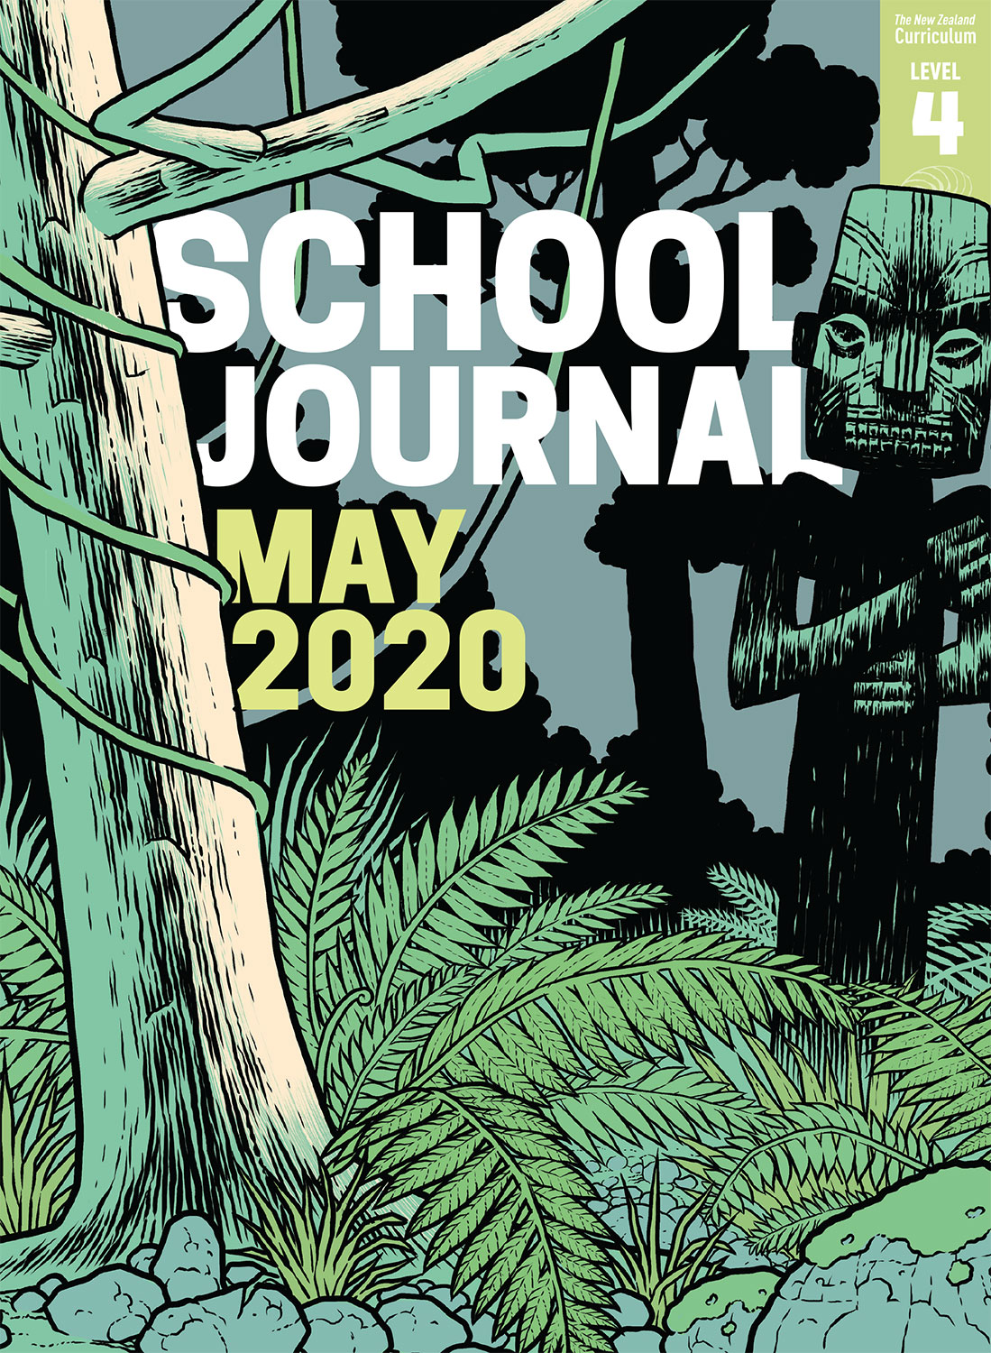

School Journal

Level 4, May 2020

**Year 8**

# Feedback

by Matt Boucher

The[Learning Progression Framework](https://curriculumprogresstools.education.govt.nz/lpf-tool/)s describe significant signposts in reading and writing as students develop and apply their literacy knowledge and skills with increasing expertise from school entry to the end of year 10.

## Overview

This article is a follow up to “Climate Change: Our Biggest Challenge”. It explains the phenomenon of feedback loops – positive feedback loops, which can cause climate change to accelerate, or negative loops, which can lessen the factors that cause change.

A PDF of the text is available at [www.schooljournal.tki.org.nz](http://www.schooljournal.tki.org.nz)

## Themes

* Climate change
* Sustainability
* Taking action

## Related texts

“**Climate Change: Our Biggest Challenge**” SJ L4 June 2018 | “**Ben Hawke, Mosgiel’s Meteorologist**” SJ L4 June 2018 | “**Global Action**” *Where to Next?* Connected L4 2017

## Strengthening reading behaviours (what to notice)

|  |  |
| --- | --- |
| Text structure and features | Requiring students to: |
| * Abstract ideas and ambiguity * Technical scientific information with illustrations, diagrams, graphs, and other visual supports * Competing information * The style of scientific writing | * keep track of information sentence by sentence across paragraphs to build understanding of the ideas * carefully integrate and interpret information as they read, using headings to navigate the development of ideas and visual features to clarify the scientific information * clarify and ask questions to differentiate between important and interesting information in relation to their purpose for reading * understand the decisions the writer has made about sentence structure and choice of vocabulary to fit the purposes for writing. |

|  |  |
| --- | --- |
| Vocabulary | |
| Possibly unfamiliar words and phrases | radically, trend, natural processes, absorb, erratic, concentration, initial, economy, exposing, mammoths, preserved, thaw, activists, empowered |
| Scientific terms | fossil fuels, energy, electricity, atmosphere, greenhouse gases, moisture, carbon dioxide, evaporates, vapour, methane, bacteria, nitrous oxide, albedo, permafrost, oxygen, deforestation |

|  |
| --- |
| Helpful prior knowledge (pre-reading and introducing the text) |
| * The planet is warming – average temperatures are increasing – and this is affecting the weather and the environment. * Climate change is threatening the future of many species. * Many groups and individuals are trying to persuade governments to take action to alleviate the rate of climate change. |

## Possible reading and writing purposes

* Find out what feedback loops are and how they affect climate change
* Identify the differences between positive and negative feedback loops
* Identify, analyse, and record the features of scientific writing
* Evaluate the effectiveness of the choices the writer has made

See *Effective Literacy Practice in Years 5–8* for information about teaching comprehension strategies ([Teaching comprehension](http://literacyonline.tki.org.nz/Literacy-Online/Planning-for-my-students-needs/Effective-Literacy-Practice-Years-5-8/Teaching-comprehension)) and for suggestions on using this text with your students ([Approaches to teaching reading](http://literacyonline.tki.org.nz/Literacy-Online/Planning-for-my-students-needs/Effective-Literacy-Practice-Years-5-8/Approaches-to-teaching-reading)).

## Possible curriculum contexts

This text has links to level 4 of the New Zealand Curriculum in:[**ENGLISH**](http://nzcurriculum.tki.org.nz/The-New-Zealand-Curriculum/English)[**SCIENCE**](http://nzcurriculum.tki.org.nz/The-New-Zealand-Curriculum/Science)

## Understanding progress

The following aspects of progress are taken from the [Learning Progression Framework](https://curriculumprogresstools.education.govt.nz/lpf-tool/)s and relate to the specific learning tasks below. See the LPFs for more about how students develop expertise and make progress in these aspects:

* Acquiring and using information and ideas in informational texts
* Making sense of text: using knowledge of text structure and features
* Making sense of text: reading critically
* Reading to organise ideas and information for learning.

## Strengthening understanding through reading and writing

The *School Journal* provides rich texts that can be returned to many times. The following suggestions are based on the premise that rereading the text is a fundamental part of developing students’ understanding and reading skills. **Select from and adapt** them, according to your students’ strengths, needs, and experiences.   
Note: Most of these activities lend themselves to students working in pairs or small groups.

* As they read the text the first time, ask the students to use stickies to record important facts and questions, for example, using 321RIQ (3 recalls, 2 insights, 1 question).
* Reread the article to deepen the students’ understanding of feedback loops. Work on pages 34 and 35 together. Change the subheading into a question (for example, “What is climate feedback?”) and, using a highlighter pen, identify the key ideas across the paragraphs that answer this question. Discuss and explore how the diagram supports these key ideas.
* Divide pages 36–39 between student pairs and ask them to continue the process in the suggestion above to build on their understanding of feedback loops. Pairs could give feedback orally about their understanding of the section.
* Discuss other examples of feedback loops that happen naturally, for example, the effects of a “mast” year, how money “grows”, how some heating systems work, and how infections spread. (For information about spreading diseases, fighting infection, microorganisms, the immune system, and many other related articles, go to the [Science Learning Hub](https://www.sciencelearn.org.nz/concepts/immune-system?level=primary).) The students could create a diagram or flowchart explaining these feedback loops.  The students could use Google Slides to create their diagram or flowchart.
* Discuss the features of scientific writing, analysing how those features support understanding. The students could explore these features using the **Writing like a scientist** template provided.
* Discuss the ways your school or community might reduce carbon emissions.
* Have the students prepare a presentation. For example, they could prepare a news item like Kea Kids News, about an aspect of the article, such as how climate change affects us, what feedback loops are, or a community idea for change.  The students could use a [Google Docs newspaper template](https://googledocstemplate.com/download/newspaper-template-4/) for this.
* Make a class glossary of words related to climate change.
* Discuss how nominalisation (changing verbs and other words into nouns) is commonly used in scientific writing because it makes a text more compact. For example, instead of saying “A liquid changes to vapour and then condenses” we could say “Vaporisation is followed by condensation.” Brainstorm other examples of nominalisation. (Note: these words often end in “tion”.) Challenge students to include some nominalisations in their own scientific writing.
* For more ideas and strategies to support English language learners, see [ESOL Online](https://esolonline.tki.org.nz/).

“Feedback” Writing like a scientist

|  |  |  |
| --- | --- | --- |
| **Scientific writing feature** | **Included ☑ ☒** | **How this supports the reader** |
|  |  |  |
|  |  |  |
|  |  |  |
|  |  |  |
|  |  |  |
|  |  |  |