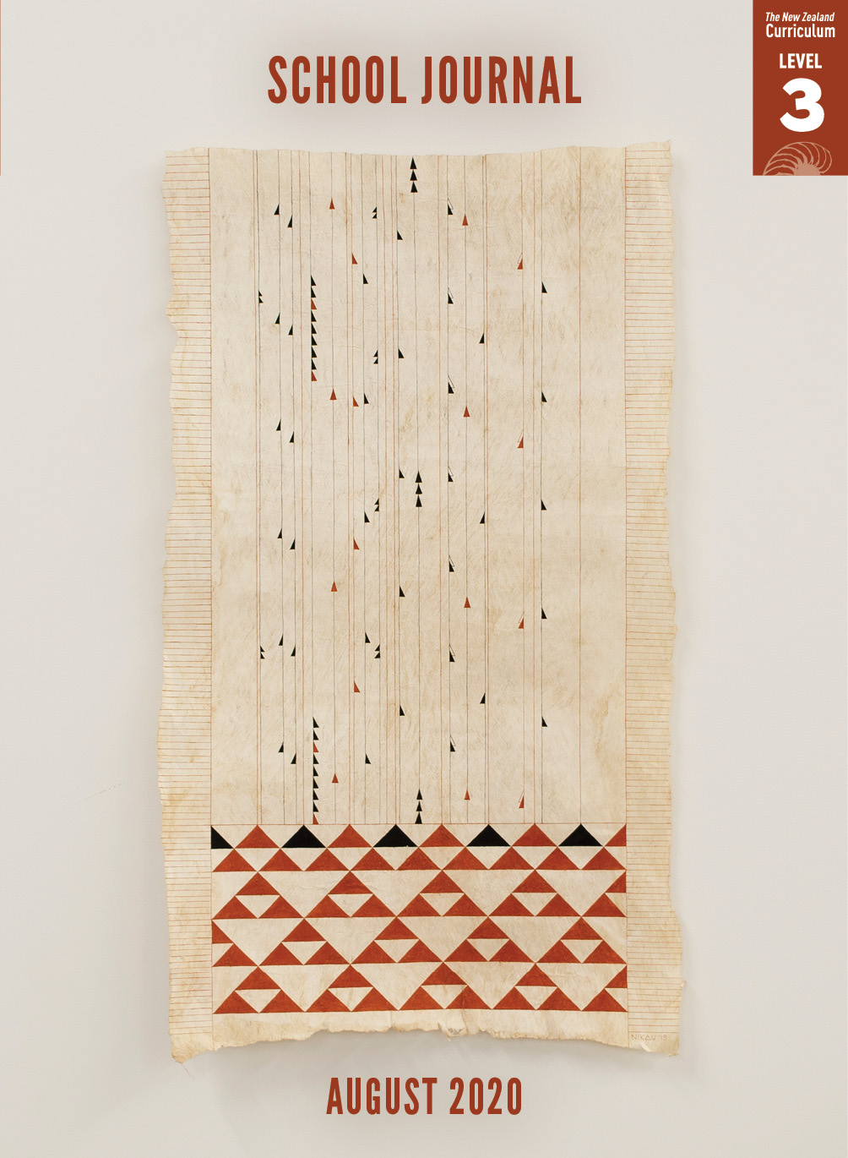

School Journal

Level 3, August 2020

**Year 6**

# The Polterheist

by James Brown

The[Learning Progression Framework](https://curriculumprogresstools.education.govt.nz/lpf-tool/)s describe significant signposts in reading and writing as students develop and apply their literacy knowledge and skills with increasing expertise from school entry to the end of year 10.

## Overview

“The Polterheist” is a comic story, deftly handled and with a tight focus, spinning great entertainment from a context many students will recognise – a school gala day. It provides a good model for student writing: taking the everyday and exploring its imaginative possibilities, with closelyobserved characterisation and a heavy reliance on dialogue to move the plot forward.

A PDF of the text is available at [www.schooljournal.tki.org.nz](http://www.schooljournal.tki.org.nz).

## Themes

|  |  |  |  |
| --- | --- | --- | --- |
| * Humour | * Suspense | * Dishonesty |  |

## Related texts

**“Suckered”** SJ L3 Nov 2018

## Strengthening reading behaviours (what to notice)

|  |  |
| --- | --- |
| Text structure and features | Requiring students to: |
| * Unattributed dialogue *“Pataphysics is a branch of philosophy or science that examines imaginary phenomena that exist in a world beyond metaphysics.”  “What?”  “It’s the science of imaginary solutions.” “Eh?”* * Competing information (mainly used for comic effect) *We breezed past the toys. There was still a small plastic mountain of them. Where did all this stuff come from? Where would it go?  “The Great Pacific Garbage Patch,” said Jeet.* * Implied information about the characters (for example, that the man knows he is manipulating the situation and being dishonest) *“Those few things? Ten bucks for the lot.”  The man’s eyes lit up. “Done!” he said, whipping out a ten-dollar note like it was a winning raffle ticket.* * Abstract ideas, including Jeet’s interest in poltergeists and explanation of pataphysics *“This is creepy,” I said. “I bet there’s a ghost.” “Or a poltergeist,” said Jeet.* | * keep track of the sequence of events, as well as use knowledge they are gaining about the characters, to follow and understand  the interactions * think critically to realise the author’s purpose for including information that is not entirely necessary for the plot * read closely, making connections to their own experiences and using prior knowledge and clues in the text, to infer what the author wants them to know about the characters to fully appreciate the nuances of the story * use prior knowledge and word knowledge to gain some understanding of these concepts. |

|  |  |
| --- | --- |
| Vocabulary | |
| Possibly unfamiliar words | jangled, poltergeist, fluorescent, abandoned, smeared, insufficient, white elephant, troublesome, verandah, delegating, bric-a-brac, occupation, pataphysicist, pataphysics, philosophy, imaginary phenomena, metaphysics, revolutionise, discernible, forlorn, beamed, manoeuvre, compressor, retractable, missile, squelch, registration, deflated |

|  |
| --- |
| Helpful prior knowledge (pre-reading and introducing the text) |
| * Experience of school gala days * Some prior knowledge that poltergeists are said to be ghosts that move things |

## Possible reading and writing purposes

* Find out how two friends save the day at the school gala
* Explore, analyse, and evaluate how the author portrays the characters in the story
* Identify how the author creates humour in the story
* Identify and understand the author’s purpose

See *Effective Literacy Practice in Years 5–8* for information about teaching comprehension strategies ([Teaching comprehension](http://literacyonline.tki.org.nz/Literacy-Online/Planning-for-my-students-needs/Effective-Literacy-Practice-Years-5-8/Teaching-comprehension)) and for suggestions on using this text with your students ([Approaches to teaching reading](http://literacyonline.tki.org.nz/Literacy-Online/Planning-for-my-students-needs/Effective-Literacy-Practice-Years-5-8/Approaches-to-teaching-reading)).

## Possible curriculum contexts

This text has links to level 3 of *The New Zealand Curriculum* in: [**ENGLISH**](http://nzcurriculum.tki.org.nz/The-New-Zealand-Curriculum/English)

## Understanding progress

The following aspects of progress are taken from the [Learning Progression Framework](https://curriculumprogresstools.education.govt.nz/lpf-tool/)s and relate to the specific learning tasks below. See the LPFs for more about how students develop expertise and make progress in these aspects:

* Reading for literary experience
* Making sense of text: reading critically
* Making sense of text: using knowledge of text structure and features
* Using writing to think and organise for learning.

## Strengthening understanding through reading and writing

The *School Journal* provides rich texts that can be returned to many times. The following suggestions are based on the premise that rereading the text is a fundamental part of developing students’ understanding and reading skills. **Select from and adapt** them according to your students’ strengths, needs, and experiences.   
Note: Most of these activities lend themselves to students working in pairs or small groups.

* Discuss the title. *What does it mean? Why did the author choose to use it?*
* Explore Jeet’s dialogue. Encourage the students to consider what is distinctive about his way of talking and what it might reveal about his character.
* Ask the students to map the story’s plot, writing down the main things that happen and the effects these events have. Explore how the author weaves all the different ideas into the story’s climax.
* Encourage the students to look for words and phrases that show the narrator’s personality. Use the **Character profile** template provided to record how the narrator’s character is revealed in his response to the various plot points.  You could create a template that the students could add to using [Google Docs](https://www.google.com/docs/about/).
* Have the students play Hot Seat, taking it in turns to be one of the characters in the story. The other students question the student in the “hot seat” who replies in role as the character.
* Explore the ways that sentences can be structured. Encourage the students to search for sentences they like and then play around with their structure, for example, by moving the [adverb](https://englishonline.tki.org.nz/English-Online/Planning-for-my-students-needs/Exploring-language/Word-Class-Adverbs) or [adverbial phrase](https://englishonline.tki.org.nz/English-Online/Planning-for-my-students-needs/Exploring-language/Bringing-It-Together-Phrases) to the beginning of the sentence.
* Identify and evaluate how the writer creates humour in the story. Have the students draw up a chart with the headings Actions, Speech, and Inner Thoughts and note down parts they find funny under the headings. They could discuss these examples with a partner to identify what makes them funny (or not). Focus also on the author’s use of word play to create humour, for example, the “OOO list”. English language learners may find it difficult to recognise and follow the humour as it is often culturally based. You could model and provide explicit explanations to help them gain greater understanding.
* Have the students write the parts of the story that the author has left out, such as what happened when the adults confronted the man who took the compressor.
* Ask the students to write about a time when they have visited or helped out at a school fair. You could ask them questions to spark their thinking, for example: *Where do you like going first? What games do you play? Have you ever donated things from home?*
* Reread the first two pages describing the boys’ visit to the storeroom together. Then have the students describe visiting an unused place themselves, using plenty of adjectives to create a picture for the reader.

|  |
| --- |
| “The Polterheist” Character profile |

In the left-hand column, outline the main parts (scenes) of the story or draw a picture to show each part. In the middle column, note what happens and/or what is said that reveals something about the **narrator**. In the right-hand column, say what each example reveals.

|  |  |  |
| --- | --- | --- |
| **Main parts of story** | **Actions and words that reveal the character (narrator)** | **What they reveal** |
| 1. In storeroom looking for white elephant stuff and carrying stuff to hall | Loved the storeroom – far away, not used  Talk about poltergeist  Smiles at Jeets vocab  “Where’s the white elephant?” – humour  Trooped back and forth – counted the trips | likes exploring places  interested in scary things  likes Jeet and his way of talking  has a sense of humour  a bit bored? |
| 2. Playing computer game |  |  |
| 3. At fair, helping at stall |  |  |
| 4. Exploring fair |  |  |
| 5. Tidying up – man buys compressor |  |  |
| 6. Stopping the man |  |  |