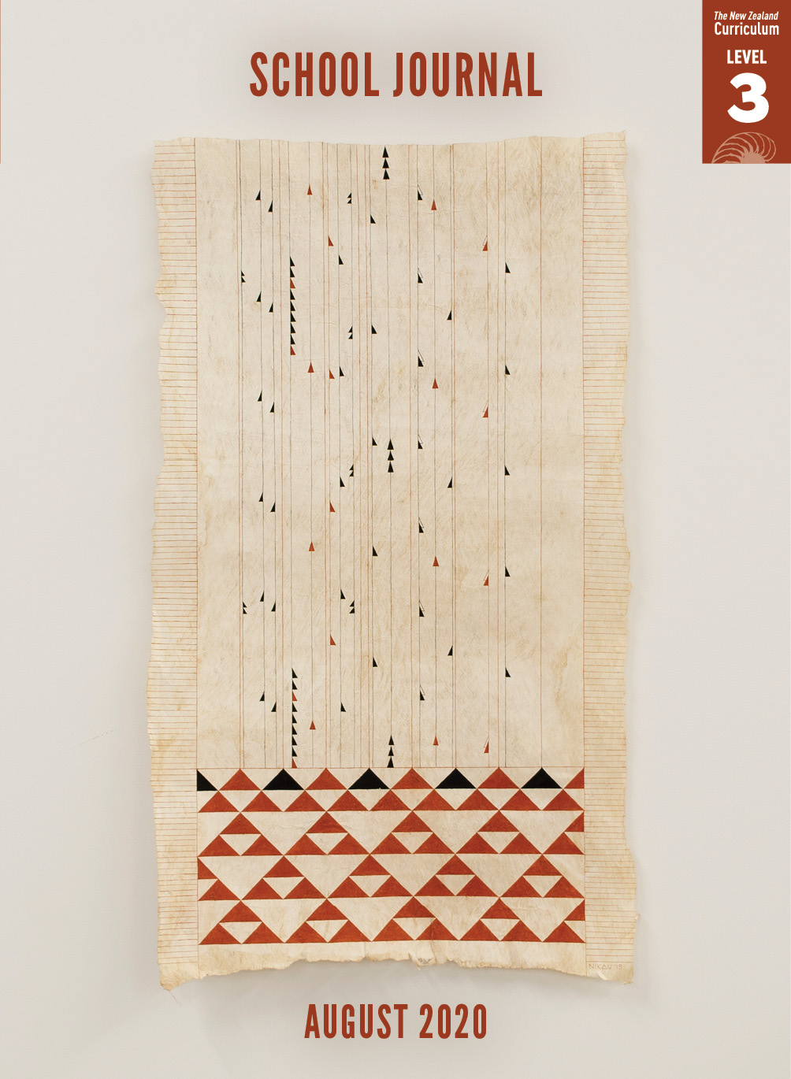

School Journal

Level 3, August 2020

**Year 6**

# Roar

by Kathryn Mercer

The [Learning Progression Framework](https://curriculumprogresstools.education.govt.nz/lpf-tool/)s describe significant signposts in reading and writing as students develop and apply their literacy knowledge and skills with increasing expertise from school entry to the end of year 10.

## Overview

Hunting is hugely popular in New Zealand’s rural communities, and it’s often done within families. This article will be welcome reading for students who already hunt, giving them the opportunity to share their knowledge with classmates. Those unfamiliar with the past-time are introduced to the basics, especially the “why” of hunting and the different skills and pleasures involved.

A PDF of the text is available at [www.schooljournal.tki.org.nz](http://www.schooljournal.tki.org.nz).

## Themes

|  |  |  |  |
| --- | --- | --- | --- |
| * Nature | * Family | * Hunting | * Sustainable living |

## Related texts

**“The Longest Walk”** SJ L3 May 2020 | **“Boy on a Bike”** SJ L3 May 2015 | **“The Wild Deer Debate”** SJSL L4 2011 |   
**“Deer, Oh Deer”** SJ 4.1.10

## Strengthening reading behaviours (what to notice)

|  |  |
| --- | --- |
| Text structure and features | Requiring students to: |
| * Competing information  *New Zealand’s Common Deer Species The Deer Problem?* * Technical information *They also carry a couple of GPS navigator/ radio handsets. These allow them to split up but still co-ordinate when they’re stalking.* | * evaluate information in relation to their reading purpose to identify the difference between important and interesting information * use vocabulary knowledge, context, and visualisation to work out the intended meaning. |

|  |  |
| --- | --- |
| Vocabulary | |
| Possibly unfamiliar words | Instantly, alert, venison, rural, urban, zilch, gadgets, imitate, supervised, assets, shrunken, dusk, cranky, cautious, grazing, butchered |
| Topic-related nouns | kit, personal locator beacon, GPS navigator/radio handsets, cow horn, firearms licence, fishing rod, fly, billy, camouflage gear |
| Possibly unfamiliar phrases | flaring in agitation, trophy hunters, valuable resource, proper management, dab hand, boiling up a brew in the billy, deer are stealthy, Vizsla dog, locking up, raging hormones, staking out territory, vital organ, flora and fauna, recreational hunters, deer management |

|  |
| --- |
| Helpful prior knowledge (pre-reading and introducing the text) |
| * Knowledge of what it’s like being out in the bush, for example, tramping, hunting, or trapping * That some people try to live off the land and hunt for their food * That people hold different views about some activities (The anticipatory guide later in this TSM may be helpful for a discussion before reading.) |

## Possible reading and writing purposes

* Find out why the Cleaver family enjoy hunting
* Identify positive and negative aspects of hunting
* Explain the safety procedures the Cleavers follow when they go hunting

See *Effective Literacy Practice in Years 5–8* for information about teaching comprehension strategies ([Teaching comprehension](http://literacyonline.tki.org.nz/Literacy-Online/Planning-for-my-students-needs/Effective-Literacy-Practice-Years-5-8/Teaching-comprehension)) and for suggestions on using this text with your students ([Approaches to teaching reading](http://literacyonline.tki.org.nz/Literacy-Online/Planning-for-my-students-needs/Effective-Literacy-Practice-Years-5-8/Approaches-to-teaching-reading)).

## Possible curriculum contexts

This text has links to level 3 of *The New Zealand Curriculum* in: [**ENGLISH**](http://nzcurriculum.tki.org.nz/The-New-Zealand-Curriculum/English)[**HEALTH AND PHYSICAL EDUCATION**](http://nzcurriculum.tki.org.nz/The-New-Zealand-Curriculum/Health-and-physical-education)

## Understanding progress

The following aspects of progress are taken from the [Learning Progression Framework](https://curriculumprogresstools.education.govt.nz/lpf-tool/)s and relate to the specific learning tasks below. See the LPFs for more about how students develop expertise and make progress in these aspects:

* Acquiring and using information and ideas in informational texts
* Making sense of text: using knowledge of text structure and features
* Reading to organise ideas and information for learning
* Using writing to think and organise for learning
* Creating texts to influence others.

## Strengthening understanding through reading and writing

The *School Journal* provides rich texts that can be returned to many times. The following suggestions are based on the premise that rereading the text is a fundamental part of developing students’ understanding and reading skills. **Select from and adapt** them according to your students’ strengths, needs, and experiences.   
Note: Most of these activities lend themselves to students working in pairs or small groups.

* Prior to reading, give the students the **Anticipatory guide**. Ask them to discuss the statements with a partner and complete the “Before reading” column. After reading, have them discuss the statements again and then fill in the right-hand column, giving reasons for their responses. They could compare and discuss their answers with those of other pairs. (You can add to or adapt the statements.  You could also create the guide in Google Docs for the students to use.)
* Have the students record questions as they arise during their first reading. If any questions remain unanswered when they have finished reading, encourage them to do further research.
* Ask the students to draw up a three-column table headed “Unknown word”, “What we think it means”, and “What we found out it means” and have them record any words they don’t understand as they read. After reading, they could discuss with a partner what they think each word means from the context and then use a dictionary to confirm the meaning.
* Have the students scan the text to identify all the items the Cleavers take with them and the things they do to be prepared and safe while hunting. The students could turn their ideas into a poster.  They could use [Google Slides](https://www.google.com/slides/about) or [Canva](https://www.canva.com/) to create their poster.
* In pairs, have the students record as bullet points the important information in each section. Use a T-chart to record facts and opinions in the article. Discuss the differences between these two categories.
* Analyse the chart on page 31. The students could compare the weights of the deer to things they know. Use a tape measure to demonstrate the height of the deer’s shoulders.
* Ask the students to identify the features of a non-fiction article in the text, such as the use of third-person narration, subheadings, a table, an introduction and a conclusion, sidebars, photographs, captions, and (in this case) expressive or descriptive language (for example, alliteration).
* Ask the students to use a T-chart to list all the positives and negatives of deer hunting mentioned in the article. Then ask them to write a summary statement saying why the family like hunting. They could highlight the parts of hunting that they would also enjoy.
* Encourage the students to find out more about an aspect of the story they aren’t familiar with, for example, personal locator beacons. The students could research what they are used for, how much they cost, how they work, and so on.
* Ask the students to write about a family trip or something their family does together (for example, going to church, eating together, celebrating a special occasion).
* Ask the students to write an argument for or against hunting, giving reasons for their stance.

|  |
| --- |
| “Roar” Anticipatory guide |

|  |  |  |  |
| --- | --- | --- | --- |
| **Before reading**  **Agree/disagree** | **Statement** | **After reading**  **Agree/disagree** | **Reasons** |
|  | Hunting is a family activity. |  |  |
|  | Hunting is good for the environment. |  |  |
|  | You need to be fit to go hunting. |  |  |
|  | Hunting is a very safe activity. |  |  |
|  | You need a lot of gear to go hunting. |  |  |