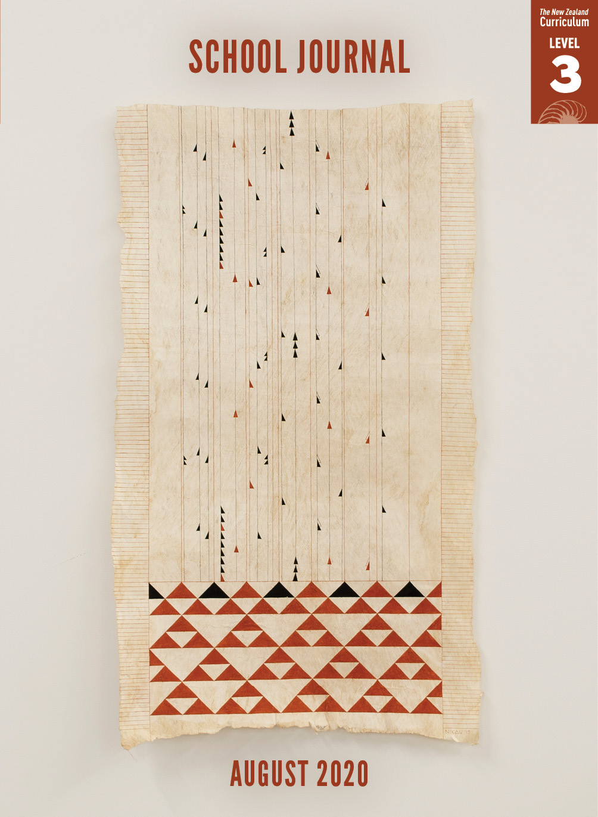

School Journal

Level 3, August 2020

**Year 5**

# The Art of Aute

by Matahana Tikao Calman

The[Learning Progression Framework](https://curriculumprogresstools.education.govt.nz/lpf-tool/)s describe significant signposts in reading and writing as students develop and apply their literacy knowledge and skills with increasing expertise from school entry to the end of year 10.

## Overview

Little is known about the history of cloth-making in Aotearoa. This article is a useful introduction to a tradition that’s found across the Pacific. Nikau Hindin has led the way with its recent revival in New Zealand – both learning a cloth-making practice that’s been around for centuries, then using this cloth for her art.

A PDF of the text is available at [www.schooljournal.tki.org.nz](http://www.schooljournal.tki.org.nz).

## Themes

|  |  |  |  |
| --- | --- | --- | --- |
| * Traditions | * Cultural identity | * Revival of traditional crafts |  |

## Related texts

**“Ngatu: Keeping the Tradition Alive”** SJ L2 June 2018 | **“For the Ancestors: One Woman’s Malu”** SJ L3 Nov 2019 |   
“**Pōhā: A Clever Way of Storing Food”** SJ L2 Sept 2014 | **Keeping Our Stories Alive** SJSL L3 2020

## Strengthening reading behaviours (what to notice)

|  |  |
| --- | --- |
| Text structure and features | Requiring students to: |
| * Use of abstraction  *All she could find, she says, “were traces about aute in our language, and some old stories”.  She began by showing Nikau how to connect with the aute plant* * Competing information on the history of aute and multiple strands to the text  *“They tell us there was no one way of making aute.” (She was told by a kapa teacher in Hawai‘i that they had seventeen different ways!)* | * use their background knowledge (including vocabulary knowledge) along with information they are gleaning from the text and the context to understand the meaning behind the words * clarify key information related to their purpose as they read, including being able to identify what information is important for their reading purpose and what information adds interest. |

|  |  |
| --- | --- |
| Vocabulary | |
| Many proper nouns | Nikau Hindin, Ngāpuhi, Te Rarawa, Motukaraka, Hawai‘i, Hawaiian, Aotearoa, Tāmaki Paenga Hira, Europe, the United States, Africa, the Pacific, Verna Takashima, Papatūānuku |
| Use of te reo Māori (many of these terms are in the glossary or explained in the text) | patu aute, pōhutukawa, kauri, mānuka, rimu, toki, pipi, hōanga, kua, te reo Māori, kūmara, taro, manu aute, maro aute, rākau nui, tūpuna |
| Possibly unfamiliar words | traces, preserved, physical evidence, delicate, sustainable, natural pigment |

|  |
| --- |
| Helpful prior knowledge |
| * Knowledge of tapa cloth and how it is made * Knowing how people reconnect with their past |

## Possible reading and writing purposes

* Find out how a Māori artist rediscovered an ancient art
* Understand the history and use of traditional aute
* Identify and explain why this ancient art is described as “sustainable”

See *Effective Literacy Practice in Years 5–8* for information about teaching comprehension strategies ([Teaching comprehension](http://literacyonline.tki.org.nz/Literacy-Online/Planning-for-my-students-needs/Effective-Literacy-Practice-Years-5-8/Teaching-comprehension)) and for suggestions on using this text with your students ([Approaches to teaching reading](http://literacyonline.tki.org.nz/Literacy-Online/Planning-for-my-students-needs/Effective-Literacy-Practice-Years-5-8/Approaches-to-teaching-reading)).

## Possible curriculum contexts

This text has links to level 3 of *The New Zealand Curriculum* in: [**ENGLISH**](http://nzcurriculum.tki.org.nz/The-New-Zealand-Curriculum/English) [**SOCIAL SCIENCES**](http://nzcurriculum.tki.org.nz/The-New-Zealand-Curriculum/Social-sciences)

## Understanding progress

The following aspects of progress are taken from the [Learning Progression Framework](https://curriculumprogresstools.education.govt.nz/lpf-tool/)s and relate to the specific learning tasks below. See the LPFs for more about how students develop expertise and make progress in these aspects:

* Acquiring and using information and ideas in informational text
* Making sense of text: vocabulary knowledge
* Reading to organise ideas and information for learning
* Using writing to think and organise for learning.

## Strengthening understanding through reading and writing

The *School Journal* provides rich texts that can be returned to many times. The following suggestions are based on the premise that rereading the text is a fundamental part of developing students’ understanding and reading skills. **Select from and adapt** them according to your students’ strengths, needs, and experiences.   
Note: Most of these activities lend themselves to students working in pairs or small groups.

* Prior to reading, share pictures of a tapa cloth to gather what the students know and to generate questions. You could ask a leading question to guide them, for example, *What skills and materials would you need to make this?*
* Watch [Creative Native: Nikau Hindin (Aute Maker)](https://www.youtube.com/watch?v=QzSuyriCQ0w) to see Nikau making aute cloth.
* Start a before, during, and after chart and have the students use stickies to record what they know about making tapa cloth. At the start, this might be quite broad and include connections to their prior knowledge. Together, review and organise the stickies under student-suggested subheadings.
* Use a questioning model to support the students to ask deep questions. Show how a question can be generated from what they know to check accuracy and extend knowledge about a topic. Use the **Questioning** template on page 3 of this TSM to record their questions, the answers (and evidence), and any further questions from during and after reading.
* Have the students record unfamiliar vocabulary on a chart like this one.  The students could use [Google Docs](https://www.google.com/docs/about/) for this activity.

|  |  |  |  |
| --- | --- | --- | --- |
| Word | I have seen this word before: Yes/No | I think it means | Definition |
|  |  |  |  |

* Have the students read across the text to find specific information about traditions, tools, materials, and skills. Review techniques for recording information, such as using bullet points and short phrases. Have the students share what they have found with the group.
* Ask the students to find and record nine facts from the article. The students could then compare their facts to see what others noticed.
* Write the words Who, What, Where, When, Why, and How on cards. Have the students choose a card and use it as a starter to ask each other a question relating to the article (for example, “What is the article about?”).
* Discuss why tradition and sustainability are important to Nikau. Check first that the students understand the concepts of tradition and sustainability. You could create [concept maps](https://esolonline.tki.org.nz/ESOL-Online/Planning-for-my-students-needs/Resources-for-planning/ESOL-teaching-strategies/Thinking-and-metacognition/Concept-map) together to help English language learners understand the words more fully.   
  Ask the students to look for evidence in the text that supports their answers. You may need to guide them with questions such as *Where did you find that out?* or *What part made you think this?*
* Have the students write about traditions that have been passed down in their own families, such as recipes, skills, or activities. Encourage them to talk to their parents and grandparents to gather ideas. Alternatively, they could write about traditions that are celebrated by their school, including annual ceremonies, artefacts on show, or people mentioned in prizes given to students.
* Have the students write down Nikau’s motivations to learn about aute, using what she says and does for evidence.

|  |
| --- |
| “The Art of Aute” Questioning |

|  |  |  |  |  |
| --- | --- | --- | --- | --- |
| **I know/think I know** | **My question related to this** | **Answer** | **Evidence from the text** | **Further questions** |
| The design has a meaning. | How does the artist select which designs to use in making the cloth? |  |  |  |
|  |  |  |  |  |