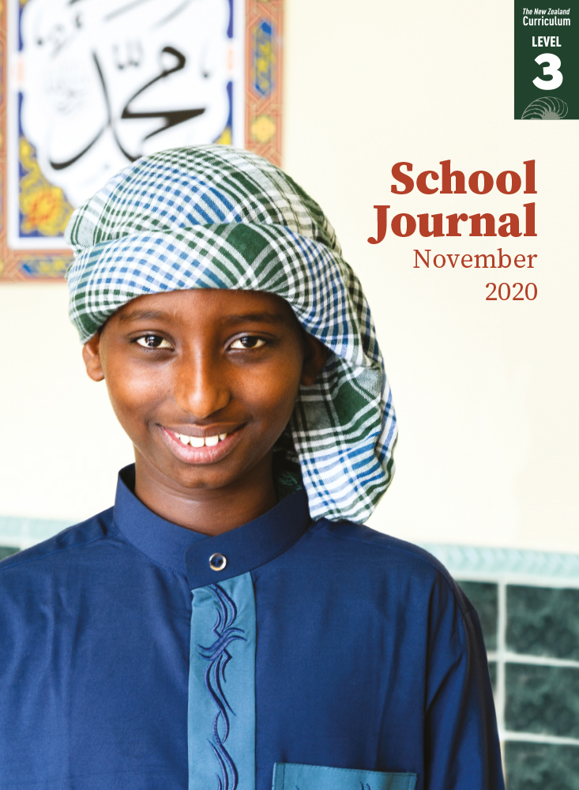

# No Girls Allowed

by Victor Rodger

School Journal

Level 3, November 2020

**Year 5**

The[Learning Progression Frameworks](https://curriculumprogresstools.education.govt.nz/lpf-tool/) describe significant signposts in reading and writing   
as students develop and apply their literacy knowledge and skills with increasing expertise from school entry to the end of year 10.

## Overview

Based on a true story: Victor Rodger explores what it means to make a difficult decision as a group to protect the interests of one person in that group – and the cost of taking a stand. He also makes the point that some things are worth calling out, especially when they involve injustice.

A PDF of the text is available at [www.schooljournal.tki.org.nz](http://www.schooljournal.tki.org.nz)

## Themes

|  |  |  |  |
| --- | --- | --- | --- |
| * Taking a stand | * Loyalty | * Justice | * Discrimination |

## Related texts

**“Four of a Kind”** SJ L4 May 2018

## Strengthening reading behaviours (what to notice)

|  |  |
| --- | --- |
| Text structure and features | Requiring students to: |
| * Figurative language *dropped the ball as though it  was covered in butter Her family lived for rugby. a rumble of agreement* * Colloquial language *Her heart sank; I went in to bat for you; You must be gutted; I pushed back; Sweet!; Get that chin up!; You got a hiding; You still smashed it!*; *I feel stink* * Many speakers  *“Well you can still play seven-a-side with the girls,” said Mum. She was always positive.  Dad frowned. “Why should she?”  “Yeah. They’re not her team,” Archie agreed.* | * use prior knowledge of figurative language to recognise the metaphors and similes and understand the meaning they convey * use prior knowledge of everyday language and the context of the story to understand the meaning the phrases carry * pay attention to the names and punctuation to notice the change of speaker and track the to and fro of the conversations. |

|  |  |
| --- | --- |
| Vocabulary | |
| Possibly challenging words | tournament, apparently, neutral, disappointment, sapasui, understatement, lousy, compromise |

|  |
| --- |
| Helpful prior knowledge (pre-reading and introducing the text) |
| * Some knowledge of player positions in rugby * Some understanding of the rules and regulations relating to tournaments, including those for children * Knowledge of the time difference between New Zealand and New York. |

## Possible reading and writing purposes

* Read a story of loyalty and how a rugby team takes a stand before an inter-school tournament
* Identify how Riley’s feelings change as the situation progresses
* Explore how the decisions made by the tournament organisers, the coach, and the team, impact on Riley
* Discuss and describe possible responses to the situation described in the story.

See *Effective Literacy Practice in Years 5–8* for information about teaching comprehension strategies ([Teaching comprehension](https://literacyonline.tki.org.nz/Literacy-Online/Planning-for-my-students-needs/Effective-Literacy-Practice-Years-5-8/Teaching-comprehension))   
and for suggestions on using this text with your students ([Approaches to teaching reading](https://literacyonline.tki.org.nz/Literacy-Online/Planning-for-my-students-needs/Effective-Literacy-Practice-Years-5-8/Approaches-to-teaching-reading)).

## Possible curriculum contexts

This text has links to level 3 of *The New Zealand Curriculum* in: [**ENGLISH**](http://nzcurriculum.tki.org.nz/The-New-Zealand-Curriculum/English)

## Understanding progress

The following aspects of progress are taken from the [Learning Progression Framework](https://curriculumprogresstools.education.govt.nz/lpf-tool/)s and relate to the specific learning tasks below. See the LPFs for more about how students develop expertise and make progress in these aspects:

* Reading for literary experience
* Making sense of text: using a processing system; using knowledge of text structure and features; vocabulary knowledge;   
  reading critically
* Creating texts to influence others
* Using writing to think and organise for learning.

## Strengthening understanding through reading and writing

**Select from the following suggestions and adapt them** according to your students’ strengths, needs, and experiences.   
Note: Most of these activities lend themselves to students working in pairs or small groups.

* Some English language learners may find this text difficult because of the frequent use of colloquial and figurative language and contractions. They may also be unfamiliar with the game of rugby. Consider what scaffolding they may need to understand the text, for example, play a game of rugby and teach the vocabulary of the game.
* To help the students to make a personal connection, invite them to share their own stories of when something was fair or not fair. Encourage them to ask questions to find out what their partner thinks about the story.
* Have the students complete the first **Points of view** template at the end of this TSM to understand the characters’ views about girls playing in a rugby tournament with boys. Discuss why the organisers might have decided girls could not play (the reader isn’t told).
* Ask the students to find evidence in the text to show how Riley is feeling and how her feelings change across time. See the TSM for “[Star-gazing](https://instructionalseries.tki.org.nz/Instructional-Series/School-Journal/School-Journal-Level-3-August-2020/Star-gazing)” or “[Waiting](https://instructionalseries.tki.org.nz/Instructional-Series/School-Journal/School-Journal-Level-3-August-2020/Waiting)” (SJ L3 Aug 2020) for a template you could adapt for this activity. The students could write a summary sentence to capture the most important thing Riley learns in the story. To support English language learners to recognise how Riley’s feelings are shown in the text, you could have them dramatise the action or illustrate the figurative language.
* Review the structure of a narrative text. The students could use a film-strip template to record the key moments in the story. For an example, see the TSM for “[Kupe and the Giant Wheke](https://instructionalseries.tki.org.nz/Instructional-Series/School-Journal/School-Journal-Level-2-May-2020/Kupe-and-the-Giant-Wheke)” (SJ L2 May 2020). They could then use a story mountain template to plot the dramatic arc of the story. For an example, see the TSM for “[Magō!](https://instructionalseries.tki.org.nz/Instructional-Series/School-Journal/School-Journal-Level-2-August-2020/Mago)” (SJ L2 Aug 2020).
* Review the conventions of punctuation that show which words are spoken, how they are spoken, and when someone new is speaking, including the function of ellipses and contractions. Explore the dialogue in the story, including examples of when dialogue is split and when many characters are talking. Focus on how the dialogue moves the narrative along and whether the dialogue is realistic. You could read a section aloud and have the students take the parts of the various characters. *Is that how they would talk?*
* The author uses metaphors, similes, and other colloquial phrases throughout the story (see Text structure and features on page 1 of this TSM). The students could use a T chart to explore these and their meanings. Have them write the phrase on the left and its literal meaning on the right. They could then compare their charts and clarify any phrases that they are unsure of.
* Have the students identify any words that were challenging and/or give them the vocabulary listed on page 1 of this TSM. Ask them to use a dictionary to find the meaning and then write the antonym for each of these words.
* Ask the students to think critically about the themes in the story. As a group, discuss how the author got his message across.
* Have the students write a letter to the tournament organisers asking them to rethink their decision, or a persuasive speech about whether gender should matter when playing sport.
* Choose an issue about which there are two opinions. Working in groups, have the students use the second **Points of view** template at the end of this TSM to give both sides of the issue and to suggest a possible compromise. To help scaffold English language learners, provide sentence starters and lists of adjectives that can be used to express opinions or comparison.

|  |
| --- |
| “No Girls Allowed” Points of view |

Analysing different value positions or points of view

**Template 1**

|  |  |  |
| --- | --- | --- |
| **Issue: Should girls be allowed to play with boys in a rugby tournament?** | | |
| **Character:** | **Point of view:** | **Possible reasons:** |
| Riley |  |  |
| Callum |  |  |
| The tournament organisers |  |  |
| Zac |  |  |
| Jody |  |  |
| Riley’s dad |  |  |
| Riley’s mum |  |  |
| Archie |  |  |
| Aunty Tiff |  |  |

Who do you believe is right and why?

**Template 2**

|  |  |  |
| --- | --- | --- |
| **Opinion 1** | **The issue:** | **Opinion 2** |
|  |
| **A possible compromise**: | | |
|  | | |