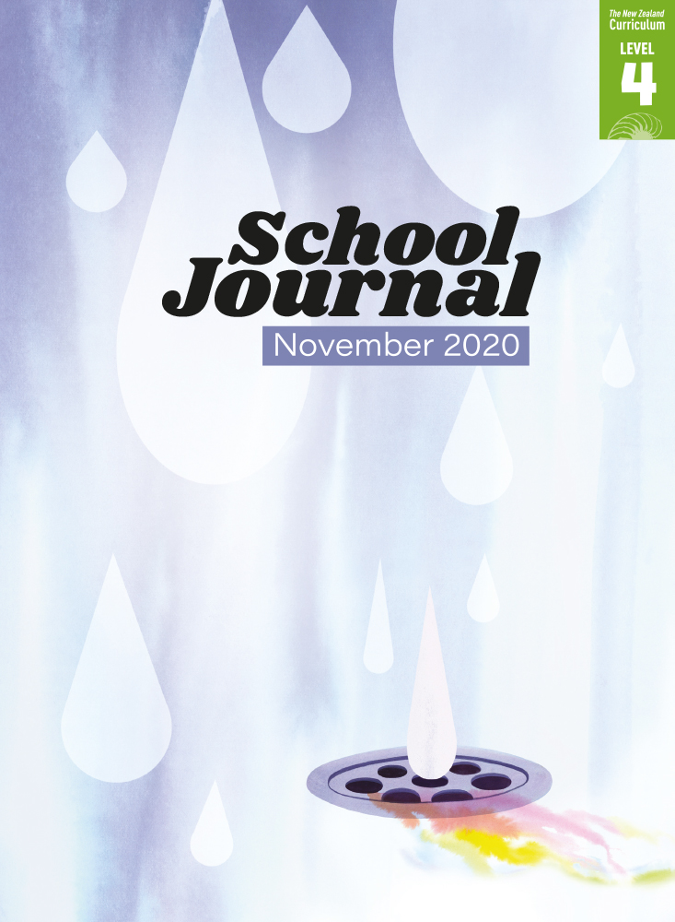

School Journal

Level 4, November 2020

**Year 8**

# Dodinga, 1858

by Paul Mason

The[Learning Progression Frameworks](https://curriculumprogresstools.education.govt.nz/lpf-tool/) describe significant signposts in reading and writing as students develop and apply their literacy knowledge and skills with increasing expertise from school entry to the end of year 10.

## Overview

A historical narrative that is a companion story to the related article “Journeys of Discovery: The Life of Alfred Wallace” – this story provides some detail about the experiences the famous amateur naturalist Alfred Wallace had while travelling in far-flung places of the globe, hoping to crack the mysteries of evolution. Dodinga is the Indonesian village where Wallace was staying when he had his famous breakthrough in 1858. An author’s note describes the story’s links to actual events.

A PDF of the text is available at [www.schooljournal.tki.org.nz](http://www.schooljournal.tki.org.nz)

## Themes

|  |  |  |  |
| --- | --- | --- | --- |
| * Natural history | * Evolution | * Scientific discovery | * Persistence and passion |

## Related texts

**“Journeys of Discovery: The Life of Alfred Wallace”** SJ L4 Nov 2020 | **“Richard Owen’s Giant Mystery”** SJ L3 Aug 2015 |   
**“Last Match”** SJ L4 May 2020

## Strengthening reading behaviours (what to notice)

|  |  |
| --- | --- |
| Text structure and features | Requiring students to: |
| * Historical fiction (using fictional ideas and description to expand the factual events) *(Wallace) rests in the shade of his new home. The air about the hut is heavy, the sunlight glaring, but a familiar chill grows in his bones.* * Abstract ideas *More than once he has crawled on hands and knees. But these toils are worth it – for the butterflies alone.* * Flashbacks or time shifts *A rustling wakes him. Something is in the  roof … Now Wallace understands … It was … all but two years ago in Amboyna.* | * use prior knowledge of how early scientists and explorers lived and travelled, along with knowledge of common diseases in the nineteenth century, to interpret the clues the author gives to understand the setting, why Wallace is there, and what might be happening to him * use knowledge of the context and setting to make inferences about the difficulties Wallace faced and his determination * work out the nature of these sequences to identify which parts help tell the story and which are merely capturing the experience of an illness. This also helps students to understand why the author has taken this approach (trying to capture the fractured nature of feverish thoughts). |

|  |  |
| --- | --- |
| Vocabulary | |
| Topic-specific words (species names)  Other possibly challenging words | *Ixora, Pieridae, Brookiana, Remus, Rosa canina, Therates labiata*  dense, masses, guilders, thatch, limbs, ulcers, toils, consultation, imperceptible, cascading, quarter, delirious, foliage, archipelago, abundant, plentiful, jangling,  orang kaya, labyrinth, tendrils, variety, writhing, natural selection, eureka |

|  |
| --- |
| Helpful prior knowledge (pre-reading and introducing the text) |
| * Reading “Journeys of Discovery: The Life of Alfred Wallace” first would provide useful background information. * Some understanding of the ideas scientists have about evolution * Some knowledge of the effect of fever on the body * The theory of evolution was developed during the mid-19th century. |

## Possible reading and writing purposes

* Read how a famous scientist’s feverish visions helped him to solve mysteries of the natural world
* Understand how true events can be crafted into a fictional story
* Analyse the features of historical fiction that the author has used in this story
* Identify the author’s purpose and evaluate the effectiveness of his writing.

See *Effective Literacy Practice in Years 5–8* for information about teaching comprehension strategies ([Teaching comprehension](https://literacyonline.tki.org.nz/Literacy-Online/Planning-for-my-students-needs/Effective-Literacy-Practice-Years-5-8/Teaching-comprehension))   
and for suggestions on using this text with your students ([Approaches to teaching reading](https://literacyonline.tki.org.nz/Literacy-Online/Planning-for-my-students-needs/Effective-Literacy-Practice-Years-5-8/Approaches-to-teaching-reading)).

## Possible curriculum contexts

This text has links to level 4 of *The New Zealand Curriculum* in: [**ENGLISH**](http://nzcurriculum.tki.org.nz/The-New-Zealand-Curriculum/English) [**SCIENCE**](https://nzcurriculum.tki.org.nz/The-New-Zealand-Curriculum/Science)

## Understanding progress

The following aspects of progress are taken from the [Learning Progression Framework](https://curriculumprogresstools.education.govt.nz/lpf-tool/)s and relate to the specific learning tasks below. See the LPFs for more about how students develop expertise and make progress in these aspects:

* Reading for literary experience
* Making sense of text: using a processing system; using knowledge of text structure and features; vocabulary knowledge;   
  reading critically
* Using writing to think and organise for learning; Creating texts for literary purposes; Creating texts to communicate current knowledge and understanding.

## Strengthening understanding through reading and writing

**Select from the following suggestions and adapt them** according to your students’ strengths, needs, and experiences.   
Note: Most of these activities lend themselves to students working in pairs or small groups.

* Discuss what Alfred Wallace is best known for. (“Journeys of Discovery: The Life of Alfred Wallace” in the same journal describes his achievements.) Ask the students what they found surprising and what they found most interesting.
* Support the students to build understanding of fevers. Draw out the idea that people feel cold even though they are hot, can experience hallucinations, can be delirious, and so on. Discuss the way the author presents Wallace’s feverish visions and the text features he uses to create these (flashbacks, implied information, Wallace’s thoughts, vivid imagery). Have the students find examples in the text and explain what each one means and how they help to convey the visions.
* Explore the structure of the narrative (plot, setting, characters, climax, some text in larger font, and an author’s note).
* Have the students read page 32 and the first sentence on page 33 (“Wallace finishes the fetching ... his new home.”) *What do you think the author wants you to think life is like for Wallace as he arrives in his “new home”? What details does he include?* Tease out the idea that the author has used factual elements to write the historical fiction.
* Clarify what is fact and what is fiction. Have the students draw up a T-chart with a third explanation column. Ask them to check some of the facts in the story, such as the names, the equipment Wallace uses, whether he suffered from fevers, and whether people see snakes when they have fevers. They could go to the [Alfred Russel Wallace](http://wallacefund.info/content/dodinga-birthplace-wallaces-theory-natural-selection) website and compare the images of Dodinga and the huts with how Paul Mason describes them. Discuss how and why an author of fiction might research places and times for authenticity. Draw out the idea that good writers include these details to make the story more convincing.
* Have the students scan the text to find words describing what Wallace sees (for example, “cascading”, “abundant”, “plentiful”, “labyrinth”, “dense”, “masses”, “variety”). With a partner, have them clarify what the words mean and what they are describing. Create lists of collocations (words that are often used together) for each new word, for example, abundant life, abundant storage, abundant evidence, abundant crop*.*
* Explore the effect of adding more than one adjective to a descriptive clause. Find examples in the text, such as “their scarlet flowers bursting in tight, cheerful clusters”.Have the students select other descriptive phrases and extend them by adding more adjectives. Discuss the effect of their additions. *How many is too many adjectives? Is there a particular order for the adjectives? What happens when we change the order? Would we want to use an extended adjectival clause in every sentence? Why or why not?*
* Have the students compare “Journeys of Discovery: The Life of Alfred Wallace” with “Dodinga, 1858”. They could use a Venn diagram to identify elements in common and elements that are only in one text. Ask them to decide which text was more effective.
* Use “Dodinga, 1858” as a model for crafting a true event into fiction. Have the students choose a recent school or local event and brainstorm ideas for storylines. You could provide a plot template, based on how this story develops, with an introduction, a description that builds a sense of place, and a series of events leading to the climax (when Wallace forms his theory of evolution).
* Have the students use the **Newspaper report** template at the end of this TSM to retell the story as a newspaper report.  You could provide a digital newspaper template from an online site such as [Flipsnack](https://www.flipsnack.com/templates/newspapers/school).

|  |
| --- |
| **“Dodinga, 1858” Newspaper report** |

Be a journalist and report on the breaking news – the theory of evolution has been put forward!

|  |
| --- |
| **Header (The name of your paper, the day and date, and where it is published written in bold capital letters)** |

|  |
| --- |
| **Headline (This should grab the attention of the reader)** |

|  |
| --- |
| **Author byline (name of the reporter and sometimes the place where they have written the story)** |

|  |  |
| --- | --- |
| **Introduction**  **A short paragraph**  **It should answer the 5Ws & H (what, when, where, who, why and how).** | **Image**  **Caption (explaining what the picture shows)** |
| **Development**  **This should expand the 5Ws & H (provide more detail).**  **Could include quotes from witnesses and others involved**  **No personal opinion from the writer** | **Conclusion**  **This summarises the story. It can suggest what might happen next.** |

