Squawkzilla
by Sophie Fern
Connected
Level 2
2020

The Literacy Learning Progressions: Meeting the Reading and Writing Demands of the Curriculum describe the literacy-related knowledge, skills, and attitudes that students need to draw on to meet the demands of the curriculum.  The Learning Progression Frameworks (LPF) describe significant signposts in reading and writing as students develop and apply their literacy knowledge and skills with increasing expertise from school entry to the end of year 10.  Overview  Squawkzilla is a giant parrot that lived in New Zealand 19 million years ago. Its bones were dug up in 2008, but it was not correctly identified for another ten years. This article tells the story of Squawkzilla’s discovery. It demonstrates how scientists work and how it is possible to make educated guesses about what life used to look like millions of years ago. It shows that scientific “discoveries” often take time and require careful observation and teamwork.  A Google Slides version of this article is available at www.connected.tki.org.nz | 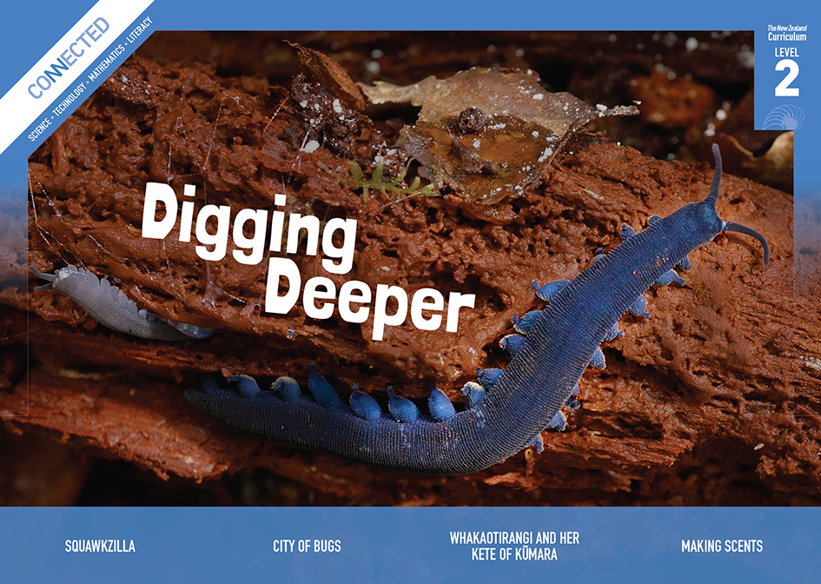  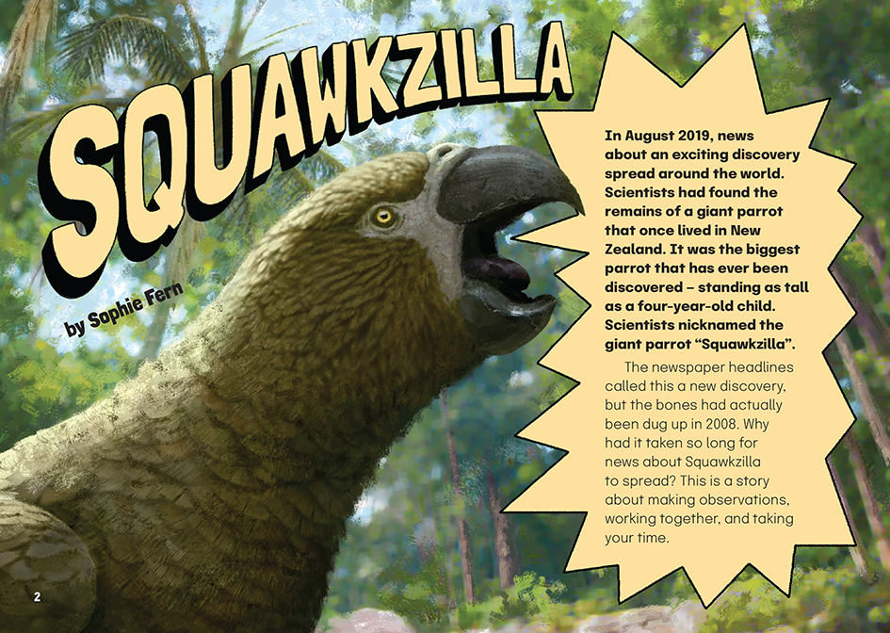
Curriculum contexts

SCIENCE: Nature of Science: Understanding about science  Level 2 – Students will appreciate that scientists ask questions about our world that lead to investigations and that open-mindedness is important because there may be more than one explanation. | Key Nature of Science idea  Scientists:  - make meaning from their observations; the meaning they make can change as they find out more about others things, or they can think differently about the same thing.
SCIENCE: Living World: Evolution  Level 2 – Students will recognise that there are lots of different living things in the world and that they can be grouped in different ways; students will explain how we know some living things from the past are now extinct. | Key science ideas  Scientists:  - group living things according to sets of features that they have  - use evidence from fossils to work out what living things from the past looked like, how they survived in their environment, and why they did not survive as their environment changed.
MATHS: Geometry and Measurement: Measurement  Level 2 – Create and use appropriate units and devices to measure length, area, volume and capacity, weight (mass), turn (angle), temperature, and time. | Key measurement idea  - Using a tape measure, you calculate the difference between two points in order to find the length or height of an item.

ENGLISH: Reading
Level 2 – Ideas: Students will show some understanding of ideas within, across, and beyond texts.
Level 2 – Language features: Students will show some understanding of how language features are used for effect within and across texts.

The New Zealand Curriculum

Meeting the literacy challenges

The main literacy demands in this article arise from a topic that may be unfamiliar to many students – fossils and palaeontology. The article also requires students to imagine prehistoric time periods and the way fossils are formed.  Students are supported to understand these big ideas with simple language. Sentence-level explanations and a glossary will help with the technical words. There are lots of friendly asides to keep the reader focused and engaged. However, some students may need opportunities to develop prior knowledge about some of the concepts before reading.  The following strategies will support students to understand, respond to, and think critically about the information and ideas in the text. | The instructional strategies below support students to meet the literacy challenges of this text. For each strategy, there are links to the relevant aspect of The Learning Progression Frameworks (Reading). The signposts on each of these aspects provide detailed illustrations on what to notice as your students develop their literacy knowledge and skills for different purposes in different curriculum areas.  You may wish to use shared or guided reading, or a mixture of both approaches, depending on the reading expertise of your students and the background knowledge they bring to the text.  After reading the text, support students to explore the activities outlined in the following pages.

INSTRUCTIONAL STRATEGIES

Building knowledge  [LPF Reading: Acquiring and using information and ideas from informational texts] [LPF Reading: Reading to organise ideas and information for learning]  TELL the students the title and EXPLAIN that they are going to read an article about a giant New Zealand parrot that lived millions of years ago. PROMPT them to share what, if anything, they know about fossils and fossil hunting. If necessary, provide a brief explanation. You may be able to show the students an actual fossil or show a video clip of archaeologists uncovering ancient creatures.  Have the students read page 2 and find the sentence that tells us what this article is about.  Clarify that the writer poses a rhetorical question and then foreshadows what the response will be. As they read, PROMPT them to think about the different people involved, the different kinds of expertise they bring, and the ways they work together. Use these insights to create a graphic organiser like the one below that the students can use to RECORD and sort what they discover about how scientists identified Squawkzilla.  Making observations Working together Taking your time  After reading, have the students think, pair, and share what they have learned about how the scientists eventually identified Squawkzilla. DISCUSS the fact that this is how scientists often work. If the students haven’t noticed for themselves, PROMPT them to find the summary sentence on page 9. | DISCUSS the fact that scientists researching ancient fossils may not be sure that their ideas are correct; new evidence may require them to change their ideas. Compare science to reading – just as we use clues in text to make inferences as readers, scientists use a range of clues to make inferences and predictions. Have the students REVIEW the text to find and then share the uncertain words and phrases that show where scientists are making predictions or an inference.  What do the scientists know about Squawkzilla?  What are the things they think may be true, but can’t yet say for sure?  Using visual features to clarify information in the text  [LPF Reading: Making sense of text: using knowledge of text structure and features]  Focus on the heading “fussy fossils”. ASK the students to find the sentence in the text box that explains this heading. Check that they understand how fossils are formed by having them sketch a flow diagram and talk it through with a partner. It may be more appropriate to do this as a shared activity and co-construct the flow diagram.  DISCUSS the purpose of the photographs on pages 4–5 and how they reinforce the message about the importance of teamwork.  Focus on the picture on page 7 that compares the size of Squawkzilla with a kākāpō and an adult human. EXPLAIN that it helps us to use what we know to imagine what we do not know.  Imagine if that picture hadn’t been there. How well could you have visualised the size of Squawkzilla without it?

Meeting the literacy challenges

Point out that on page 3, the writer tells us that the ancient lake at St Bathans was nine times the size of Lake Taupō. Use a map to show the area that would be covered if Lake Taupō were nine times larger.  Have the students focus on the comparative diagrams on page 6. Have them use rulers so they can compare the length of the bones from the three different birds. Check that they understand where the bones would have been attached to muscle, leaving scars. | Dealing with unfamiliar vocabulary  [LPF Reading: Making sense of text: vocabulary knowledge]  PROMPT the students to predict why the parrot may have been given the official name of Heracles inexpectatus. Have them go online to check their predictions.

The Learning Progression Frameworks
The Literacy Learning Progressions
Effective Literacy Practice: Years 1–4

Illustrating the key ideas

Scientists make meaning from their observations.  Living things are grouped according to sets of features that they have.  The meaning that scientists make can change as they find out more. |  | 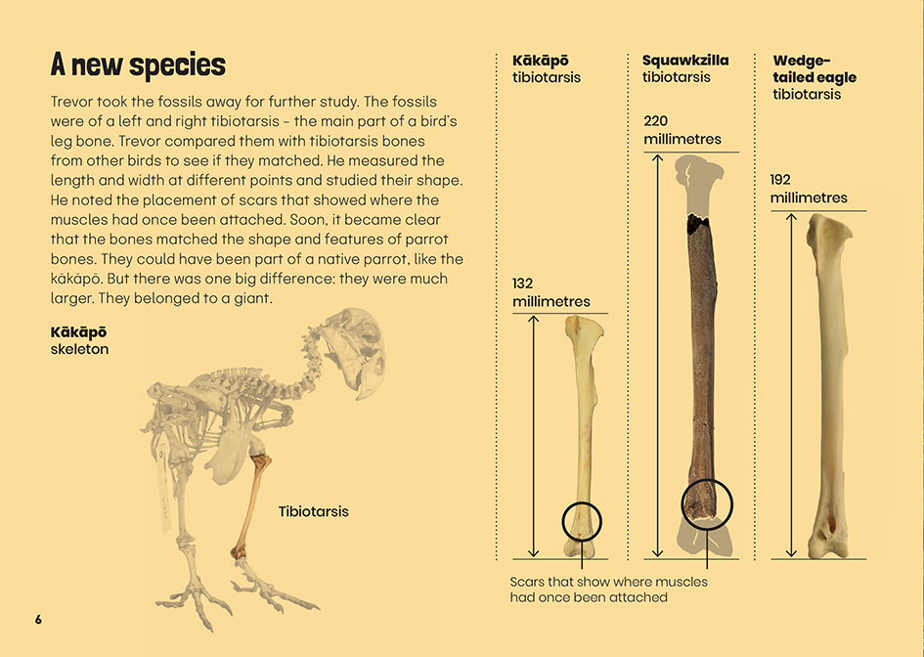  Measuring between two points finds the length or height of an item.

Learning activities – Exploring the science,
mathematics and statistics

Activity 1 – Wanted! A sharp-eyed expert …  The article finishes with the sentence, “perhaps they just need a sharp-eyed expert to take a second look …” Tell the students that GNS Science wants to recruit a new member for its team of scientists researching New Zealand’s ancient wildlife. It has asked them to lead the search for a suitable person. They will need to create a recruitment poster or video explaining what the job involves and what makes it worthwhile. To do this, they will need to do some research. This could involve activities such as the following:  - They could use material on the Science Learning Hub to learn about the value of fossils and the work of fossil hunters such as Joan Wiffen and James Crampton.  - Have them gain personal experience of being a fossil hunter. For example, they could try the correlation activity on the Science Learning Hub. The GNS Science website itself has sorting activities and one for casting fossils.  - They can read about the crocodilian in the Connected article, “A New Zealand Crocodile?” by Sophie Fern. They could compare this discovery with that of Squawkzilla.  - Have them read the School Journal article “Mary Anning Fossil Hunter” and compare the techniques Anning used in the nineteenth century with those used by scientists today. What is different and what remains the same?  - Using activities in Building Science Concepts, Book 41, students can investigate the process of fossilisation and deepen their understandings about how things slowly change over time.  - Have students investigate whether there is a fossil hunter in the local community or someone who uses fossils in their work. Pay a visit to the site or have them come to the class to talk about what they do, how they do it, and why.  Before the students begin work on their recruitment material, discuss how they can use what they have learned to persuade people to consider a career as a scientist researching fossils.  Most people want a career that’s interesting and worthwhile. What could you tell people about how rewarding this work is?  What skills and ways of working would give them a good chance of getting this job?  Activity 2 – Adaptable beaks  Have the students review what the article says about Squawkzilla’s beak and the beaks of other birds. Discuss the fact that birds’ beaks are adapted to the food that is available and the techniques for eating it. Have the students think, pair, and share what they have noticed about how birds in the local environment use their beaks.  What are some of the birds we are used to seeing?  What do they eat?  How would you describe the shape and size of their beaks? How do you think this helps them find and eat their food? | The following activities and suggestions are designed as a guide for supporting students to explore and extend their content knowledge across the learning areas. Adapt these activities to support your students’ interests and learning needs.  Have the students conduct the Science Learning Hub activity on classifying bird adaptations. Alternatively, Brilliant Bird Beaks: An Experiment to Understand Animal Adaptation is a more hands-on activity that involves experimenting with models of beak shapes and different types of bird food. It would have to be adapted to birds in the New Zealand context.  Work with the students to design an observation activity where they use what they have learned to take a closer look at the birds in their local environment and how their beaks have adapted to the food that is available to them.  There are some related activities you could follow up with from Building Science Concept Book 3: Birds: Structure, Function, and Adaptation.  Extension  The students now know that birds have evolved beaks that are adapted to the food that’s available in their habitat. But what happens when the habitat is destroyed and that food is no longer available? Have the students inquire into the other birds mentioned in the article.  How have their beaks adapted to the food in their habitat?  Is there still plenty of food available to them?  What is happening to their numbers?  What can be done about this?  Activity 3 – A matter of scale  Have the students use the measurements in the article to demonstrate how big Squawkzilla was in real life. They could do this with chalk against a concrete wall. They could also use weights and a set of scales to get a sense of how heavy it was.  Have the students find out the weight and height of the other birds mentioned in the article. They could draw them to scale, create a graph, or devise another way of showing this information.  Discuss the concept of “scale” – the idea that we can create an accurate version of an object that either reduces or enlarges the actual size. Use the image of a butterfly on the Maths is Fun site to clarify this point and discuss why it is useful to be able to create a scale image of a large or small item (for example, to draw a map or make plans for a house). In contrast, we use a set of scales to get an accurate idea of weight, and when we draw something “to scale”, we are drawing it at its actual size.

Activity 3 – A matter of scale (continued)  If you haven’t already done so, have the students look closely at the picture on page 7 that compares the size of Squawkzilla with a kākāpō and an adult human. Have the students identify other examples of comparisons or measurements in the text that could be shown visually (for example, a timeline that gives us a sense of how long ago Squawkzilla lived or a scale drawing comparing the size of Lake Taupō with the size of the ancient lake in Central Otago). | Search the size of Lake Taupō and compare that with the current size of St Bathans. Scroll out to see if you can predict how much land the ancient lake covered? Which towns would it have covered? How can you tell by the colourings on the map that this could have been the lake? Plot where you think the ancient lake was.  Using Tinkercad, create 3D designs of each of the tibiotarsus on page 6, showing the different scales.

RESOURCE LINKS

Connected and School Journal  “A New Zealand Crocodile”, Connected 2013, Level 3, Food for Thought  “The Tsunami That Washed Time Away”, Connected 2014, Level 3, Why Is That?  “Foulden Maar: Fossils or Food?”, Connected 2020, Level 4, Feeling the Heat  “Our Rocks Rock!”, School Journal, Level 2, April 2013  “New Zealand Dinosaurs”, School Journal, Level 2, November 2017  “Mary Anning Fossil Hunter”, School Journal, Level 3, September 2012  “The Dinosaur Hunter”, School Journal, Level 3, September 2012  “The Past beneath Our Feet”, School Journal, Level 3, May 2016  Building Science Concepts  Book 3: Birds: Structure, Function, and Adaptation  Book 41: Fossils: Digging up the Past  Science Learning Hub  Heritage scientist timeline – Joan Wiffen: https://www.sciencelearn.org.nz/resources/2426-heritage-scientist-timeline-joan-wiffen  Fossils: https://www.sciencelearn.org.nz/topics/fossils  Fossil correlation (activity): https://www.sciencelearn.org.nz/resources/1516-fossil-correlation  How old is that dinosaur?: https://www.sciencelearn.org.nz/videos/812-how-old-is-that-dinosaur  Classifying bird adaptations: https://www.sciencelearn.org.nz/resources/1169-classifying-bird-adaptations  Native bird adaptations: https://www.sciencelearn.org.nz/resources/1162-native-bird-adaptations | The Spinoff  The giant parrot proves we have to save Foulden Maar: https://thespinoff.co.nz/science/17-08-2019/the-giant-parrot-proves-we-have-to-save-foulden-maar/  Discovered: The massive AF parrots that once roamed New Zealand: https://thespinoff.co.nz/science/07-08-2019/discovered-the-massive-af-parrots-that-once-roamed-new-zealand/  Other  Canterbury Museum: New Zealand big bird a whopping Squawkzilla: https://www.canterburymuseum.com/about-us/media-releases/new-zealand-big-bird-a-whopping-squawkzilla/  Australian Academy of Science: World’s largest parrot “Squawkzilla” discovered: https://www.science.org.au/curious/earth-environment/worlds-largest-parrot-squawkzilla-discovered  NZHerald: Giant parrot discovery: Hercules the Unexpected stalked New Zealand: https://www.nzherald.co.nz/nz/news/article.cfm?c_id=1&objectid=12256251  New Zealand Geographic: Deep secrets: https://www.nzgeo.com/stories/deep-secrets/  GNS Science: New Zealand fossils: https://www.gns.cri.nz/Home/Learning/Science-Topics/Fossils/NZ-fossils  Education.com: Brilliant bird beaks: An experiment to understand animal adaptation: https://nz.education.com/science-fair/article/brilliant-bird-beeks/  Mathematics  Maths is fun: Definition of scale drawing: https://www.mathsisfun.com/definitions/scale-drawing.html  Khan academy: Scale drawings: https://www.khanacademy.org/math/cc-seventh-grade-math/cc-7th-geometry/cc-7th-scale-drawings/v/scaled-drawings-worked-examples  Mathematics centre: Scale drawing: https://mathematicscentre.com/taskcentre/041scale.htm  Tinkercad: https://www.tinkercad.com/

