City of Bugs
by Dr Cynthia Winkworth
Connected
Level 2
2020
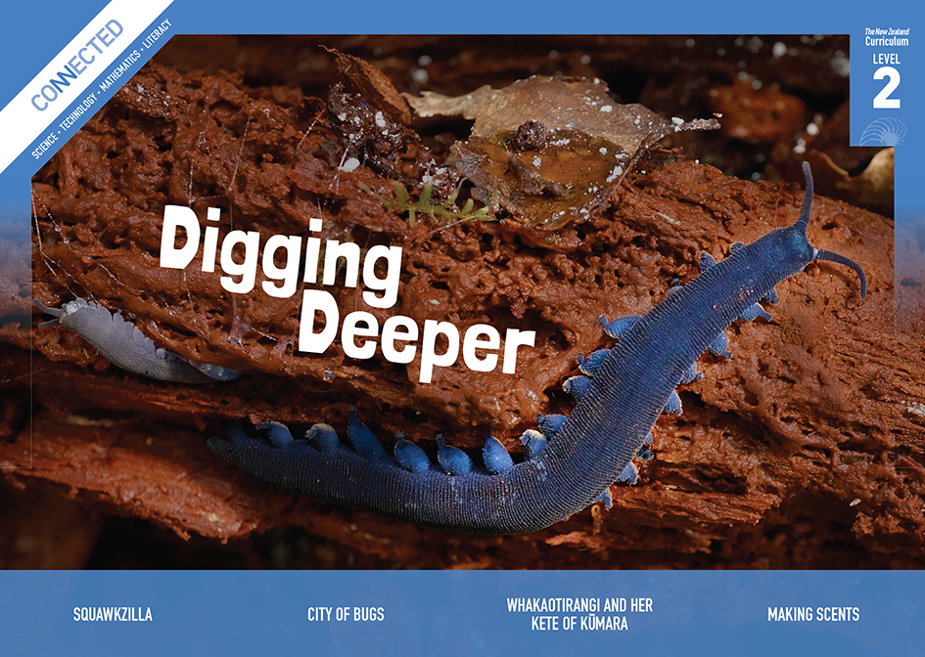
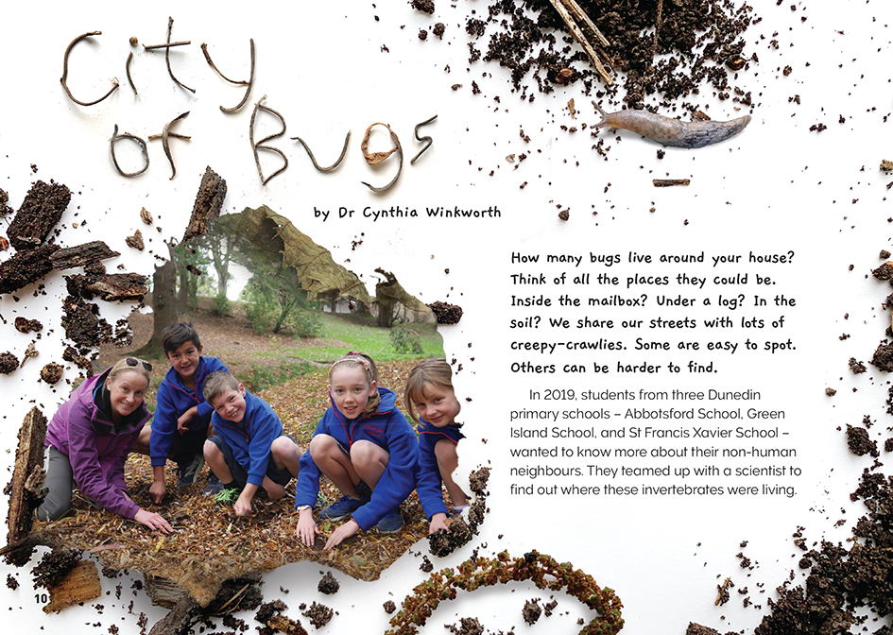

The Literacy Learning Progressions: Meeting the Reading and Writing Demands of the Curriculum describe the literacy-related knowledge, skills, and attitudes that students need to draw on to meet the demands of the curriculum.
The Learning Progression Frameworks (LPF) describe significant signposts in reading and writing as students develop and apply their literacy knowledge and skills with increasing expertise from school entry to the end of year 10.

Overview
This article follows a science project conducted by students in three Dunedin schools. The topic – insects and invertebrates – should appeal to most students. The article demonstrates how to conduct a scientific investigation. It also emphasises the importance of communicating so people can take action in response to scientific information.
A Google Slides version of this article is available at www.connected.tki.org.nz
Curriculum contexts

SCIENCE: Nature of Science: Investigating in science  Level 2 – Students will extend their experiences and personal explanations of the natural world through exploration, play, asking questions, and discussing simple models.  SCIENCE: Nature of Science: Communicating in science  Level 2 – Students will build their language and develop their understandings of the many ways the natural world can be represented. | Key Nature of Science ideas  Scientists:  - work carefully and systematically to make sure the data they collect is accurate and can be compared  - have to make sense of the data they collect; they look for patterns, including similarities and differences  - represent and share their findings in different ways; they think about who their audience is, what they want them to understand and how best to convey their message.
SCIENCE: Living World: Evolution  Level 2 – Students will recognise that there are lots of different living things in the world and that they can be grouped in different ways.  SCIENCE: Living World: Life processes  Level 2 – Students will recognise that all living things have certain requirements so they can stay alive. | Key science ideas  - Invertebrates are a large group of living organisms that are grouped together because they do not have a backbone.  - Different kinds of invertebrates can look very different from each other.  - Invertebrates, like all living organisms, need food, water, air, and shelter.  - Different invertebrates can have specialised adaptations that enable them to survive and reproduce in their environment.
TECHNOLOGY: Nature of Technology: Characteristics of technological outcomes  Level 2 – Students will understand that technological outcomes are developed through technological practice and have related physical and functional natures. | Key technology ideas  - Research can inform technological development (for example, researching the natural homes of different insects when designing an insect hotel).  - Technological outcomes are tested for their effectiveness (for example, whether insects move into the insect hotel, and if not, coming up with some possible explanations).
MATHEMATICS and STATISTICS: Statistical investigation  Level 2 – Students will conduct investigations using the statistical enquiry cycle. | Key mathematics ideas  - Data can be used to answer multiple questions.  - Organising data can reveal information, patterns, and trends.  - Looking for patterns is an important part of statistical thinking.

ENGLISH: Reading
Level 2 – Ideas: Students will show some understanding of ideas within, across, and beyond texts.
Level 2 – Language features: Students will show some understanding of how language features are used for effect within and across texts.

The New Zealand Curriculum

Meeting the literacy challenges

The main literacy challenge in this text arises from the technical information that explains relevant background information (for example, what an invertebrate and an ecosystem are). This information is supported by explanations, glossaries, and visual support.  The structure of the article follows the process used by the students in Dunedin. It is a structure that isn’t uncommon to Connected articles but could be new to some readers.  The article exposes readers to subject-specific vocabulary relating to scientific investigations. It breaks this up with short sentences or questions that directly address the reader.  The following strategies will support students to understand, respond to, and think critically about the information and ideas in the text. | The instructional strategies below support students to meet the literacy challenges of this text. For each strategy, there are links to the relevant aspect of The Learning Progression Frameworks (Reading). The signposts on each of these aspects provide detailed illustrations on what to notice as your students develop their literacy knowledge and skills for different purposes in different curriculum areas.  You may wish to use shared or guided reading, or a mixture of both approaches, depending on the reading expertise of your students and the background knowledge they bring to the text.  After reading the text, support students to explore the activities outlined in the following pages.

INSTRUCTIONAL STRATEGIES

Engaging with key ideas  [LPF Reading: Acquiring and using information and ideas in informational texts]  TELL the students the title and give them a brief overview of the article.  Use the questions in the first paragraph to PROMPT the students to share their experiences of bugs and insects and encourage them to come up with any questions or wonderings. RECORD these for later investigation.  What do you think when you hear the word “bugs”?  The students at Abbotsford, Green Island, and St Francis Xavier schools wanted to know more about the bugs that live around them. What do you think they wanted to know about the bugs? What would you like to know?  What bugs live in your area? Which ones would you like to investigate?  Pause after reading pages 10–13 to DISCUSS the purpose of the schools’ investigation and how they went about it. Have the students scan the following pages, then talk through how they could summarise this investigation. A simple graphic organiser using headings from the text with students recording key information underneath could help this process.  Have the students take a jigsaw approach to reading about the three survey methods. After reporting back to their jigsaw groups on what each method involves, have them use a Venn diagram to identify what is the same and what is different about the three methods. Refer back to the sidebar on reliable data (page 13) to PROMPT discussion about how the survey methods helped ensure the data was reliable. | Using diagrams and pictures to clarify the text  [LPF Reading: Making sense of text: using knowledge of text structure and features]  EXPLAIN that diagrams and other images help readers to understand ideas in written text. Labels are an important feature of diagrams. Look closely at the picture on page 11.  What does the picture represent? How do you know?  Can you explain to a partner what each of the labels means?  Evaluating language choices  [LPF Reading: Making sense of text: reading critically]  PROMPT the students to notice that various everyday terms (“bugs”, “creepy-crawlies,” “many-legged neighbours”) are used for invertebrates before we read the scientific term and its definition and elaboration. ASK QUESTIONS to help them consider how the writer has shaped the language to appeal to the reader.  What effect did these everyday words have on you as a reader? Do you think the writer should have used scientific language?  Think about the title. Would you have felt differently about the article if it had a more technical title like “Survey of invertebrates”?  What are some other things the writer has done to make you want to read her article?

Meeting the literacy challenges

Exploring topic-specific vocabulary  [LPF Reading: Making sense of text: vocabulary knowledge]  ASK the students:  If an invertebrate is an animal that doesn’t have a backbone, what is a vertebrate?  What are some examples of vertebrates?  Have the students skim the text to IDENTIFY and list other examples of subject-specific vocabulary. (For some students, this will include words related to different kinds of media.) DISCUSS the meanings of these words, prompting the students to use:  - their prior knowledge  - the explanations in the text  - contextual information  - the glossary  - the photographs and their captions.  Have the students use an online thesaurus (for example, Thesaurus.com) to find and list other words meaning “bug” or “insect”. Note that “bug” has different meanings.  What else can the word “bug” mean?  How can you make sure your online search finds the words related to insects?  Some students may need additional support with the pronunciation of the words and phrases in te reo Māori. You may need to EXPLAIN that a macron indicates the lengthening of the vowel. Other students may be able to share the names of these creatures in their own language or tell the class about the invertebrates in other places they have lived. | Understanding language features  [LPF Reading: Making sense of text: using knowledge of text structure and features]  EXPLAIN that a noun phrase is a noun with a modifier  – usually an adjective that describes the noun. They enable the writer to convey a fuller picture. For example, “tall forests”, “bushy gardens”, and “dense soils” give us a good sense of the sorts of environments in which you can find invertebrates. Have the students find all the examples of noun phrases in this article.

The Learning Progression Frameworks
The Literacy Learning Progressions
Effective Literacy Practice: Years 1–4

Illustrating the key ideas
Scientists work carefully and systematically to make sure the data they collect is accurate and can be compared.

Scientists have to make sense of the data they collect; they look for patterns, including similarities and differences. | Different kinds of invertebrates can look very different from each other.  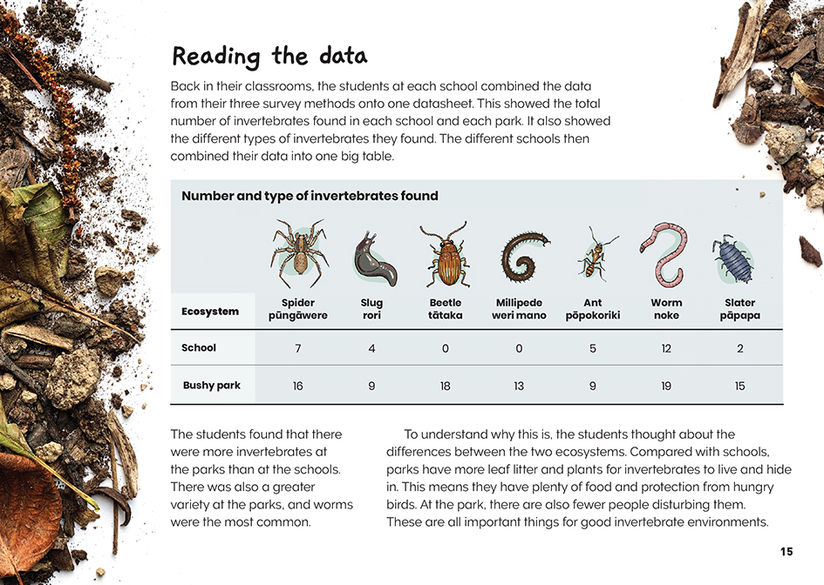  Invertebrates, like all living organisms, need food, water, air, and shelter.
Scientists represent and share their findings in different ways. | 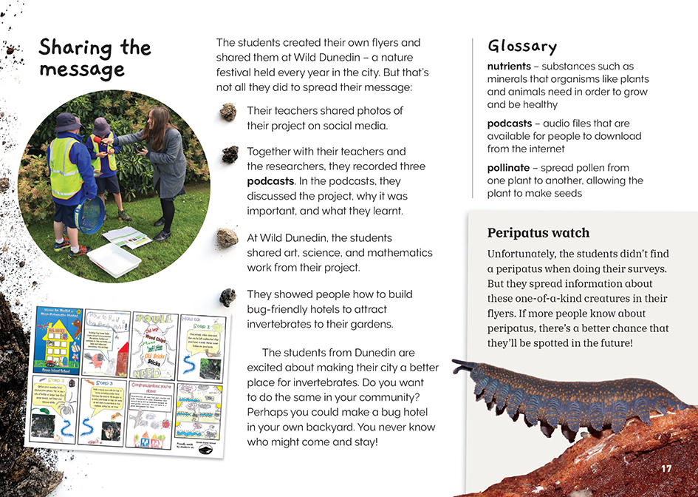

Learning activities – Exploring the science
and technology

Activity 1 – Insects in our place  Have the students reread the sidebar on page 13 about reliable data. Have them keep this in mind while critiquing the methods used by the students and while reflecting on the survey’s success.  Do you think the data that the students recorded was reliable? Are there different kinds of invertebrates that they might not have collected or counted with the survey methods they used?  What did the students do to ensure that they gathered their data in similar ways across all the sites? Are there other things the students might have done to ensure they gathered similar data from all the sites?  The students had two goals but achieved only one. Was the time and effort they put into their investigation justified?  The Dunedin students surveyed three different schools and worked with a university scientist. Why do you think they did this? How do you think it helped?  The students put a lot of work into communicating what they found out. Do you agree that young people should try to influence people in their community like this?  Invite the students to think back to the questions they raised when they began the reading.  Are there questions that you still have?  Who are some people in our community who might have similar questions? Who could we work with to find answers?  Support the students to use what they have learned to plan and conduct their own investigation into invertebrates. They might want to compare invertebrates in the ecosystem of their school with those in another local ecosystem or investigate a rare invertebrate that lives locally. They might want to investigate how changes in the time of day, weather, or season affects which invertebrates they find.  Support the students to identify and address any gaps in their knowledge, which they will need to fill to complete their investigation. For example, students need to be able to:  - identify and sort the insects they find  - design datasheets and tally charts  - graph their survey results  - investigate other methods of collecting their data (such as the bug traps described in “An Invasion of Yellow Crazies”).  Students may wish to incorporate digital technology tools into their scientific process, for example, they might:  - take digital photos of each survey count and compare and check their results  - use a digital microscope to examine their bugs  - create a simple database that stores their data on the number of invertebrates found in different locations. | The following activities and suggestions are designed as a guide for supporting students to explore and extend their content knowledge across the learning areas. Adapt these activities to support your students’ interests and learning needs.  When they have completed their investigation, the students could design their own means of communicating their findings. (See page 7 of this TSM.)  Activity 2 – Peripatus  Your students could investigate the peripatus to find out more about what makes them so special. Prompt them to ask questions like:  What makes them so interesting?  How have they survived for 500 million years? What features do they have that help them stay alive? Where are they currently found? Why are they not found anywhere else?  Challenge the students to think about whether the fate of the peripatus really matters and, if so, why.  Extension  Insects are a hot topic. There is widespread alarm about the decline of insects, such as honeybees and monarch butterflies. On the other hand, insects like the varroa mite are pests that threaten our livelihoods. The students could investigate some of these insects as a context for exploring bigger questions, for example:  What roles do invertebrates play in ecosystems?  How can we protect native invertebrates? Why is this important?  Why are some invertebrates classified as pests? What can we do about them?  Activity 3 – Bug hotels  Students might be interested in designing and building their own bug hotels. They could experiment with adaptations to make them safe and appealing to “good” insects and repel the pests. Having found success, they could then promote their idea to others in the community.

Activity 4 – Getting the message out  Having conducted their own investigations, the students could design posters or information sheets to show people in the community what is in their neighbourhood. Alternatively, they could:  - create and publish their own podcasts  - use a digital camera and software to create a digital collage  - make a video to be published online.  Reinforce the importance of knowing who the audience is and being clear about the message they are trying to communicate. Support this thinking by having the students review the section in the article on good communication. They could look at the flyers created by the Dunedin students and critique them in light of the tips for designing a good flyer. Remind the students of the techniques the writer used to appeal to the reader (such as the title and the inclusion of everyday language) and to add detail (such as the use of noun phrases). | Do these tips help us to plan our own way of getting our message out?  Are there other things we should be thinking about to make sure we reach our audience?  Have the students reflect on the effectiveness of their communication and perhaps do a survey to check its effectiveness. Have them use what they learn to write their own set of tips for effective scientific communication using their chosen media.

RESOURCE LINKS

Connected and School Journal  “The Takeaway Table”, Connected 2013, Level 2, I Spy …  “Operation Duck Pond”, Connected 2015, Level 2, Have You Checked?  “An Invasion of Yellow Crazies”, Connected 2016, Level 2, Show and Tell  “Kimihia Kermit”, Connected 2019, Level 2, Wild Discoveries  “Olly’s Cicadas”, School Journal, Level 3, November 2019  “Wētā”, School Journal, Level 2, August 2019  Building Science Concepts  Book 6: Soil Animals: Diversity beneath Our Feet  Science Learning Hub  Differences between moths and butterflies: https://www.sciencelearn.org.nz/resources/506-differences-between-butterflies-and-moths  Identifying bugs (activity): https://www.sciencelearn.org.nz/resources/1449-identifying-bugs  Catchments Otago  If we build it, will peripatus come?: http://www.catchmentsotago.org/peripatusproject  Peripatus art: http://www.catchmentsotago.org/peripatusart  Bug hotel flyers: http://www.catchmentsotago.org/peripatusproject  CitSci hub  Phil Bendle collection: https://www.citscihub.nz/Phil_Bendle_Collection:Worm_(Velvet)_New_Zealand  Snails, slugs, and worms: https://www.citscihub.nz/Category:Snails,_Slugs_and_Worms  Insects: https://www.citscihub.nz/Category:Insects | Department of Conservation  New Zealand peripatus/ngaokeoke: https://www.doc.govt.nz/globalassets/documents/conservation/native-animals/invertebrates/peripatus-ngaokeoke-report.pdf  Peripatus guide: https://www.doc.govt.nz/globalassets/documents/conservation/native-animals/invertebrates/peripatus-facts-brochure.pdf  Manaaki Whenua Landcare Research  Peripatus (Onchyphora): https://www.landcareresearch.co.nz/discover-our-research/biodiversity/plants-invertebrates-fungi-and-bacteria/invertebrate-systematics/peripatus/  Invertebrate systematics: https://www.landcareresearch.co.nz/science/plants-animals-fungi/animals/invertebrates/systematics  What is this bug?: https://www.landcareresearch.co.nz/resources/identification/animals/bug-id/what-is-this-bug  Other  YouTube: Peripatus at Auckland Zoo: https://www.youtube.com/watch?v=rYxYeeLlu7I&feature=emb_title  thisNZlife: DIY project: Build a “bug hotel” to attract beneficial insects: https://thisnzlife.co.nz/diy-project-build-a-bug-hotel-to-attract-beneficial-insects/  Stuff: How to build a bug hotel for your garden: https://www.stuff.co.nz/life-style/home-property/84043723/how-to-build-a-bug-hotel-for-your-garden  Super simple: Bug hotel: https://supersimple.com/article/bug-hotel/  Go gardening: Kids go gardening – make a bug hotel: https://www.gogardening.co.nz/in-the-garden/2-0-1045/kids-go-gardening-make-a-bug-hotel

