Whakaotirangi and her
Kete of Kūmara
by Dr Diane Gordon-Burns
Connected
Level 2
2020
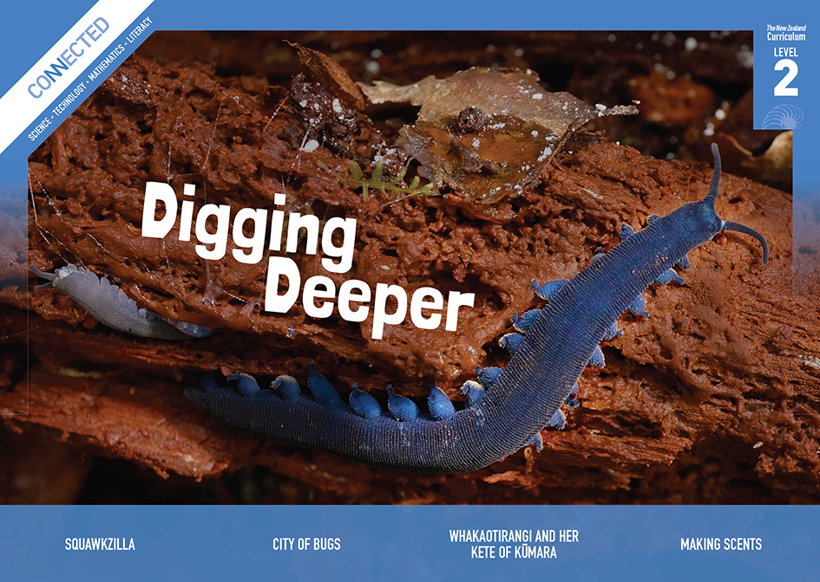
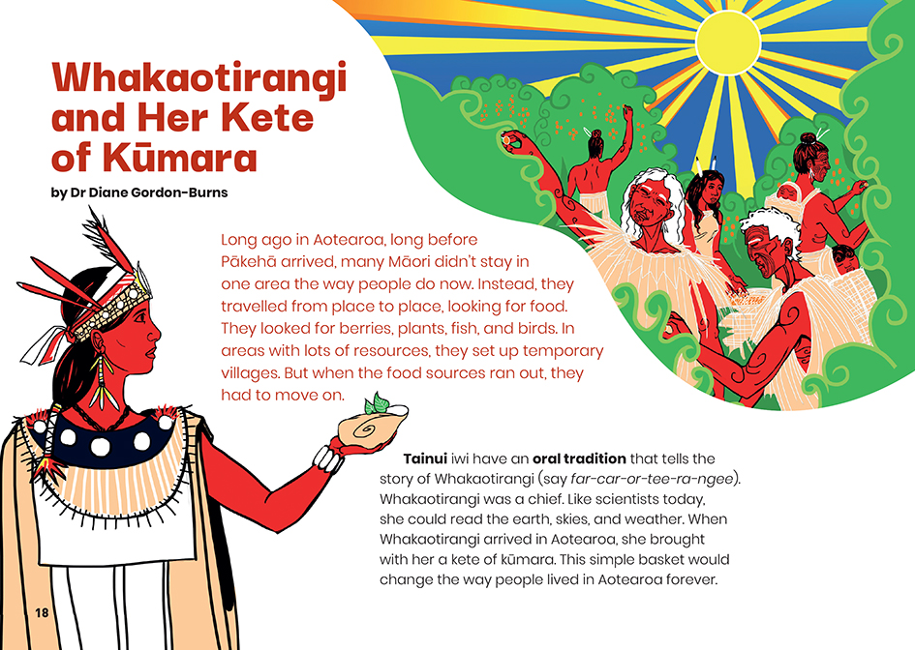

The Literacy Learning Progressions: Meeting the Reading and Writing Demands of the Curriculum describe the literacy-related knowledge, skills, and attitudes that students need to draw on to meet the demands of the curriculum.
The Learning Progression Frameworks (LPF) describe significant signposts in reading and writing as students develop and apply their literacy knowledge and skills with increasing expertise from school entry to the end of year 10.

Overview
This article recounts an important story from the oral tradition of Tainui. It tells of how the iwi’s ancestor, Whakaotirangi, brought kūmara and other plants to Aotearoa and describes the techniques she used to plant, grow, and store them. Whakaotirangi’s gardens made it possible for Tainui to settle in one place, rather than having to keep moving to seek food. In time, Whakaotirangi’s kete of kūmara changed how people live across Aotearoa.
A Google Slides version of this article is available at www.connected.tki.org.nz
Curriculum contexts

SCIENCE: Nature of Science: Understanding about science  Level 2 – Students will appreciate that scientists ask questions about our world that lead to investigations and that open-mindedness is important because there may be more than one explanation. | Key Nature of Science idea  Scientists:  - are people who carefully and systematically observe what happens to learn about how the world works.
SCIENCE: Living World: Life processes  Level 2 – Students will recognise that all living things have certain requirements so they can stay alive.  SCIENCE: Living World: Ecology  Level 2 – Students will recognise that living things are suited to their particular habitat. | Key science ideas  - Plants need nutrients, light, and water to grow.  - Plants have developed different ways to survive that fit with the environments where they usually grow.  - We need to know what particular plants need if we want to grow them for our needs.

ENGLISH: Reading
Level 2 – Ideas: Students will show some understanding of ideas within, across, and beyond texts.
Level 2 – Language features: Students will show some understanding of how language features are used for effect within and across texts.

The New Zealand Curriculum

Meeting the literacy challenges

This text requires students to appreciate the significance of the story and to visualise the historical setting. This story is hundreds of years old and has been passed down orally.  The article follows the structure of a historical recount, rather than a scientific article. Students will need to recognise the scientific concepts and how Whakaotirangi used and passed on her scientific knowledge to ensure the survival of her people. The illustrations support the written explanations of the scientific processes she used, and the map supports students to trace the places she visited.  The article comes from an explicitly te ao Māori worldview and includes a lot of te reo Māori names, words, and phrases. There is an extensive glossary to support language comprehension. The reader is also supported by the narrator’s use of simple language, short sentences, and a structure that is easy to follow. | The instructional strategies below support students to meet the literacy challenges of this text. For each strategy, there are links to the relevant aspect of The Learning Progression Frameworks (Reading). The signposts on each of these aspects provide detailed illustrations on what to notice as your students develop their literacy knowledge and skills for different purposes in different curriculum areas.  The following strategies will support students to understand, respond to, and think critically about the information and ideas in the text.  You may wish to use shared or guided reading, or a mixture of both approaches, depending on the reading expertise of your students and the background knowledge they bring to the text.  After reading the text, support students to explore the activities outlined in the following pages.

INSTRUCTIONAL STRATEGIES

Understanding the historical setting  [LPF Reading: Acquiring and using information and ideas in informational texts]  TELL the students the title of the article and ASK QUESTIONS to help them make connections and share their prior knowledge about New Zealand’s early history and mātauranga Māori. Allow time for students to share what they know with each other. Students of Tainui descent may know this story, but do not assume this to be so.  Who do you think Whakaotirangi is? Why might her story be important?  What is so important about kūmara?  Have the students read page 18 and clarify what we mean by an “oral tradition”. EXPLAIN that long before the invention of writing, people told stories aloud to pass on knowledge.  Stories can be passed down through many generations  – so Whakaotirangi grew up hearing stories of her ancestor Kupe, and her descendants grew up hearing stories of her. These stories often carry an important lesson. Even today, we sometimes learn more by talking and listening to each other than by writing and reading.  Provide an example of an oral tradition that is passed down in your whānau and why you think it is important. PROMPT the students to make personal connections by asking them to tell a buddy about a story or legend that has been passed down to them. | We are told, “Long ago in Aotearoa, long before Pākehā arrived …” Students may need help getting a sense of when these events happened. EXPLAIN that many traditions name Kupe as the first explorer of Aotearoa, and that current evidence suggests that Aotearoa was first settled sometime between 1250 and 1300. The first Pākehā to see New Zealand were on the ship with Abel Tasman, in 1642, but their ship did not land. The first Pākehā to step on the land was James Cook in 1769.  Use the information and clues in the text to predict when Whakaotirangi made her voyage.  How long ago was that?  Focus on the sentence, “Like scientists today, she could read the earth, skies, and weather.” Divide the class into groups and challenge them to make sense of this concept and to find examples of how Whakaotirangi read the environment and what she learned. ASK QUESTIONS to prompt deeper thinking and discussion. They could record their thinking in a table like the one below.  How might you “read” the earth, sky, or weather? Why?  Looking outside, what information is the sky giving you now?  How do you think scientists “read” the weather today?

Meeting the literacy challenges

Reading the environment  Earth  Sky  Weather  PROMPT discussion about what Whakaotirangi achieved.  How did Whakaotirangi ensure the kūmara and other plants survived the voyage?  How did she make sure they grew well and could be harvested and used?  What did you learn about gardening from Whakaotirangi? How is the way she gardened the same or different from how people in Aotearoa garden today?  There were already Māori living in Aotearoa before Whakaotirangi arrived and planted the first garden. Have another look at the opening paragraph. How do you think gardening changed their lives?  Using visual features to clarify information in the text  [LPF Reading: Making sense of text: using knowledge of text structure and features; Reading to organise ideas and information for learning]  PROMPT the students to look closely at the map and track Whakaotirangi’s movements as they read.  Point out that the text doesn’t just tell us what Whakaotirangi did; it explains the reasons. Using the example on page 19, MODEL how the students could use a graphic organiser (such as the one below) to capture what they learn about how Whakaotirangi cared for her kūmara. Demonstrate how you can use the information in the pictures to check you have understood the written explanation. Have the students complete the graphic organiser in pairs using the rest of the text. Then, partner students up with another pair to check their accuracy.  Caring for and gardening with kūmara  Action Reason  Kept the plants in the shade, with the roots wrapped up and kept moist They would die if they dried out | Extension  The students could use the graphic organisers to write a procedural text and use imperatives to set out instructions for safely storing, planting, and harvesting kūmara. [Note – this could also be used as an activity in developing an unplugged algorithm to support students’ learning in digital technology.]  Dealing with unfamiliar vocabulary  [LPF Reading: Making sense of text: vocabulary knowledge]  If necessary, MODEL how to use the explanation on page 18 to correctly pronounce Whakaotirangi’s name prior to the reading. Give the students time to practise until they become comfortable.  PROMPT the students to notice the importance of naming the places in a new land. Have them look up the meanings of these place names and check how to pronounce them. They could use an online tool, such as the Māori Dictionary. Work towards the understanding that names can carry important stories about a place and people’s relationship with that place, and that naming something gives people a sense of ownership.  PROMPT the students to use the information in the text and glossary on page 24 to give an oral explanation, in their own words, of:  - what a whakataukī is  - what “Te rukuruku a Whakaotirangi” means.  For additional support, see the text and video on the Science Learning Hub: Whakataukī.

The Learning Progression Frameworks
The Literacy Learning Progressions
Effective Literacy Practice: Years 1–4

Illustrating the key ideas

Scientists are people who carefully and systematically observe what happens to learn about how the world works. | 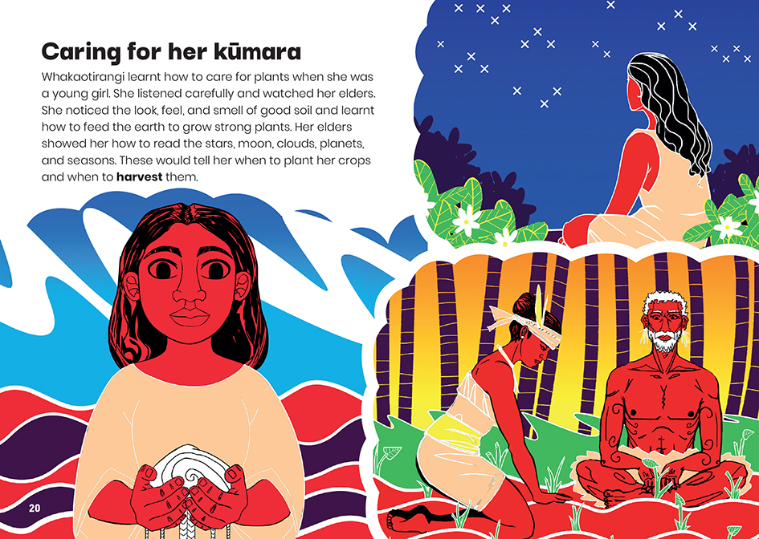
Recognise that all living things have certain requirements so that they can stay alive. | 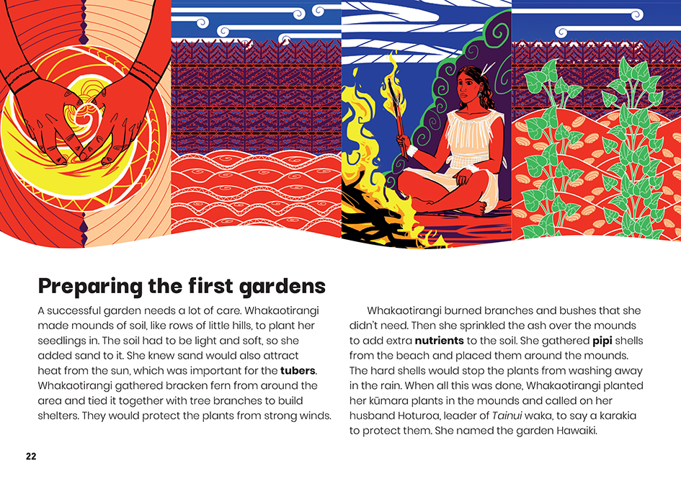  We need to know what particular plants need if we want to grow them for our needs.

Learning activities – Exploring the science

Activity 1 – Following Whakaotirangi  The article concludes by suggesting that readers try some of Whakaotirangi’s methods in their own gardens. Your school may already have a garden where students could apply what they have learned. If not, this could be an opportunity to create a garden for them to grow kūmara or other traditional Māori crops. Several items in Connected and the Building Science Concepts series suggest ways to investigate plants and gardening at school (see Resource links below).  The Science Learning Hub item on Māori soil science provides useful information to add to what the students have learned about the importance of “reading” the soil and adapting gardening techniques to a new environment. The Te Ara item about oneone (soil) includes the fact that Māori gardeners had at least thirty names for different types of soil.  Let’s take a look at the soil in our garden. How would you describe it?  Why might we need to modify our soil to successfully grow kūmara? How would we do that?  Te Parapara Garden Project is a joint project between Ngā Mana Toopu o Kirikiriroa and the Hamilton City Council. It showcases traditional practices, materials, and ceremonies related to food production and storage. The video provides an opportunity for students to see the mahi this requires and to get some insight into how the cultural and spiritual realms are woven into gardening practice for iwi Māori.  Many Māori view taewa and kūmara as taonga. Why do you think that is?  When are karakia said and why?  Many students will know about taewa (Māori potatoes). These are not one of the plants Whakaotirangi brought. Instead, they were adopted by Māori when introduced by Pākehā about two hundred years ago. The students could explore the gardening practices used to store and grow taewa.  How do these practices compare with those used for kūmara?  Where exactly did taewa originate? What sort of adaptations did Māori have to make to grow the new plant in Aotearoa?  Why do you think taewa have done so well here?  As Te Parapara Garden Project shows, traditional Māori gardening practices have not been lost. On marae, such as Koukourārata Marae on Banks Peninsula and Ohinemutu Pā in Rotorua, traditional Māori gardening is being combined with modern science to offer people nutritious food and create new businesses. The students could explore how this is being done and what the benefits are. They could apply some of these techniques to their own gardens and consider how they could use their gardens to benefit people in their local community. This could be done in partnership with local iwi or community groups. | The following activities and suggestions are designed as a guide for supporting students to explore and extend their content knowledge across the learning areas. Adapt these activities to support your students’ interests and learning needs.  Extension  Students could visit the Digital Future Aotearoa site and explore The Electric Garden where kūmara was grown in Te Tai Rāwhiti.  Activity 2 – Our food basket  In the article, we learned that before Whakaotirangi arrived in Aotearoa, Māori moved from place to place looking for food. With the arrival of gardening, life became more settled.  Whakaotirangi’s story was set in Kāwhia. What about where you live? Support the students to investigate the food resources that were naturally available to mana whenua in your local area and the foods they chose to grow.  Seek the support of mana whenua to learn oral traditions about plants and gardening. Visit local sites to find out about useful plants and see traditional horticultural practices in action. Help the students to “read” the land to see where there is evidence of gardening mounds and storage pits.  Have the students give back to the people who share their knowledge. This could involve offering practical help in tending for gardens or by creating artwork, such as the image on page 22, which plays with patterns and symmetry to evoke a kūmara garden. If you have access to it, the resource He Papahuia Toi Māori: Māori Visual Culture in Visual Arts Education Years 1–6 offers useful ideas for this mahi.

RESOURCE LINKS

Connected and School Journal  “Garden with Science”, Connected 2014, Level 2, How Do You Know?  “Winning the Bledisloe Cup”, Connected 2014, Level 2, How Do You Know?  “Gardening in the Living Room”, Connected 2017, Level 2, Taking Action  “Listening to the Land”, Connected 2018, Level 3, Cracking the Code  Building Science Concepts  Book 25: Flowers, Fruits, and Seeds: Plants and Their Reproductive Parts  Book 26: Making New Plants: How Flowering Plants Reproduce  Book 63: Growing Plants Indoors: What an Indoor Plant Needs  Science Learning Hub  Māori soil science: https://www.sciencelearn.org.nz/resources/888-maori-soil-science  The cultural value of taewa (Māori potatoes): https://www.sciencelearn.org.nz/resources/783-the-cultural-value-of-taewa-maori-potatoes  Whakataukī: https://www.sciencelearn.org.nz/resources/1296-whakatauki | Other  Digital Future Aotearoa: The electric garden: https://www.electricgarden.nz/  NZHerald: Kūmara: Aotearoa’s super food: https://www.nzherald.co.nz/lifestyle/news/article.cfm?c_id=6&objectid=10821494  Hamilton Gardens: Te Parapara Garden: https://hamiltongardens.co.nz/collections/productive-collection/te-parapara-garden  Te Ara: Oneone – soils: https://teara.govt.nz/en/oneone-soils  Rongoa New Zealand: Wiremu (Bill) Tawhai – Te Whanau Apanui, on Maramataka and growing kūmara: https://rongoanz.blogtown.co.nz/2010/02/25/bill-tawhai-te-whanau-apanui-on-maramataka-growing-kumara/ [link to video housed on TVNZ Waka Huia – On Demand]  RNZ: Taewa for tea: https://www.rnz.co.nz/national/programmes/countrylife/audio/201848636/taewa-for-tea  Tui: Kūmara growing guide: https://tuigarden.co.nz/how-to-guide/kumara-growing-guide/  Tāhuri Whenua: Representing Māori interest in the horticulture sector: https://www.tahuriwhenua.org/  New Zealand History: Encounters: https://nzhistory.govt.nz/culture/encounters  Māori Dictionary: https://maoridictionary.co.nz/  Ministry of Education (2007). He Papahuia Toi Māori: Māori Visual Culture in Visual Arts Education Years 1–6. Wellington: Learning Media.

