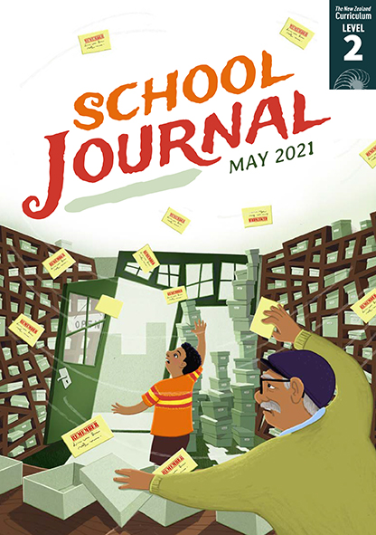

The Memory Toolbox
by Bronwen Wall
School Journal
Level 2, May 2021
Year 4

The Learning Progression Frameworks (LPFs) describe significant signposts in reading
and writing as students develop and apply their literacy knowledge and skills with increasing
expertise from school entry to the end of year 10.

Overview
This article explains the difference between short-term and long-term memory and describes various techniques for improving memory, such as using acronyms, chunking information, and making word associations. It includes a sidebar about memory championships. In addition to being a fascinating topic in its own right, the suggestions for brain exercises could have practical applications for students.
A PDF of the text and an audio file as an MP3 are available at www.schooljournal.tki.org.nz

Themes
- Memory | - Improving your recall

Related texts
“Reconnecting the Brain” Connected L4 2015

Strengthening reading behaviours (what to notice)
Text structure and features | Requiring students to:
- Abstract ideas  If you use your short-term memory, you’ll forget it in a few seconds. You need to put the number into your long-term memory. You can do this by writing it down, repeating it in your head, and saying it aloud a few times. | - compare their own experiences of how they recall things with the examples described in the text to understand the difference between short- and long-term memory
- Headings  Training your memory  We all use our memory every day … Did you know that you can train your memory to hold more information? Here are some ways to do that.  Write it down … | - use the headings as clues to find important information about how to train their memories and use their knowledge of text structure to find the instructions under each heading. They also draw on their knowledge of text design and layout to understand that the subheadings in italics all relate to the main heading.

Vocabulary
Topic-related words  Te reo Māori  Other possibly challenging words  and phrases | store, recall, short-term memory, long-term memory, chunk, acronym, championships, memorise, Ryu Song I  waiata, “Ngā Tamariki o Matariki”  toolbox, repeating, alphabet, mental, solar system, Mercury, Venus, Earth, Mars, Jupiter, Saturn, Uranus, Neptune, unicorns, napping, Roy G. Biv, indigo, violet, imagine, water wings, palace, strengthen, competitions, competitors

Helpful prior knowledge (pre-reading and introducing the text)
- We store information and recall it using our memory.
- Our memory is a function of the brain.
- Some people have better memories than others.
- We can improve our memory with practice.
- Rainbows are made up of seven colours.

Possible reading and writing purposes
- Understand and explain how memory works
- Describe all the ways we can improve our memories
- Identify how the features and structure of the text support their understanding.
See Effective Literacy Practice in Years 1–4 for suggestions on using this text with your students (Approaches to teaching reading) and for information about teaching comprehension strategies (Building comprehension and Text processing strategies).

Possible curriculum contexts
This text has links to level 2 of The New Zealand Curriculum in: ENGLISH HEALTH AND PHYSICAL EDUCATION

Understanding progress
The following aspects of progress are taken from the Learning Progression Frameworks and relate to the specific learning tasks below. See the LPFs for more about how students develop expertise and make progress in these aspects:
- Acquiring and using information and ideas in informational texts
- Reading to organise ideas and information for learning
- Making sense of text: using knowledge of text structure and features
- Creating texts to communicate current knowledge and understanding
- Using writing to think and organise for learning.

Strengthening understanding through reading and writing
Select from the following suggestions and adapt them according to your students’ strengths, needs, and experiences.
Note: Most of these activities lend themselves to students working in pairs or small groups.
- Before the students read the article, invite them to share their thoughts and ideas about memory. Prompt them with questions such as How do you remember things? What is the best way of remembering? How come we find some things easy to remember and other things we can’t remember at all? Where do we keep information so that we can recall it later? Have you heard of long- and short-term memory? What is the difference between them?
- After the first reading, revisit the questions above. Ask the students if any of their thoughts about remembering have changed. Have them draw up a two-column chart headed Long-term memory and Short-term memory and use it to list the differences between the two. Some students may benefit from listening to the audio of the text either before or after the first reading
- Explore the word family for “memory”. Build lists of possible collocations (for example, good memory, bad memory, memory bank, short-term memory, long-term memory, excellent memory, memory loss, from memory, muscle memory, memory lane).
- Underline key words related to training your memory and model how to rephrase them into your own words. Ask the students to close the book and then try to recall all the ways described to train the memory. Write these as headings on a shared document. Have them check back to find any they missed. Divide the methods between the students to summarise and explain in their own words (as you modelled), adding their own personal examples of how each method works (to demonstrate that they have applied the information). They could add their summaries to the shared document directly using Google Docs or with sticky notes and then take turns sharing their information with the whole group. They might do this by writing a skit and acting it out, drawing a poster, creating a slide presentation, or giving a short talk.
- If they haven’t done it already, have the students complete the memory test on page 18. Then ask them to try out some of the suggestions in the article for training memory. For example, write up a shopping list and have the students make up a story to remember the items on the list. Conceal the list, and see if the stories help them recall the items.
- Analyse how a story is different from an article. Ask the students to look through the text together and make a list of the things they notice. If necessary, prompt them with questions. How many illustrations are used? Why does the article have headings? How might these help the reader? What is the difference between the way this article is presented and “Memory Bank”, the story on page 10? They could make a list of the format, features, and language associated with information texts and record an example of each from the text. These might include illustrations and diagrams, captions, text boxes, subheadings, use of the present tense, descriptive verbs, topic or technical words sometimes defined in a glossary, an introduction, a number of paragraphs each with a lead sentence and supporting details, and a conclusion. The students could look at other texts and add any features that are not included in this article.
- The article provides an opportunity for the students to practise finding main points or taking notes. Ask them to find nine interesting facts from the article and record these on the Tic-tac-toe grid at the end of this TSM. They could do this by drawing, copying key points, or writing in their own words. When they have finished, they can share the grids with their partner or group.
- The students could design and create their own memory game.

“The Memory Toolbox” Tic-tac-toe: interesting facts

