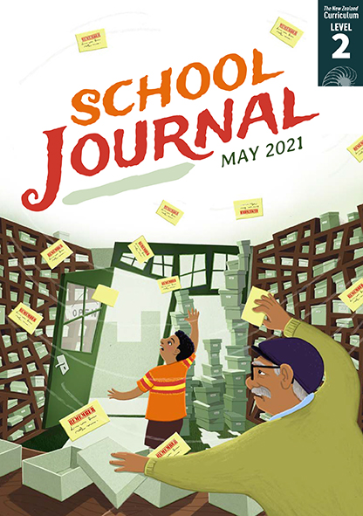
School Journal
Level 2, May 2021
Year 4

Bawang Putih and Bawang Merah
A traditional tale from Indonesia,
retold by Lavinia Disa Winona Araminta

The Learning Progression Frameworks (LPFs) describe significant signposts in reading and writing as students develop and apply their literacy knowledge and skills with increasing expertise from school entry to the end of year 10.

Overview
This story is a popular children’s story in Indonesia and Malaysia. There are several different versions. Bawang Merah and Bawang Putih are stepsisters – one good and selfless, the other greedy and selfish. In the course of the story, the good sister is rewarded and the selfish sister is taught a lesson and sees the error of her ways.
The story allows students with Indonesian and Malaysian heritage to see themselves reflected in the journal by including a familiar story from their own culture. Students will be able to use their prior knowledge of traditional tales to recognise aspects of theme and plot while extending their repertoire of cultural literature.
A PDF of the text is available at www.schooljournal.tki.org.nz

Themes
- Virtue is its own reward | - Culture and heritage | - Helping others | - Selflessness

Related texts
“Kupe and the Giant Wheke” SJ L2 May 2020 | “Stealing Maru” SJ L2 Aug 2019 | “Baskets of Fire” SJ L2 Nov 2018 |
“The Race” SJ L2 May 2017 | “Sons of Ma‘afu” SJ L2 Oct 2015 | “Sleeping Tiger” JJ 60 | “Nian, the New Year Monster” JJ 60 | “Rātā me te Rākau” JJ 60 | “Chang-O and the Moon” JJ 56 |

Strengthening reading behaviours (what to notice)
Text structure and features | Requiring students to:
- Abstract ideas  “Remember hardships make us stronger. They are not meant to break us”; mustered all her courage; lived together in harmony | - use the context and storyline as well as their developing knowledge of vocabulary and figurative language to interpret the author’s meaning
- Implied information  Bawang Merah and her mother pretended to be kind and loving … But once his ox and cart were out of sight, their gentle manner would change. | - use prior knowledge of familiar traditional storylines to infer that Bawang Merah and her mother were cruel to Bawang Putih
- Phrases typical of traditional tales/fairy tales  Bawang Putih and Bawang Merah lived in a small village; Every week, their father went to the city. | - draw on their knowledge of how familiar or typical traditional stories are organised and use these cohesive devices (signal words) to navigate and track the events in the story.

Vocabulary
Names  Other possibly challenging words  and phrases | Bawang Putih, Bawang Merah, Indonesia  stepsisters, manner, stepmother, taunt, shawl, growled, precious, rinsed, mind wandered, trickled, current, downstream, desperately, shack, mustered, hardships, break, pumpkins, rage, scorpions, centipedes, shrieked, creatures, sincere, apologies, harmony

Helpful prior knowledge (pre-reading and introducing the text)
- Traditional tales have particular elements such as good and bad stepsisters, magic, and a moral.
- Indonesia is a country in Asia.
- Traditional tales are often set in the past, sometimes in a pastoral setting, where life was different with little technology.

Possible reading and writing purposes
- Read and enjoy a traditional tale from Indonesia
- Find out how a kind old lady rewards two stepsisters in very different ways
- Identify the figurative language and other devices the author has used
- Make comparisons between a traditional tale from Indonesia with traditional tales they already know.
See Effective Literacy Practice in Years 1–4 for suggestions on using this text with your students (Approaches to teaching reading) and for information about teaching comprehension strategies (Building comprehension and Text processing strategies).

Possible curriculum contexts
This text has links to level 2 of The New Zealand Curriculum in: ENGLISH SOCIAL SCIENCES

Understanding progress
The following aspects of progress are taken from the Learning Progression Frameworks and relate to the specific learning tasks below. See the LPFs for more about how students develop expertise and make progress in these aspects:
- Reading for literary experience
- Making sense of text: using knowledge of text structure and features; reading critically
- Creating texts to communicate current knowledge and understanding
- Writing meaningful text: using knowledge of text structure and features.

Strengthening understanding through reading and writing
Select from the following suggestions and adapt them according to your students’ strengths, needs, and experiences.
Note: Most of these activities lend themselves to students working in pairs or small groups.
- Before reading the text, discuss what the words “helpful”, “selfless”, and “kind” mean. What actions would you associate with someone who was described like that? Repeat the question for the words “selfish”, “greedy”, and “unkind”. You could also explore how prefixes and suffixes change the meaning of the root word. Build word families for these key words.
- Ask the students to read the tale on their own, then have them share their opinions about it. You could ask them to talk about their favourite part or character, a word or phrase they liked or didn’t understand, any questions they have, and their thoughts about the ending. Would you have been so forgiving if you were Bawang Putih? Why?
- Discuss what would change in the story if it were set in a different country. Use the illustrations to scaffold this discussion. The students could add their ideas to a Venn diagram showing what would stay the same and what would change.
- Alternatively, depending on the needs of your students, you could stop at appropriate points during the first reading and prompt them to find and discuss specific events and actions to scaffold their understanding. For example:
  - (page 27) How did the stepmother and stepsister treat Bawang Putih? How did they treat her differently? What chores was she expected to do that her sister Bawang Merah didn’t do?
  - (page 29) Why did the old woman give each girl the choice of two pumpkins?
  - (page 31) Why do you think the old woman put something different in the bigger pumpkin? What did Bawang Merah and her stepmother expect to be in the pumpkin? Why? What do you think might happen next? What would you like to happen?
- Draw a two-column chart with the headings Actions and Conclusions. Choose one of the characters and model how to use the chart to look at their actions and what those actions tell you about that character. Have the students complete the chart and discuss their conclusions. The students could then work in pairs to complete a chart for the other characters.
- Support the students to make links to other traditional tales they know. Discuss some common elements, including a virtuous main character, an evil opponent (sometimes a mean stepmother or stepsister), a quest or task to complete, the use of magic, and a lesson or moral for the reader (for example, The Tortoise and Hare, The Boy Who Cried Wolf, The Ant and the Grasshopper – see Related texts for more). Have the students choose a tale and use the Comparing features template at the end of this TSM to identify similarities and differences between the two.
- Ask the students to think critically about the sentence “They knew there must be a reason for what had happened, and this made them think about the way they treated Bawang Putih.” Draw out the main ideas in the story that led to this sentence, for example, the ways they mistreated Bawang Putih, their greed, and the reasons why Bawang Putih got the jewels. Ask the students to consider how the old lady was kind to both sisters. What was the lesson the old woman wanted the girls and mother to learn? What was the message the author wanted the reader to take from the story?
- Have the students write about a time when they learnt from something that didn’t go well. Support them with ideas if needed, including ideas about how the greatest learning often happens from getting it wrong the first time.

“Bawang Putih and Bawang Merah” Comparing features

Compare the features of “Bawang Putih and Bawang Merah” with those of another traditional tale.
Some features of traditional tales | “Bawang Putih and Bawang Merah” | Another traditional tale
Characters and traits
Setting
Problem
Solution (the ending)
Magical elements
Unique or standout words or phrases

Explain how one of the features is similar across both tales.

Explain how one of the features is different between the tales.

Something new I learnt from the tales:

Theme or moral (message) from the tales:

