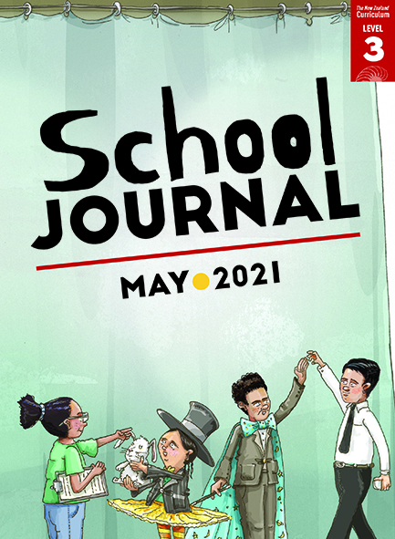

School Journal

Level 3, May 2021

Year 6

# Mauri Mahi, Mauri Ora

by Kate Paris

The[Learning Progression Frameworks](https://curriculumprogresstools.education.govt.nz/lpf-tool/) (LPFs) describe significant signposts in reading and writing as students develop and apply their literacy knowledge and skills with increasing expertise from school entry to the end of year 10.

## Overview

A humorous play with an intriguing setting and multiple features that allow students interested in drama to hone their performances.

A PDF of the text is available at [www.schooljournal.tki.org.nz](http://www.schooljournal.tki.org.nz)

## Themes

|  |  |  |  |
| --- | --- | --- | --- |
| * Performance | * Character and human psychology | * Anxiety | * Humour |

## Related texts

**“Car Games”** SJ L3 Aug 2016 | **“Waiting for Toni”** SJ L4 May 2016

## Strengthening reading behaviours (what to notice)

|  |  |
| --- | --- |
| Text structure and features | Requiring students to: |
| * Implied information ***HOKI***(suddenly worried). *What if he does a poo?* ***AMANDA***(confused)*. Who?* ***HOKI***(scornfully). *Who do you think? Honestly!* ***KYLA***(jiggling on the spot). *I’m sick of this. And I really need to go. Now.* | * use prior knowledge and context to fill in the gaps and interpret the students’ feelings of nervousness and anxiety |
| * Some disconnected text ***HOKI***(relieved). *He’s stopped twitching.* ***TUCK***(still scrolling and freaking out). *Can someone please, please help?****HOKI*** (impatiently)*. Look in your recents. Give it here.* | * piece together threads of conversation to follow the sequence of events and identify the underlying anxiety of each performer. |

|  |  |
| --- | --- |
| Vocabulary | |
| Te reo Māori, some not translated, requiring students to piece together prior knowledge with the context and characters’ actions to predict meaning | Mauri mahi, Mauri ora, Kia kaha e hoa mā, Kia tau, wharepaku, Horoia ō ringaringa,  Nāna anō tōna mate i kimi, Aē, Kua tīneine au, Ināianei, Whaea |
| Other possibly challenging words  and phrases | consulting, cue cards, scrolling, anxiously, scornfully, allergic, sanitiser, jiggling, offended, schedule, reluctantly, interrupting, outraged, dress rehearsal, delays |

|  |
| --- |
| Helpful prior knowledge (pre-reading and introducing the text) |
| * Performing in a school show or assembly is a special experience. * Performing can make us nervous or anxious. * Plays have a particular structure and purpose. |

## Possible reading and writing purposes

* Find out how a group of students feel and act as they prepare for a school show
* Identify and evaluate how the language and ideas make this play appealing
* Think critically about the theme and messages in the storyline
* Identify and practise how to read dialogue with appropriate expression to reveal character traits.

See *Effective Literacy Practice in Years 5–8* for information about teaching comprehension strategies ([Teaching comprehension](https://literacyonline.tki.org.nz/Literacy-Online/Planning-for-my-students-needs/Effective-Literacy-Practice-Years-5-8/Teaching-comprehension))   
and for suggestions on using this text with your students ([Approaches to teaching reading](https://literacyonline.tki.org.nz/Literacy-Online/Planning-for-my-students-needs/Effective-Literacy-Practice-Years-5-8/Approaches-to-teaching-reading)).

## Possible curriculum contexts

This text has links to level 3 of *The New Zealand Curriculum* in: [**ENGLISH**](http://nzcurriculum.tki.org.nz/The-New-Zealand-Curriculum/English)

## Understanding progress

The following aspects of progress are taken from the [Learning Progression Framework](https://curriculumprogresstools.education.govt.nz/lpf-tool/)s and relate to the specific learning tasks below. See the LPFs for more about how students develop expertise and make progress in these aspects:

* Reading for literary experience
* Making sense of text: reading critically; using knowledge of text structure and features
* Creating texts for literary purposes
* Using writing to think and organise for learning.

## Strengthening understanding through reading and writing

**Select from the following suggestions and adapt them** according to your students’ strengths, needs, and experiences.   
Note: Most of these activities lend themselves to students working in pairs or small groups.

* Have the students read through the text independently to familiarise themselves with the storyline and characters. Ask them to share their opinions about the play and identify their favourite character, favourite line, what they found funny, and what they thought of Amanda’s trick. They could also discuss similar experiences they’ve had of feeling nervous or worried about an event. You could give them a response template to complete, such as the one provided in the TSM for “Megabyte” (SJ L2 May 2020).
* Explain to the students that the dialogue is short and fast-paced. *Why do you think the author wrote it like this? Is this what it’s like backstage during a show? The outcome of the play has a twist – what had Amanda planned and why do you think she did this? Did the other characters pick up on it before the end? Do you think they cared?*
* Have the students identify and evaluate the language and ideas that made this play appealing (for example, humour, use of te reo Māori, relatable characters, realistic dialogue, and the theme). They could list their ideas and then share them with a partner or another group and discuss the effectiveness of each aspect.
* Prompt the students to consider what the author is saying about anxiety. *What were the students worried about? What might have gone wrong? What did go wrong? Was it really a big problem? How does the author help us understand this?*
* As a group or in pairs, discuss the stage directions in brackets that accompany many of the characters’ lines. *How do these help when reading the play? How important are they and why?*
* Ask the students to describe three characters in the play. Have them explore how the play reveals what each character feels based on what they say and do. You could use or adapt the **Character chart** template at the end of this TSM. The students could then focus on one of the characters and practise reading their lines to demonstrate what they discovered about how this character thinks and feels.  You could provide the template as a Google Doc.
* Have the students retell the play as a narrative.  They could record this to share with their whānau.
* The students could choose a character and create a business card for them. Tell them that the card should have a picture of the character, a short sentence summarising their personality and qualities, and contact details (invented).  The students could use Google Drawing to create the card.
* The students could imagine another situation (for example, opening night of the show) and, using the same characters and the play as a model, write some convincing dialogue for a short scene. Prompt them to include stage directions to show how the characters are speaking.
* To build vocabulary knowledge, you could provide a template with spaces for the students to write the unknown word, the sentence in which the word was used, their own explanation of the word, a synonym, and an antonym. They could also draw a picture or symbol to show the meaning of the word.
* Have the students perform the play in small groups. They could record this using video or audio. Each group could then share their recording with the class.

|  |
| --- |
| “Mauri Mahi, Mauri Ora” Character chart |

|  |  |  |  |
| --- | --- | --- | --- |
|  | **Character 1** | **Character 2** | **Character 3** |
| What this character is like |  |  |  |
| A word that best describes how they feel |  |  |  |
| Dialogue that best shows  this feeling |  |  |  |
| An action that best shows  this feeling |  |  |  |
| How did they prepare for  the play? |  |  |  |
| Their biggest worry |  |  |  |
| What, if anything, went wrong? |  |  |  |
| What did they learn about themselves? |  |  |  |

