Down on the Farm
Word Meanings

Calfeteria
Usually a circular drum with rubber teats around top third. These are filled with milk. Sometimes these are on wheels and towed behind a farm bike to wherever the calves may be on the farm. Smaller ones can be hung over rails.

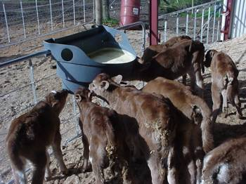
Colostrum
The first milk produced by a cow, which contains natural chemicals for fighting infection. This milk can be stored for calves to drink without it deteriorating. It is not to be sent to the Dairy factory mixed with ordinary milk. Colostrum milk is now being used to manufacture colostrum powder and creams for medicinal purposes.

Addlib
Milk is put into calfeteria daily and calves feed whenever they are hungry.

Bobby calves
Calves not wanted by the farmer as replacement stock for his herd. These are usually sold to people who wish to rear them or put on a bobby calf collection truck to be slaughtered.

Springer
A term used to identify a cow that looks as though she may calve soon. She begins to look bigger and fuller in the udder.

Topping
A farmer may cut off areas of older seed heads or an areas of the paddock that has a lot of older grass as the cows love cut grass.

Effluent
Cow poo that is washed off the cow shed floor and stored in ponds or spread on pasture.

